**GRADUATE PROJECT**

**How COVID-19 Negatively Affects the Stability of Companies’ Performance**

**Submitted to the Lebanese International University**

**The School of Business**

in Fulfillment of the

Requirements for the Degree of

**Master of Business Administration in Management**

By

**Fatima Mohammad**

ID: 21430214

Campus: Rayak

Supervised by: Dr. Mohammad Mtairek

Spring 2019 – 2020

**DEDICATIONS**

To the ones who always believe in me,

To the ones who support and encourage me,

To the ones who want to see me at the top,

To my valuable family, my support system, and my best friend.

I would love to dedicate my work to my family, who always stands by my side.

My father who works hard to see me at this level,

My mother who encourages me to reach success,

My lovely sisters, my only brother, my sister in law, my nephew, and my best friend,

Thank you for your support and care.

**ACKNOWLEDGEMENTS**

 I owe this success to Dr. Mohammad Mtairek, the one who follows and supports me throughout my Graduate Project. I would like to thank him for his encouragement and support.

Special thanks for my brothers, the double Mohammad’s.

 Thanks to my brother, the one who helps me distribute the questionnaires among his employees and scan them back to me.

My second brother, the one who always checks my work before submitting it**.**

**ABSTRACT**

Management is a word expressed as the process of dealing with or controlling things or people. The importance of management is to guide the development process and the allocated resources to attain the organizational goals. The roles of a manager are to plan, lead, organize, and control. Besides, a manager needs to be always ready for any changes that might affect the plan. Managers should set strategies and other procedures to follow them in case of the appearance of any changes to guarantee the achievement of the targeted goals. Business witnesses many changes due to the unstable environment. COVID-19 is one of the changes and events that attacks the world and affects the business cycle. In this project, a study is going to be applied to show how COVID-19 negatively affects the stability of companies and how they manage themselves preventing the risk of being lost. Hypotheses are set-up for the aim of studying the relationship between the work conditions amid COVID-19, employees' performance, and companies' performance. . A questionnaire is distributed among employees to know what procedures are taken by the company to protect its workforce from being infected by the virus, what conditions are set to ensure its employees' safety, salary, working hours and others, and how managers act to show their creativity in problem-solving.

Table of Contents

LIST OF TABLES 7

LIST OF FIGURES 8

CHAPTER 1: INTRODUCING THE GRADUATE PROJECT 9

1. Introduction 9

1.1. Research Question 10

1.2. Research Aim and Objectives 10

1.3. Overview of the Organization 11

1.4. Research Hypotheses 13

1.5. Structure of the Graduate Project 14

CHAPTER 2: LITERATURE REVIEW 15

2. Overview 15

2.1. COVID-19 and the Company’s Performance 17

2.2. Impacts of COVID-19 on the Profitability Level of Companies 22

2.3. COVID-19 Has Put the Jobs in Jeopardy 24

2.4. The Effect of Safety Methods Amid COVID-19 on the Companies’ Performance 27

2.5. Summary of Literature Review 30

CHAPTER 3: RESEARCH METHODOLOGY 32

3.1 Research Philosophy 33

3.2 Research Approach 34

3.3 Research Strategy (Data Collection Method) 35

3.4 Research Methodological Choice 37

3.5 Time horizon 39

3.6 Techniques and/or Procedures for Data Analysis 40

CHAPTER 4: FINDINGS AND ANALYSIS 41

4.1. Introduction 41

4.2. Findings (Descriptive Statistics) 41

4.3. Analysis 55

4.4. Summary of Findings and Analysis 56

CHAPTER 5: CONCLUSION, LIMITATIONS, AND RECOMMENDATIONS 57

5.1. Conclusion 57

5.2. Limitations 60

5.3. Recommendations 60

REFERENCES 61

APPENDICES 62

APPENDIX 1: QUESTIONNAIRES 63

APPENDIX 2: INTERVIEW FORMS 66

APPENDIX 3: 67

# **LIST OF TABLES**

Table 1: Gender Demographic Characteristics 41

Table 2: Age Demographic Characteristics 41

Table 3: Educational Level Demographic Characteristics 42

Table 4: Employment Status Demographic Characteristics 42

Table 5: Descriptive Characteristics 43

Table 6: Frequencies 43

Table 7: Frequency results of precautionary methods 44

Table 8: Frequency results of remote-working 44

Table 9: Frequency results of sanitization 44

Table 10: Frequency results of salary 45

Table 11: frequency results of employees' performance 45

Table 12: Frequency results of e-commerce 45

Table 13: Frequency results of expansion 46

Table 14: Frequency results of shifting to other product lines 46

Table 15: Frequency results of employees' performance 46

Table 17: T-Test Results 52

Table 18: One Sample Test Result 53

Table 19: Correlation Between Salary and Employees' Performance. 53

Table 20: Correlation Between Salary and Employees' Performance 54

# **LIST OF FIGURES**

Figure 1: The Company's Logo 11

Figure 2: Percentage Increase in the revenue of some companies 17

Figure 3: Zoom Growth Amid COVID-19 19

Figure 4: Google Classroom amid COVID-19 20

Figure 5: percentage of Hoarding masks and sanitizers amid COVID-19 24

Figure 6: Percentage of Laid off employees amid COVID-19 26

Figure 7: Managerial Roles 30

Figure 8: Research Onion 32

Figure 9: Inductive-Deductive Approaches 34

Figure 10: Abductive Approach 35

Figure 11: Concepts of Quantitative and Qualitative methods 39

Figure 12: Pie Chart results of precautionary methods 47

Figure 13: Pie Chart results of remote-working 48

Figure 14: Pie Chart results of sanitization 48

Figure 15: Pie Chart results of salary 49

Figure 16: Pie Chart results of employees' performance 49

Figure 17: Pie Chart results of e-commerce 50

Figure 18: Pie Chart results of expansion 50

Figure 19: Pie Chart results of shifting to other product lines 51

Figure 20: Pie Chart results of employees' performance 51

# **CHAPTER 1: INTRODUCING THE GRADUATE PROJECT**

# **Introduction**

COVID-19 is a disaster that not only attacks the health of people, but it also touches the world of business. We cannot say that it is the first health problem that spreads all over the globe. Else, other viruses that came before and changed the actions of businesses such as Malaria and Ebola viruses that affected the world of business, causing huge losses and some companies to bankruptcy. So, we can say that this is not the first time that entrepreneurs face such disasters. What happens in West Africa amid Ebola is now happening to the world amid COVID-19. When the Ebola epidemic first appears, managers suffer from managing their situation and maintaining their performance and are not able to continue operating. Nowadays, companies are suffering amid the pandemic. Some of them take some procedures such as reducing the employees’ working hours and workforce. Others aren’t able to overcome this situation that causes them to vanish from the market due to the absence of their capabilities to handle such situations. A similar situation took place in Sierra, in which layoffs and other measures applied to overcome the Ebola epidemic (Hamilton, 2014). . Besides, Economists stat that the Gross Domestic Product will witness a 1% decrease (from 4.5% to 3.5%) due to the closure of borders with it.

History is repeating itself, but leaders’ knowledge and awareness help them to set up creative strategies to protect their enterprises.

# **Research Question**

The question addressed through this project is:

* How COVID-19 affects negatively and positively the stability of the companies, and what are the managerial measures taken to protect their companies from being lost?

The problem of COVID-19, the crisis that affects the stability of companies and people’s lives all over the world, is going to be discussed through this project highlighting the effect of this issue on companies and how managers deal with this situation to overcome this crisis and battle this virus. The managers’ actions and problem-solving methods will be analyzed to show the managers’ roles and skills.

# **Research Aim and Objectives**

 The main objective of this project is to discuss the procedures and measures taken by the managers to deal with certain crises. It is essential to shedding lights on the managers’ roles in solving problems.

The objectives that are developed in accordance with the research question are as follow:

* How do governmental measures help the companies battle this virus?
* What are the companies’ procedures that help in staying at the safe side in the market?
* How do the Management and Human Resource departments cooperate together to overcome the COVID-19 pandemic?

# **Overview of the Organization**



Figure : The Company's Logo

Nazih Cosmetic is the selected organization. It is a retail market and distribution company. In this project, we are going to study how the pandemic affects the performance of this company.

Nazih Group is a company established in 1975 by the founder Nazih Hamad, a Lebanese person. The company headquarters is in Sharjah, UAE. Nazih group is known as the market leader in marketing and distributing cosmetics for all individuals, barbers, Spas, and fitness centers. Nazih spreads his work in the MENA region covering 21 countries in addition to Europe and Canada. He has branches in Lebanon, Iraq, Qatar, Yaman, Bahrain, Oman, Syria, Egypt, Jordan, Iran, and Libya, in addition to Abu Dhabi, Dubai, Ras Al Khaimah, Al Ain, and Fujairah in UAE, Jeddah, Riyadh, Abha and Al Khobar in Saudi Arabia. Nazih Group offers beauty products such as masks, makeup, skincare creams, and others, hygiene products, disposables for sanitation, non-medical equipment, and beauty equipment such as scissors, hairdryer, baby Lees and others. This group is considered as one of the well-known marketers for more than 100 highly famous brands such as O. P. I, Guinot Paris, Ghd, Jaguar, eprouvage, Alter Ego, Ardell, and others.

In 2006, the company opened a new department for shipping and delivering products worldwide for the aim of expanding its business abroad.

More than four thousand employees are working at Nazih Group. The firm seeks to be more innovative and attain sustainable development in addition to employees’ development the thing that helps the group to spread its work through twelve business sectors.

There are one hundred showrooms based in the Middle East and North Africa and equipped with highly service-systems.

The company participates in regional and international exhibitions to maintain its image as the leading market in the beauty industry.

**Values:**

It is known that the company works on a training support system to help employees improve their performance. This thing helps the company to be at the top, maintains its performance, and accomplishes the needs and wants of its customers. The latest follows some strategies for the aim of increasing its sales level and its profit margin. The firm depends on professional teamwork and believes that working as a team is an important method that helps in increasing the creativity and innovation levels of the company.

**Vision**:

The company's vision is to attain sustainable growth, and each business unit achieves competitive advantage among others in the domains of quality and services.

The main goals of the company are to achieve growth, increase innovation, and ensure employees' satisfaction.

**Mission:**

The company’s mission is to promote sustainable growth by providing women and men highly products to take care of their beauty. The group offers products for hair care, skincare, body care, perfumes, accessories, beauty Parlour and Spa’s furniture, beauty equipment, and non-medical beauty products.

# **Research Hypotheses**

In quantitative methods, a hypothesis should be drawn to test the relationship between independent and dependent variables. This study aims at investigating the effect of COVID-19 pandemic on the company’s performance. In order to study the relation between the virus and the company’s performance, a study is conducted to show how COVID-19 affects the companies’ regulations and the managers’ procedures toward this pandemic, how these procedures affect employees’ performance and companies’ performance. So, the hypotheses to be studied are:

H11: There is a significant relationship between work conditions amid COVID-19, employees’ performance and companies’ performance.

H01: There is no significant relationship between work conditions amid COVID-19, employees’ performance and companies’ performance.

# **Structure of the Graduate Project**

This project is organized in a standard way. The project is composed of five chapters that are mentioned respectively: Introduction, Literature Review, Methodology, Findings and analysis, and finally Conclusion, Limitation, and Recommendations. For example, in the introduction part, we introduce the graduate project, objectives, questions to be discussed, the overview of the organization to be studied in addition to the hypothesis that we are going to study if it is valid or invalid. In the Literature Review part, we are going to discuss the existing information about the effects of COVID-19 on the company’s performance and how some companies act to reduce the risk of being lost. Examples are going to be mentioned in addition to the leaders’ strategies applied in the middle of the pandemic. While Methodology Chapter illustrates philosophies, approaches, strategies, methods, time horizon, and techniques to analyze data that we are going to use through this project to reach the desired outcomes. In the fourth chapter, findings through data analysis techniques such as SPSS will be discussed. Finally, the last chapter will embody the summary of the whole project.

# **CHAPTER 2: LITERATURE REVIEW**

# **Overview**

“COVID-19 is a global crisis that knows no borders, has impacted millions of lives and has left no organization or economy untouched. It’s shown how systemic risks can have exponential repercussions — on health systems, sudden unemployment, supply chains, and the global economic outlook.” (Herweijer and Evison , 2020)We all live in an unstable environment that affects our lives negatively and positively. The year 2020 is a global nightmare causing recession and affecting the performance of all companies. COVID-19 first attacks the human health, but then it spreads to attack all businesses and changes the paths of all managers. Not only do these unseen particles affect micro-companies, but also they reach the large enterprises affecting their sales, performance, and sometimes blocking their road to attain their goals to be at the top. All companies are struggling with the virus that acts in a vicious way towards their businesses.

COVID-19 forces the government to adopt procedures such as lockdown of all businesses and schools, self-isolation, social distancing, and travel restrictions that lead to reducing the workforce and hence vanishing from the market. Whereas, some sectors such as the food and health sectors are the ones who benefit from this situation. In this way, only qualified managers and leaders can handle the problem and turn this situation into an opportunity to maintain their position and preserve their image in the marketplace. Jocelyn Murray emphasizes this reality by stating that weak men cannot handle power, it will either crush them or they will use it to crush others. (Murray, no date )

This virus is first found in China. Some leaders think that the virus is just an economical war against China, the number one country in the world of business and development. But this war extends globally and affects the economy of many more countries and changes the performance of their companies just to stay in the market. Starting from the small shops climbing up into the hyper companies all point out that coronavirus has harmfully affected the performance of the companies pushing them to shift from their main cause of existing to behave in other ways just for the reason of maintaining their position. 2020 has shaken the world of business from manufacturing to marketing due to the presence of this deadly virus. In the world of business, you have to be more creative and capable to think in an extraordinary way in such extraordinary situations.

Being a good leader is the thing that matters. Coronavirus has helped entrepreneurs adapt to this crisis that threatens their business and to be able to deal with it as an opportunity to succeed by deriving into creative models. In the world of business, crises are found to serve opportunities and help business leaders to seize them. The way they preserve the jobs is considered a win-win method (Watson, 2020). Some industries such as technology benefit from this world war and increase the number of their users. As a result of the lockdown, people start to be more professional in using technology to accomplish their duties. In addition, people hurry to shop online which leads to an increase in the profit margin of some online companies such as Alibaba and Taobao, an eBay-like digital marketplace. On the other hand, a technology provider adopts an active learning platform helping students continue learning online.

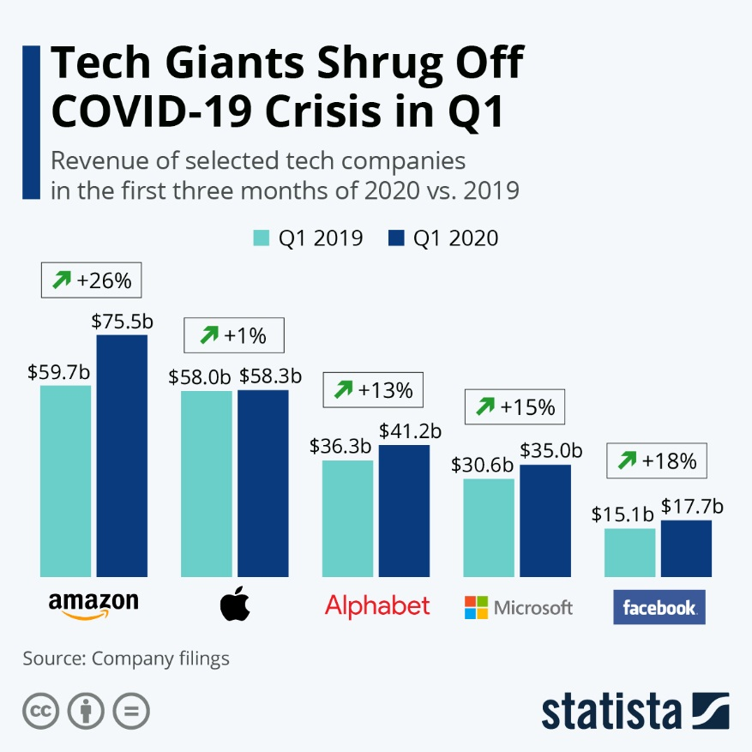

Figure : Percentage Increase in the revenue of some companies

* This figure shows how people’s usage of technology has skyrocketed and how companies record an increase in their performance, sales, and profitability levels.
* We can see how the revenues of Amazon, an e-commerce company, increase from $59.7bn to $75.5bn at the beginning of the spread of this virus compared to the revenues of the previous year.
* This increase is translated to an increase of 26%.

# **COVID-19 and the Company’s Performance**

* **Company’s Measures VS. Company’s Performance.**

Volcanoes destroy islands, then create new ones. Similarly to COVID-19, a sudden crisis that attacks the world of business keeping behind many disasters and scars for some companies, but success for others. Due to this virus, some companies aren’t able to improve or maintain their performance, others take advantage of the virus to improve their accomplishments and gain a competitive advantage in the market. (Herweijer and Evison , 2020)

The Hertz Corporation, an automotive corporation, wasn’t able to maintain its performance or manage its liabilities and hence failed and went to bankruptcy. The main causes behind the bankruptcy were the governmental procedures, the lockdown, and the closure of the airports.

Other companies, such as fashion companies have witnessed a noticeable decrease in sales and the overall performance level. At the beginning of the closure, the impact of this virus has touched all the companies whether they are small companies or large entrepreneurs. Both jobs and business life have stopped globally for approximately two months. People stop buying anything except food. They see that there is no need to buy anything else because everyone is doing nothing. Why should people buy clothes if they cannot go out? Why should people rent a car if they cannot go anywhere? (Mclntosh, 2020)

On the other hand, GAP and H&M companies were able to increase their performance by increasing the sales by 70% due to selling only the clothes that can be worn at home such as leggings.

Besides, many companies are forced to close down three-quarters of their branches amid the quarantine to save the rental costs and reduce the liabilities costs. The performance of these companies has shrunk down due to the closure and the decrease in the sales level.

The banks go through joining their forces together by reducing the working hours of their employees and the number of branches in order to stay safe from the infection of this virus as mentioned by the Canadian Bankers Association.

The technology sector is mainly the most beneficial from the crisis. The self-isolation and the closure of the schools and universities push the administrators to use applications such as Zoom, Hangouts-meet, Microsoft Teams, and others. (Watson, 2020)

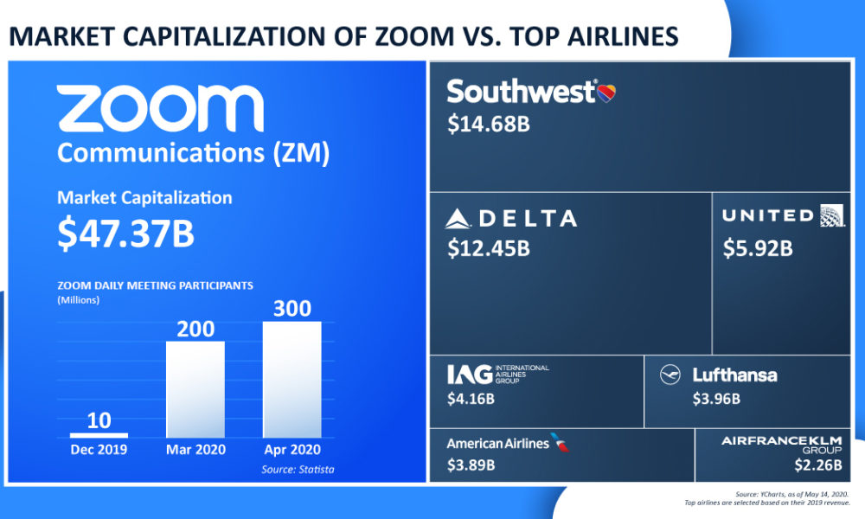

Figure : Zoom Growth Amid COVID-19

* As has been mentioned in the above figure, the Zoom Communication app has recorded an incredible increase in its market capitalization after the increase in the number of users. The number of daily users has increased from 10 million to 200 million between December 2019 and March 2020 then increased to 300 million in April. Due to the closure of the schools and Universities, the administrators go through using the Zoom app to continue teaching students, to facilitate the communication between students and teachers, and to finish their curriculum.

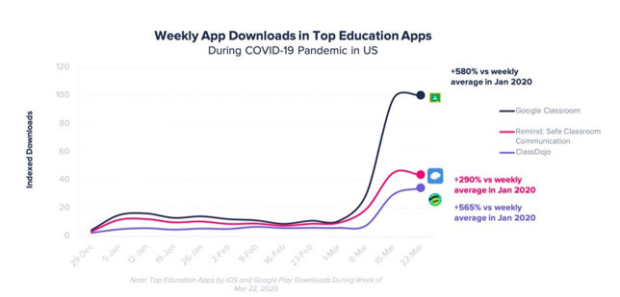

Figure : Google Classroom amid COVID-19

* Another application that is mostly used by the educational sector is Google classroom. This app is considered one of the top educational apps in the United States. This graph shows the variation of the increased download of the educational apps as a function of time.
* These three applications, Google Classroom, Class Dojo and remind: Safe Classroom Communication are used not only for educational needs but also for social needs. The family members use this application to communicate with each other.

The procedures taken by the managers of the previous companies to battle COVID-19 that affects their performance illustrate the manager’s roles. The managers have several roles to deal with in the company such as:

* Interpersonal roles: Summarized by the relationship between the manager and others.
* Informational roles: Summarized by gathering information.
* Decisional roles: Summarize the ability of the managers to make decisions and solve problems among crises.

The lockdown and social distancing push companies to deviate their ways of working and selling and go towards online selling to maintain their profit and position (Lee, 2020). In South Africa, the government facilitates the way of buying the needs and services for its citizens by using applications to shop online for their food and beverages. In addition to other online applications and programs that facilitate the work of people who cannot reach their offices amid the COVID-19 crisis. The managers are thinking critically to find a way to continue working amid the attack of coronavirus without causing the employees to lose their jobs, so they start working remotely and shed lights on the online advertisements to maintain the stability of their performance. (Herweijer and Evison , 2020)

Regarding the health sector, Pfizer, a pharmaceutical company that produces drugs and medicines has seen a massive production of a vaccine called Prevnar13 that treats pneumonia. Pneumonia is an illness that infects people who suffer from COVID-19. As this virus first appeared and spread globally, the company started producing and selling large amounts of this vaccine that increased its profits due to the increase of the demand on this vaccine and hence increasing its price. Not only does this company take advantage of the hunter virus, but also so many others. . For this aim, thousands of branches are prepared for new projects all under a unique titled serious event which is COVID-19. Health sectors are in the spotlight in which shades are directed towards them. (Globaldata Healthcare , 2020)

Corporate cleaning Inc., a cleaning company that seeks to clean and sanitize homes, companies, shops and restaurants is now, in the midst of the virus, attaining more profit as a result of the increase of the customers who are willing to sanitize their homes more in this situation pushing such companies to hire more employees to be able to handle such a huge demand. (Ludwig, no date )

* **Employee’s performance Vs. Company’s Performance**

There is a directly proportional relationship between employees’ performance and the companies’ performance. So, in the presence of any factor that affects the employees, the company will be affected. There are many factors that can negatively affect the performance of a company. For instance, when companies go toward the methods of laying off the workforce, downsizing, cutting off, and executing temporary contacts they will negatively affect the performance of other employees. They will think that their work is unstable and can be laid off at any time later on. So, this thing will decrease employees’ performance as well as companies’ performance.

On the other hand, due to the deviation in working methods from the traditional ones towards the modern ones such as working- remotely, the employees aren’t able to deal with technology and face many problems while working. In addition to that, the absence of supervision on their online work will decrease both: the employees’ performance and companies’.

Besides, it’s important to shed light on the psychological effects that result from the appearance of COVID-19. In this situation, there are many people who have faced stress, anxiety, pessimism, and depression. These feelings that affect the worker’s psyche will have negative impacts on the company. So, it’s important for the manager through the Human Resource department to think of a way to keep the employees satisfied and motivated.

# **Impacts of COVID-19 on the Profitability Level of Companies**

The word profitability is mainly composed of two words: profit and ability. Concerning this point we can define profitability as the ability to attain profit. The main cause for the presence of any company is to attain profit.

There is a directly proportional relationship between sales, performance, and profitability. As sales decrease, performance decreases and so does the profitability. Heidelberger Druckmaschinen, a German mechanical engineering company, declares that amid COVID-19 the company has faced a 6% decrease in the profitability level as compared to the profitability level before the appearance of this virus. COVID-19 has worsened the macroeconomic conditions and negatively affected the sales level as compared with the previous year. Rainer Hundsdörfer, the CEO of the company was able to maintain the company’s stability and boost profitability amid this crisis by taking some actions. (Hundsdörfer, Wassenberg and Wiesloch, 2020)

This crisis has taught many managers and leaders a strong lesson and let them show their capabilities to maintain their work in such disasters. In this situation, the only thing that matters is how to stay at the safe side without losing the success that everyone has achieved after a long hard work. (Robaton, 2020)

Some managers deviate to another product line in order to cover the loss of their normal sales such as producing sanitizers, masks, and gloves due to the increase in the demand of these products and thus maintaining their profitability level. For instance, LVMH, a luxurious company used to manufacture luxuries and perfumes; it deviates its work and starts producing hand sanitizers, and delivers them to the French authorities for free. Others like hotels cooperate with the government and change the hotels to quarantine centers attaining by that more profit.

Poteet, the owner of Shine Distillery& Grill restaurant, has to save his work. Due to the governmental declaration which states that all restaurants have to close down and work only on delivery, Poteet saw that this will cause him a lot of loss and decrease the profitability level. So, he deviated his work and started producing sanitizers and selling them to people.

He sells more than 4,000 bottles and makes $6,000 daily, exceeding the revenues he used to attain from food.

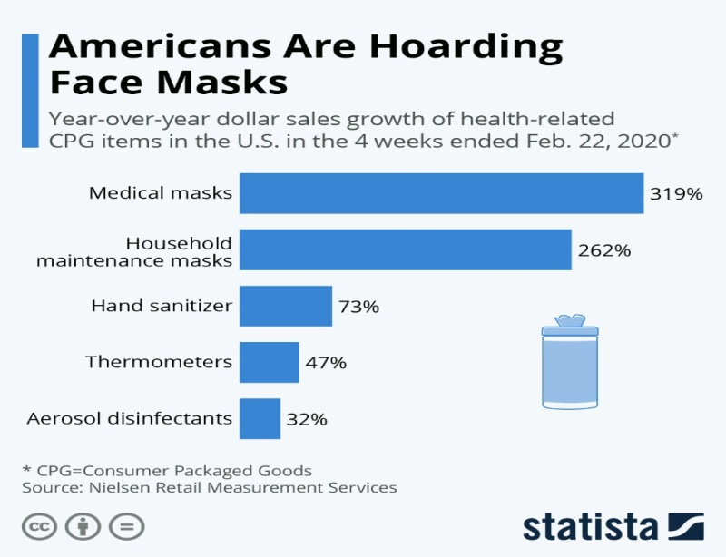

Figure : percentage of Hoarding masks and sanitizers amid COVID-19

The above statistics show the turnout on the masks and sanitizers after the governmental force to apply the precautionary procedures that reduce the spread of COVID-19. This figure illustrates how the companies that are producing these things or other companies that deviate their work toward these products are now attaining high level of profitability due to the massive demand on them.

# **COVID-19 Has Put the Jobs in Jeopardy**

COVID-19 is a virus that not only attacks people’s health, but also their ways of living. When it first attacked, it affected the business’s regulations and tracks. Due to the government’s procedures such as the lockdown causes a shrink in the economic levels. The majority of the companies have seen a decrease in their performance. Some of them aren’t able to deal with this change or pay the wages for their employees, so they are forced to take some actions. The managers have to think in a way to stay on the safe side.

After struggling to reach their goal to have a good and successful career that helps them support their families, their dream collapses by the appearance of the virus that hits the economical ecosystem. Some companies aren't able to deal with the labor expenses or even maintain their performance and preserve their profit margin, they cannot do anything, so they think of 5 ways to reduce costs.

1. Some of them apply layoffs for large numbers of their employees such as Air Canada that lays off more than 50% of its labor force.
2. Others apply the cutoff on wages in addition to giving the employees unpaid leaves in the middle of this situation such as United Airlines Holding. (Zadikian, 2020)
3. Downsizing and termination, a process in which the companies reduce the number of their labor force by eliminating number of workers in the presence of crisis.
4. Temporarily contracts with less wages.
5. Giving employees’ unpaid annual leaves.

Walt Disney is an example of one of the corporations who has faced many obstacles through this crisis. Due to this, it applies the cost cutting method for half of its workforce. The reason behind this is to save millions of dollars after the closure of its parks and hotels. This action from the manager is a problem solving method to compensate the loss behind this closure. This returns badly on the reputation of Disney Corporation since many people are against this step and they plan not to visit the parks anymore. It’s true that this is beneficial for the company to maintain its performance, but that way affects negatively on the reputation and on the long-term performance. (Doğantekin, 2020)

AT&T, American Telephone and Telegraph, is considered as one of the largest telecommunications multinational corporations in United States. It is the provider of mobile and fixed phone service. This profitable enterprise has faced many problems due to the

spread of coronavirus. This company has forced to cut off thousands of jobs and close hundreds of its stores. The cut off is a result of the economic effect caused by the pandemic. (Eadicicco, 2020)

Today, Lebanon is facing a crisis amid a crisis. Lebanon has witnessed an increase in the dollar exchange rate, before having the opportunity to overcome this disaster. COVID-19 strikes the globe and reaches the country leaving behind enormous economical, social, psychological, financial and behavioral stigma. Currently, American University of Beirut’s hospital is firing over 800 employees as a result of the financial crisis toward the country and the attack of this virus let people feel in danger everywhere and at any time. This prevents them from going to the hospital to avoid the possibility of being infected by the virus.

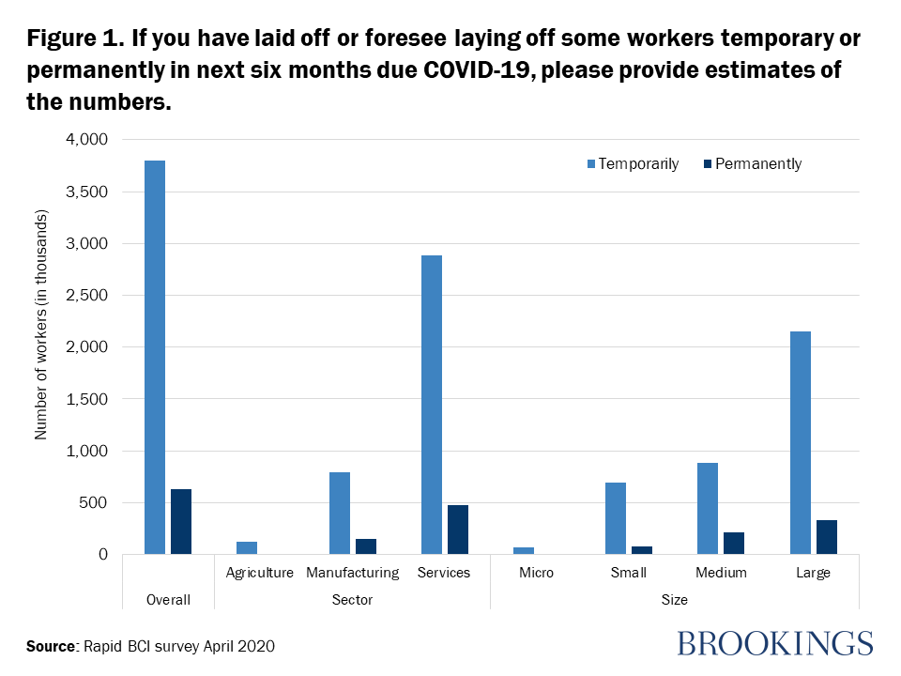

Figure : Percentage of Laid off employees amid COVID-19

This graph shows the variation of the number of permanent and temporal employees as a function of the company’s sizes and sectors. It illustrates the percentage decrease in the workforce amid COVID-19 of the permanent and temporal workers. It indicates how the crisis has affected all small, medium, and large enterprises of all sectors. This means that this unprecedented extraordinary situation targets all people all over the world with no exceptions.

We can see that the number of temporary workers is greater than the number of permanent workers. The overall number of temporal employees exceeds 3500 employees, while the permanent does not reach the 1000 employees.

# **The Effect of Safety Methods Amid COVID-19 on the Companies’ Performance**

The main responsibility for a company in the presence of any crisis is to guarantee the safety of its employees. When the company assures all the safety measures to protect them, it will gain the trust of customers whom in turn will positively affect the performance of the company by increasing the profit. For that, during COVID-19 crisis, the thing that matters is how the company manages the safety and security among all parties to protect them from the possibility of being infected by the virus. All companies go through the sanitization methods that are summarized by using devices to sanitize the workplace, forcing employees to wear masks, gloves, and use hand sanitizers. In addition to preserving social distancing. (Basnayake, Mack and Tong, 2020)

As a part of the managerial role, managers should be steady for any extraordinary change that may affect their plan or target. When the crisis first appeared, managers started to think about plans to save their companies and maintain their performance. First of all, they shed light on the safety of their employees, go through another path to accomplish their goals, find a way to communicate with customers and deliver their wants and needs and finally follow the procedure provided by the government.

The first step companies do is remote working. They train their employees how to deal with technology to accomplish their work at home. In this way, all employees will be safe at home and at the same time doing their tasks and duties without any shortage. Through this, they will improve the technical and knowledgeable skills for some of their employees. Besides, they start providing online services and delivery process to prevent their customers from facing the virus. (Basnayake, Mack and Tong, 2020)

Some companies battle COVID-19 by sanitizing the workplace every short period of time. They apply social distancing by imposing restrictions on the entry and exit of the company. They use the downsizing strategy, in which only half of the workers can go to their work stipulating the employees to wear gloves and masks and also the customers. When customers see that the company is caring about them, they will feel comfortable to buy from it, which leads to the increasing in their profits and hence the performance. It is all about how the company thinks in order to solve or battle such situations. In this way, managers think in a critical way that can protect their employees’ health, performance as well as the company’s performance.

,In Ras Al-Khaimah, Al Hamra and Al Manar malls have set several procedures to be followed in order to assure the safety for all customers, employees and others. (Gillet, 2020) These procedures are summarized by:

1. **Immediate Requirements To Resume Trading:**

|  |
| --- |
| 1. Evidence to show negative test results for all staff employed at each mall for Covid-19 2. Fully cleaned and sanitized store, both front and back of house 3. Availability of sanitizers at every counter and P.O.S 4. Staff mandated to wear surgical masks and gloves at all times whilst present in the mall 5. 2.5 meters minimum clearance between tables – Food outlets only 6. Evidence to show that only disposable utensils with take away packaging are in use - Food outlets only. 7. **Other Mandatory Tenant Requirements:**  * Random staff temperature checking and monitoring throughout trading hours. * Daily and regular store sanitization. * Store capacity that does not exceed one customer per 5 square meters. It is advisable to put a sign on your shop front when the capacity is exceeded. * Cashless transactions to be encouraged at all times * No refunds or exchanges permitted. * Sanitization of trolleys before and after every use. * Restriction of product testing such as makeup, shoe trials, perfumes and total closure of changing rooms. * Daily restaurant sanitization including tables and seats after every use – Food outlets only * Salons limited to hair and nails services only by appointment with no waiting areas and implementing social distancing measures.  1. **Other General Requirements**  * Mall opening hours restricted to 12pm – 9pm (except Supermarkets, pharmacies and foreign exchanges who can trade from 9am – 12am) * Prayer rooms, gyms, cinemas and entertainment areas will remain closed until further notice * Adults Over 60 years of age not allowed entry to either mall * Food & beverage outlets will operate at 30% seating capacity, and with a maximum of 4 people per table * Car parking availability reduced to 50% of normal capacity therefore both parking buildings will be closed. * Temperature screening at all mall entrances. |

# **Summary of Literature Review**

COVID-19 is an unprecedented event that not only affects the health of people globally but also touches businesses all over the world. All aspects of business such as schools, universities, restaurants, shops, malls, cinemas, and others are affected by the appearance of this virus. The government sets several procedures to decrease the percentage of infection by this pandemic such as self-isolation, social distancing, lockdown, and travel restrictions the things that hit the performance of these companies. In this situation, the managers are being tested to see if they are able to come up with unconditional strategies to face this virus. One of the manager’s roles is to set up problem-solving methods to overcome problems and crises.

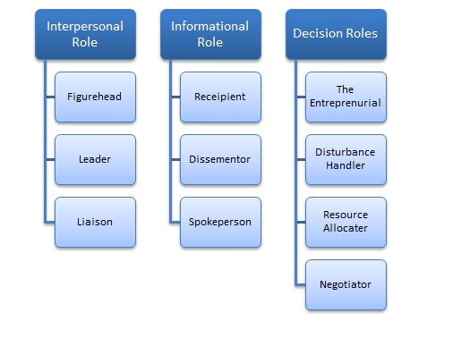

Figure : Managerial Roles

This figure summarizes the managerial roles that every manager has to attain in order to preserve the company and reach the targeted goals.

During the closure, companies followed certain conditions to protect their place in the market and survive from being lost or bankrupted. The managers deviate their ways of working from the traditional ones to modern ones such as selling online and working-remotely. These procedures are adopted for some reasons.

* Protecting their employees from the risk of being infected, since the main responsibility for a company is to guarantee the safety of its employees.
* Maintaining the company’s performance.

Besides, companies depend on the downsizing methods in which they reduce the number of employees in the workforce using several ways such as layoff, cutoff, unpaid annual leaves and depending on the temporary contracts to reduce costs due to the decrease in their profitability level amid the closure.

After the closure, when companies start to re-open their businesses, the managers must set a safe plan to protect their employees, customers, stockholders, and suppliers from the possibility of being infected. Some of the procedures taken are:

* Using gloves and masks.
* Sanitize the workplace.
* Leave a space between every single one around 1.5 square meters.

This crisis has helped the managers to know how to turn the problem into an opportunity to attain goals, overcome the crisis and use it to crush others in the market rather than threatening the company’s appearance.

# **CHAPTER 3: RESEARCH METHODOLOGY**

Through this chapter of our graduate project, philosophies, approaches, strategies, time horizon and techniques for data analyses used in any research are going to be discussed.

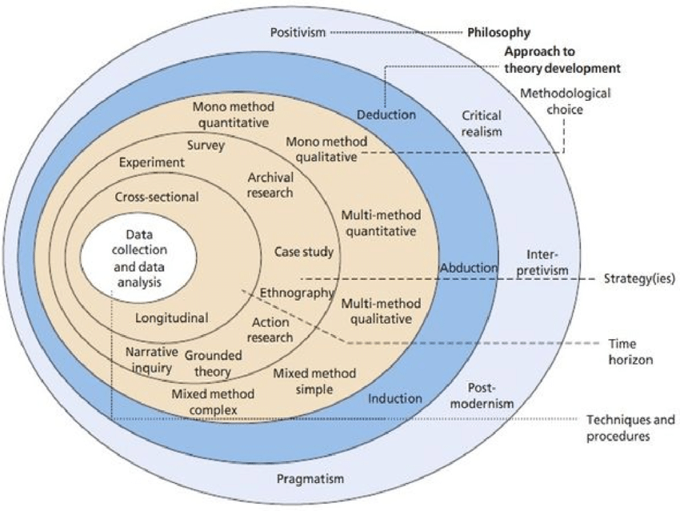

Figure : Research Onion

This figure summarizes the different types of philosophies, approaches, methods, strategies, time horizon and techniques used through the whole project.

# **Research Philosophy**

Research Philosophy illustrates how information about a certain case should be collected, examined, and used. It is the application of the scientific method in searching for the truth about a specific business phenomenon. There are 5 major philosophies that can be utilized in any research based on the research’s objective and aim.

1- The positivism philosophy: is an objective philosophy used for quantitative observation of a phenomenon that aims at collecting and analyzing data through statistics. It relies on experiments, logic, and truths. The data collection method used in this philosophy is a kind of survey such as questionnaires.

2- Interpretivism philosophy: focuses on how people are experiencing the world. It is a descriptive method. It does not follow the hypothesis testing model. It seeks to understand the social world from the participants’ points of view. The data collection method used is qualitative, data are collected through tools such as interviews.

3- Critical realism philosophy: It is a heterogeneous method that relies on both quantitative and qualitative data collection methods. It states the difference between the real and observable world.

4- Pragmatism philosophy: It is the branch of philosophy that assesses the truth in terms of practicality. It is a mixture of qualitative and quantitative data collection methods. It is used to evaluate success.

5- Postmodernism philosophy: States that there is no absolute truth.

Through this project, the positivism approach that relies on quantitative data collection method is going to be applied.

# **Research Approach**

There are three main approaches that can be used in any research. They can be summarized by inductive, deductive, and abductive approaches.

1. Inductive approach: Is a bottom-up approach. It focuses on observations and tests then comes up with a theory. It is mainly used for Interpretivism philosophy when applying qualitative data analysis.

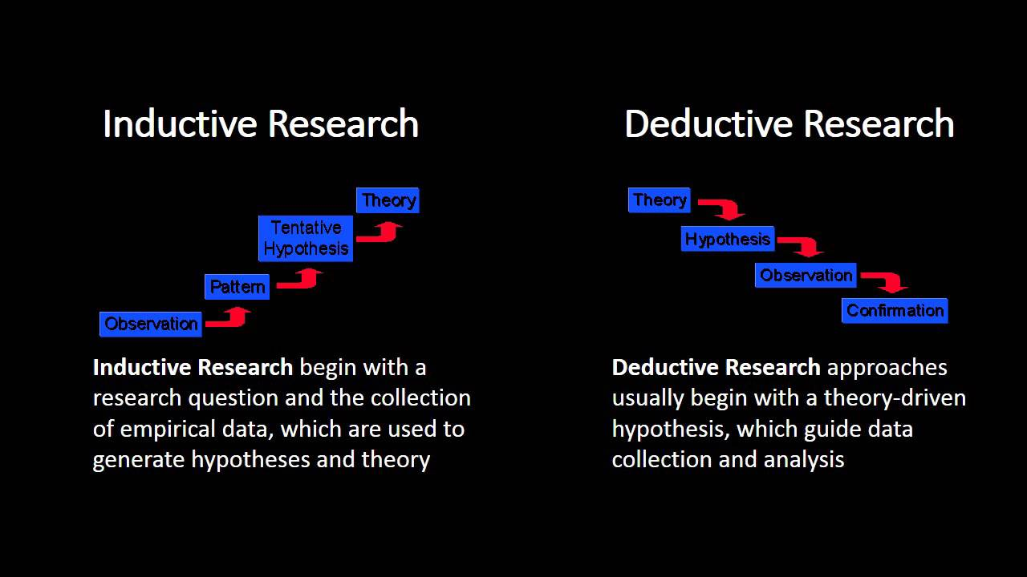

Figure : Inductive-Deductive Approaches

1. Deductive approach: It is the opposite of the inductive approach. It is a top-bottom approach. It focuses on the theory and then uses the study methods to test the hypothesis. It aims at testing the existing theories.

It is used for positivism philosophy when applying quantitative analysis. In this project, the deductive approach using quantitative analysis is going to be applied.

1. Abductive approach: It is an approach in which we develop a hypothesis based on a theory and then tests it using a research strategy.

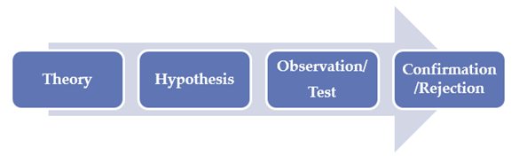

Figure : Abductive Approach

# **Research Strategy (Data Collection Method)**

There are many methods that can be used to collect data. Some of them can be used for quantitative research (when dealing with measurable factors that are expressed in numbers,

graphs or statistics) and others for qualitative (when dealing with non-measurable factors, they are expressed in terms of hypotheses).

The quantitative method is used when researchers want to study and verify the hypothesis that they are working on. The collected data are classified by numbers, graphs, and statistics that confirm the facts of the understudied case. This type of analysis ensures accuracy within the collected data.

According to Creswell (1994), the qualitative method is used to recognize a certain phenomenon and explore ideas and hypotheses. The data are classified as words.

Data collection methods that can be used are:

- Experiment: is an inquiry used to test a hypothesis. It is mainly used in quantitative analysis.

- A survey is a list of questions that are used to collect information about a certain topic. It is used in both quantitative and qualitative analysis.

- Case study: is a detailed method of a certain case. It is used in qualitative analysis.

- Archival research: is a method of collecting data from archives. It is used in both quantitative and qualitative analysis.

- Ethnography: is related to collecting information about the culture of individuals. It is used in qualitative, quantitative, or both.

- Action research: used in qualitative, quantitative, or both.

- Grounded theory: used in qualitative, quantitative, or both.

- Narrative inquiry: used in qualitative, quantitative, or both.

In this research, a survey design will be applied, in which data are collected through a questionnaire.

**Data Collection**

A questionnaire was used as a primary source for collecting data to examine the hypothesis about the relationship between work conditions amid COVID-19 and the company's performance. A questionnaire is a tool of quantitative data analysis followed by working on SPSS software to analyze the obtained results. The questions in the questionnaire are easy and need no time to be answered. The questions are divided into demographic questions that are used to identify the gender, age, business status, marital status, and educational level of the participant, while the others are structural questions about the procedures taken that might affect the employees’ performance and thus the companies’.

# **Research Methodological Choice**

Selecting the type of methodology used depends on the type of project and the form of data that is going to be collected. If the researcher is working on a hypothesis and wants to confirm the issue s/he is stating, then the best way to collect data is through quantitative methods such as surveys. This information will be translated into graphs and statistics that give more accurate facts. While if s/he is working on exploring a specific phenomenon or hypothesis that needs to be analyzed, then it is better to work on a qualitative analysis that is summarized by collecting information. The best way to collect the data is through interviews by asking open-ended questions. Also, there is a mixed method which is a combination of both qualitative and quantitative methods. It is used when the researcher is exploring a specific phenomenon and working on interviews to collect data then testing the hypothesis through a questionnaire.

In this research, the quantitative method is being used to test the hypothesis. A questionnaire is going to be distributed to employees who work at Nazih, a cosmetic corporation based in UAE. The questionnaire is going to be conducted by email, then the employees are going to scan the information back.

There are three methods used for collecting data and each method consists of other methodological choices.

1- Quantitative analysis: is a method that translates data into graphs and statistics. It is divided into:

a- Mono method quantitative: it is a method used when using only one technique in collecting data. In this method, we only use quantitative analysis.

b- Multi-method quantitative: it is a method used with more than one technique to collect data. We can use both qualitative and quantitative data collection.

2- Qualitative analysis: is a method used to collect data in the form of words. It is divided into:

a- Mono method qualitative: it is a method used when using only one technique in collecting data. In the mono qualitative method, we only use qualitative analysis.

c- Multi method Qualitative: it is a method used with more than one technique to collect data. We can use both qualitative and quantitative data collection.

3- Mixed method: is a method used to collect data using both quantitative and qualitative methods. It is divided into:

a- Mixed method simple.

b- Mixed method complex.

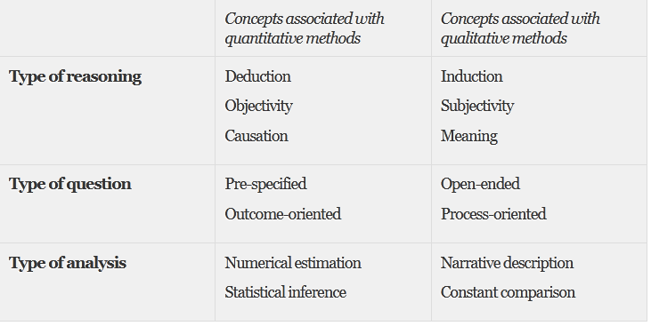

Figure : Concepts of Quantitative and Qualitative methods

This table illustrates the difference between both qualitative and quantitative methods. In a quantitative method, the researcher works on examining a certain hypothesis by collecting data through statistics and graphs, thus deductive approach is used.

The quantitative method is a cause-effect method that deals with objectivity. The questions that are asked are specific and accurate. They are estimated by numbers.

Whereas the qualitative method deals with subjectivity, the researcher collects information to come up with a new theory. The data are collected by asking open-ended questions. These results are analyzed through narrative descriptions and words.

# **Time horizon**

All of the approaches, strategies, methods, and time horizon are related to each other. It is important to clarify the time frame for a project. There are two types of time horizon:

Cross-sectional and longitudinal.

1- Cross-sectional time frame is used for the short term, in which information is collected once. This type of time frame is going to be used in this project since data are going to be collected once.

2- Longitudinal time frame is used for the long term in which data are collected more than one time due to the change of the phenomenon. For example, if a researcher wants to study the behavior of management before and after COVID-19, the best time frame to be used is the longitudinal one.

# **Techniques and/or Procedures for Data Analysis**

Techniques and procedures that are used for data analysis depend on the data collection method and approaches. When applying quantitative methods, the best technique used to analyze and interpret these results is SPSS. Statistical Package for the Social Science (SPSS), a software used to analyze survey data. It offers statistical analysis of a specific phenomenon.

Whereas, when applying qualitative methods or mixed methods, the best technique used to analyze the results is NVIVO, a software that is used to analyze qualitative data such as interviews and open-ended surveys. NVIVO is developed by QSR International that helps researchers develop and analyze qualitative collected data.

To study the relationship between work conditions amid COVID-19, employees’ performance, and companies’ performance, data should be collected from employees to know their points of view toward the discussed topic and to test the hypothesis. So, the decision taken is to collect data through the quantitative method which is the questionnaire. Once data are collected, results are going to be analyzed through the SPSS software.

# **CHAPTER 4: FINDINGS AND ANALYSIS**

# **Introduction**

In the previous chapter, the methodological choices were determined to be applied in the current section. In this part, the data will be analyzed and the relation between the dependent and the independent variables will be defined. The SPSS program was used to analyze the results of the questionnaire that was distributed to 90 employees at Nazih Group. The analysis aims to test the mentioned hypothesis and decide whether to reject or accept it.

# **Findings (Descriptive Statistics)**

**Frequencies**

1. **Overview of demographic characteristics:**

|  |  |  |  |  |  |
| --- | --- | --- | --- | --- | --- |
| **Gender** | | | | | |
|  | | Frequency | Percent | Valid Percent | Cumulative Percent |
| Valid | Male | 64 | 71.1 | 71.1 | 71.1 |
| Female | 26 | 28.9 | 28.9 | 100.0 |
| Total | 90 | 100.0 | 100.0 |  |

Table : Gender Demographic Characteristics

The participants who respond to the questionnaire are 90 employees. 64 out of them are males and 26 are females.

|  |  |  |  |  |  |
| --- | --- | --- | --- | --- | --- |
| **Age** | | | | | |
|  | | Frequency | Percent | Valid Percent | Cumulative Percent |
| Valid | 20-29 | 36 | 40.0 | 40.0 | 40.0 |
| 29-39 | 37 | 41.1 | 41.1 | 81.1 |
| 39-49 | 17 | 18.9 | 18.9 | 100.0 |
| Total | 90 | 100.0 | 100.0 |  |

Table : Age Demographic Characteristics

|  |  |  |  |  |  |
| --- | --- | --- | --- | --- | --- |
| **Educational level** | | | | | |
|  | | Frequency | Percent | Valid Percent | Cumulative Percent |
| Valid | High school | 30 | 33.3 | 33.3 | 33.3 |
| Bachelor | 55 | 61.1 | 61.1 | 94.4 |
| Masters | 5 | 5.6 | 5.6 | 100.0 |
| Total | 90 | 100.0 | 100.0 |  |

This table shows that 36 out of 90 employees are between 20 and 29 years, 37 are between 29 and 39 years, and 17 are between 39 and 49 years.

Table : Educational Level Demographic Characteristics

This table indicates that the majority of the respondents have bachelor degrees (55 employees), 30 employees finish their high school, and 5 have a master’s degree.

|  |  |  |  |  |  |
| --- | --- | --- | --- | --- | --- |
| **Employment status** | | | | | |
|  | | | | | |
|  | | Frequency | Percent | Valid Percent | Cumulative Percent |
| Valid | Full time | 90 | 100.0 | 100.0 | 100.0 |

Table : Employment Status Demographic Characteristics

This table shows that all employees work full-time.

**Descriptive**

|  |  |  |  |  |  |
| --- | --- | --- | --- | --- | --- |
| **Descriptive Statistics** | | | | | |
|  | N | Minimum | Maximum | Mean | Std. Deviation |
| Does the company take any precautionary methods against COVID-19 | 90 | 3.00 | 5.00 | 4.4556 | .54383 |
| Has the company developed a plan to work remotely | 90 | 2.00 | 5.00 | 3.6444 | .78341 |
| Are sanitizers found at all cash desks | 90 | 4.00 | 5.00 | 4.7222 | .45041 |
| Do you think remote working affect your performance | 90 | 1.00 | 5.00 | 3.2222 | .87124 |
| Has this situation affected your salary | 90 | 2.00 | 5.00 | 3.8000 | .78182 |
| Has your company shifted to another product lines | 90 | 2.00 | 5.00 | 3.6556 | .79551 |
| Has your company deviated to e-commerce websites to sell its products | 90 | 4.00 | 5.00 | 4.0556 | .23034 |

|  |  |  |  |  |  |
| --- | --- | --- | --- | --- | --- |
| Has the company expanded its work amid the virus | 90 | 2.00 | 5.00 | 3.6667 | .67040 |
| Do the procedures taken by the company help in improving your performance | 90 | 1.00 | 4.00 | 3.4889 | .79668 |
| Valid N (list wise) | 90 |  |  |  |  |

Table : Descriptive Characteristics

|  |  |  |  |  |  |  |  |  |  |  |
| --- | --- | --- | --- | --- | --- | --- | --- | --- | --- | --- |
| **Frequencies**  **Statistics** | | | | | | | | | | |
|  | | Does the company take any precautionary methods against COVID-19 | Has the company developed a plan to work remotely | Are sanitizers found at all cash desks | Has this situation affected your salary | Do you think remote working affect your performance | Has your company deviated to e-commerce websites to sell its products | Has the company expanded its work amid the virus | Has your company shifted to another product lines | Do the procedures taken by the company help in improving your performance |
| N | Valid | 90 | 90 | 90 | 90 | 90 | 90 | 90 | 90 | 90 |
| Missing | 0 | 0 | 0 | 0 | 0 | 0 | 0 | 0 | 0 |
| Mean | | 4.4556 | 3.6444 | 4.7222 | 3.8000 | 3.2222 | 4.0556 | 3.6667 | 3.6556 | 3.4889 |
| Std. Deviation | | .54383 | .78341 | .45041 | .78182 | .87124 | .23034 | .67040 | .79551 | .79668 |
| Variance | | .296 | .614 | .203 | .611 | .759 | .053 | .449 | .633 | .635 |
| Range | | 2.00 | 3.00 | 1.00 | 3.00 | 4.00 | 1.00 | 3.00 | 3.00 | 3.00 |
| Sum | | 401.00 | 328.00 | 425.00 | 342.00 | 290.00 | 365.00 | 330.00 | 329.00 | 314.00 |

Table : Frequencies

**Frequency Table**

|  |  |  |  |  |  |
| --- | --- | --- | --- | --- | --- |
| **Does the company take any precautionary methods against COVID-19** | | | | | |
|  | | Frequency | Percent | Valid Percent | Cumulative Percent |
| Valid | Neutral‎ | 2 | 2.2 | 2.2 | 2.2 |
| Yes | 45 | 50.0 | 50.0 | 52.2 |
| Extremely yes | 43 | 47.8 | 47.8 | 100.0 |
| Total | 90 | 100.0 | 100.0 |  |

Table : Frequency results of precautionary methods

Some companies develop precautionary methods to protect their employees from the possibility of being infected by the virus. According to the study, 43 employees agree that the company extremely develop some methods. 45 employees agree that methods were set, and 2 employees state that the company’s action was neutral. This means that the company’s priority is to protect its employees and ensure a safe environment.

|  |  |  |  |  |  |
| --- | --- | --- | --- | --- | --- |
| **Has the company developed a plan to work remotely** | | | | | |
|  | | Frequency | Percent | Valid Percent | Cumulative Percent |
| Valid | No | 12 | 13.3 | 13.3 | 13.3 |
| Neutral | 13 | 14.4 | 14.4 | 27.8 |
| Yes | 60 | 66.7 | 66.7 | 94.4 |
| Extremely yes | 5 | 5.6 | 5.6 | 100.0 |
| Total | 90 | 100.0 | 100.0 |  |

Table : Frequency results of remote-working

60 employees agree that the company is preventing its stability by setting plans to work remotely due to the current situation. 13 employees state that the company’s action is neutral. 12 employees state that the company did not deviate to remote-working, while the rest 5 believe that the plans are well developed.

|  |  |  |  |  |  |
| --- | --- | --- | --- | --- | --- |
| **Are sanitizers found at all cash desks** | | | | | |
|  | | Frequency | Percent | Valid Percent | Cumulative Percent |
| Valid | Yes | 25 | 27.8 | 27.8 | 27.8 |
| Extremely yes | 65 | 72.2 | 72.2 | 100.0 |
| Total | 90 | 100.0 | 100.0 |  |

Table : Frequency results of sanitization

All employees state that sanitizers are found at all cash desks to protect employees, customers, and others from the infection by the virus. 65 employees witness the extensive care of the company.

|  |  |  |  |  |  |
| --- | --- | --- | --- | --- | --- |
| **Has this situation affected your salary** | | | | | |
|  | | Frequency | Percent | Valid Percent | Cumulative Percent |
| Valid | No | 6 | 6.7 | 6.7 | 6.7 |
| Neutral | 20 | 22.2 | 22.2 | 28.9 |
| Yes | 50 | 55.6 | 55.6 | 84.4 |
| Extremely yes | 14 | 15.6 | 15.6 | 100.0 |
| Total | 90 | 100.0 | 100.0 |  |

Table : Frequency results of salary

Amid COVID-19, companies’ performance changes and increases their costs. So, some of them take actions such as reducing the salary of employees. This table indicates that 14 employees are suffering from more than half a reduction in their wages. Salary of 50 employees is possibly affected, in which they get unpaid leaves. 20 employees state that salary reduction was not remarkable, while 6 employees witness no change in their salary. It means that salaries of the majority are affected amid COVID-19.

|  |  |  |  |  |  |
| --- | --- | --- | --- | --- | --- |
| **Do you think remote working affect your performance** | | | | | |
|  | | Frequency | Percent | Valid Percent | Cumulative Percent |
| Valid | Extremely no | 2 | 2.2 | 2.2 | 2.2 |
| No | 16 | 17.8 | 17.8 | 20.0 |
| Neutral | 36 | 40.0 | 40.0 | 60.0 |
| Yes | 32 | 35.6 | 35.6 | 95.6 |
| Extremely yes | 4 | 4.4 | 4.4 | 100.0 |
| Total | 90 | 100.0 | 100.0 |  |

Table : frequency results of employees' performance

After deviating to remote-working, 2 employees extremely reject the effectiveness of remote working on their performance. 16 employees reject this cause-effect relation. 36 employees state that remote working has a neutral effect on their performance. The performance of 36 employees is affected amid remote-working.

|  |  |  |  |  |  |
| --- | --- | --- | --- | --- | --- |
| **Has your company deviated to e-commerce websites to sell its products** | | | | | |
|  | | Frequency | Percent | Valid Percent | Cumulative Percent |
| Valid | Yes | 85 | 94.4 | 94.4 | 94.4 |
| Extremely yes | 5 | 5.6 | 5.6 | 100.0 |
| Total | 90 | 100.0 | 100.0 |  |

Table : Frequency results of e-commerce

85 employees agree that the company has deviated to e-commerce websites to sell its products, and 5 employees extremely agree. This indicates that the company uses websites to sell its product online amid the COVID-19 crisis.

|  |  |  |  |  |  |
| --- | --- | --- | --- | --- | --- |
| **Has the company expanded its work amid the virus** | | | | | |
|  | | Frequency | Percent | Valid Percent | Cumulative Percent |
| Valid | No | 8 | 8.9 | 8.9 | 8.9 |
| Neutral | 16 | 17.8 | 17.8 | 26.7 |
| Yes | 64 | 71.1 | 71.1 | 97.8 |
| Extremely yes | 2 | 2.2 | 2.2 | 100.0 |
| Total | 90 | 100.0 | 100.0 |  |

Table : Frequency results of expansion

According to the respondents, 66 employees believe that the company has expanded its work amid coronavirus. 16 responders state that the company’s work pace was stable, and 8 employees reject the possibility of expansion amid the virus. This means that the majority believe that the company has expanded its work amid the COVID-19 crisis.

|  |  |  |  |  |  |
| --- | --- | --- | --- | --- | --- |
| **Has your company shifted to another product lines** | | | | | |
|  | | Frequency | Percent | Valid Percent | Cumulative Percent |
| Valid | No | 16 | 17.8 | 17.8 | 17.8 |
| Neutral | 1 | 1.1 | 1.1 | 18.9 |
| Yes | 71 | 78.9 | 78.9 | 97.8 |
| Extremely yes | 2 | 2.2 | 2.2 | 100.0 |
| Total | 90 | 100.0 | 100.0 |  |

Table : Frequency results of shifting to other product lines

This table shows that 16 employees agree that the company did not shift to other product lines, 73 employees believe the opposite, and 1 employee states that nothing has changed. This indicates that the majority ensure that the company deviates to other product lines to maintain its work and situation.

|  |  |  |  |  |  |
| --- | --- | --- | --- | --- | --- |
| **Do the procedures taken by the company help in improving your performance** | | | | | |
|  | | Frequency | Percent | Valid Percent | Cumulative Percent |
| Valid | Extremely no | 4 | 4.4 | 4.4 | 4.4 |
| No | 5 | 5.6 | 5.6 | 10.0 |
| Neutral | 24 | 26.7 | 26.7 | 36.7 |
| Yes | 57 | 63.3 | 63.3 | 100.0 |
| Total | 90 | 100.0 | 100.0 |  |

Table : Frequency results of employees' performance

According to the participants, the performance of 57 employees is improved due to the company’s procedures, while the performance of 24 employees is still stable. 9 employees deny the effect of the company’s procedures on their performance.

**Pie Chart**

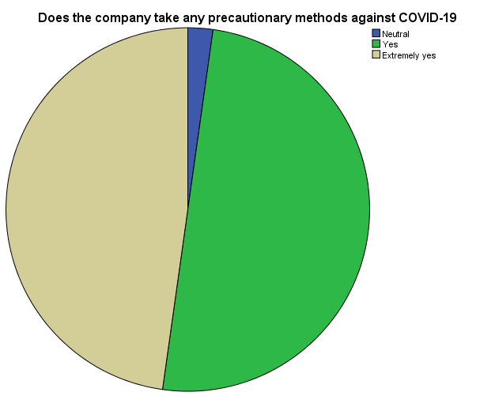

Figure : Pie Chart results of precautionary methods

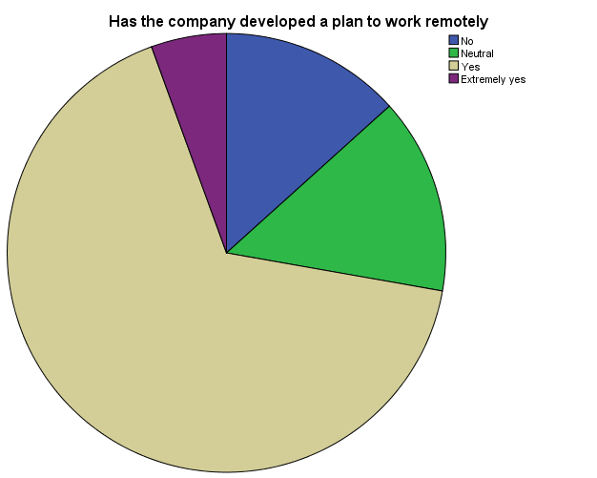

Figure : Pie Chart results of remote-working

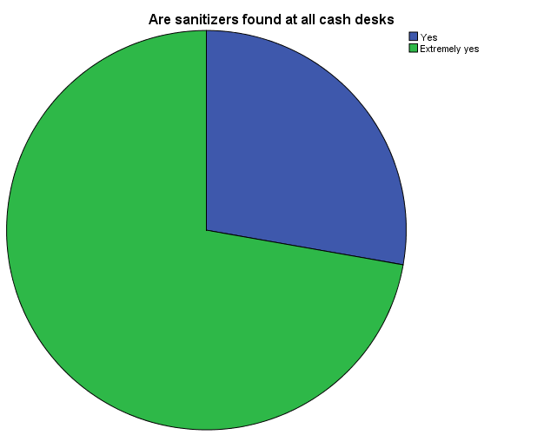

Figure : Pie Chart results of sanitization

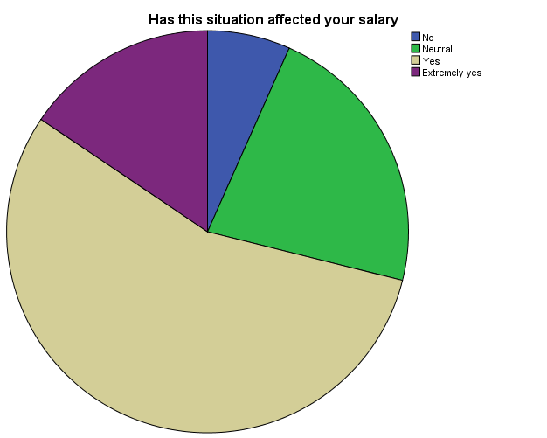

Figure : Pie Chart results of salary

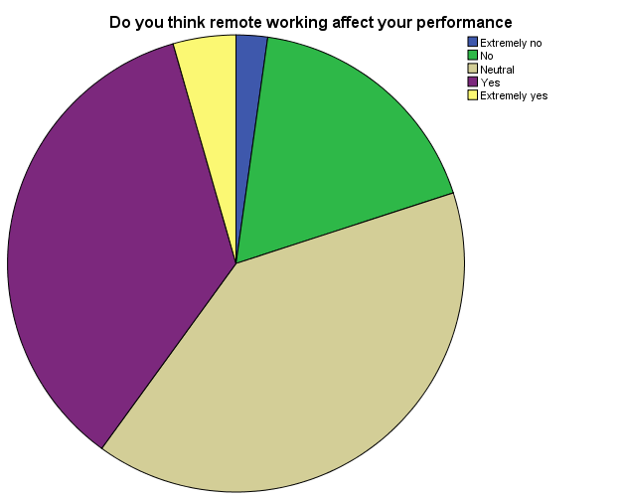

Figure : Pie Chart results of employees' performance

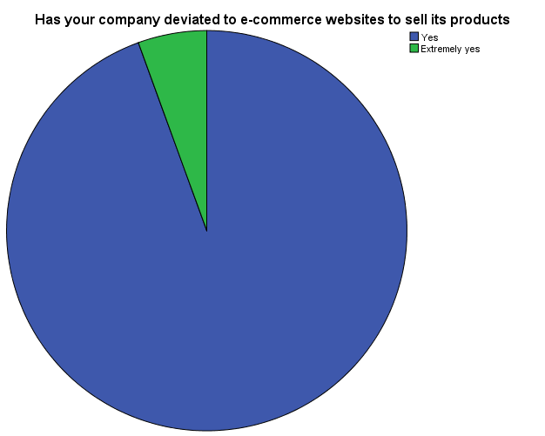

Figure : Pie Chart results of e-commerce

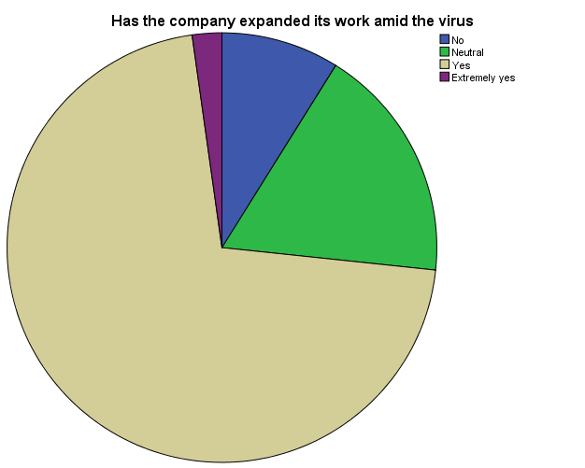

Figure : Pie Chart results of expansion

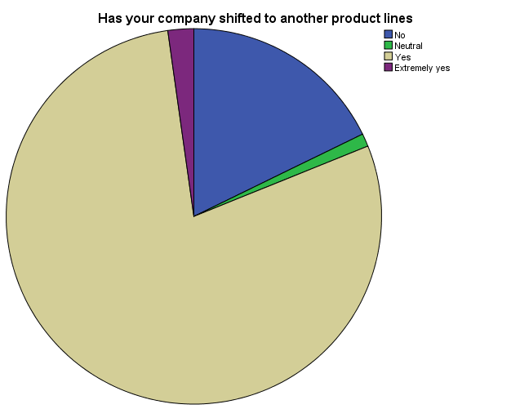

Figure : Pie Chart results of shifting to other product lines

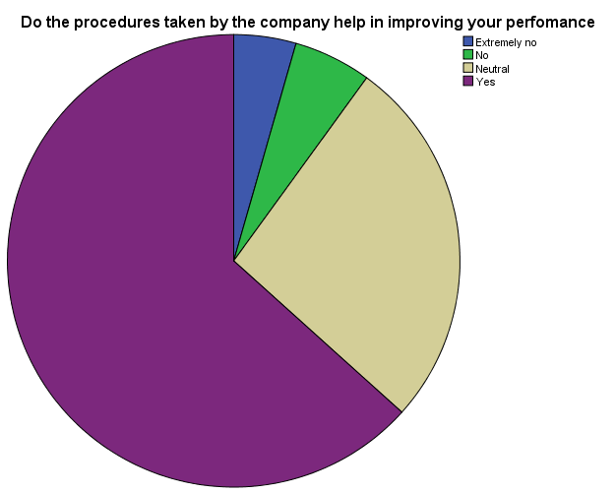

Figure : Pie Chart results of employees' performance

**T-Test**

|  |  |  |  |  |
| --- | --- | --- | --- | --- |
| **One-Sample Statistics** | | | | |
|  | N | Mean | Std. Deviation | Std. Error Mean |
| Does the company take any precautionary methods against COVID-19 | 90 | 4.4556 | .54383 | .05733 |
| Do the procedures taken by the company help in improving your performance | 90 | 3.4889 | .79668 | .08398 |
| Has the company expanded its work amid the virus | 90 | 3.6667 | .67040 | .07067 |
| Has your company deviated to e-commerce websites to sell its products | 90 | 4.0556 | .23034 | .02428 |
| Has this situation affected your salary | 90 | 3.8000 | .78182 | .08241 |
| Has the company developed a plan to work remotely | 90 | 3.6444 | .78341 | .08258 |
| Are sanitizers found at all cash desks | 90 | 4.7222 | .45041 | .04748 |
| Has your company shifted to another product lines | 90 | 3.6556 | .79551 | .08385 |
| Do you think remote working affect your performance | 90 | 3.2222 | .87124 | .09184 |

Table : T-Test Results

|  |  |  |  |  |  |  |  |  |  |  |  |  |
| --- | --- | --- | --- | --- | --- | --- | --- | --- | --- | --- | --- | --- |
| **One-Sample Test** | | | | | | | | | | | | |
|  | Test Value = 0 | | | | | | | | | | | |
| T | | df | | Sig. (2-tailed) | | Mean Difference | | 95% Confidence Interval of the Difference | | | |
| Lower | | Upper | |
| Does the company take any precautionary methods against COVID-19 | 77.724 | | 89 | | .000 | | 4.45556 | | 4.3417 | | 4.5695 | |
| Do the procedures taken by the company help in improving your performance | 41.545 | | 89 | | .000 | | 3.48889 | | 3.3220 | | 3.6558 | |
| Has the company expanded its work amid the virus | | 51.887 | | 89 | | .000 | | 3.66667 | | 3.5263 | | 3.8071 | |
| Has your company deviated to e-commerce websites to sell its products | | 167.030 | | 89 | | .000 | | 4.05556 | | 4.0073 | | 4.1038 | |
| Has this situation affected your salary | | 46.111 | | 89 | | .000 | | 3.80000 | | 3.6363 | | 3.9637 | |
| Has the company developed a plan to work remotely | | 44.133 | | 89 | | .000 | | 3.64444 | | 3.4804 | | 3.8085 | |
| Are sanitizers found at all cash desks | | 99.462 | | 89 | | .000 | | 4.72222 | | 4.6279 | | 4.8166 | |
| Has your company shifted to another product lines | | 43.594 | | 89 | | .000 | | 3.65556 | | 3.4889 | | 3.8222 | |
| Do you think remote working affect your performance | | 35.087 | | 89 | | .000 | | 3.22222 | | 3.0397 | | 3.4047 | |

Table : One Sample Test Result

**Correlations**

|  |  |  |  |  |  |  |
| --- | --- | --- | --- | --- | --- | --- |
| **Descriptive Statistics** | | | | | | |
|  | | Statistic | Bootstrapa | | | |
| Bias | Std. Error | 95% Confidence Interval | |
| Lower | Upper |
| Has this situation affected your salary | Mean | 3.8000 | -.0023 | .0852 | 3.6333 | 3.9778 |
| Std. Deviation | .78182 | -.00688 | .06054 | .68752 | .91373 |
| N | 90 | 0 | 0 | 90 | 90 |
| Do the procedures taken by the company help in improving your performance | Mean | 3.4889 | .0057 | .0837 | 3.3444 | 3.6444 |
| Std. Deviation | .79668 | -.00481 | .08093 | .62449 | .95779 |
| N | 90 | 0 | 0 | 90 | 90 |
| a. Unless otherwise noted, bootstrap results are based on 90 bootstrap samples | | | | | | |

Table : Correlation Between Salary and Employees' Performance.

|  |  |  |  |  |  |
| --- | --- | --- | --- | --- | --- |
| **Correlations** | | | | | |
|  | | | | Has this situation affected your salary | Do the procedures taken by the company help in improving your performance |
| Has this situation affected your salary | Pearson Correlation | | | 1 | .141 |
| Sig. (2-tailed) | | |  | .186 |
| N | | | 90 | 90 |
| Bootstrapc | Bias | | 0 | .018 |
| Std. Error | | 0 | .089 |
| 95% Confidence Interval | Lower | 1 | -.043 |
| Upper | 1 | .328 |
| Do the procedures taken by the company help in improving your performance | Pearson Correlation | | | .141 | 1 |
| Sig. (2-tailed) | | | .186 |  |
| N | | | 90 | 90 |
| Bootstrapc | Bias | | .018 | 0 |
| Std. Error | | .089 | 0 |
| 95% Confidence Interval | Lower | -.043 | 1 |
| Upper | .328 | 1 |
| c. Unless otherwise noted, bootstrap results are based on 90 bootstrap samples | | | | | |

Table : Correlation Between Salary and Employees' Performance

This table shows that there is a significant relationship between working conditions and employees’ performance. This depends on the working conditions. When the company applies the salary reduction process to its employees, their satisfaction decreases. They are demotivated to continue their work or either to put more effort in achieving the targeted goals. This affects negatively the company’s performance. While when the company ensures the safest environment for its employees, they will be motivated, their performance will increase and will positively affect the company’s performance.

# **Analysis**

90 employees respond to the questionnaire. 64 out of them are males and 26 are females. All of them work full-time. The majority are from the new generation and most of them have a bachelor's degree. The results show that the salary of the majority is affected during the coronavirus pandemic. The reduction procedures are summarized by salary reduction, unpaid leaves, and cutoff. Some employees reach a 70% reduction in their base salary, and more than half are given unpaid leaves. Precautionary methods are applied to prevent employees from being infected by the virus. When the company applies precautionary methods to prevent its employees, they affect their performance. When employees feel safe and secure in their workplace, they work more effectively and this might positively reflect on their performance. All of the workforces approve that the company takes many procedures and safety methods such as sanitizing the workplace to protect employees and customers from the pandemic, indicating the necessity of wearing gloves and masks, and putting sanitizers at the cash tables. Like all other companies mentioned before, Nazih Cosmetic deviates to e-commerce websites to sell its products to overcome the crisis, maintain its performance, and stay at the safe side. The company focuses on social media ads to market its products. The company develops a process and plan to work remotely. The results show that not all employees work- remotely. It depends on their position and type of work. Besides, as a manager states, the company shifts to other product lines such as masks. It develops machines and equipment to sanitize malls, shops, homes, restaurants, and others. The majority of the employees agree that the company amid COVID-19 was able to expand its work and take the advantage to develop its business.

# **Summary of Findings and Analysis**

The results of the analysis can be summarized as follow:

* The majority of the respondents are men.
* All of the employees work full-time.
* The majority of the employees are from the new generation.
* Half of them have a bachelor's degree.
* The salary of around 70% of the employees is affected.
* The company takes the precautionary methods to prevent its workforce from the risk of being infected by the virus.
* The company deviates to e-commerce websites.
* Half of the employees work remotely.
* The company was able to develop and expand amid the coronavirus pandemic.
* COVID-19 affects the work condition of the employees.
* Employees’ performance is affected.

# **CHAPTER 5: CONCLUSION, LIMITATIONS, AND RECOMMENDATIONS**

# **Conclusion**

It is essential shedding lights on the managers’ roles and skills. The way they act reflects their attitudes, behaviors, and abilities. To test their abilities, it is important to know how do they deal and act to overcome a crisis or a problem. The main point to focus on as a manager, who has to think for the long term, is to always set another plan ( plan B), an unconditional strategy to face an unconditional crisis. When a crisis first attacks, the managers have to respond to it, they cannot respond as they used to do during the daily routine emergencies by following plans drawn in advance, but they have to adjust to ongoing practices that can be used even after passing the crisis. For instance, remote-working, a method that is applied by every manager in every company during the crisis can be used even after the pandemic. This will help the companies to use other strategies in their working process. This strategy can help the company to develop its way of working and increases the employees’ technical skills.

We all know that we live in an unstable environment, which means that it is possible to face a problem that is not expected to happen. It is important to get ready for any unexpected problem and think of ways to solve it. According to a study, managers’ emotions and moods play an important role in decision making and creativity. Since one of the managerial roles is to make decisions. It is essential to know what the factors that affect this decision are. We have to mention that the type of leadership style affects the decision. So, the manager should always be optimistic and relaxed in order to think creatively and make the best decision to save the company and maintain its performance.

COVID-19 is a crisis that attacks the globe leading to many disasters on all levels and sectors without any exclusion. The pandemic leads to a huge health and life disasters. In accordance with the results obtained after distributing the questionnaires to employees, they approve the acceptance of the hypothesis that states that there is a relationship between work conditions amid COVID-19, employees' performance, and companies' performance. This relationship can have a positive and negative impact on performance. According to the study applied to the workers at Nazih Group, it assures that work conditions affect positively and negatively the employees' performance. Amid COVID-19, the company takes many decisions such as reducing employees' salaries due to the decrease in the sales levels because of the governmental decisions such as the lockdown and travel restrictions. These procedures decrease the employees’ performance level and affect the company’s performance. The mentioned decisions shed light on the government's role to battle the virus. In addition, the firm applies the cutoff and the layoff methods on the workforce because of debt owed to the company. This step decreases the level of employees' motivation that will decrease their performance in the company. These procedures show how Management Department and Human Resource Department cooperate together to overcome the crisis.

The safety methods are taken by the company to prevent their employees from being infected by the virus such as sanitizing the workplace and wearing gloves and masks, motivate the employees to continue their duties and responsibilities in comfortable places thus improving their performance. Also, these procedures preserve customers’ safety that helps in maintaining the company's performance. In addition, the company sets a plan to work remotely in order to maintain the working process and manage its situation amidst the pandemic to prevent the employees from facing the virus. All of these procedures taken by the company plays an important role on the employees' performance. Some of the working conditions motivate the employees to work hard and perform well, while others affect negatively their performance. Not to mention, there is a relationship between the motivation levels on employees' performance. If the company provides its employees with good working conditions such as training, safety, work-life balance, and others, the employees' motivational level will increase, thus increasing their performance and achieving more profits. These are considered as the measurements taken by the company to manage its operation and maintain its performance amid coronavirus. This study shows that COVID-19 affects businesses' life and cycle.

The strategies applied by the firm such as deviating through other product lines and shifting to remote working play an important role in helping the company to stay at the safe side in the market. All of the above-mentioned procedures specify the aims and the objectives of the research and answers the question that is asked at the beginning of the project.

So, as a result of all of the given studies and reports about many companies that develop specific strategies and plans to follow them during the pandemic, the effect of the companies’ and governmental procedures that are followed to prevent all of the employees, suppliers, customers, and others, in addition to the cooperation and unity of all the workforce and departments in the company, all plays an important role in battling the virus. Besides, the results of the collected questionnaires are all evidence that show that there is a significant relationship between the work conditions applied in the company amid the COVID-19 pandemic, employees’ performance, and companies’ performance. These three approaches are linked together in a ring the shows the effect of one on another.

# **Limitations**

COVID-19 was not an obstacle that prevents us from distributing the questionnaires over the employees. The questionnaire was sent through emails and then the answers were scanned back to us in order to work on SPSS program. There was no problem in collecting the primary data. But on the other hand, since the pandemic has newly attacked the globe, there were not enough information about the crisis and its impact on businesses by scholars to be used in the literature review.

# **Recommendations**

Managers have to be good leaders who can manage the company successfully and attain the targeted goals. It is important for the managers to apply their roles and think critically in solving unconditional problems. They have to be always ready, with unconditional plans amid unconditional crises.

1. Managers have to take actions such as deviating through other product lines.
2. Managers have to develop plans to attain their targets.
3. The company has to improve the safety of its employees to maintain their performance.
4. It is important to preserve good work conditions to maintain employees’ performance.
5. It is essential for the company and the employees to work together and unite amid any crisis in order to overcome it.

Due to the technological development, it is necessary to train the workers to have access in technology and teach them how to work remotely.

# **REFERENCES**

Basnayake, Mack and Tong, (2020). *COVID-19 business continuity plan: Five ways to reshape.*

Doğantekin, (2020). *Disney stops paying nearly half of staff amid COVID-19.*

Eadicicco, (2020). *AT&T is laying off thousands of workers and shutting down at least 250 stores.*

Gillet, (2020). *Al Hamra Mall and Manar Mall reopen in Ras Al Khaimah.*

Globaldata Healthcare ,( 2020). *The impact of big pharma on Covid-19.*

Herweijer and Evison , (2020). *The Environmental Opportunity Created By COVID-19.*

Hundsdörfer, Wassenberg and Wiesloch, (2020). *Our goals: Profitability –Competitiveness –Safeguarding the future.*

Lee, (2020). *Saving lives and the economy using technology amid COVID-19 pandemic.*

Ludwig, (no date) . *15 Small Businesses Thriving During Coronavirus.*

Mclntosh, (2020). *Coronavirus: Why the fashion industry faces an 'existential crisis'.*

Murray,( no date) . *The English Pirate*.

Robaton, (2020). *Small Businesses Reinvent Themselves to make products needed for the coronavirus crisis.*

Watson, (2020). *How to Govern, Manage, and Work Amid COVID-19.*

Zadikian,(2020). *COVID-19 jobs tracker: Layoffs, furloughs and hiring during the pandemic.*

# **APPENDICES**

# **APPENDIX 1: QUESTIONNAIRES**



1. Demographic Characteristics:

* Gender :
* Male
* Female
* Age :
* 20-29
* 29-39
* 39-49
* Educational level;
* High school
* Bachelor
* Masters
* Employment status:
* Full time
* Part time

1. Does the company apply any precautionary method against the pandemic?

* Extremely No
* No
* Neutral
* Yes
* Extremely Yes

1. Has your company developed a plan to work -remotely?

* Extremely No
* No
* Neutral
* Yes
* Extremely Yes

1. Do you think the remote working affect your performance?

* Extremely No
* No
* Neutral
* Yes
* Extremely Yes

1. Has your company deviated to e- commerce websites to sell its products?

* Extremely No
* No
* Neutral
* Yes
* Extremely Yes

1. Has your company shifted into another product lines?

* Extremely No
* No
* Neutral
* Yes
* Extremely Yes

1. Has COVID-19 opened the door in front of your company to expand its work?

* Extremely No
* No
* Neutral
* Yes
* Extremely Yes

1. Do you think that the procedures taken by the company help in improving your performance?

* Extremely No
* No
* Neutral
* Yes
* Extremely Yes

1. Has this situation affected your salary?

* Extremely No
* No
* Neutral
* Yes
* Extremely Yes

1. Are Sanitizers found at all cash desks?

* Extremely No
* No
* Neutral
* Yes
* Extremely Yes

**Thank you for your cooperation**

# **APPENDIX 2: INTERVIEW FORMS**

# 

# **APPENDIX 3:**