**GRADUATE PROJECT IN HUMAN RESOURCES MANAGEMENT**

**BHRM695**

**THE USE OF SOCIAL MEDIA IN RECRUTMENT**

**IN THE MEDIA SECTOR IN LEBANON**

**Submitted to the Lebanese International University**



The School of Business

In Fulfilment of the

Requirements for the Degree of

**BHRM - Masters in Human Resources**

By

**BASSAM FAWZI AL-HAJJ KHALIL**

11131702

Beirut, Lebanon

Supervised by Dr JAWAD CHAHINE

Fall 2017-2018

**DEDICATIONS**

I dedicate this project with love to my parents and friends, who supported me and provided me with the needed time and motivation.

**ACKNOWLEDGEMENTS**

I would like to express my profound gratitude to my advisor **Dr JAWAD CHAHINE** who helped me with his valuable feedback and encouragement throughout the duration of the project.

I would like to express my deepest appreciation to those who helped me during the field work:

-Administrative and human resource departments at AL-Jadeed TV represented by **Mr Ibrahim Alhalabi**/ the Head of administrative department.

-Administrative and human resource departments at Al-Quds TV represented by **Mr Wissam Hajjar**/ the Head of administrative department.

-Administrative and human resource departments at Palestine TV represented by **Mr Seifiddin Maweid**/ the managing Director.

Finally, I would like to give my sincere gratitude to all the employees who filled in the survey, because without them this research would be incomplete.

**ABSTRACT**

This study shed light on the use of “Social Media” in human resource management, specifically in the recruitment process, and tried to understand how social media are used as a recruitment tool and the challenges and opportunities associated with it. The study employed quantitative analysis and for that purpose collected data through interviews conducted with two human resource managers working in two TV stations based in Lebanon, in addition to a questionnaire directed at persons working in the media sector. The study found that the increased use of social media platforms has increased their role in the recruitment process, whether for employers or candidates. It also found that candidates are aware that their social media profiles could affect the hiring decision while at the same time employers might track information posted by candidates on their accounts where certain posts could lead to their direct exclusion from the recruitment process. The study concluded with recommendations for TV administrations and for candidates as well. It advised employers to shift for using the professional social media platforms in recruitment, also recommended not to make quick judgments but rather filter information from social media. On the other hand the study recommended candidates to present themselves positively on social media and be honest while demonstrating an optimistic approach.

**TABLE OF CONTENTS**

[PART I: THE THEORETICAL FRAMEWORK 8](#_Toc503926855)

[CHAPTER 1: INTRODUCING THE GRADUATE PROJECT 9](#_Toc503926856)

[**1. INTRODUCTION 9**](#_Toc503926857)

[**2. REASEARCH PROBLEM 11**](#_Toc503926858)

[**3. OBJECTIVE OF THE PROJECT 12**](#_Toc503926859)

[**4. REASERCH HYPOTHYSIS 13**](#_Toc503926860)

[**5. OVERVIEW OF THE SECTOR 14**](#_Toc503926861)

[**6. ORGANIZATIONS 26**](#_Toc503926862)

[CHAPTER 2: LITERATURE REVIEW 28](#_Toc503926863)

[**1. RECRUITMENT 28**](#_Toc503926864)

[**2. SOCIAL MEDIA 40**](#_Toc503926865)

[PART II: THE PRACTICAL FRAMEWORK 54](#_Toc503926866)

[CHAPTER 3: RESEARCH METHODOLOGY 55](#_Toc503926867)

[**1. DATA COLLECTION METHOD 55**](#_Toc503926868)

[**2. DATA COLLECTION TOOLS 58**](#_Toc503926869)

[**3. STUDY LIMITATIONS 61**](#_Toc503926870)

[CHAPTER 4: FINDINGS AND RESULTS 62](#_Toc503926871)

[**1. DATA ANALYSIS METHOD: 62**](#_Toc503926872)

[**2. FACT FINDING RESULTS 63**](#_Toc503926873)

[**2.1. FACT FINDING RESULTS-QUANTITATIVES DATA 63**](#_Toc503926874)

[**2.2. FACT FINDING RESULTS-QUALITATIVE DATA: 74**](#_Toc503926875)

[PART III: GRADUATE PROJECT CONCLUSIONS AND RECOMMENDATIONS 82](#_Toc503926876)

[CHAPTER 5: CONCLUSIONS & RECOMMENDATION 83](#_Toc503926877)

[**1. CONCLUSIONS 83**](#_Toc503926878)

[**2. RECOMMENDATIONS 86**](#_Toc503926879)

[REFERENCES 88](#_Toc503926880)

[APPENDIXES 96](#_Toc503926881)

**LIST OF TABLES**

[Table 1: Press Freedom Index in the MENA region 16](#_Toc503769063)

[Table 2: Popularity Of local TVs during 2009 21](#_Toc503769064)

[Table 3: Websites ranking in Lebanon 2017 24](#_Toc503769065)

[Table 4: Interview analysis, Question one: managerial position 74](#_Toc503769066)

[Table 5: Number of employees and departments 74](#_Toc503769067)

[Table 6: Social media platforms and uses in HR tasks 75](#_Toc503769068)

[Table 7: Frequent of recruiting 75](#_Toc503769069)

[Table 8: Steps of recruiting process and tools used 76](#_Toc503769070)

[Table 9: Using social media in recruitment process 77](#_Toc503769071)

[Table 10: Benefits and disadvantages of using social media in recruitment 77](#_Toc503769072)

[Table 11: How the information on candidate’s social media profiles can affect the hiring decision? 78](#_Toc503769073)

[Table 12:Why it’s important to candidate to have social media profile? 79](#_Toc503769074)

[Table 13: Employers advice to candidate about using social media 80](#_Toc503769075)

[Table 14:Describes employer approach to researching prospective candidates on social media 80](#_Toc503769076)

[Table 15: Favored method of advertising a new role 80](#_Toc503769077)

[Table 16: Information which had caused them not to hire a candidate 80](#_Toc503769078)

[Table 17: Information will let employer hire a candidate 81](#_Toc503769079)

[Table 18: Reasons will make employer use social media for recruitment 81](#_Toc503769080)

[Table 19**:** Reasons will make employer not use social media for recruitment 81](#_Toc503769081)

**LIST OF FIGURES**

[Figure 1:Lebanon’s press freedom index 2009- 2017 17](#_Toc503754292)

[Figure 2: Use ofeach social media platform 22](#_Toc503754293)

[Figure 3: Digital advertising spending in Lebanon 2009-2014 23](#_Toc503754294)

[Figure 4: Social Media Stats in Lebanon - 2017 25](#_Toc503754295)

[Figure 5: Steps in recruitment and selection process 34](#_Toc503754296)

[Figure 6: Traditional paper-based recruitment process 35](#_Toc503754297)

[Figure 7: Responsibilities of HR managers during recruitment 37](file:///H:\graduateprojectinitiation\2017\Bassam%201-1-2018.docx#_Toc503754298)

[Figure 8: Leading social networks worldwide 2017 43](#_Toc503754299)

[Figure 9: Number of social network users worldwide 2010- 2021 44](file:///H:\graduateprojectinitiation\2017\Bassam%201-1-2018.docx#_Toc503754300)

[Figure 10: The evolution of the innovations in recruiting from the 1990s to 2010 46](#_Toc503754301)

[Figure 11: Hypothesis one 57](file:///H:\graduateprojectinitiation\2017\Bassam%201-1-2018.docx#_Toc503754302)

[Figure 12: Hypothesis two 57](file:///H:\graduateprojectinitiation\2017\Bassam%201-1-2018.docx#_Toc503754303)

# PART I: THE THEORETICAL FRAMEWORK

## CHAPTER 1: INTRODUCING THE GRADUATE PROJECT

### INTRODUCTION

#### Social Media:

Social media, defined as “a group of Internet-based applications that build on the ideological and technological foundations of Web 2.0, and that allow the creation and exchange of user-generated content” (Kaplan and Haenlein, 2010), “have changed the life of individuals and corporations alike” (Hennig-Thurau et al., 2010).

According to (Holm, 2011), “the concept of Social Media is top of the agenda for many business executives today. Decision makers, as well as consultants, try to identify ways in which firms can make profitable use of social media”.

Social Media opens new avenues for communicating by (1) “increasing distinctiveness of messages through transparent communication and trusted sources” (Hauptmann and Steger, 2013), (2) “allowing consistent universal (multiple devices, multiple protocols) and egalitarian (ease to join, free access, affordable hardware) access to communication channels and information for participants at all levels (e.g. in organizational context this includes potential and current employees, middle- and top-managers, alumni etc.)” (Boyd and Ellison, 2008) and by (3) “providing accessible and uncensored two-way communication platforms which contributes to dialogue and consensus building” (Lim, 2012).

The potential of social media uses within the HR department is enormous. “Initial adopters are trying to reduce turnover and to improve recruitment, commitment, affinity and retention through the use of social network while others are fostering knowledge flow and processes.” (Leader-Chivee L. Hamilton B.A. and Cowan E., 2008).

#### The Human Resources Management Responsibility

Human resources management is responsible to achieve organizational goals by using the human capital in its best way. Armstrong (2009) defines human resource management (HRM) “as a strategic, integrated and coherent approach to the employment, development and well-being of the people working in organizations. This definition shows that the first objective of HRM is to ensure that the organization is able to achieve success through people”. “One of the main objectives in strategic human resource management is to implement strategies that are integrated with the business strategy and by doing this it is important to employ the most talented skilled and engaged people it needs”. (Armstrong, 2014, p.5)

“Recruitment is the process of finding and hiring the best-qualified candidate (from within or outside of an organization) for a job opening, in a timely and cost effective manner. The recruitment process includes analysing the requirements of a job, attracting employees to that job, screening and selecting applicants, hiring, and integrating the new employee to the organization” (Armstrong, 2009).

According to (human resources MBA website, no date), “Human resource management involves more than just planning a good benefits package for company employees; human resource managers are responsible for knowing and following laws regarding discrimination and privacy protection, also expected to help build the company’s brand and reputation using their industry knowledge and expert interpersonal skills”.

#### Subject of the research: Using social media in recruitment:

“The recruitment process involves the sourcing, advertising and interviewing of future employees” (Sangeetha, 2010). According to Shikari (2011), “social networking is one of the most effective sourcing tools to benefit recruiters especially with today’s generation”. Despite of the increasing use of the Internet as efficient tools for recruitment, the Chartered Institute of Personnel and Development, highlights that “most companies still use traditional way in recruitment” (Branine, 2008).

The main advantages for using social media in recruitment, is that cost effective, it is much ease and in less time, and there are no geographical limits. “The advantages and disadvantages are endless; however employers are now combing traditional methods of recruitment with online recruitment by posting job vacancies on printed adverts to revert jobseekers to apply online”. (Rees and French, 2010)

### REASEARCH PROBLEM

Three factors should be taken into consideration before defining the research problem: First, nowadays it is no longer a question of should organizations be using social media, but rather how they can use them efficiently and effectively to drive their business forward. It is not only about using these platforms for marketing but also in Human Resource Management (HRM) strategies and practices, mainly in recruitment. Second, human resource managers are responsible to use the most efficient and effective ways and tools in recruitment, and must also keep up with technology and embrace their roles as internal branders. Third, the popularity of social networking sites has rapidly increased over the past few years allowing social media users to communicate their thoughts and perceptions over different topics with a large number of audiences, connect with new people, share opinions and convictions, post personal information and personal experiences as well as education and all daily information. This has made social media platforms reflect valuable information for employers consequently affecting the hiring decision positively or negatively.

This research focuses on understanding the use of “Social Media” in human resource management, specifically in the recruitment process, in order to know how social media are used as recruitment tools and what opportunities and challenges they throw up for employers and jobseekers.

The subject of this research is individuals working in the media sector and human resource managers in media organizations in Lebanon who are responsible for driving the recruitment processes in their organizations.

The study chose the media sector given that social media, now referred to as the “New Media,” have become one of the most popular platforms used in this sector. The study seeks to find whether the increased use of social media by those working in the media sector has resulted in more reliance by this sector on social media in the recruitment process. To this end, a study sample has been selected comprising three media organizations based in Lebanon.

### OBJECTIVE OF THE PROJECT

The main objectives of this graduate project are:

* To find out how social media are used by TV outlets and employees in the media sector in Lebanon for different purposes.
* To realize how employers in the media sector in Lebanon use social media for recruitment and the reasons behind selection of particular social media tools.
* To explain the importance of using social media in recruitment processes for the employer, and determine the advantages and disadvantages aligned to it.
* To explain the importance of using social media for jobseekers.
* To inquire whether candidates are aware how their social media profiles can affect the hiring decision.

### REASERCH HYPOTHYSIS

In order to achieve the objectives through the quantitative data collected, the researcher proposed the following hypothesis, “The using of social media affect the recruitment process”. This main hypothesis elaborated by two sub-hypotheses as following:

* 1. **Hypothesis one (*H1*):**

***H10***: there is no relationship between using social media by jobseeker and job finding.

***H11***: there is a statistically relationship between using social media by jobseeker and job finding.

* 1. **Hypothesis three (H2)**

***H20***: In the case using social media by recruiter and jobseeker, Way and purpose using social media doesn’t have a significant role on hiring decision.

***H21***: In the case using social media by recruiter and jobseeker, Way and purpose using social media play a moderating role with hiring decision.

### OVERVIEW OF THE SECTOR

#### Media sector in Lebanon

“Historically, Lebanon has been portrayed as a center of human rights and freedoms in the Arab world. Freedom of expression is enshrined in the Lebanese Constitution as well as in international treaties to which Lebanon is a party”. (March, 2016)

According to report made by Bankmed (2014), the Lebanon’s media industry went through several phases before it developed to its current status, summarized as follows:

* Pre-War Period (1950 – 1973): Lebanon’s media and advertising industry was the most developed in the region during this period, due to the following competitive advantages: “the concentration of multi-national corporations in Beirut, the open and liberal Lebanese society, as well as the talented and educated labor force”.
* Civil War Period (1974 – 1990): The local media industry had witnessed a sharp contraction, were shifted to oil-rich countries in the region with several multinational media and advertising agencies which previously operated in Beirut, “relocated to other cities, mainly Dubai which started to emerge as the region’s services hub during that period”. After relocation to the Gulf region, these media Lebanese agencies have created job opportunities to Lebanese skilled media graduates, hence positively affecting the country’s balance of payments.
* Post-War Period (1990 – 1999): As political stability was restored in Lebanon, the Lebanese media and advertising sector witnessed a healthy growth during the period 1990-1999. As such, the media industry accounted for about 10.5% of the total Arab media market, yet failed to recover its pre-war share, which had reached 24.6% of the market. This is a direct result of the fact that media and advertising companies had already established themselves in other Arab marketing, reducing Beirut’s chances of becoming a regional media and advertising hub during that period.
* Recent Period (2000 – Today): During the period 2000-2003, low economic growth rates negatively affected media and advertising budgets, which proved highly elastic to the economic conditions. Furthermore, the decision of the media regie to lower media commissions by five percentage points (to 15%) has resulted in a series of closures and mergers among advertising agencies. In the following period, although the year 2004 witnessed an expansion in the media industry, the following two years saw a negative reversal given the political developments and the July war. Since then, Lebanon’s media and advertising industry has been thriving in a challenging economic environment. The development in the sector is greatly attributed to the expansion of digital media along with the boost in advertising services which was started in 2010.
* **Ranking of press freedom index in Lebanon comparison within MENA region:**

According to Reporters without Borders (RSF centre, 2015) that provides information about the media freedom situation worldwide, “Lebanon ranked in 2nd position in the Arab World on the Press Freedom Index 2015 and 98th worldwide, right after Kuwait which ranked first in the region (90th worldwide). Lebanon was followed by Qatar (115th worldwide). This reveals that Lebanon is still characterized as having one of the freest presses in the Arab world”, the following table show the press freedom index rank and score for Lebanon among some other countries in the middle east during 2015.

BankMed report, “Analysis of Lebanon media and advertising sector”, (2015).

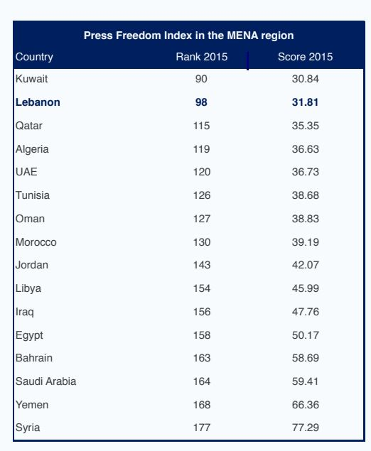

*Table 1:* Press Freedom Index in the MENA region

* **Regression of Lebanon’s Press Freedom Index between 2009 and 2017:**

Lebanon’s Press Freedom Index “having deteriorated consistently since 2009, then witnessed a slight improvement in 2015, reaching a score of 31.81, dropping down from 31.89 in the previous year”, this improvement deteriorated again in year 2016 and 2017 to reach 31.95 and 33.01 respectively”, more details about the Lebnone score in the below table. (Reporters without Borders centre, 2017).

Figure 1:Lebanon’s press freedom index 2009- 2017

* **Other facts about media sector in Lebanon:**

The Investment Development Authority of Lebanon (IDAL, no date) classified Lebanon media industries as one of the most noteworthy in the Middle East, and enhances this by the following facts:

* “Lebanese media sector is highly developed and consists of varied industries including television broadcasting, advertising services, audio visual production, publishing, music production as well as new emerging markets such as Digital media”.
* “The industry is a major contributor to the Lebanese economy”.
* “The Media Industry accounted for nearly 4.75% of Lebanese GDP in 2013 and generated an added value generated of around 55.3%”.
* “The Media Sector comprises more than 450 companies and employs around 4.5% of the Lebanese labor force”.
* “Lebanon heads the advertising community in the Levant with a total spending of USD 463 million. It also has the highest contribution of creative industries to the national GDP in the MENA”.
* “The Media Industry spans across several fields: Television Broadcasting, Advertising, Production & Post Production, Digital Media, Publishing and Music”. (Investment Development Authority of Lebanon, no date)
* **TVs in Lebanon:**
* (Fanack, 2017) – “an independent online media analysis organization middle east and north africa”- outlines an overview about Lebanon’s Media Landscape, the following parts talking about the TVs in Lebanon:
* **Cable and satellite television:**

“Cable and satellite television is pervasive in Lebanon, and the majority of the [population](https://fanack.com/lebanon/population) has access to foreign channels through official or pirated subscriptions. However, local channels catering to specific sects and political interests continue to attract the highest viewership. A 2009 Nielsen survey placed no foreign news channel among the top ten preferred channels”.

* **The most popular local outlets are as follows:**
* **Lebanese Broadcasting Company (LBC):**
  + **Foundation:** “Founded during the Lebanese civil war in 1985. In 1996, it formed its internationally orientated satellite channel LBC-Sat, based in the Cayman Islands and therefore not subject to Lebanese broadcasting law, allowing it to broadcast previously censored films and TV programs”.
  + **Funded by:** “Saudi financiers, including media mogul Prince al-Waleed Bin Talal, own nearly half of LBC-Sat, and their sizeable investments have allowed the satellite network to grow and compete internationally”
  + **Other details:** “it’s one of the region’s best-known entertainment channels, having piloted a series of highly popular variety and game shows over the past decade”.
* **Al-Jadeed:**
  + **Foundation:** “Established as an independent channel by the[Lebanese Communist Party](https://books.google.nl/books?id=9O6aZGPkqoUC&pg=PA120&lpg=PA120&dq=new+tv+lebanese+communist+party&source=bl&ots=1rGwbnpxP2&sig=16zOyjGR09QhRtgQMrysvOtJv5o&hl=en&sa=X&redir_esc=y#v=onepage&q=new%252520tv%252520lebanese%252520communist%252520party&f=false) in 1991 under the name New TV, and has since changed hands several times”.
  + **Funded by:** “In 1992, it was purchased by Tahsin Khayyat. Throughout the 1990s, the channel broadcast illegally and was shut down in 1996. It was finally granted a license in 2000”.
  + **Other details:** “In 2001, it was rebranded al-Jadeed and claimed to operate as a ‘neutral‘Lebanese news outlet”.
* **Orange TV (OTV)**:
  + **Foundation:** “Granted a license in 2006 and officially began broadcasting in 2007.”
  + **Funded by: “**It is privately owned and affiliated with the Lebanese president, Christian Maronite [Michel Aoun](https://fanack.com/lebanon/faces/michel-aoun/), and his Free Patriotic Movement (FPM)”.
* **Future TV:**
  + **Foundation: “**It was established by Rafiq Hariri in 1993, and in 2007, a sister channel, Future News also began broadcasting”.
  + **Funded by: “**Owned by the prominent Hariri family”.
  + **Other details:** “A 2010 Ipsos survey estimates that both channels attract 5.7 per cent of primetime audiences”.
* **MTV**:
  + **Foundation: “**Established in 1991, the channel was shut down in 2002, following a raid by security forces, in a move that Ghazi Aridi, then minister of information, condemned as “purely political”.
  + **Funded by: “**owned by al-Murr family”.
  + **Other details:** “The channel relaunched in 2009, after significant changes in Lebanon’s political environment”.
* **Al-Manar TV:**
  + **Foundation: “**Privately owned satellite television channel established in 1991, although unlicensed until 1998”.
  + **Funded by: “**The channel is closely affiliated with Hezbollah”.
  + **Other details:** “The channel [broadcasts](https://books.google.nl/books?id=xJYLNUBgSeUC&pg=PA60&lpg=PA60&dq=al+manar+tv+programs&source=bl&ots=nu35zAFQ78&sig=BN3kxMRMIeHT8kA4MLjav2q6QJo&hl=en&sa=X&redir_esc=y#v=onepage&q=al%252520manar%252520tv%252520programs&f=false) 24 hours a day and uses international newswire footage and reporting in much of its programming. However, it also airs its own talk shows and news bulletins. In 2006, the channel’s Beirut offices came under heavy [aerial bombardment](https://cpj.org/2006/07/israeli-forces-strike-almanar-tv-facilities.php)from Israeli aircraft during the[Israeli offensive in Lebanon](https://fanack.com/palestinian-israeli-conflict/arab-israeli-wars/the-israel-hezbollah-war-of-2006/)”.
* **Al-Mayadeen:**
  + **Foundation:** Pan-Arab satellite station established in Beirut in 2012.
  + **Funded by: “**Details of its ownership and funding sources remain scarce, with the channel simply claiming to be [financed](http://www.france24.com/en/20120612-al-mayadeen-new-anti-al-jazeera-channel-media-lebanon-syria) by ‘Arab businessmen‘”.
  + **Other details:** “The channel was established as an alternative to the Gulf-owned, pan-Arab networks al-Jazeera and al-Arabiya, and many of al-Mayadeen’s initial staff were former al-Jazeera journalists”. (Fanack website, 2017).
* The popularity of local television channels stated in the table below according to survey conducted by (Dubai Press Club, 2010), during the years 2009:

|  |  |
| --- | --- |
| **Channel** | **Top channels: % of respondents who identify channel as a favourite** |
| Lebanese Broadcasting Company (LBC) | 62% |
| Al-Jadeed | 54% |
| Orange TV (OTV) | 39% |
| Future TV | 27% |
| Murr TV (MTV) | 26% |
| Al-Manar TV | 25% |

Table 2: Popularity Of local TVs during 2009

* Another foreign TVs channels established in Lebanon:
* **Palestine Today:** 
  + **Foundation:** Palestinian Television channel began broadcasting on 2012.
  + **Funded by:** Close to the Palestinian Islamic Jihad movement, owned by Palestinians and Arab businessmen and Journalists.
  + **Other details:** The channel is committed to full responsibility towards the Palestinian people and their values, cause, suffering, steadiness.
* **Al-Quds TV:**

**Foundation**: is a Palestinian satellite channel broadcast on Arab satellite Nilesat and Arabsat, which began broadcasting on 2008.

* + **Funded by:** Pro-Palestinian editorially and is Hamas's second satellite.
  + **Other details:** Highlighting the rights of the Palestinian people in all kinds of resistance to defeat occupation and restore the legitimate rights.

#### Social media in Lebanon:

While the using of social media is developing very quickly worldwide, “Lebanon is one of the five leading countries on social media in the Middle East. Though the UAE, Qatar, Kuwait, Bahrain and Lebanon are the leading five countries in the region according to the percentage of Facebook and Twitter users, social media growth was the fastest in those countries experiencing social unrest”. (Arab Social Media Report, 2011)

* **The Most popular social media platforms use in the Middle East in 2015:**

The table show the most popular social media platforms used in Middle East and illustrate how the using go on in three different ways, direct communication, finding/ sharing new and finding/sharing for entertainment.

Source: North-Western University Qatar Survey “Media use in the Middle East, (2016):

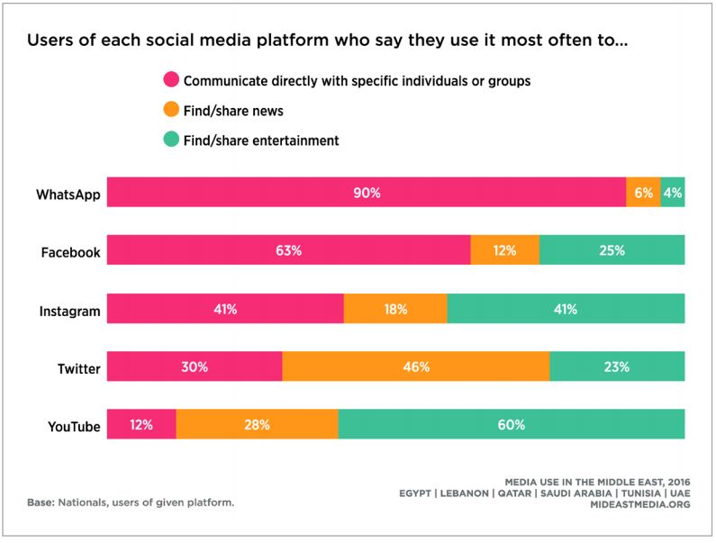

Figure 2: Use of each social media platform

* **Expansion of social media within the media industry in Lebanon from 2009 until 2014:**

Digital and social media despite the fact that it has not yet fully developed, Lebanon’s digital media sector is presently witnessing the fastest expansion within the media industry.

“Lebanon’s digital media sector is further enhanced by the rise in digital advertising. “Digital advertising has witnessed the highest growth over the past few years, rising by an average 77% annually during 2009-2013, to reach a value of USD 18.5 million in 2014” (BankMed, 2015).

Digital Advertising Spending In Lebanon from 2009 until 2014, from (BankMed report, 2015), “Analysis of Lebanon’s Media and Advertising Sector”:

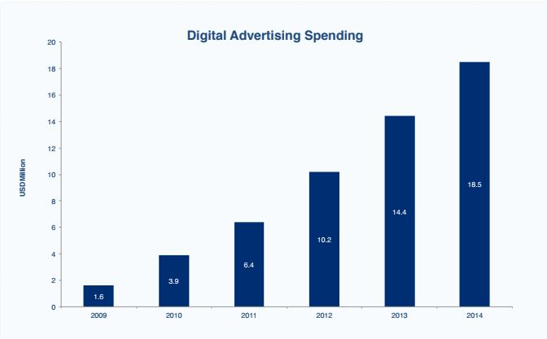

Figure 3: Digital advertising spending in Lebanon 2009-2014

* **Top websites in Lebanon:**

To better assess Lebanon’s digital media penetration, the table below displays ranking of top 10 websites in terms of monthly internet reach in Lebanon. Unsurprisingly, the most popular website is Lebanon is Google search engine, followed by YouTube and Facebook; 6 social media network are among the top 10 website reached in Lebanon during the December 2017:

Source: Similar Web, “top website ranking for all categories in Lebanon, December 2017:

| **Rank** | **Website** |
| --- | --- |
| 1 | google.com.lb website analytics google.com.lb |
| 2 | [youtube.com website analytics](https://www.similarweb.com/website/youtube.com) youtube.com |
| 3 | [facebook.com website analytics](https://www.similarweb.com/website/facebook.com) facebook.com |
| 4 | [google.com website analytics](https://www.similarweb.com/website/google.com) google.com |
| 5 | [live.com website analytics](https://www.similarweb.com/website/live.com) live.com |
| 6 | [instagram.com website analytics](https://www.similarweb.com/website/instagram.com) instagram.com |
| 7 | [wikipedia.org website analytics](https://www.similarweb.com/website/wikipedia.org) wikipedia.org |
| 8 | [yahoo.com website analytics](https://www.similarweb.com/website/yahoo.com) yahoo.com |
| 9 | [twitter.com website analytics](https://www.similarweb.com/website/twitter.com) twitter.com |
| 10 | [whatsapp.com website analytics](https://www.similarweb.com/website/whatsapp.com) whatsapp.com |
| 11 | [lebanonfiles.com website analytics](https://www.similarweb.com/website/lebanonfiles.com) lebanonfiles.com |
| 12 | [linkedin.com website analytics](https://www.similarweb.com/website/linkedin.com) linkedin.com |

Table 3: Websites ranking in Lebanon 2017

* **Most popular social media tools used in Lebanon during 2017:**

According to (Statcounter website, 2017), a newest statistics show the ranking of some of the most popular social media tools used in Lebanon during 2017 are Facebook ranked at first with score 68.28% and then YouTube with 11.97, the following graph show the other social media tools used in Lebanon:

Figure 4: Social Media Stats in Lebanon - 2017

### ORGANIZATIONS

#### Al Jadeed TV:

* Formerly known as New TV, Established as an independent channel by the Lebanese Communist Party in 1991, based in Beirut.
* It’s a privately owned and was purchased by Tahsin Khayyat in 1992.
* A Lebanese 24-hour pan-Arab TV station, started broadcasting in 2001.
* On 9 May 2005, Al Jadeed was also launched in America and the Pacific, reaching Arab speaking immigrants in the United States, Canada, South America and Australia.
* Not affiliated with a political party. In the recent years the channel is under attack by threats and intimidation attempts.
* Today, Al Jadeed TV is one of the most watched broadcasters in Lebanon and in the entire Arab world.
* As of 2012, it has become available for viewers in South America through over-the-top technology on.

#### Al-Quds TV:

* Palestinian satellite channel broadcast on Arab satellite Nilesat and Arabsat, based in Beirut.
* Start broadcasting on November 11, 2008.
* The station is Pro-Palestinian editorially and is Hamas's second satellite TV channel, after Al-Aqsa TV.
* It is licensed in London, with offices in the Gaza Strip, West Bank, Beirut and Damascus.
* On November 18, 2012 during Operation Pillar of Cloud, Israel bombarded the office of the Al-Quds TV station in Gaza, injuring three staff.
* Highlighting the rights of the Palestinian people in all kinds of resistance to defeat occupation and restore the legitimate rights and working on organizing and unifying all types of resistance to serve a common national political program fulfilling the aspirations and hopes of the Palestinian people.

#### Palestine Today TV:

* Palestinian Television channel began broadcasting on 2012.
* Based in Beirut.
* Licensed in London.
* Broadcast on Arab satellite Nilesat.
* The channel is committed to full responsibility towards the Palestinian people and their values, cause, suffering, steadiness and their resistant mobility and their national program of liberation and return.
* Close to the Palestinian Islamic Jihad movement, owned by Palestinians and Arab businessmen and Journalists.

## CHAPTER 2: LITERATURE REVIEW

The purpose of this chapter is to define the concepts and to review the previous relevant studies. The researcher will define first the concepts of Recruitment and E-recruitment, the steps of recruitments, the characteristics of good recruiting system and the responsibilities of human resource managers during recruitment. Then, the main focus will be on describing how social media used in recruitment with reviewing the literature and taking examples of relevant previous studies. And finally, taking a quick view on the advantages and disadvantages of using social media in recruitment, and on Human resources policies that could be used to assure the legal and risk issue.

### RECRUITMENT

Recruitment is the mean by which the business source and acquires its most precious asset, its people. When it is carried out hastily, it is fraught with dangers. When it is carried out with skills, it can be one of the most important investments you ever make.

Branine (2008) states that “when a recruitment program is effective, it will appeal to a greater number of applicants. Furthermore, having more applications leaves the recruiter with more of a choice”.

#### Definition of recruitment:

“Recruitment is the process of discovering potential candidates for actual or anticipated organizational vacancies. Or from another perspective, it is a linking activity—bringing together those with jobs to fill and those seeking jobs.” (DeCenzo and Robbins, 1998)

“Recruitment is a matching process and the capacities and inclinations of the candidates have to be matched against the demand and rewards inherent in a given job or career pattern.” (Plumbley, 1991)

According to Prof. Griffin (2013), “Recruiting is the process of attracting qualified persons to apply for the jobs that are open.”

According to Flippo (1984), “Recruitment is the process of searching for prospective employees and stimulating them to apply for jobs in the organization.”

The above different definitions emphasize common chief aim of recruitment, “to appoint someone to your team who can do the job you want filled to the required standard of performance”. While this is the chief aim of the recruitment, “there are 5 other aims which affect the way you meet the chief aim. These are:

* To be cost-effective.
* To be fair.
* To meet future needs as well as present ones.
* To be consistence
* To manage the public face of the organization”. (Garner, 2013).

#### Recruiting Sources

Recruiting is more likely to achieve its objectives if recruiting sources reflect the type of position to be filled. Certain recruiting sources are more effective than others for filling certain types of jobs. As we review each source in the following sections, we will emphasize their strengths and weaknesses in attempting to attract lower-level and managerial-level personnel.

* **The Internal Search:** Many large organizations attempt to develop their own entry-level employees for higher positions. These promotions can occur through an internal search of current employees who have bid for the job, been identified through the organization’s human resource management system, or even been referred by a fellow employee. Some advantages of this source are: promotes good public relations, builds morale, encourages individuals who are qualified and ambitious, improves the probability of a good selection, because information on the individual’s, less costly than going outside to recruit. There can be distinct disadvantages, however, to using internal sources. Promoting from within an organization creates problems if the organization uses less-qualified internal candidates only because they are there, when excellent candidates are available on the outside.
* **Employee Referrals and Recommendations:**

One of the better sources for individuals who will most likely perform effectively on the job is a recommendation from a current employee. Employees rarely recommend someone unless they believe the individual can perform adequately. The recommender often gives the applicant more realistic information about the job than could be conveyed through employment agencies or newspaper advertisements. There are, of course, some potentially negative features of employee referral. For one, recommenders may confuse friendship with job performance competence. Employee referrals may also minimize an organization’s desire to add diversity to the workplace.

* **External Searches:** In addition to looking internally for candidates, organizations often open up recruiting efforts to the external community. These efforts include advertisements (including Internet postings), employment agencies, schools, colleges and universities, professional organizations, and unsolicited applicants.
  + **Advertisements:** When an organization wishes to tell the public it has a vacancy, advertisement is one of the most popular methods used. The type of job often determines where the advertisement is placed.
  + **Employment Agencies:** Three different types of employment agencies exist to help employers and workers find each other. Public or state agencies, private employment agencies, and management consulting firms all provide valuable employment matching services.
  + **Schools, Colleges, and Universities** Educational institutions at all levels offer opportunities for recruiting recent graduates. Most educational institutions operate placement services where prospective employers can review credentials and interview graduates, also allow employers to see a prospective employee’s performance through cooperative arrangements and internships. Educational institutions are an excellent source of potential employees, although it’s usually viewed as sources for inexperienced entrants to the workforce.
  + **Job Fairs:** Once thought to be a little old fashioned and not very cost effective; job fairs are making a comeback as an effective recruiting tool. Often held on or near college campuses in the spring, they’re a good opportunity to build a company’s employment brand.
  + **Professional Organizations**: Professional organizations serving such varied occupations as industrial engineering, psychology, accounting, legal, and academics publish rosters of job vacancies and distribute these lists to members.
  + **Unsolicited Applicants:** Unsolicited applications, whether they reach the employer by letter, e-mail, online application, telephone, or in person, constitute a source of prospective applicants.
* **Online Recruiting:** Most companies, both large and small, use the Internet to recruit new employees by adding a “careers” section to their Web site. Those organizations that plan to do a lot of Internet recruiting often develop dedicated sites specifically designed for recruitment. In addition to building the employment brand of the organization, they include the typical information you might find in an employment advertisement, such as qualifications sought, experience required, and benefits provided.(David A, Robbins, and Stephen 2010)

#### Characteristics of a good recruiting system:

According to Simplicant, a recruiting consultant company specialized in social platforms, the following are the characteristics to have effective recruiting system:

* **Fits you business’ needs:** Recruiting systems aren’t one-size fits all. A good recruiting system is one that fits the specific needs of employer organization. A small- or medium-sized business does not have all of the same recruiting needs of a large global enterprise or a recruiting agency
* **Facilitates collaboration and communication:** Offers the most effective ways for recruiter team to prepare for interviews, share their candidate evaluations and work together to reach a decision. Also that makes it easier to communicate with candidates throughout the hiring process.
* **Enhances the candidate experience:** Creates a positive user experience for everyone that uses it. Not only does it impact whether a candidate applies or gives up partway through the process it also reflects organizations brand.
* **Integrates social media recruiting:** Seamlessly integrates with social media and allows you to leverage the recruiting power of social networks within a single platform.
* **Supports an employee referral program:** Support an internal employee referral program.
* **Performs powerful searches:** Quickly and accurately parse résumés by keywords to sift out the top candidates and displays results logically in a way that recruiter team can quickly understand and apply.
* **Compatible with your website and other HR tools:** Fits with employer career website and any other HR tools may use.
* **Automates your recruiting tasks and workflow:** Keeps recruiter team on track by streamlining and automating administrative tasks and setting out a logical workflow, and integrates with employer email system that provides alerts to recruiter team when they are coming up to a deadline or when a candidate has spent too long at any stage in the hiring funnel.
* **Migrates data easily:** Make it easy to migrate all of human resources data stored in another system or in various files and keeping all information on one platform.
* **Supports data-driven decisions:** Capable of providing useful data, reports and recommendations.

#### Recruitment process:

* In the figure below show the general steps in recruitment and selections process:

Source: (Gary D., 2005), “Human resource management”

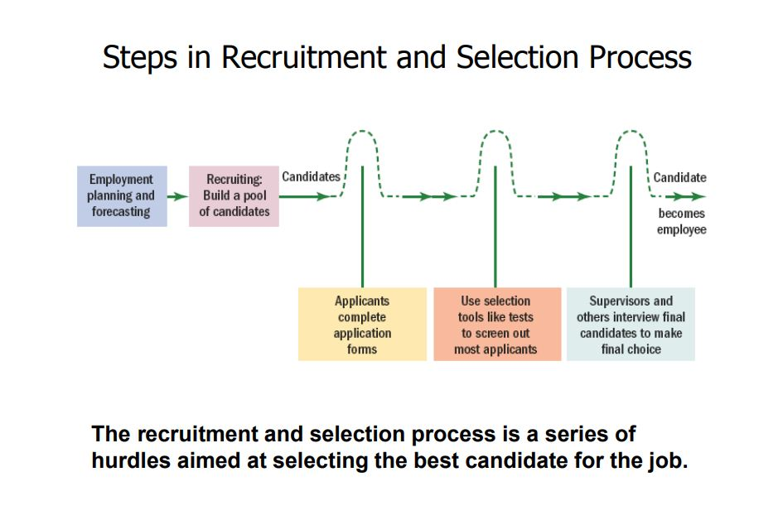

Figure 5: Steps in recruitment and selection process

* The next figure illustrate the traditional paper-based recruitment process using job advertising, from case study done by Anna B. Holm (2008- 2009) in Aarhus University, Denmark, “The Effect of E-recruitment On the Recruitment Process”:

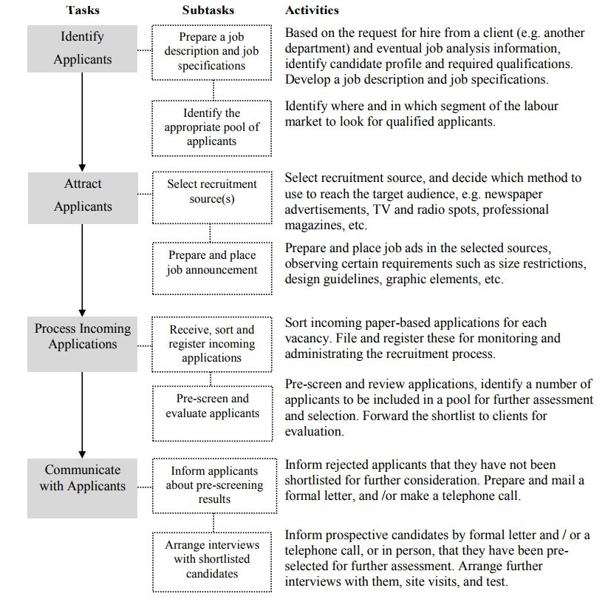

Figure 6: Traditional paper-based recruitment process

#### E-recruitment:

“The Internet has drastically changed the face of recruitment. Employers must now actively market themselves by instituting a well-implemented e-recruitment program to find better quality candidates and improve hiring decisions, all in less time and at a lower cost.” (Smith and Rupp, 2004)

The digital world has brought a new dimension to the world of recruiting. “The World Wide Web, or Web 1.0, shortened the search time, costs and offered a transparent method of information for candidates”. (Salmen, 2012)

E-recruitment includes those practices and activities carried on by the organization through internet with the primary purpose of identifying and attracting potential employees.

“E-recruitment, where employers use the internet in some form to aid conventional recruitment processes, has a number of important advantages compared to more traditional forms of recruiting”. (Smith and Rupp, 2004)

#### Responsibilities of Human resource managers during recruitment:

Human resource manager are responsible to make recruitment successful and effective, according to [Susan](https://www.thebalance.com/susan-m-heathfield-1916605) (2017), some action must be taken by employer in order to make successful recruitment summarized by following chart:

Figure 7: Responsibilities of HR managers during recruitment

* The main points elaborated in this article by (Susan, 2017)” emphasize how to get the best employee are the following:
* First, improve your candidate Pool: Employer select candidates who walk in their door or answer an advertisement of the job vacancy will miss the best candidates, so employer must improve their candidate pool by looking for them on LinkedIn and in other social media outlets, seeking the online boards for the potential candidates who may have resumes online even if they're not currently looking, and use the professional association websites to advertise.
* Second, employer must hire the sure thing and achieve true potential that fit the job and the company culture. "Employer should hire a person who has done this "exact job, in this exact industry, in this particular business climate, from a company with a very similar culture", and “the past behavior is the best predictor of future behavior". (Pfau and Kay, 2001)
* Third, be known as a great employer: not just being a great employer but letting people know that you are a great employer. This is how you build your reputation and your company brand. You'll want the best prospects seeking you out because they respect and want to work for your brand. Herman and Gioia, (2000) said: “A company that is an (Employer of Choice) will be more attractive to prospective employees. This attractiveness will also enable the company to attract a higher caliber of worker. Not only will the company have more applicants to choose from, but the overall quality of applicants will be significantly better than companies which are not recognized as Employers of Choice.”

Being known as great employer will make mediocre jobseekers not to apply to your company, because they fearing that their performance would not be acceptable, while higher quality jobseekers will apply to these companies because they feel like they belong and can achieve high performance and can build a good job profile at these places.

* Forth, “use your website for recruiting”, using website will give the jobseeker more information about the job and the company, like [vision](https://www.thebalance.com/build-a-strategic-framework-through-strategic-planning-1916834), [mission](https://www.thebalance.com/mission-is-what-you-do-1918182), [values](https://www.thebalance.com/core-values-are-what-you-believe-1918079), goals, and products, and describes the available positions at the company.
* **According to “web solution” website (2016), some characteristics of the company website that make it a powerful recruiting tools is:**
* **Have** a careers page.
* Give potential hires a taste of your culture.
* Allow a cover letter.
* Gather information and provide targeted content.
* Ability to Communicate with your candidates
* Supported **with using social media**
* “Recruitment professionals now need to wear many hats to be effective in the new recruiting landscape. It is no longer acceptable to be glorified administrators, sitting between line managers and the job boards. To add value to a company they need to offer additional skills” (HeadWorth, 2015). In his opinion some skills not previously associated with recruiters, are to be (1) great communicators, (2) better listeners, (3) relationship builders, (4) sales people, (5) marketers, (6) socially media savvy, (7) curious and another characteristics. Andy consider to be familiar with social media is one of the important skills of the recruiter.

### SOCIAL MEDIA

#### Definition of Social media:

Techopedia -the IT Education Site- mention two definitions for term social media, first definition describe generally the main usage of social media and the other is technical definition.

“Generally, social media is a catch-all term for a variety of internet applications that allow users to create content and interact with each other”. This interaction can take many forms, but some common types include:

* Sharing links to interesting content produced by third parties
* Public updates to a profile, including information on current activities and even location data
* Sharing photos, videos and posts
* Commenting on the photos, posts, updates, videos and links shared by others

“Technically, social media is perceived as a Web 2.0 development, which is to say that it is founded on the concept of a user-driven, interactive web”. (Techopedia, no date)

#### An overview for some of the most popular social media website worldwide:

Maina (2017) explore in his article  “20 Popular Social Media Sites Right Now”, the main information about different social media sites, the researcher shows 8 of them and summarized as the following:

* **Facebook:** This is the biggest social media network on the Internet, both in terms of total number of users and name recognition. Founded on February 4, 2004, [Facebook](https://www.facebook.com/" \t "_blank) has within 12 years managed to accumulate more than 1.59 billion monthly active users and this automatically makes it one of the best mediums for connecting people from all over the world with your business. It is estimated that more than 1 million small and medium-sized businesses use the platform to advertise their business.
* **Twitter:** is social media platform has more than 320 million active monthly users who make use of the 140 character limit to pass on information. Businesses can use [Twitter](https://twitter.com/) to interact with prospective clients, answer questions, release latest news and at the same time use the targeted ads with specific audiences. Twitter was founded on March 21, 2006, and has its headquarters in San Francisco, California.
* **LinkedIn:** Founded on December 14, 2002, and launched 0n May 5, 2003, [LinkedIn](https://www.linkedin.com/) is hands-down the most popular social media site for professional networking. The website is available in 24 languages and has over 400 million registered users. LinkedIn is great for people looking to connect with people in similar industries, networking with local professionals and displaying business related information and statistics.
* **Google+:** While it’s no Twitter, Facebook or LinkedIn, [Google+](https://plus.google.com/) has its place among the popular social media sites. Its SEO value alone makes it a must-use tool for any small business. Launched on December 15, 2011, Google+ has joined the big leagues registering 418 active million users as of December 2015.
* **YouTube:** the largest and most popular video-based social media website — was founded on February 14, 2005, by three former PayPal employees. It was later bought by Google in November 2006 for $1.65 billion. YouTube has over 1 billion website visitors per month and is the second most popular search engine behind Google.
* **Instagram**: is a visual social media platform. The site, launched on October 6, 2010, has more than 400 million active users and is owned by Facebook. Many of its users use it to post information about travel, fashion, food, art and similar subjects. The platform is also distinguished by its unique filters together with video and photo editing features.
* **Snapchat**[:](https://www.snapchat.com/" \t "_blank) is an image messaging application software product that was created by Reggie Brown, Evan Spiegel and Bobby Murphy when they were students at Stanford University. The app was officially released in September 2011, and within a short span of time they have grown immensely registering an average of 100 million daily active users as of May 2015.
* **WhatsApp**: Messenger is a cross-platform instant messaging client for smartphones, PCs and tablets. The app relies on the Internet to send images, texts, documents, audio and video messages to other users that have the app installed on their devices. Launched in January 2010, WhatsApp Inc. was acquired by Facebook on February 19, 2004, for about $19.3 billion. Today, more than 1 billion people use the service to communicate with their friends, loved ones and even customers.
* **Social Media Facts:**
* The following statistic done by “Statista Inc.” (2017)- one of the leading statistics companies-, show the following ranking of the most famous social media platform as of September 2017, ranked by number of active accounts:

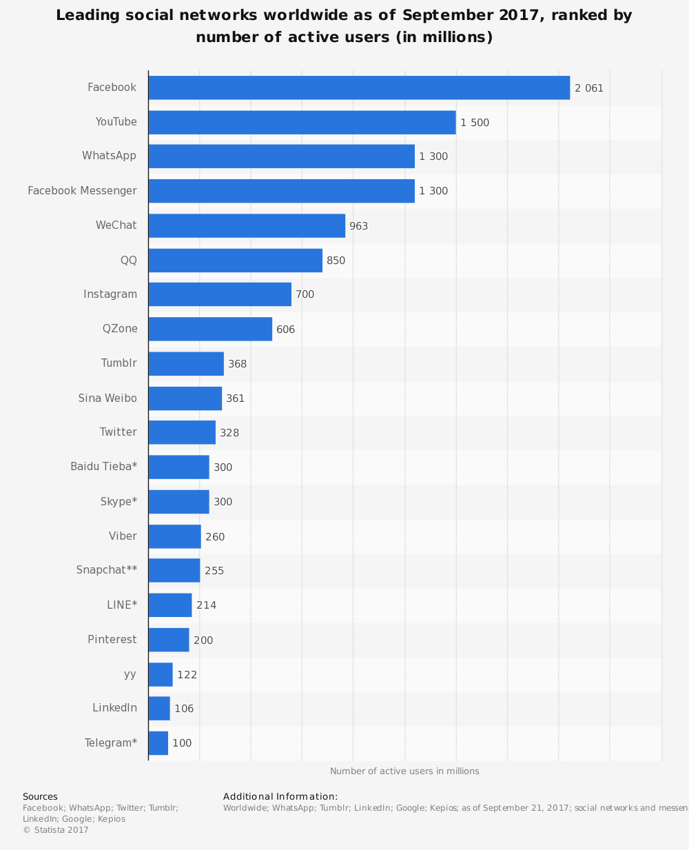

Figure 8: Leading social networks worldwide 2017

* Another statistics from Statista Inc. (2017), shows the number of social media users worldwide from 2010 to 2016 with projections until 2021 (in billions):

**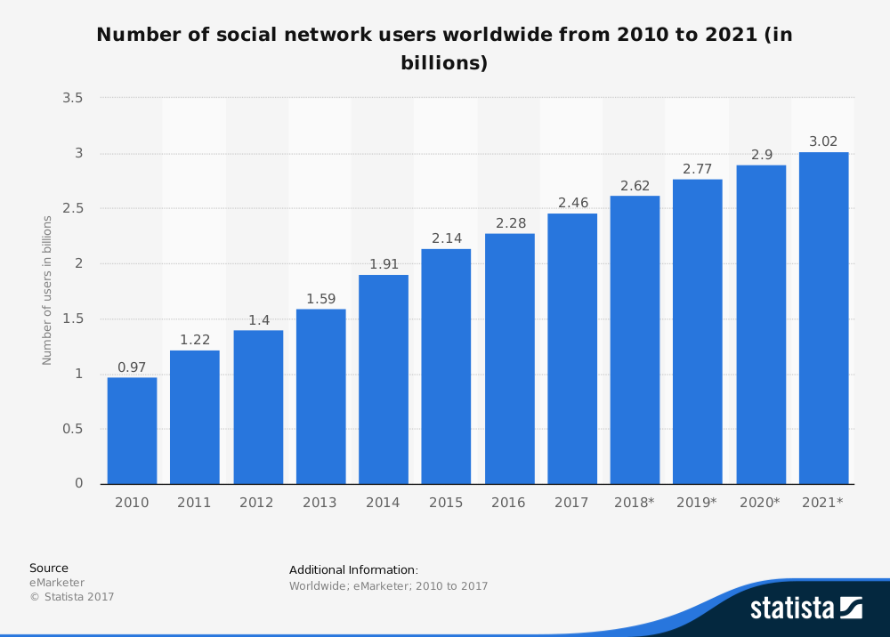**

Figure 9: Number of social network users worldwide 2010- 2021

* **Quick facts about Social media in 2017:**
  + Internet users spend an average of over two hours a day on social media (Mander, 2017)
  + The fastest-growing demographic on LinkedIn is students, with 40 million student and recent graduates having accounts on the platform (Simply Measured, 2016)
  + Uploading a professional photo to your LinkedIn profile gets you 21 times more profile views, and 36 times more messages (Chaudhary, 2017).
  + LinkedIn now has 3 million active job listings on the platform (Chaudhary, 2017).

#### Using of social media in recruitment:

Like many buzzwords, the meaning of social media is a moving target that gets shifted around according to what the person using it wants it to mean.

Wicks (2012) in his book “An Introduction to Social Media for Small Business”, elaborates the social media term as: “it’s not just about dealing with what people say about you online though, it’s about communicating with your customers and future customers, it’s about building a community, being part of other communities; it’s about educating people, listening to them, and letting them know all about you, your company, the people that work for you, your products, your services, your business philosophy, your integrity and your organizational culture”.

The Society for Human Resource Management (SHRM) surveyed on the use of social media for employee recruitment and selection for his members in years 2008, 2011 and 2013, revealed that 77% of respondent companies use social networking sites to recruit candidates for specific jobs, up from 56% in 2011 and 34% in 2008. (SHRM, 2013)

* **For what purpose social media used in recruitment and how this using developed?**

“In the last five years we have seen technology improve significantly, economies recover from the financial calamities triggered in 2007, the demographic balance of the workforce change, the proliferation of ‘big data’ and, of course, we are now very much a social media and mobile world. This has all resulted in the recruiting landscape fundamentally changing for both Companies and job seekers” (HeadWorth, 2015). This development of using social media and its advantages for different business sides, it has also advantages for job applicants and stockholders, “it allows finding information on new employers and gauging an informed picture of company’s culture, it makes the corporate culture and common practices of the company more transparent as well as the positive and negative aspects”. (Laick and Dean, 2011)

* **The evolution of the innovations in recruiting from the 1990s to 2010:**

The figure below displays a timeline of how recruiting has developed and evolved from the traditional sense of print media like newspapers to social media on the Internet. Give or take, there was a five year interlude between each innovation. Each media had its selective audience which it reached, for example, print media only reached a certain area of their audience, whereas social media now can attract different people in different areas.(Chris, 2012)

**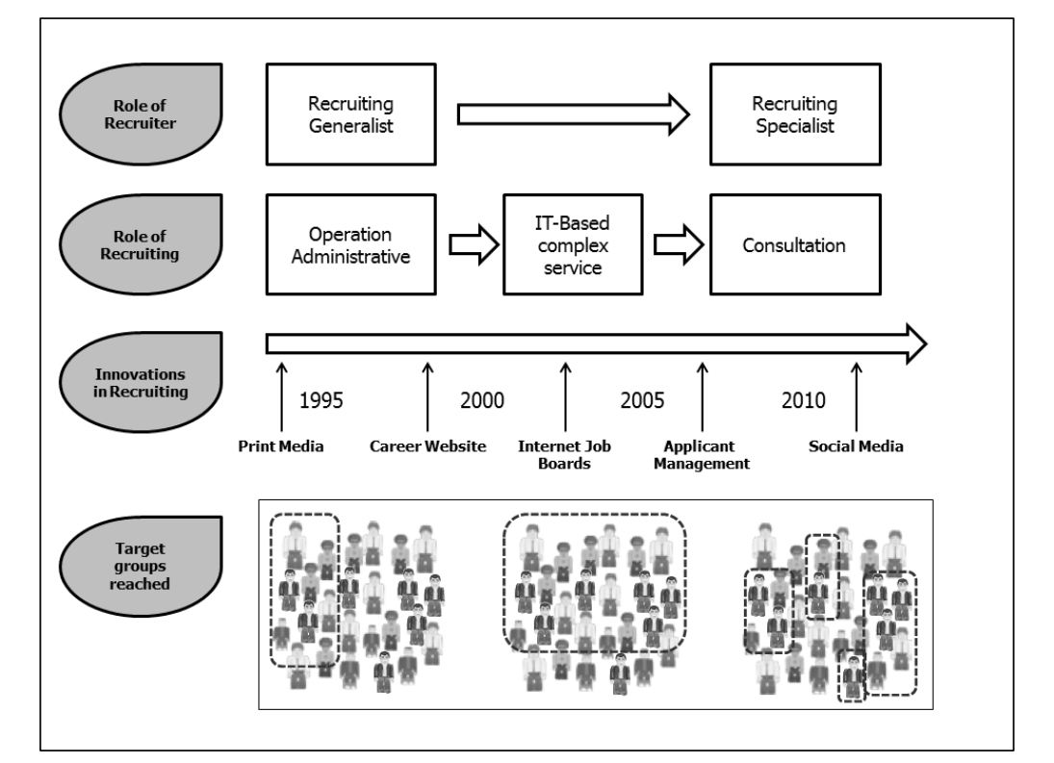**

Figure 10: The evolution of the innovations in recruiting from the 1990s to 2010

* Many research, surveys and article showed how much social media used today in recruitment by both employer and jobseeker. According to survey done by “CareerBuilder center” and was conducted online within the U.S. among 2,380 hiring and human resource managers between February 16 and March 9, 2017, found that “57% employer are less likely to interview a candidate they can't find online, 54% have decided not to hire a candidate based on their social media profiles, half of employers check current employees' social media profiles, over a third have reprimanded or fired an employee for inappropriate content, and 70% of employers use social media to screen candidates up from 11% in 2006”. (Rachel Nauen, 2017)
* Recruiter use social media in hiring process for different purpose and its acheives several benefits. (1) “Recruiters consider it an effective method in finding candidates especially passive candidates”, Haberman, 2015). (2) “Its offer a source of information concerning passive jobseekers”, (DeKay, 2009). (3) “Allow companies to recruit from a broader pool” (zeidner, 2008). (4) “Provide additional information HR professional can use to screen applicants” (Madera, 2012). (5) “Help employers looking for the character of the person they are hiring” (Mary, Charlie, Jitendra, and Bharat, 2010). (6) Building relationships with candidates. (Stoller, 2012)
* The annual technology market survey conducted by Eurocom Worldwide (2012), shows that almost one in five technology industry executives say that a candidate’s social media profile has caused them not to hire that person, and 40% of the survey respondents from technology companies review job candidate’s profiles on social media sites.
* Job seekers today’s use social media especially researching a company and looking for job postings. According to (ICIMS, 2015) survey, “57% of job seekers said that they used social media at least once a month to learn more about potential employers”.

#### How some social media tools used in recruitment?

There are millions of people on social media sites like LinkedIn, Facebook or Twitter, that equals a lot of potential talent for employers and recruitment agencies today, the following review adapted from two articles from different management specialist websites, summarizing how some social media tools used in recruitment:

**LinkedIn:** It’s the most obvious ways to use to post jobs you have available and search for candidates. LinkedIn users often include information in their profiles about themselves that potential employers may not legally consider when hiring. It’s provides a free and easy way to network with large numbers of people they know and the people that those people know. LinkedIn also allows job seekers to follow the news and [job postings](https://www.thebalance.com/how-to-post-jobs-online-1917752) for their targeted employers. For employers, LinkedIn provides a wealth of information about the qualifications of job seekers and can help employers leverage their own networks (and those of their employees) to find potential candidates for job openings. Employers can create company profiles and set up feeds of information (including new job postings) for those who would like to follow them. LinkedIn also offers employers a fee-based solution that allows them to more quickly and easily find potential job candidates that best match the qualifications of the job they want to fill.

**Facebook Page**: is a public profile that enables you to share your business and products with Facebook users, providing easy and affordable ways to increase your applicant pool. By free job posting you can't target it to a specific group of people like you can with a Facebook Ad, where you can choose the exact audience that you are looking to target.

Facebook can be useful as it’s an easy way to ask your personal connections for information and advice about your career or job search and can also provide a resource of information on both individuals and companies. The informal nature of the site, and its interactivity, means that you can often obtain information and communicate with employers in a way that may not be possible elsewhere. While social networking sites present excellent opportunities for recruitment, it also means that employers, both current and prospective, have become extremely sensitive to their employees’ web-presence. Facebook enables employers to create a presence that reflects their employment brand, find potential candidates, and [post jobs](https://www.thebalance.com/how-to-post-jobs-online-1917752).

In addition, it enables great opportunities for interaction with candidates and allows organizations to create a community.

**Twitter:** is a public platform for people to post and exchange short messages. People use it to interact with other people or organisations they find interesting or useful, including attaching links or photos that they want to share with their Twitter community.

Twitter can be powerful for small companies or a recruiter who wants to get an edge over the competition. Employer can engage with candidates and see what topics they tweet about, evaluate their activity to see how often they tweet, if they have a healthy balance between followers and following, how big is their network and the quality of their tweets, do they keep a balance between personal and professional tweets?

If jobseekers are trying to attract the attention of recruiters and others in your field, then they must represent themselves in an attractive and professional light, they don’t have to tweet themselves – they can just follow companies or topics and retweet, they can use their own tweets to show their interest in a particular career and tweet about current affairs in the sector they wish to work in. Jobseeker twitter profile should include a professional looking photo, an appropriate bio and a link to their CV, LinkedIn profile or website. (Guardian Jobs, 2017) (Tiffany Black, 2010)

#### Advantages and disadvantages of using social media on recruitment:

Although using social media for recruiting process can be rewarding, but also it is associated with risks some, in the following paragraph we will summarize some advantages and disadvantages of using social media, and how can minimize risk and maximize rewards:

* **Advantages of using social media:**

Brown and Vaughn find it worthy to recruiter using social media, “provide a readily available public forum to research candidates while incurring minimal cost, allowing even small businesses to engage in such practices. Potential employers may have access to detailed information that would allow them to draw conclusions or make inferences about the applicant’s character or personality that might not be as easily or economically obtained through traditional means.” (Brown and Vaughn, 2011)

(Reddy, no date) with 12 years of Experience within the International BPO/ Operations and recruitment areas lists in an article the following advantages:

* **Enhance Brand Awareness:** improving the visibility of the firm and numerous candidates will notice, also a sign that the company is updated with technology and following the latest trends.
* **Cost**-**Effective**: The Company may spend comparatively less amount of money on social media strategies and various tactics involved in it.
* **It improves the quality of candidate hired:** People who are well-versed in social media and tools related to it are very much in demand in the present world. It is because they are perceived as innovative and tech savvy.
* **It serves as an excellent opportunity to reach passive applicants:** It might happen that passive candidates (who are not looking for a job change), may change their job if they came across an interesting job opportunity. Also recruiter may get to know about such candidates through their social networking profiles.
* **It advances referrals:** If a business can work well by procuring referrals, then referrals may also reap great results in the hiring process.
* **It is fast:** Recruiters can circulate their job opening link to multiple platforms in one go. Even job candidates can apply to different posts with ease and in less time.
* **It might give a good cultural fit to the organization:** If potential applicants already have a connection with existing employees, then it is a sign that the new employee will be a better fit for the company.
* **It provides your company with a competitive edge:** Developing a corporate social media presence can make it to have a competitive edge over companies who are still not implementing it.
* **Boost ROI:** Posting job openings on numerous social networking platforms can deliver more productive returns as compared to the posting job on a single portal.
* **Impressive to the Candidate:** Potential candidates are interested to work for companies who are interested in reaching them.
* **Disadvantages of using social media:**

‘Companies can’t ignore the risk associated with these technologies. A major challenge for companies is the lack of control associated with social media; they have to manage intellectual property leakages, loss of confidential information, criticism of management or the company and embarrassing employee behaviour that can damage the brand. (Distaso, McCorindale, and Wrigth, 2011)

Many studies reveals that main disadvantages of using social media is the loss of confidential information, “Employers must be careful with what types of information they are accessing through social media, as accessing the wrong type of information can actually lead to discrimination cases. In addition, a social media profile doesn’t always give the best overview of a potential employee, and you might make a decision without trying to get a glimpse at the candidate’s bigger picture.” (Summit Search Group, no date). Other disadvantages are “Two risks related with social media are harassment and public disparagement” (Segal, 2011). The recruiter must take in consideration the cost of these risks, “by using social media networking technologies in recruitment process employer may face discrimination and violation of privacy laws issues, through reviewing social media sites employers can discover individual’s race, ethnicity of other protected information. This can cost company both in the financial sense and damage the company’s reputation” (Mary, Charlie, Jitendra and Bharat, 2010).

“Using social media for recruiting process just like a coin has two sides, even this recruitment tool also has two sides, the positives come with the negatives” ([Reddy](https://content.wisestep.com/author/chitra/), no date), she explain the negative side as below:

* **Privacy Invasion:** For potential candidates who think that employers should not have the right to visit their personal networking accounts might take a serious action against it. It is because even candidates who allow their profile to be viewed by the general public may ask the employers to permit them a reasonable amount of privacy.
* **Discrimination:** The discriminatory hiring decisions based on sensitive categories such as colour, religion, race, and more.
* **Authenticity and Accuracy:** Employers are not sure about the information that they are receiving. Maybe the information is not correct or partially correct.

Another disadvantages is that “not all information available on social media and some attributes can be evaluated on social networking websites, so firms may fail targeting the right online communities or unintentionally eliminating candidates by being quick in judgment” (Stamper, 2010) or “because potential applicants may not necessarily be active on social networking website” (Kaplan and Hanelein, 2009). Finally “organization that use social networking websites as selection tool are perceived less fair than organization that don’t, what lead to lower job pursuits intention for these organization” (Madera, 2012), and this can leads to negative perception of the company.

“Everwall” Company of social media explains how to minimize risk and maximize benefits when using social media to recruit, summarized as following:

* **Be consistent across the board**: The hiring process must be fair, so if recruiter is going to look at one applicant’s social media profile, then this should done with the rest.
* **Leave this up to the HR department**: It is best if a dedicated party or HR department dig information on all candidates and reviewing all social media profiles, so it ensures a fair hiring process. Furthermore, HR professionals know the laws in regards to what type of information can and cannot be used.
* **Take your time:** Reviewing the social media profiles of hundreds of candidates will take hours on end, it’s better to recruiter to wait until interviewing several qualified applicants, that it will save you quite a bit of time.
* **Set strict guidelines:** Determine in guidelines what to search in the social profiles; the information that must be taken in consideration and what details that don’t factor into hiring decision. “When employer set and follows these guidelines, there is always something to fall back on should an applicant claim they were discriminated against”. (Chris , 2015)

# PART II: THE PRACTICAL FRAMEWORK

## CHAPTER 3: RESEARCH METHODOLOGY

The previous chapters helped to review the academic background and the relevant literature. This chapter will deal with the methodology adopted. It will summarize the research method and the data collection tools used. At the end of the chapter, the researcher will describe the main limitations faced.

### DATA COLLECTION METHOD

After reviewing the secondary data (business themed books and relevant articles and online materials), the researcher was able to elaborate and conceptualize the topic and define the variables and generate the hypothesis. To prove the hypothesis and achieve the research goals, the researcher collected raw data from the field (TVs) using the mixed method approach (qualitative and quantitative data collection and analysis). More precisely, the researcher adopted the mixed method research which means using quantitative and qualitative data collection techniques and analysis procedures, one after the other (sequential), “this means that quantitative data are analyzed quantitatively and qualitative data are analyzed qualitatively” (Saunders, Lewis, & Thornhill, 2009). First, the researcher distributed a self-administered survey then collected it and analyzed it quantitatively. And second, the researcher conduct two face to face interviews with two management representatives to have the management point of view and to acquire added data helping to fill in some gaps emerged in the quantitative study.

#### Defining the Variables

The research’s variables were:

* 1. **The dependent variable (the criterion variable) DV**: (=the variable that is predicted and/or affected with by other variables) The Dependent variables for this research is the hiring decision/chance.
  2. **The independent variable (the predictor variable) IV:** (=the variable that is expected to influence the dependent variable in some way). In this research, the predictors: using of social media by recruiter for recruitment and jobseeker generally.
  3. **The moderating variable MV: (=** which is the variable that changes the nature of a relationship between the independent and dependent variables). The researcher hypothesized the way and purpose the employer and jobseeker use the social media play a moderating role in the relation between the using social media and hiring decision.

#### Defining Hypothesis

In order to achieve objectives through the quantitative data collected, the researcher proposed two hypotheses:

1. **Hypothesis one (*H1*)**

***H10***: there is no relationship between using social media by recruiter and jobseeker and the hiring decision/chance.

***H11***: there is a statistically relationship between using social media and hiring decision/chance.

***H1***

Hiring Decision/chance

(DV)

Using social media by recruiter and jobseeker (IV)

Figure 11: Hypothesis one

1. **Hypothesis two (*H2*)**

***H20***: In the case using social media by recruiter and jobseeker, Way and purpose using social media doesn’t have a significant role on hiring decision/ chance.

***H21***: In the case using social media by recruiter and jobseeker, Way and purpose using social media play a moderating role with hiring decision/ chance.

Hiring decision/chance

(DV)

Way and purpose using social media

(MV)

Using social media by recruiter

(IV)

***H2***

Figure 12: Hypothesis two

### DATA COLLECTION TOOLS

At step one, the researcher distributed an online a self-administered survey to collect quantitative data from individuals work in media sector in Lebanon. A step two, two face to face interviews helped to acquire the human resource management viewpoint.

#### Self-Administered Survey

1. **Overview**: to collect individuals work media sector opinions, the researcher used the self-administered questionnaire. The researcher choose the questionnaire, then using an online Google forms because it is easy to be managed and distributed, it can cover a wide sample over a wide geographical area in short time, and it is easy to be quantitatively analyzed later through specialized software.
2. **Target population:** The target population consisted of the employees working in the sample TVs.
3. **Sampling method:** Due to the time constraint (and other consideration cited in the limitation section) the researcher referred to the non-probability sampling technique. Non probability sampling has different approach like quota sampling and purposive sampling and snowball sampling and self-selecting sampling (Zikmund et al, 2009). The researcher referred to the Judgment (purposive) sampling.

Although that the sample size is not sharp in this technique, the main concern for the researcher was to maintain a representative sample. So the researcher adopted the following procedures:

First, the researcher referred to the numbers of employees offered by the 3 sample TVs, Then, the researcher targeted the employee from news, programming, Production, and engineering departments, (excluding administrative departments) in order to scope about individuals work in media specialist.

The researcher chose an equal number of participants from each TVs, and the online link send to 45 employees from each TV. Finally, the target was between 100 and 130, and the researcher received response from 119 employee.

Figure 13: Sampling method

1. **Language and distribution:** The questions were presented in Arabic and English and were distributed through online Link for the administrative managers in the three TV channels, and they send the Link with cover letter to the different department on their private internal WhatsApp groups, and then start receiving responses within one week as average.
2. **Overview on The Questions:** The questionnaire consisted of 16 closed questions representing the research problem. The questions were mainly a modified version of an online survey published by “docs.google.com/forms”. The full questionnaires are available in Appendix A.

#### Face To Face Interviews:

1. **Overview**: The researcher wanted to explore the human resource management point of view and discuss the using of social media in their recruitment process. Two interviews were arranged in Al-Jadeed TV and Al-Quds TV. The interviews were face to face, with semi structured questions where the researcher had prepared a list of themes and questions relevant to the objectives and based on the results of the questionnaire, and some multiple choice questions.
2. **Target population:** the representative of the human resource departments in the TV channels targeted.
3. **Place and period:** the first interview was conducted at AL-Jadeed TV in 9-1-2018 and the second one at Al-Quds TV in 10-1-2018.
4. **Overview on the questions:** Ten semi structured questions and six multiple choice questions were assigned for each interview. The questions followed six main categories (The full interviews (questions and answers) are available in Appendices B, C and D):

* **One question** to introduce the interviewee. (“Introduce yourself and your position”)
* **One questions** to get more information about the number of employee and the different departments inside the TV.
* **Two questions** to describe general steps in their recruitment process.
* **Four questions** to describe their use of social media in recruitment process.
* **Two questions** to give advice for the candidate about using social media.
* **Six multiple** choice questions to describe the effects of using social media in recruitment.

**F. participants:**

The researcher did two interviews with two managerial positions:

•In AL-Jadeed TV with Mrs. Dora Shams AL Ghazal, Senior HR Officer.

•In Al-Quds TV, with Mr. Wissam Hajjar, Head of administrative department.

### STUDY LIMITATIONS

Although the study has reached its aims, some limitations and shortcomings were unavoidable during the research process. These included:

* Specifying the scope of the research subject:

During formulation of the subject and objective of the research, the researcher found that the scope of the research must be narrowed in order to meet requirements in terms of time limits standard of the research. So, the researcher had to recommend two ideas to futuer researches:

First: Comparing the variance of the effect of using social media in recruitment between different job positions and levels or different work domains.

Second: In order to get more accurate indicators about using social media in recruitment in Lebanon, the researcher tried to conduct a survey covering fifty human resource managers in Lebanon. However, it was impossible during the limited time to get the acceptance and responses from this number of managers.

* Late response from the head of human resource managers in the three TV channels and adding another layer of bureaucracy to the approval process for the interviews and survey.

- Late response from participants in the online survey, which needed the researcher to follow up as many times as necessary to get a response.

## CHAPTER 4: FINDINGS AND RESULTS

### DATA ANALYSIS METHOD:

Two kinds of data were collected, quantitative data through 119 surveys and qualitative data through two interviews.

#### Quantitative Data:

The researcher referred to the SPSS (Statistical Package for the Social Science-version 22) to analyze the 119 surveys. The tests used were to explore and present the variables:

* **Frequencies**: are usually used to summarize a single categorical variable. They have for aim to describe the responders and to explore initially the data collected. The data were presented in tables and bar charts.
* **Cross tab (cross tabulation):** is usually used to summarize the relationship between two categorical variables. The result is a table that shows the number of times each of the possible category combinations occurred in the sample data.

#### Qualitative Data:

“To analyse qualitative data collected from the interviews, the researcher referred to: summarizing data, categorizing data and comparing data to draw conclusions” (Saunders, Lewis, & Thornhill, 2009). The following steps were followed:

* Step 1: reading the transcripts
* Step 2: labeling relevant ideas (concepts, opinions.)
* Step 3: creating categories (by bringing several codes together)
* Step 4:comparing categories
* Step 5: write up the results

### FACT FINDING RESULTS

### FACT FINDING RESULTS-QUANTITATIVES DATA

This section will present the results of the analyzed data. The researcher has followed these steps:

* **First, presenting an overview of the participants:** showing the percentage of employees from different TVs, and defining the social media platforms have and active accounts on.
* **Second, analyzing the hypothesis**: the hypothesis will be tested according to the data of using social media and its affect the hiring decision.
* **Finally, analyzing and presenting employees’ general opinion**: after analyzing the two hypotheses, this part will present employees general opinions collected via the questionnaire in the survey.
  + 1. **An overview of the participants:**
* **Participants:**
* 119 employees filled in the survey.
* 39 of the respondents were from Al-Quds TV, 42 from Aljadeed TV, and 38 from Palestine Today TV. (Table 4).

|  |  |  |  |  |
| --- | --- | --- | --- | --- |
| *Table 4: Participants / Media outlet* | | | | |
| **Media outlet** | **Frequency** | **Percent** | **Valid Percent** | **Cumulative Percent** |
| Al-Quds TV | 39 | 32.8 | 32.8 | 32.8 |
| AL-Jadeed TV | 42 | 35.3 | 35.3 | 68.1 |
| Palestine Today TV | 38 | 31.9 | 31.9 | 100.0 |
| Total | 119 | 100.0 | 100.0 |  |

In the (Table 5) below the different social media platforms the participants have an active account on. The table shows that the most popular social media accounts between participants are WhatsApp and Facebook with percentage of users 95%, and 93% respectively. Also all participants at least having one social media account. LinkedIn and Google+ as professional social media for recruitment have good number of users among the participants with percentages 39.5% and 26.6% respectively. (See figure 14)

*Table 5: Active Social Media Account of participants - Frequencies*

|  |  |  |  |
| --- | --- | --- | --- |
| **Social Media accounts** | **Responses** | | **Percent of Cases** |
| **N** | **Percent** |
| LinkedIn | 47 | 11.2% | 39.5% |
| Facebook | 111 | 26.4% | 93.3% |
| Twitter | 61 | 14.5% | 51.3% |
| WhatsApp | 113 | 26.8% | 95.0% |
| Instagram | 55 | 13.1% | 46.2% |
| Google+ | 34 | 8.1% | 28.6% |
| Total | 421 | 100.0% | 353.8% |

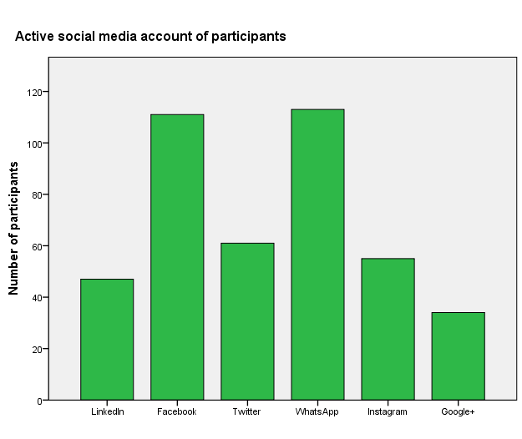

*Figure 14: Active Social media account for participants*

* + 1. **Hypothesis testing:**

1. **Hypothesis one:**

* **Statement of the Hypothesis:**

***H10***: there is no relationship between using social media by recruiter and jobseeker and the hiring decision/chance.

***H11***: there is a statistically relationship between using social media and hiring decision/chance.

* **Test used:** cross tabulation
* **Result and interpretation**: The cross tabulation test showed that 43% of the participant have heard about/applied to their current/previous job position through social media, all of them have Facebook account (100%), 98% of them have WhatsApp account, 78.8% LinkedIn, 76.9% Twitter, 69.2% Instagram and 55.8% have Google+ account. On the other hand only 6 participants of those who have account on LinkedIn never applied/heard about job through social media, they equal 9% only of all those didn’t apply or heard about job through using social media. The same meaning reflected from the other percentages showed in the (Table 6).

Figure 15 shows the percentage expectations that the employer check the candidate social media profile in the opinion of employees, this result show that candidates when using social media take inconsideration that employers will check theirs profiles on social media, and that’s another prove for the existence of relationship between social media and recruitment.

As a result, ***H10*** is rejected and ***H11*** is accepted. There is a statistically relationship between using social media and hiring decision/chance.

*Table 6: Social Media account of participants \* previous apply/heard about Job via SM “Cross tabulation”*

|  |  |  |  |  |  |
| --- | --- | --- | --- | --- | --- |
|  | | | **apply/heard about job via Social Media** | | **Total** |
| **No** | **Yes** |
| Social Media accounts | LinkedIn | Count | 6 | 41 | 47 |
| % within $Social Media Account | 12.8% | 87.2% |  |
| % within apply Job via SM | 9.0% | 78.8% |  |
| % of Total | 5.0% | 34.5% | 39.5% |
| Facebook | Count | 59 | 52 | 111 |
| % within Social Media Account | 53.2% | 46.8% |  |
| % within apply Job via SM | 88.1% | 100.0% |  |
| % of Total | 49.6% | 43.7% | 93.3% |
| Twitter | Count | 21 | 40 | 61 |
| % within Social Media Account | 34.4% | 65.6% |  |
| % within apply Job via SM | 31.3% | 76.9% |  |
| % of Total | 17.6% | 33.6% | 51.3% |
| WhatsApp | Count | 62 | 51 | 113 |
| % within Social Media Account | 54.9% | 45.1% |  |
| % within apply Job via SM | 92.5% | 98.1% |  |
| % of Total | 52.1% | 42.9% | 95.0% |
| Instagram | Count | 19 | 36 | 55 |
| % within Social Media Account | 34.5% | 65.5% |  |
| % within apply Job via SM | 28.4% | 69.2% |  |
| % of Total | 16.0% | 30.3% | 46.2% |
| Google+ | Count | 5 | 29 | 34 |
| % within Social Media Account | 14.7% | 85.3% |  |
| % within apply Job via SM | 7.5% | 55.8% |  |
| % of Total | 4.2% | 24.4% | 28.6% |
| Total | | Count | 67 | 52 | 119 |
| % of Total | 56.3% | 43.7% | 100.0% |
| Percentages and totals are based on respondents. | | | | | |

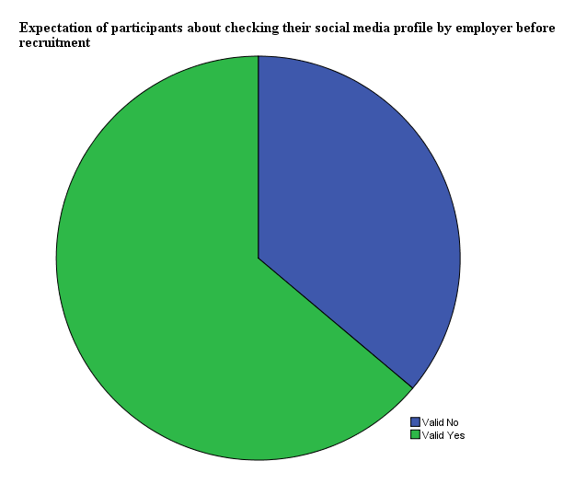

*Figure 15: Expectation of participants about checking their social meida profile by employer before recruitment*

1. **Hypothesis two:**

* **Statement of the Hypothesis:**

***H20***: In the case using social media by recruiter and jobseeker, Way and purpose using social media doesn’t have a significant role on hiring decision/ chance.

***H21***: In the case using social media by recruiter and jobseeker, Way and purpose using social media play a moderating role with hiring decision/ chance.

**•Test used:** cross tabulation and frequency table.

**•Result and interpretation**: The cross tabulation test showed, 49.3% of participants publishing daily personal activities believes that what they publish on social media don’t affect hiring decision and 41.3% believe that have positive effect, on the other. Also the test shows that participants publishing their professional skills and experience 95.7% of them believe that social media affect positively hiring decision. On the other hand the result shows that all the participants that believe social media have negative effect on hiring decision they publishing their political and religious views on social media, another percentages confirms this hypothesis are in the below Table 7.

Table 8 shows the percentages of different reasons the employer check the candidate social media profiles in the opinion of the participants, 54.6% of participants believes that employer check candidate social media profile in order to the political and religious views before recruiting.

As employer, candidate explore the organization social media profile before apply to job, Table 9 shows the percentages of different purposes from the point of view of participants, this also prove that information explored by candidate may affect their decision to apply to the job, it’s another side from relation between the way social media used and the hiring decision /chance.

As a result, ***H20*** is rejected and ***H21*** is accepted. There Way and purpose using social media play a moderating role with hiring decision/ chance.

*Table 7: Information Published On Social Media by candidate \* Effect of social media on hiring (participants opinions) - Cross tabulation*

|  |  |  |  |  |  |  |
| --- | --- | --- | --- | --- | --- | --- |
|  | | | **SM affects hiring decision** | | | **Total** |
| **negatively** | **Neutral** | **Positively** |
| Information Published On SM by candidate | personal activities | Count | 7 | 37 | 31 | 75 |
| % within Publish On SM | 9.3% | 49.3% | 41.3% |  |
| % within SM Affect Hiring | 25.9% | 90.2% | 60.8% |  |
| % of Total | 5.9% | 31.1% | 26.1% | 63.0% |
| professional skills | Count | 0 | 2 | 44 | 46 |
| % within Publish On SM | 0.0% | 4.3% | 95.7% |  |
| % within SM Affect Hiring | 0.0% | 4.9% | 86.3% |  |
| % of Total | 0.0% | 1.7% | 37.0% | 38.7% |
| political and religious views | Count | 27 | 10 | 26 | 63 |
| % within Publish On SM | 42.9% | 15.9% | 41.3% |  |
| % within SM Affect Hiring | 100.0% | 24.4% | 51.0% |  |
| % of Total | 22.7% | 8.4% | 21.8% | 52.9% |
| problems and situations at work | Count | 2 | 3 | 7 | 12 |
| % within Publish On SM | 16.7% | 25.0% | 58.3% |  |
| % within SM Affect Hiring | 7.4% | 7.3% | 13.7% |  |
| % of Total | 1.7% | 2.5% | 5.9% | 10.1% |
| Total | | Count | 27 | 41 | 51 | 119 |
| % of Total | 22.7% | 34.5% | 42.9% | 100.0% |
| Percentages and totals are based on respondents. | | | | | | |

*Table 8: Things mostly checked by employer on candidate SM profile- Frequencies*

|  |  |  |  |
| --- | --- | --- | --- |
| **Type of information** | **Responses** | | **Percent of Cases** |
| **N** | **Percent** |
| verifying info in CV | 48 | 22.7% | 40.3% |
| info about previous experience | 44 | 20.9% | 37.0% |
| Political and religious views | 65 | 30.8% | 54.6% |
| professionalism and communication skills | 54 | 25.6% | 45.4% |
| Total | 211 | 100.0% | 177.3% |

*Table 9: Reasons for candidate to explore employer social media - Frequencies*

|  |  |  |  |
| --- | --- | --- | --- |
| **Reasons** | **Responses** | | **Percent of Cases** |
| **N** | **Percent** |
| Information on the organization | 80 | 34.8% | 67.2% |
| Insight into company culture | 38 | 16.5% | 31.9% |
| Insight into how the business wants itself to be perceived | 30 | 13.0% | 25.2% |
| Career opportunities | 40 | 17.4% | 33.6% |
| Profiles of existing employees | 42 | 18.3% | 35.3% |
| Total | 230 | 100.0% | 193.3% |

1. **Analyzing and presenting employees’ (participant) general opinions:**

* **The participants looking forward to use social media**

In the Picture 16), 95.8% of participants answer that may consider social media in the future in searching for jobs vacancies and (Table 10), show that participants, mostly preferred to use professional social media to search for jobs opportunities in future (59.7% preferred using professional social media platforms). Picture17 shows the percentages of different social media platforms participants may consider as tools for job seeking, its shows that employees preferred professional social media platforms (LinkedIn) to search for job.

*Table 10: Participants Preferred method applying to job- Frequencies*

|  |  |  |  |
| --- | --- | --- | --- |
| **Methods to apply to a job** | **Responses** | | **Percent of Cases** |
| **N** | **Percent** |
| organization’s website | 56 | 30.4% | 47.1% |
| professional social networking site | 71 | 38.6% | 59.7% |
| job board | 31 | 16.8% | 26.1% |
| recruitment consultancy | 26 | 14.1% | 21.8% |
| Total | 184 | 100.0% | 154.6% |

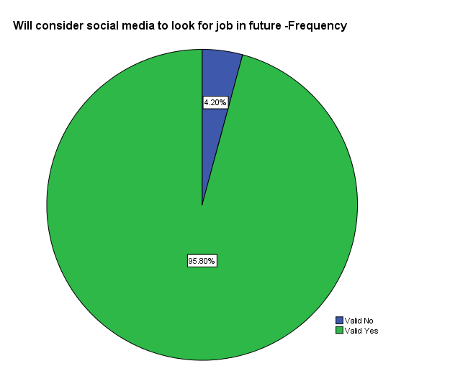

Figure 16: Social Media Platforms participants may use to search for job in future- Frequencies

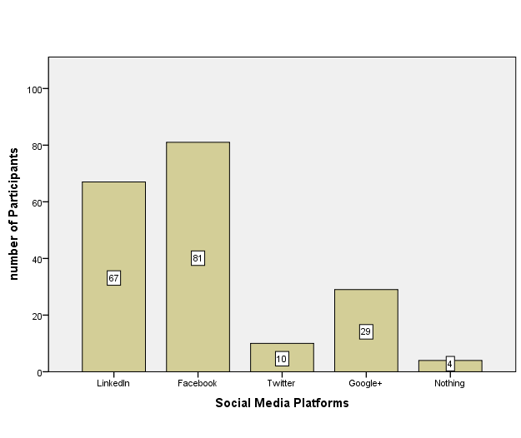

*Figure 17: percentages of social media platforms may use by employee in recruitment*

* **The accuracy of information and professional use of social media:**

The researcher ask participants about the accuracy of professional level social media can reflect for the user, 47% agree that social media profile can reflect the professional level attitude and aptitude, while 53% disagree. (Table 11)

*Table 11: Is social Media reflecting a person’s professional level?*

|  |  |  |  |  |  |
| --- | --- | --- | --- | --- | --- |
|  | | **Frequency** | **Percent** | **Valid Percent** | **Cumulative Percent** |
| Valid | strongly agree | 13 | 10.9 | 10.9 | 10.9 |
| Agree | 43 | 36.1 | 36.1 | 47.1 |
| Disagree | 51 | 42.9 | 42.9 | 89.9 |
| Strongly Disagree | 12 | 10.1 | 10.1 | 100.0 |
| Total | 119 | 100.0 | 100.0 |  |

(Table 11) shows that participants agree that social media pages should regarded as personal not professional, 76% agree and 24% disagree.

*Table 12: Is social media should regard as personal not professional pages?*

|  |  |  |  |  |  |
| --- | --- | --- | --- | --- | --- |
|  | | **Frequency** | **Percent** | **Valid Percent** | **Cumulative Percent** |
| Valid | strongly agree | 37 | 31.1 | 31.1 | 31.1 |
| Agree | 54 | 45.4 | 45.4 | 76.5 |
| Disagree | 26 | 21.8 | 21.8 | 98.3 |
| Strongly Disagree | 2 | 1.7 | 1.7 | 100.0 |
| Total | 119 | 100.0 | 100.0 |  |

This part (Table 13), explains how individuals can use social media for professional purposes. Most participants consider joining professional groups in their industry domain very important, (86.6% agree that individual must join professional group for different purposes. (Table 14) show the different purposes of joining this professional groups in the opinion of the participants.

*Table 13: Is it important to join professional groups on social media?*

|  |  |  |  |  |  |
| --- | --- | --- | --- | --- | --- |
|  | | **Frequency** | **Percent** | **Valid Percent** | **Cumulative Percent** |
| Valid | No | 16 | 13.4 | 13.4 | 13.4 |
| Yes | 103 | 86.6 | 86.6 | 100.0 |
| Total | 119 | 100.0 | 100.0 |  |

*Table 14: Purpose of joining Professional Groups on social media - Frequencies*

|  |  |  |  |
| --- | --- | --- | --- |
|  | | | |
|  | **Responses** | | **Percent of Cases** |
| **N** | **Percent** |
| General market intelligence | 56 | 26.2% | 47.1% |
| To find out about people in your industry | 37 | 17.3% | 31.1% |
| To discuss the latest trends and connect with people in your industry | 71 | 33.2% | 59.7% |
| To find out about the latest job opportunities/recruitment trends | 50 | 23.4% | 42.0% |
| Total | 214 | 100.0% | 179.8% |

### FACT FINDING RESULTS-QUALITATIVE DATA:

Two interviews were conducted with two managerial positions. In this section the interviewees’ answers will be analysed and compared. Full answers are presented in appendices C and D. Note that, in the tables below:

**A1** will represent Mrs Dora Shams AL Ghazal answers, (AL-Jadeed TV)

**A2** will represent Mr Wissam Hajjar answers, (Al-Quds TV).

**A1+A2** will represent the concepts agreed by both interviewees.

* + 1. **Analysis of question one:**

Question one was about the managerial position for both interviewees (see table 4). Results showed that both have managerial positions in Human resource department that give them the ability to have deep understanding for recruitment process in their organizations.

*Table 15: Interview analysis, Question one: managerial position*

|  |  |
| --- | --- |
| **A1** | Senior HR Officer |
| **A2** | Head of administrative department |

* + 1. **Analysis of question two**

Question two asks about the number of employee and the different department in each TV. (See Table 5)

*Table 16: Number of employees and departments*

|  |  |
| --- | --- |
| **A1** | 270 employees  Other many freelancers  Contract with external companies some infrequent programs |
| **A2** | 180 employees inside Lebanon including many freelancer  75 employees outside Lebanon located mainly in in Palestine (Gaza Strip, West Bank, and Jerusalem) |
| **A1+A2** | The main departments are: news, program, social media, and the administrative department |

* + 1. **Analysis of question three**

Question two ask about what social media platforms they have and how benefits from them as HR department. The two TV channels have many different accounts on different social media platforms, for example they have Facebook page for programs and other for News and political programs. The two organizations don’t have any direct benefits from these platforms.

*Table 17: Social media platforms and uses in HR tasks*

|  |  |
| --- | --- |
| **A1+A2** | Large social media department.  Different accounts on Facebook, Twitter, YouTube and Instagram |
| **A1** | Benefit from social media to reflect the internal culture of the Organization  Planning to start an official LinkedIn account  Planning page on Al-Jadeed official website for the HR department |
| **A2** | WhatsApp official Account for Breaking News  Use Al-Quds Facebook page and WhatsApp account to post new job |

* + 1. **Analysis of question four**

Question two asks about how frequent they recruit annually, and how many posts they open each time. The two organizations don’t recruit in frequent manner; it depends on the need of new position or replacement of those retired ones.

*Table 18: Frequent of recruiting*

|  |  |
| --- | --- |
| **A1+A2** | Didn’t recruit in frequent manner  Recruit for new position or replacement of those retired ones |
| **A1** | Benefit from social media to reflect the internal culture of the Organization.  Planning to start an official LinkedIn account |
| **A2** | Recruit when planning for a new round of programs |

* + 1. **Analysis of question five**

Question five the two managers describing the steps in the recruitment process. Both interviewees declared that their used the traditional ways in recruitment, after determining the job vacancy and job description they declare for the position using different tools like Facebook posts, announce the job internally. Interviewee one added that they receives CVs from their mother organization “Tahsien Khayat Group”. After receiving responses from different candidate continue the traditional recruiting process, including short listing the candidates that mostly fit the qualifications, interviewing them, testing them, and then select to make the hiring decision. Interviewee two added that before recruiting the candidate join the organization for one month as trainers, and after evaluating their performance and skills they officially hire them.

*Table 19: Steps of recruiting process and tools used*

|  |  |
| --- | --- |
| **A1+A2** | Using traditional recruiting methods  1st step determining the job vacancy and job description  2nd step declare for the position using different tools like Facebook posts, announce the job internally.  3rd step receive response and short listing the candidates that mostly fit the qualifications  Other steps interview them, test them, and then select to make the hiring decision |
| **A1** | Receives CVs from their mother organization |
| **A2** | Recruiting employee in the external offices through recruitment agencies  1st month candidate training in the position before hiring |

* + 1. **Analysis of question six**

Question six is to show how they using social media in recruitment process. Both interviewees declared that don’t using social media for recruitment in professional way, they using them to announce for job vacancies, receiving response from applicant, and in other steps they using social media to scan candidate. Interviewee one using its personal Facebook to announce for the job vacancies, while interview two using the official Facebook page of the TV and the official WhatsApp account. Both interviewees agreed that by screening candidate using social media can collect information related to qualifications, skills, professionalism and creativity aside to those mentioned in the CV.

*Table 20: Using social media in recruitment process*

|  |  |
| --- | --- |
| **A1+A2** | Using social media for recruitment not on professional bases.  Declare for job vacancies using Facebook  Screening candidate using social media  Information collecting including qualifications, skills, professionalism and creativity |
| **A1** | Using personal Facebook page to announce job vacancies |
| **A2** | Using official Facebook page and WhatsApp account to announce job vacancies |

* + 1. **Analysis of question seven**

Question seven was to investigate about the benefits and the disadvantages of using social media in recruitment. Both interviewees agreed that using social media recruitment is cost and time efficient and allow them to attract large number of candidate in short time. On the other hand they also agreed that the main disadvantage is that large number of responses received, where many of them are unqualified so there will be work overload. Interviewee one added that using social media in recruitment process make it very simple to the candidate to apply for the job, and many social media accounts accessed for free.

*Table 21: Benefits and disadvantages of using social media in recruitment*

|  |  |
| --- | --- |
| **A1+A2** | Time and cost effective  Attract large number of candidate in short time  Receive applicant from many unqualified candidate |
| **A1** | Simple for candidate to apply. |
|  | Many social media platforms are for free. |

* + 1. **Analysis of question eight**

Question eight was to investigate about how the information on candidate’s social media profiles can affect the hiring decision. Both interviewees agreed profile includes any offense of others political or religious will lead to exclude them immediately. Interviewee one added that social media profiles reflect poor communication skills, poor language proficiency levels and information falsified qualifications listed in candidate CVs also will lead to exclude them, while Interviewee two considered social media profile includes any offense on their ex-employers is main reason that affect the hiring decision negatively. On the other hand also the two interviewees agreed social media profiles reflect information about candidate include; good-quality work in previous professional experiences and convenient skills to the position required, will lead to increase the probability of hiring these candidates. Interviewee one also considers social media profiles contained information that reflect a positive behaviour, professionalism and creativity of candidate encourage selecting the owners of theses profiles.

*Table 22: How the information on candidate’s social media profiles can affect the hiring decision?*

|  |  |
| --- | --- |
| **A1+A2** | **Affect hiring decision negatively:**   * Offense of others political or religious will lead to exclude them |
| **A1** | * Poor communication skills, poor language proficiency levels * Information falsified qualifications listed in candidate CVs |
| **A2**  **A1+A2**  **A1** | * Offense on their ex-employers   **Affect hiring decision positively:**   * Good-quality work in previous professional experiences * Convenient skills to the position required * Positive behavior, professionalism and creativity |

* + 1. **Analysis of question nine**

Question nine was to explore why it’s important to candidate to have social media profile. Both interviewees said that for several reasons it’s very important for candidate to have accounts on different social media platforms included; boosts themselves as potential candidates in order to increase their chances to find a job. Interviewee one added that its most important for candidate to have an account on the professional social media platforms like LinkedIn, this will allows candidates to develop, expand and interact with a network of professionals in their domains. Also interviewee two added that he is not enthusiastic to hire someone without active social media profile.

*Table 23: Why it’s important to candidate to have social media profile?*

|  |  |
| --- | --- |
| **A1+A2** | Boosts themselves as potential candidates  Increase their chances to find a job |
| **A1** | Candidate must have account on professional social media platforms like LinkedIn  allows candidates to develop, expand and interact with a network of professionals in their domains |
| **A2** | It’s not enthusiastic to hire someone without active social media profile |

* + 1. **Analysis of question ten**

Question ten was to explore what advices employers can give to candidate about using social media. Both interviewees give many advices; they agreed that candidate must post on their profiles what’s related to their professional experience and activities. Interviewee added several advices; candidate must be honest and truthful when using social media, avoid offending different political and/or religious views, benefit from groups that help develop, expand, and interact with a network of professionals, and reflect the level of professionalism, creativity and communication skills. Interviewee two submits the following advices to candidates; keep it positive and to only post appropriate information when using social media, the information in the CV must match with that shared on social media.

*Table 24: Employers advice to candidate about using social media*

|  |  |
| --- | --- |
| **A1+A2** | Sharing their professional experience and activities |
| **A1** | To be honest and truthful  Avoid offending different political and/or religious views  Benefit from groups that help develop, expand, and interact with a network of professionals  Reflect the level of professionalism, creativity and communication skills |
| **A2** | To keep it positive and to only post appropriate information  Shared information confirming CV |

* + 1. **Analysis of question eleven**

|  |  |
| --- | --- |
| *Table 25:**Describes employer approach to researching prospective candidates on social media* | |
| **A1+A2** | They don’t routinely do that but would if they thought that social profile would provide them with useful information about the candidate |

* + 1. **Analysis of question twelve**

|  |  |
| --- | --- |
| *Table 26: Favored method of advertising a new role* | |
| **A1+A2** | Engaging a recruitment consultancy  Posting job adverts on personal social media websites (e.g. Facebook, Twitter, Google +) |

* + 1. **Analysis of question thirteen**

|  |  |
| --- | --- |
| *Table 27: Information which had caused them not to hire a candidate* | |
| **A1+A2** | Displaying poor communication skills  Conveying information associated with alcohol or illegal drug use  Revealing information that falsified qualifications listed in a CV  Posting content disparaging previous employers |
| **A1** | Posting of inappropriate photographs or information |

* + 1. **Analysis of question fourteen**

|  |  |
| --- | --- |
| *Table 28: Information will let employer hire a candidate* | |
| **A1+A2** | Professionalism and creativity |
| **A2** | Strong references from others |

* + 1. **Analysis of question fifteen**

|  |  |
| --- | --- |
| *Table 29: Reasons will make employer use social media for recruitment* | |
| **A1+A2** | Ease of use.  Cost effective  Timeliness  To find out information about candidates, that’s would not be possible by other means |
| **A2** | To access a wider range of candidates than with traditional recruitment methods |

* + 1. **Analysis of question sixteen**

|  |  |
| --- | --- |
| ***Table 30:*** *Reasons will make employer not use social media for recruitment* | |
| **A1+A2** | Disadvantages candidates who do not have access to/do not use social media  Larger number of applicants |
| **A2** | Increase in workload |

# PART III: GRADUATE PROJECT CONCLUSIONS AND RECOMMENDATIONS

## CHAPTER 5: CONCLUSIONS & RECOMMENDATION

### CONCLUSIONS

The next section will summarize the main findings in line with the research objectives and will link the findings with the previous studies done in this field.

* 1. **Finding One:** The research aimed to find out how social media are used by TV outlets and employees in the media sector in Lebanon for different purposes. The quantitative data collected from 119 participants in the survey show that social media are now a rooted phenomenon with mass appeal, (each participant at least have one type of social media). The qualitative data collected from the two interviews (Shams, 2018) (Hajjar, 2018) suggest that using social media in TVs has expanded and developed as they have large social media departments operating wide and different social media platforms. Both Al Jadeed TV and Al Quds TV plan to invest more in their social media departments by hiring new employees, opening more accounts on social media platforms, and expanding media production for these platforms.
  2. **Finding Two**: The research aim was to explain how employers in the media sector in Lebanon use social media for recruitment and the reasons behind selection of particular social media tools. Collected qualitative data (Shams, 2018) (Hajjar, 2018) show that although social media platforms are widely used for different purposes in the media business, they are still not fully invested in professional manner for recruitment purposes. Instead, they are mainly used in two ways; first, as advertising tools to announce job vacancies and to receive applications, and second, as screening tools for social media profiles of candidates. Also, the research concluded from the 119 surveys that professional social media recruitment platforms (like LinkedIn) are not used extensively among candidates (39.5% having Linked In), which in turn explains why employers do not perceive them as a rich pool of candidates. The two HR managers who were interviewed agreed that social media can be helpful but cannot replace or override personal contact, specifically interviews as an integral component of established recruitment processes that employers use to assess candidates.
  3. **Finding Three:** The research aimed to explain the importance of using social media in recruitment processes for the employer, and determine the advantages and disadvantages aligned to it. Results from the survey conducted with 119 employees from the three TV stations revealed that candidates are more interested in using social media to search for job positions in the future (95% that will consider using social media to search for job in future). According to Shams (2018) and Hajjar (2018), “the benefits of using social media platforms are the cost and time effectiveness, simplicity of use, rich pool of candidates, and provision of valuable and useful information about candidates to the employer which cannot be accessed by other means”. Remarkably, both HR managers noted that when using social media for recruitment, particularly posting for new job vacancies, a large number of applications are received from non-qualified candidates, which leads to a work overload in the HR departments. In addition, if social media are used as the only recruitment technique, employers would not be able to assess the candidates efficiently.
  4. **Finding Four:** The research aimed to explain the importance of using social media for jobseekers. Results from the survey conducted with 119 employees from the three TV stations showed that the candidates explore social media profiles of the employer before applying to jobs. This is done for several reasons (67% explore employer social media profile to get information about organization), mainly to get information about the employer/organization and insight into the organization’s culture. Also, the survey showed that individuals are interested in joining groups related to their profession on social media platforms as they believe there are several advantages of participation in these groups like being informed about the general market intelligence, discussing the latest trends, and connecting with people in their industry. According to Shams (2018) and Hajjar (2018), it can be very important for individuals to have social media profiles in order to increase their employment chances. To make this achievable, however, they need to join the big four social media platforms (Facebook, Twitter, LinkedIn, Google+), join professional groups in order to build personal and professional network in addition to sharing their professional skills and activities.
  5. **Finding Five**: The research inquired whether candidates are aware how their social media profiles can affect the hiring decision. Results from the survey conducted with 119 employees showed that most of them expect that the employer has checked their social media profiles before recruitment, 64% expect that the employer has checked their social media profiles before recruitment), and that the employer -when checking their profiles- would have mostly searched for different kinds of information including past experience, political and religious views, professionalism, creativity, and communication skills…etc. According to Shams (2018) and Hajjar (2018), “information found on the candidate’s social media profiles, including any offense on ex-employers, political or religious offense to others, poor communication, and unprofessional skills, will lead to immediate exclusion. Yet, when the information presented on the candidate’s profile aligns with what is mentioned in their curriculum vitae, and good-quality work in previous professional experiences is shared, this would boost their chance to get hired”.

### RECOMMENDATIONS

* 1. **General Recommendations**
  2. **For TVs’ administrations:**
* Using professional social media for recruitment (like LinkedIn) is very important, gives a positive image about the organization, and attracts professional candidates.
* It is not professional from HR personnel to use their personal social media pages to declare about the job, and this may cause embarrassment among real friends, and will lead to using their personal page for office work.
* Information available on social media may be incorrect or evaluated wrongly, which leads to elimination of qualified candidates. There should not be quick judgments, and information must be filtered and tested carefully.
  1. **For candidates/individuals in media sector:**
* Social media are an enduring reality of online existence; candidates/individuals as professional employees in media sector must join the big four social media platforms: Facebook, Twitter, LinkedIn, Google+.
* Candidates/individuals in the media sector must present themselves positively on their social media pages. Their social media are not for personal ends only; they must share beneficial information, professional skills, achievements and activities.
* Candidates/individuals in the media sector must be honest on their social media profiles, and show a half-full and optimistic approach.
  1. **Future Researches**

Upon completion of this study, the researcher suggests the following future researches:

* Studies on the risk of using social media in recruitment: Organization’s image, discrimination and unfairness...etc.
* Studies about different effects of using social media within different work position level and type.
* Studies about the use of social media in others human resources management topics aside to recruitment.

# REFERENCES

**REFERENCE LIST**

|  |
| --- |
| **TEXT BOOKS and E-BOOKS** |
| Armstrong, m. (2009), “*armstrong's handbook of human resources practices”,*  London and Philadelphia: koganpage.  Armstrong, M. (2014), “*Armstrong’s Handbook of Human Resource Management Practice*”, 13th ed. UK: Kogan Page Limited  Boyd, D. M. and N. B. Ellison (2008), “*Social Network Sites: Definition, History, and Scholarship*”, Journal of Computer-Mediated Communication*,* P.231  Branine, M. (2008),"*Graduate recruitment and selection in the UK", Career Development International*”, Emerald Insight. [Online], P.498  Brown, V. and Vaughn, D. (2011) *'The writing on the (Facebook) wall: The use of social networking sites in hiring decisions*'. *Journal of Business Psychology*, Vol.26, Issue 2: P.219  Bruce N. Pfau, (2001) “*The Human Capital Edge 21 People Management Practices Your Company Must Implement or Maximise Shareholder Value*”, McGraw-Hill  Chitra Reddy, (no date), *“Using Social Media in the Hiring Process: 26 Tips & Benefits”,* from website: <https://content.wisestep.com/using-social-media-in-the-hiring-process-tips-benefits/>  Chris, (2012), quoted in Maureen Sills, “*E-recruitment: A comparison with traditional recruitment and the influences of social media”* (2014) P.16: Adapted and translated from German source: Recruiting Trends: Ein Rückblick auf 10 Jahre “Recruiting Trends: EinRückblick auf 10 Jahre. Frankfurt am Main: Centre of Human Resources Information Systems.  Decenzo, A, David; Robbins, P, Stephen, (1998), “*Personnel/ Human Resource Management*”, P.117  DeCenzo, David A, Robbins and Stephen (2010), “*Fundamentals of Human Resource Management*”, 10th ed., P.144  DeKay, S. (2009), “*Are Business oriented social networking websites useful resources for locating passive jobseekers?*” Results of a recent study. Business Communication Quarterly, P. 102  Distaso, M.W., McCorkindale, T., and Wrigth, D.K. (2011), “*How public relations executives perceive and measure the impact of social media in their organizations*”, P. 326  Edwin B. Flippo, (1984), “*Personnel Management*, *Mc. Grow-Hill*”, New York, P.114  Eric Garner, (2012), “*Recruitment and selection: Hiring the people you want*”. 1st ed., P. 10, published online 2013  Gary Dessler, (2005), “Human resource management”, 10 ed., P.171  Hauptmann, S. and T. Steger, (2013), “*A brave new (digital) world? Effects of In-house Social Media on HRM*”, Zeitschrift für*,* P.46  Hennig-Thurau, T., Malthouse, E.C., Friege, C., Gensler, S., Lobschat, L., Rangaswamy, A. and Skiera, B. (2010), “*The impact of new media on customer relationships*”, Journal of Service Research, P.311  Holm, A. B. (2011), “*E-recruitment: The move towards a virtually organized recruitment process*”, Human resource management in the digital economy: Creating synergy between competency models and information, P95, IGI Global.  Kaplan, A.M, and Haenlein, M. (2009), “*The fairyland of Second Life: Virtual social worlds and how to use them Business Horizons*”, P.568  Kaplan, A.M., & Haenlein, M. (2010), “*Users of the world, unite! The challenges and opportunities of social media*”, Business Horizons, ,P. 59  Lim, M. (2012). “*Clicks, Cabs, and Coffee Houses: Social Media and Oppositional Movements in Egypt 2004–2011*”, Journal of Communication P*.*248  Madera. J. (2012), “*Using social networking websites as selection tool: The role of selection process fairness and job pursuit intentions*”, Int. J. Hospitality Manage P. 2, 4  Mary, O., Charlie, P., Jitendra, M., and Bharat, M. (2010), “*Employers Use Face Book Too, for Hiring. Advance in management*”, P. 14  Mary, O., Charlie, P., Jitendra, M., and Bharat, M. (2010). “*Employers Use Face Book Too, for Hiring. Advance in management*”, P. 16  Mike Haberman, (2015), “*The Hiring Process: Using LinkedIn as a Recruitment Tool*”  Mike Wicks, (2012), “*An Introduction to Social Media for Small Business*”, Publisher: Blue Beetle Books Inc., P.4  North-Western University Qatar Survey, Everette E., Justin D., Robb W., and Marium S., (2016), *“MEDIA USE IN THE MIDDLE EAST - A Six-Nation Survey”*, P.32  Plumbley, P. R. (1991). “Recruitment & selection”. London, United Kingdom: Institute of Personnel Management  Ricky W. Griffin, (2013), “*Management*”, 11th ed., Texas A and M university, P.390  Roger Herman & Joyce Gioia , (2000) , “How to Become an Employer of Choice”, chapter 1  Salmen, S. (2012), “*What's Next - Die nächsten Trends. In B. H. Rath, & S. Salmen, Recruiting in Social Web*”, P.284, Göttingen: BusinessVillage GmbH.  Saunders, m., Lewis, p., & Thornhill, a. (2009). *research methods for business students* (fifth ed.). italy: prentice hall-financial times.  Segal, J. (2011), “*Dancing on the Edge of a Volcano: From hiring to harassment, social media can explode on employers*”, HR Magazine, P. 84  Smith, A.D. and Rupp, W.T. (2004), “*Managerial challenges of e-recruiting: extending the life cycle of new economy employees*”, P.61, 74.  Stamper, C. (2010), “*Commoin mistakes companies make using social media tools in recruiting efforts*”, CMA Management, p.13  Stoller, J., (2012). “*Recruiting with social media: Online tools open doors*”. CMA Magazine, P. 40.  Zeidner, R. (2008). “*The Tech Effect on Human Resource. HR Magazine*”, P.53 |
| **ARTICLES** |
| [Antony Maina](https://smallbiztrends.com/author/antony-maina), (2017), “20 Popular Social Media Sites Right Now”, from website: <https://smallbiztrends.com/2016/05/popular-social-media-sites.html>  Chris, (2015),” *Social Media Hiring: Maximize Benefits, Reduce Risk”,* Everwall Company  Fanak website, (2017), article “*Lebanon’s Media Landscape: An Overview*”, from website: <https://fanack.com/lebanon/society-media-culture/lebanon-media/>  Guardian Jobs, (2017),”*How to use social media in your job search”* <https://jobs.theguardian.com/article/how-to-use-social-media-in-your-job-search/>  <https://everwall.com/blog/social-media-hiring-maximize-benefits-reduce-risk/>  <https://www.thebalance.com/top-tips-for-successful-employee-recruiting-1918953>  Leader-Chivee, L., Hamilton, B. A., Cowan, E. (2011), “*Networking the way to success: online social networks for workplace and competitive advantage*”, from <http://findarticles.com/p/articles/mi_6768/is_4_31/ai_n31909656/pg_6>  Meenakshi Chaudhary, (2017) “*LinkedIn by the Numbers: 2017 Statistics*”, LinkedIn, from website:<https://www.linkedin.com/pulse/linkedin-numbers-2017-statistics-meenakshi-chaudhary/>  Simplicant website, (no date), “*10 Qualities Of good recruiting system*”, from website: <https://www.simplicant.com/blog/10-qualities-good-recruiting-system/>  Susan, (2017), Heathfield is a Human Resources expert and a member of the Society for Human Resource Management (SHRM).  Techopedia, (no date), “*Social Media*”, <https://www.techopedia.com/definition/4837/social-media>  Tiffany Black, (2010), “*How to Use Social Media as a Recruiting Tool*”, <https://www.inc.com/guides/2010/04/social-media-recruiting.html>  Web Solution, (2016), “*characteristics of the company website that make it a powerful recruiting tools*”, from wesite: <https://www.websolutions.com/Blog/10-ways-to-turn-your-website-into-a-powerful-recruiting-tool/> |
| **INTERVIEWS** |
| DORA SHAMS, (2018, 01, 09). management view point about using social media in recruitment, AL-Jadeed Tv, (B. Fawzi Alhajj khalil, Interviewer)  WISAM HAJJAR, (2018, 01, 10). management view point about using social media in recruitment, AL-Quds Tv, (B. Fawzi Alhajj khalil, Interviewer) |
| **REPORTS** |
| Andy HeadWorth, (2015), “*Social media recruitment, How to successfully integrate social media into recruitment strategy*”  Anna B. Holm, (2008- 2009), case study “*The Effect of E-recruitment On the Recruitment Process*”, Aarhus University, Denmark,  Dubai School of Government’s, (2011), “*Arab Social Media Report*”, from website: [www.ArabSocialMediaReport.com](http://www.ArabSocialMediaReport.com).  Eurocom Worldwide, (2012), annual survey,” *technology market survey*” <http://www.eurocompr.com/prfitem.asp?id=14921>  ICIMS survey (2015), “*Recruitment marketing: fad or future*” <https://www.icims.com/sites/www.icims.com/files/public/Recruitment-Marketing_eBook-final_1.pdf>  Jason Mander, (2017), “*Daily time spent on social networks rises to over 2 hours*”, Global web Index, from website: <https://blog.globalwebindex.net/chart-of-the-day/daily-time-spent-on-social-networks/>  Laick, S., and and Dean A.A., (2011), “*Using web technology in personnel marketing to transmit corporate culture*”. International Journal of Management Cases  MARCH, 2016 “*Freedom of Expression Online Report*”  Mazen, S., Stephanie, G., Ziad, H. and Rita, N. (2015) “*ANALYSIS OF LEBANON’S MEDIA AND ADVERTISING SECTOR”,* Lebanon, BankMed, ([www.bankmed.com.lb](http://www.bankmed.com.lb))  Mazen, S., Stephanie, G., Ziad, H., Nadine, Y., and Rita, N. (2014) “*ANALYSIS OF LEBANON’S MEDIA AND ADVERTISING SECTOR”,* Lebanon, BankMed, from website [www.bankmed.com.lb](http://www.bankmed.com.lb)  Rachel Nauen, (2017), “*CareerBuilder Study, Number of Employers Using Social Media to Screen Candidates*”, from website: <http://press.careerbuilder.com/2017-06-15-Number-of-Employers-Using-Social-Media-to-Screen-Candidates-at-All-Time-High-Finds-Latest-CareerBuilder-Study>  SHRM Survey, (2013), “*Social Networking Websites and Recruiting/Selection*” <https://www.slideshare.net/shrm/social-networkingwebsitesrecruitingselectingjobcandidatesshrm2013final>  Simply Measured, (2016) “*the state of social marketing annual report”*  Source: Dubai Press Club, (2010 “*Arab Media Outlook Survey 2009-2013,”Forcast and analysis of traditional and digital media in the arab world*” |
| **WEBSITES** |
| http://www.humanresourcesmba.net  http://investinlebanon.gov.lb  https://rsf.org/en/ranking  <https://www.similarweb.com/top-websites/lebanon>  http://gs.statcounter.com  https://www.statista.com  https://www.summitsearchgroup.com |

# APPENDICES

**APPENDIX A**

**QUESTIONNAIRE**

****

Dear,

Thank you for taking time to participate in our survey. This survey is part from an on-going research about the “use of social media in recruitment” (as a graduate project in MBA). All the information is for academic purpose and will not be shared outside the university. Thank you.

|  |  |  |  |  |  |  |  |  |  |  |  |  |  |  |  |  |  |  |  |  |  |  |  |  |  |
| --- | --- | --- | --- | --- | --- | --- | --- | --- | --- | --- | --- | --- | --- | --- | --- | --- | --- | --- | --- | --- | --- | --- | --- | --- | --- |
|  | **في أي وسيلة إعلامية تعمل:** | | | | | | | | | | | | | | **In any media outlet do you work?** | | | | | | | | | | |
| Al Quds TV | | | | | | | | | | Palestine Today TV | | | | | | | | | | | | Al Jadeed TV | | | |
|  | **أي من وسائل التواصل الاجتماعي تمتلك عليها حسابًا؟** | | | | | | | | | | | | | | **Which social media sites do you own an account on?** | | | | | | | | | | |
| Instagram | | | | Google+ | | | | | | | | | WhatsApp | | | | Twitter | | | | Facebook | | | | LinkedIn |
|  | **هل علمت عن/ تقدمت لوظيفتك الحالية/السابقة عبر وسائل التواصل الاجتماعي؟** | | | | | | | | | | | | | | **Have you heard about/ applied to your current/previous job position through social media?** | | | | | | | | | | |
| No | | | | | | | | | | | | | | | Yes | | | | | | | | | | |
|  | **هل يمكن أن تستخدم وسائل التواصل الاجتماعي للبحث عن وظيفة في المستقبل؟** | | | | | | | | | | | | | | **Will you consider using social media in search for a job position in the future?** | | | | | | | | | | |
| No | | | | | | | | | | | | | | | Yes | | | | | | | | | | |
|  | **أي من وسائل التواصل الاجتماعي هذه يمكن أن تستخدمها للبحث عن عمل؟** | | | | | | | | | | | | | | **Which of these social media platforms may you use to look for a job?** | | | | | | | | | | |
| Google+ | | | | | | | Twitter | | | | | | | | Facebook | | | | | | | LinkedIn | | | |
|  | **ما هي الطريقة المفضلة التي يمكن أن تستخدمها للبحث عن وظيفة؟** | | | | | | | | | | | | | | **What method would you prefer to apply for a job?** | | | | | | | | | | |
| recruitment consultancy | | | job board | | | | | | | | | | | professional social networking site | | | | | | | | | | organization’s website | |
|  | **هل تعتقد أن الشركة التي تتقدم لطلب توظيف فيها تبحث عنك في وسائل التواصل الاجتماعي؟** | | | | | | | | | | | | | | **Do you expect that the company would find out about your profile in social media before recruitment?** | | | | | | | | | | |
| No | | | | | | | | | | | | | | | Yes | | | | | | | | | | |
|  | **هل تعتقد أنه مقبول أخلاقيًا من أرباب العمل التحقق من حسابك على مواقع التواصل الاجتماعي كجزء من عملية التوظيف؟** | | | | | | | | | | | | | | **Do you think it’s ethical for employers to check your profiles on social media as part of the recruitment process?** | | | | | | | | | | |
| No | | | | | | | | | | | | | | | Yes | | | | | | | | | | |
|  | **برأيك ما هي الأمور التي تبحث عنها الشركة في حسابات التواصل الاجتماعي للشخص المتقدم إليها؟** | | | | | | | | | | | | | | **In your opinion, what things are mostly checked by company on your social media profiles during the recruitment process?** | | | | | | | | | | |
| professionalism, creativity, communication skills | | | | | Political and religious views | | | | | | | | | Information about previous experiences | | | | | | | | | | verifying information in a cover letter or CV | |
|  | **هل تعتقد أن حسابات التواصل الاجتماعي تعكس المستوى المهني للشخص وقدراته وسلوكه؟** | | | | | | | | | | | | | | **Do you think social media profiles reflect a person's professional level, attitude and aptitude?** | | | | | | | | | | |
| Strongly Disagree | | | | | | | | | | | | Disagree | | | | | | | Agree | | | Strongly Agree | | | |
|  | **بإعتقادك، ما تكتبه على حسابات التواصل الاجتماعي كيف يؤثر في قرار التوظيف؟** | | | | | | | | | | | | | | **11) In your opinion what you write on social media profiles how affects the selection decision?** | | | | | | | | | | |
| Negatively | | | | | | | | | Neutral | | | | | | | | | | | Positively | | | | | |
|  | **هل توافق أنّ وسائل التواصل الاجتماعي يجب أن تعتبر شخصية وليست مهنية؟** | | | | | | | | | | | | | | **Do you agree that social media should be regarded as personal and not professional?** | | | | | | | | | | |
| Strongly Disagree | | | | | | | | | | | | Disagree | | | | | | | Agree | | | Strongly Agree | | | |
|  | **ما هي الأمور التي تنشرها على حساباتك عبر وسائل التواصل الاجتماعي؟** | | | | | | | | | | | | | | **What do you publish on your profiles through social media?** | | | | | | | | | | |
| Problems and situation at my work | | | | | | Political and religious views | | | | | | | | Professional skills, knowledge, and experience | | | | | | | | | Daily personal and social activities | | |
|  | **ما هي الأسباب التي يمكن أن تدفعك للاطلاع على مواقع التواصل الاجتماعي للشركة التي تتقدم للعمل فيها؟** | | | | | | | | | | | | | | | **Why would you be interested to explore corporate social media profiles while applying for a job?** | | | | | | | | | |
| Profiles of existing employees | | Career opportunities | | | | | | | | | Insight into how the business wants itself to be perceived | | | | | | | Insight into company culture | | | | Information on the organization | | | |
|  | **هل تعتقد انه من المهم الانضمام لمجموعات تختص بمجالك العملي على مواقع التواصل الاجتماعي؟** | | | | | | | | | | | | | | **Do you think it’s important to join groups relating specifically to your profession on social media sites?** | | | | | | | | | | |
| No | | | | | | | | | | | | | | | Yes | | | | | | | | | | |
|  | **من المفيد الانضمام لمجموعات مختصة بمجالك العملي على مواقع التواصل الاجتماعي لـ:** | | | | | | | | | | | | | | **Joining profession-specific groups on social media sites is useful for:** | | | | | | | | | | |
| To find out about the latest job opportunities/recruitment trends | | | | | | | | To discuss the latest trends and connect with people in your industry | | | | | | | To find out about people in your industry | | | | | | | General market intelligence | | | |

**APPENDIX B**

**INTERVIEW QUESTIONS**

* **Open questions:**

**Question 1**: Name and position?

**Question 2**: How many employees do you have in your company, other than the administrative and logistic staff?

**Question 3:** What social media sites do you have company profile on? And how do you benefit from them as HR manager?

**Question 4**: How frequently do you recruit annually? And how many posts do you open each time?

**Question 5**: Describe your steps and action during the recruitment process. What tools do you use during it?

**Question 6**: If you use social media in recruitment process, at which level/step do you use them, what tools do you use, and how do you use them?

**Question** **7:** If you use social media platforms in recruitment, why do you use them, and, in your opinion, what are the benefits and risks of using social media in recruitment?

**Question 8:** What kind of information on a candidate’s social media profile would lead to excluding them from the recruitment process, and what kind of information would lead to hiring them?

**Question 9:** As HR manager, do you think it is important for individuals in media sector to have profile on social media, and how does this affect their chances to find a job?

**Question 10:** As an employer, what advice do you give to candidates about using social media in order to increase their probability to find jobs?

* **Multiple choice questions:**

**Question 11:** Which of the following viewpoints describes your approach to researching prospective candidates on social media?

1. We routinely check candidates out on personal social networking sites
2. We don’t routinely use these sites but would if we thought they would provide us with useful information about the candidate
3. We do not and would not check social networking sites during the recruitment process

**Question 12:** What would be your favored method of advertising a new role?

* Engaging a recruitment consultancy
* Posting on a job board (e.g. daleel madani, hirelebanese, bayt... etc)
* Posting job adverts on a professional social networking site (e.g. LinkedIn)
* Posting job adverts on personal social media websites (e.g. Facebook, Twitter, Google +)
* Advertise directly on your organization’s website

**Question 13:** According to survey conducted by CareerBuilder.com, 2012, employers who used SNSs for screening reported that they had found the following information which had caused them not to hire a candidate; which of this information will let you take the same decision: (Multiple choice possible)

* Posting of inappropriate photographs or information
* Displaying poor communication skills
* Conveying information associated with alcohol or illegal drug use
* Revealing information that falsified qualifications listed in a CV
* Posting content disparaging previous employers

**Question 14:** However, below is the information when found on SNSs had made them more likely to hire a candidate; which of this information will let you take the same decision: (Multiple choices possible)

* Professionalism and creativity
* Good communication skills
* Strong references from others

**Question1 5:** What of the following reasons will make you use social media for recruitment? (Multiple choices possible)

* To access a wider range of candidates than with traditional recruitment methods
* Ease of use
* Cost effective
* To target niche candidates
* Timeliness
* To find out information about candidates which would not be possible by other means.
* To help with the selection process
* Industry norm

**Question 16:** What of the following reasons will make you not use social media for recruitment? (Multiple choices possible)

* Disadvantages candidates who do not have access to/do not use social media
* Concerns regarding candidates’ privacy
* Larger number of applicants
* Discrimination based on candidate personal characteristics
* Increase in workload
* Limited selection of candidates
* Concerns regarding organization’s reputation

**APPENDIX C**

**INTERVIEW 1: FULL ANSWERS**

Date: 9-1-2018 Place: Al-Jadeed Television, With: Mrs. Dora Shams Al Ghazal

**Answer 1:**

Ms. Dora Shams Al Ghazal – Senior HR Officer at Al-Jadeed Television.

**Answer 2:**

We have 270 employees in total, as well as many freelancers whom we work with in different departments in the Television station. The main departments are: news, program, social media, and the administrative department (the latter includes: the finance, human resource and public relations).

Some of our infrequent programs, which are not aired regularly (in a daily or weekly manner), need specialized huge studios, with high quality equipment and a large operating team. For these, we have contracts with external companies to shoot these shows there.

**Answer 3:**

The social media department is a large department. It is now one of the most effective marketing tools for our programs, and the main platform beside the TV screen.

We have accounts on the following social media: Two Facebook accounts (one for the programs and one for the news), one Instagram account (for the programs), four Twitter accounts (for programs, art, news, and sports), three YouTube channels (live streams, programs, and news) and the official website.

As HR department we do not use these social media accounts for any human recourses activity. Yet, we generally benefit from it in the branding and the image of our organization, especially when posting videos or reports about our team, which reflect the internal culture of the organization.

One of our objectives this year is to have a special page on Al-Jadeed official website for the HR department, and to use it in order to announce job vacancies and allow online applications through it. We are also planning to start an official LinkedIn account for our organization.

**Answer 4:**

Vacancies are not announced so frequently. It depends whether there’s a need to replace those who retired or a need to recruit for new positions.

Due to financial considerations, it’s not so common to have vacancies new positions in the meantime. The last time we declared a job vacancy was 5 months ago, in order to replace 4 employees in the social media department.

**Answer 5:**

After checking on available vacancies and taking the decision to recruit, we review or write the job description for the position(s), in order to determine the candidate’s qualifications. Then we announce the job internally, to involve current employees, in case they can recommend candidates. Also, I advertise the vacancies by posting them on my personal Facebook as HR manager in the TV station using “friend of friend” privacy posts. In addition we contact universities for specific requirements and qualifications, or refer back some to an initially existing pool of curriculum vitaes.

In addition, we get recommendations for potential candidates from the mother organization, “Tahsien Khayat group”, as they participate on different recruitment exhibitions, attracting candidate for the companies they hold.

After handling responses from the different above sources, we shortlist the candidates that mostly fit the qualifications, interview them, test them, and then select to make the hiring decision.

**Answer 6:**

Using social media as recruitment tools is still not implemented on fully professional basis. As mentioned above, at Al-Jadeed TV I only use my personal Facebook account for the recruitment process, in order to advertise the job vacancies and receive applicantions. After posting on my Facebook page we receive large number of responses through direct messages, emails and phone calls.

Also we use social media to screen the profiles of candidates, in order to check their professionalism and creativity, which is reflected in their use of social media, the language they use, and their moral behavior.

**Answer 7:**

Using social media today is not a choice, although as HR department we are still not using social media in professional and organized manner for recruitment, but at least we use it as one of the main tools at two levels during recruitment.

There are mainly two benefits of using social media in the recruitment process. First, it’s a very simple too that provides a lot of publicity to the available vacancies, and allows us to find a large number of candidates. Second, it is a time and cost effective tool; most social media platforms can be accessed for free, and enable us to reach out to potential candidates, as well as to validate their information in less time and in a direct manner.

Yet, the main disadvantage of using social media is that a large number of responses received, so there will be work overload in order to check the admitted CVs and applications.

**Answer 8:**

Some candidates use the Internet to copy paste skills and qualifications to their CVs. Then, while screening their social media profiles, we reveal the discrepancy in their information and the falsified qualifications listed in their CVs. Other candidates use social media immorally to offend people with different political and/or religious view. Also, social media profiles reflect the communication skills, as well as language proficiency levels. So, through screening the candidate s’ profiles it will be clear if they have poor communication and language skills, as these info is reflected in their profiles, and this may lead to excluding them from the recruitment process.

On the other hand, profiles that reflect additional info about past experience, convenient skills to the position required, positive behavior, professionalism and creativity, encourage selecting the owners of theses profiles for the interview and increase the probability of hiring them.

**Answer 9:**

As mentioned earlier, it is not a choice for the jobseeker and the recruiters today to use social media, it is rather a requirement. For the jobseekers, social media is an important tool to profile themselves as potential candidates and to increase their chances to find a job. For this purpose, it is very important for individuals to have social media accounts especially in professional recruitment platforms like LinkedIn.

Although LinkedIn is not well used until now in Lebanon, it is still important to have an account on in it. LinkedIn allows people to develop, expand and interact with a network of professionals to whom the employer or recruiter can send a request for a referral of a recommended candidate for a particular job opening.

**Answer 10:**

Our advice to candidates is to be honest and truthful when using social media. It is important to avoid offending different political and/or religious views. Also it is important for candidates to benefit from groups that help develop, expand, and interact with a network of professionals. Social media profiles are not only for personal use, they reflect the level of professionalism, creativity and communication skills, so it is important for candidates to post on their profiles what’s related to their professional experience and activities.

* **Multiple choice questions:**

**Answer 11:**

* We don’t routinely use these sites but would if we thought they would provide us with useful information about the candidate

**Answer 12:**

* Engaging a recruitment consultancy
* Posting job adverts on personal social media websites (e.g. Facebook, Twitter, Google +)

**Answer 13:**

* Posting of inappropriate photographs or information
* Displaying poor communication skills
* Conveying information associated with alcohol or illegal drug use
* Revealing information that falsified qualifications listed in a CV
* Posting content disparaging previous employers

**Answer 14:**

* Professionalism and creativity

**Answer 15:**

* Ease of use
* Cost effective
* Timeliness
* To find out information about candidates which would not be possible by other means.

**Answer 16:**

* Disadvantages candidates who do not have access to/do not use social media
* Larger number of applicants

**APPENDIX D**

**INTERVIEW 2: FULL ANSWERS**

Date: 10-1-2018, Place: Al-Quds Television, With: Mr. Wisam Hajjar

**Answer 1:**

Mr. Wisam Hajjar – Administrative Manager at Al-Quds Television.

**Answer 2:**

We have 180 employees inside Lebanon and 75 employees outside, in external branches and offices, located mainly in Palestine (Gaza Strip, West Bank, and Jerusalem). Employees in the headquarters in Lebanon support the following departments: 47 employees in the news department, 10 in Political programs department, 8 in general programs departments, 15 in social media department, and 40 in the administrative and public relation department (including IT team, technicians, finance, logistics, public relations and human resources…). We work on freelance basis with the others.

**Answer 3:**

Our social media department is a new yet ambitious department. Our plan for the this year to invest more in this new department, hire new employees, open more accounts on social media platforms, and expand the media production for these platforms.

Currently we have the following social media accounts: Two Facebook accounts (one for the programs and one is the official TV’s page), one Instagram account (for the programs), two Twitter accounts (one for breaking news, and one is the official TV’s page), one YouTube channel, whatsApp for breaking news and programs, and the official website.

As HR department we use only the official Facebook page and whatsApp posting for any new job vacancies and receiving response from applicants.

**Answer 4:**

We do not recruit that frequently, as jobs are only announced in case of a vacancy (an employee resigned and his/her position and needs to be filled), or after the planning for a new round of programs where we may need additional employees or those in specific expertise.

**Answer 5:**

Before announcing the job, as HR we determine what it is, develop the job description and specifications. Then we disseminate the call using traditional ways like advertising in newspapers, and through word of mouth by involving current employee to recommend or refer potential candidate. We also use social media platforms sometimes to announce availability of jobs. As HR, we in turn use our relations in order to attract some candidates for managerial positions.

Then, the applicant will fill an application from (hard copy) and submit to us. After reviewing the received application and CVs, we select the most qualified and appropriate candidate, and sometimes use social media in order to screen their profiles. Later on we schedule interviews with the selected applicants. In the first month, they may join the organization for one month as trainers, and after evaluating their performance and skills we officially hire them.

To note, this process only applies in Lebanon, while elsewhere we refer to recruitment agencies to support in the recruitment process.

**Answer 6:**

We do not use professional social media platforms for recruitment, but rather for advertising the available vacancies, specifically Facebook and Whatsapp. Even though we accept applications sent through these, we’d still require applicants to fill in the hard copy application form in order to proceed with their application.

Another aspect related to using social media is to screen candidate’s social media profile(s) ahead of the interview in order to get more information their qualifications and skills, aside to those mentioned in the CV.

**Answer 7:**

Using social media in recruitment is both cost and time efficient, more than traditional ways. When we advertise in the newspaper it takes more time to receive applications, and we will also be paying for this advertisement. In addition, the number of applications received through newspaper announcement is low, as less people nowadays seek employment opportunities in newspapers. On the other hand, using social media offers us so many applications in a matter of days. But the main disadvantage in this, is that a large number of non-qualified candidates apply through social media too.

**Answer 8:**

If the candidate’s social media profile includes any offense on their ex-employers, any indecent comments or posts, and any political or religious offense to others, we exclude them immediately. If on the other side the information presented on their profile aligns with what’s mentioned in their curriculum vitae, and good-quality work in previous professional experiences is shared this would boost their application.

**Answer 9:**

It is very important for people in this domain to have a Facebook profile for example. I am personally not so enthusiastic to hire someone with no active social media profile, at least on Facebook. This can help in building personal and professional network, and in increasing employment chances.

**Answer 10:**

The social media profile reflects the personality of the individual, so it’s always better to keep it positive and to only post appropriate information. In addition, info on the CV must match with that shared on social media, even small section like hobbies, as well as the skills. It is also good to post activities related to our work on these profiles.

* **Multiple choice questions:**

**Answer 11:**

* We don’t routinely use these sites but would if we thought they would provide us with useful information about the candidate

**Answer 12:**

* Engaging a recruitment consultancy
* Posting job adverts on personal social media websites (e.g. Facebook, Twitter, Google +)

**Answer 13:**

* Displaying poor communication skills
* Conveying information associated with alcohol or illegal drug use
* Revealing information that falsified qualifications listed in a CV
* Posting content disparaging previous employers

**Answer 14:**

* Professionalism and creativity
* Strong references from others

**Answer 15:**

* To access a wider range of candidates than with traditional recruitment methods
* Ease of use
* Cost effective
* Timeliness
* To find out information about candidates this would not be possible by other means.

**Answer 16:**

* Disadvantages candidates who do not have access to/do not use social media
* Larger number of applicants
* Increase in workload

**APPENDIX E**

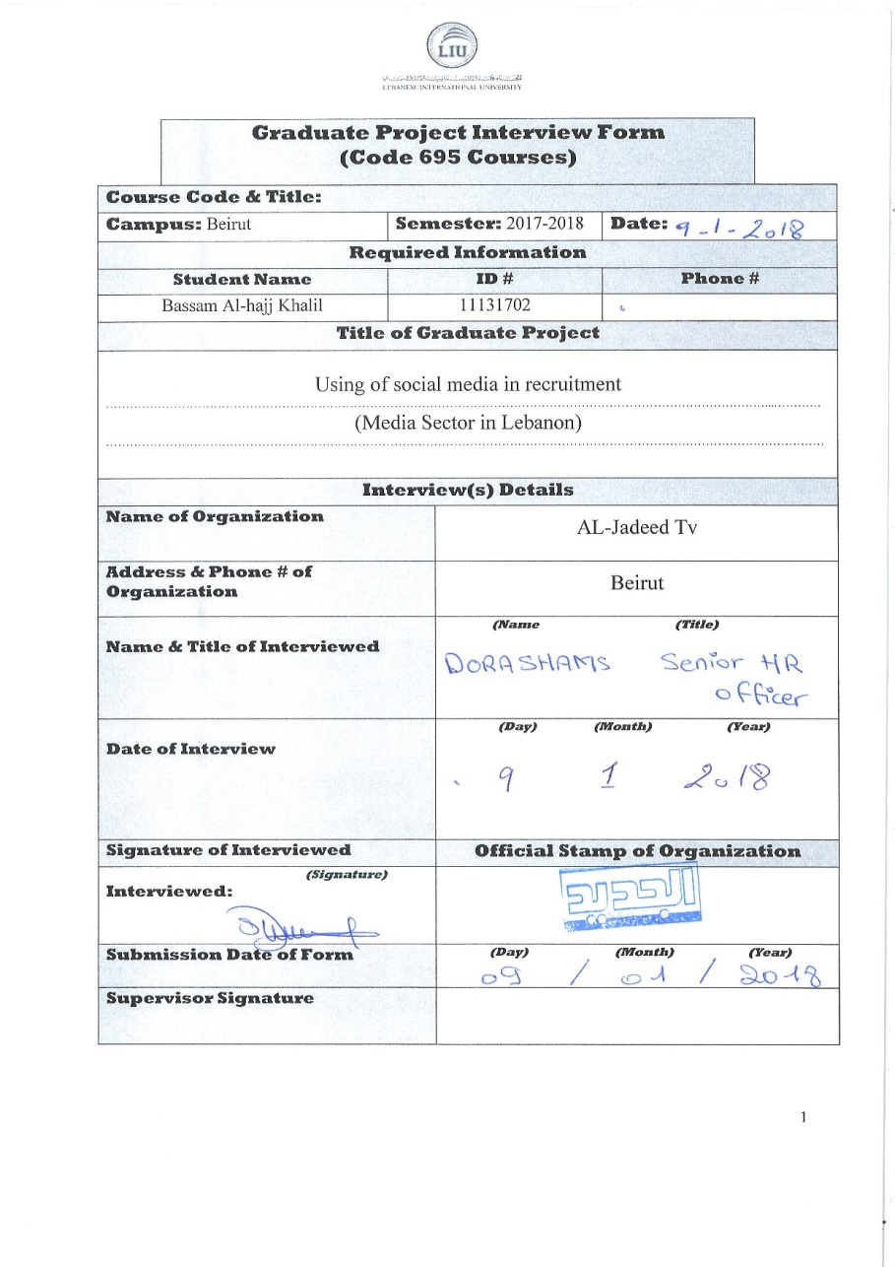**GRADUATE PROJECT INTERVIEW FORM - 1**

**APPENDIX F**

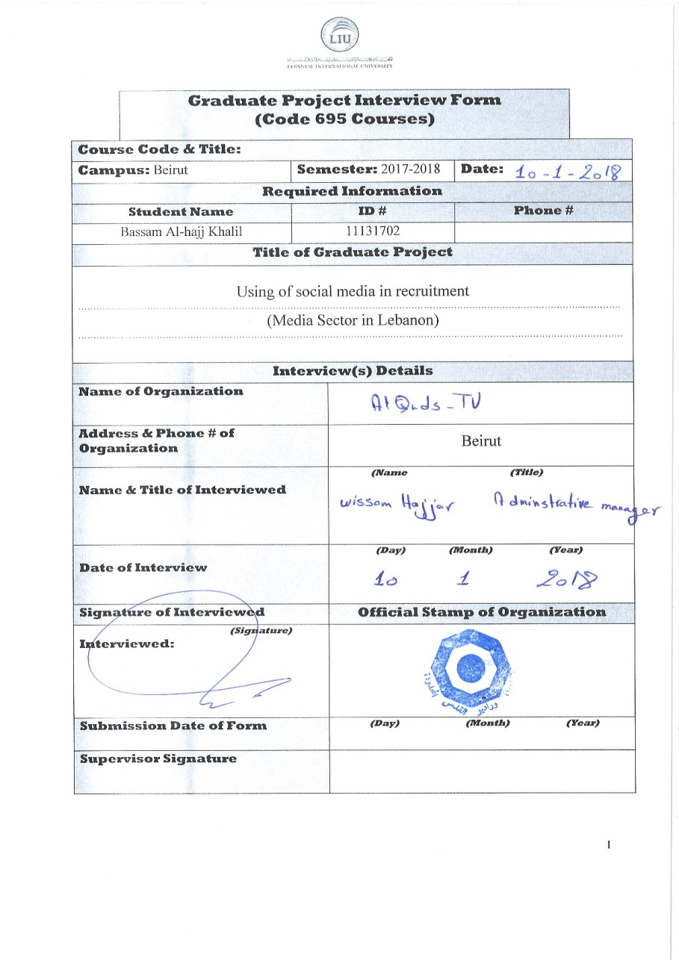**GRADUATE PROJECT INTERVIEW FORM - 2**