

**DEDICATIONS**

Wholeheartedly, I dedicate this thesis to my parents, Riad and Rima, who have always believed in me before I believed in myself, who encouraged me to build and be the best version of myself, and who taught me to keep moving forward no matter how hard the road gets.

I also dedicate this thesis to my two brothers, Mohammad and Ibrahim, my backbone, who taught me to stand up for myself even if everyone stands against me, and whom I know are always by my side, against the world.

Last but not least, to my only sister, Reem, who’s very special and affectionate, I dedicate this work.

And to myself, I dedicate this thesis, for that it taught me that I am capable to do whatever I set my mind to.

**ACKNOWLEDGEMENTS**

I would like to sincerely acknowledge and thank my supervisor Dr. Mohammad Mtairek, for enriching me with his generous expertise and constant support, and whom without his assistance and encouragement, this work wouldn’t be complete.

I would also like to gratefully thank my friends Sara and Kalthoum, and my cousin Amena for always checking on me and providing constant emotional support throughout the conduction of this thesis for me to reach my full potential, that they believed is high.

A special thanks goes to all my friends who assisted me to reach the needed sample, and to every participant in this research.

**ABSTRACT**

The outbreak of the novel COVID-19 virus was not only considered a global health crisis, but also an international economic threat, that has potentially disruptive impacts on the careers of organizations and employees across the globe. However, as a way to comply with lockdown and social distance government regulations to contain the virus, and instead of totally shutting businesses, telecommuting, an alternative work arrangement to traditional in-office work that is based on the use of information and computer technologies while working away from the central office, was implemented. This research study and preview of relevant literatures focus on telecommuting, as an emergent change in work practices, in order to investigate its impact on job satisfaction among employees. An online survey was conducted, and data was collected from 117 NGO employees in Lebanon showing that telecommuting has a slight, positive, impact on job satisfaction. However, the results suggest that employees experience a high level of social isolation, a typical aspect of telework, that is probably intensified due to additional social distancing measures of COVID-19. Furthermore, the results suggest that employees also experience a level of professional isolation, as well as challenges to maintain boundaries between work and family. All these challenges may be related to the sudden, unexpected shift to a full-time mode of telework, being unprepared, and having no related experience. Some conclusions and recommendations are drawn to support employers to better take advantage of telecommuting work arrangement so they can better manage employees’ work and increase their levels of job satisfaction.

**Table of Contents**

**LIST OF TABLES 7**

**LIST OF FIGURES 8**

**CHAPTER 1: INTRODUCING THE GRADUATE PROJECT 9**

**1. Introduction 9**

**1.1. Research Questions 10**

**1.2. Research Aim and Objectives 11**

**1.3. Overview of the Sector/ Domain/ Organization 11**

**1.4. Research Hypotheses 13**

**1.5. Structure of the Graduate Project 14**

**CHAPTER 2: LITERATURE REVIEW 16**

**2. Literature Overview 16**

**2.1. Telecommuting 17**

**2.1.1. History and Definition 17**

**2.1.2. Benefits and Challenges 20**

**2.2. The Shift to Telecommuting During the Emergence of Covid-19 24**

**2.3. Job Satisfaction 26**

**2.3.1. Definition 26**

**2.3.2. Key Factors 27**

**2.3.3. Outcomes 28**

**2.3.4. Measurements 29**

**2.4. Telecommuting and Job Satisfaction During COVID-19 32**

**2.4.1. Factors Affecting Telecommuting Job Satisfaction 32**

**2.4.2. Impact of Telecommuting on Job Satisfaction 39**

**2.5 Literature Review Summary 41**

**Chapter 3: Research Methodology 43**

**3.1. Research Philosophy 43**

**3.2. Research Approach 45**

**3.3. Research Strategy (Data Collection Method) 46**

**3.4. Research Methodological Choice 48**

**3.5. Time Horizon 49**

**3.6. Techniques and/or Procedures for Data Analysis 49**

**CHAPTER 4: FINDDINGS AND ANALYSIS 51**

**4.1. Introduction: 51**

**4.2. Findings (Descriptive Statistics) 51**

**4.3. Analysis 65**

**CHAPTER 5: CONCLUSION AND RECOMMENDATIONS 70**

**5.1. Conclusion 70**

**5.2. Limitations 71**

**5.3. Recommendations 72**

**REFERENCES 74**

**APPENDIX: QUESTIONNAIRE 79**

# LIST OF TABLES

Table 1: Sample of Telecommuting Definitions Used in the Literature (Allen, et al., 2015) 19

Table 2: Opportunities and Risks of Teleworking (Contreras, et al., 2020) 23

Table 3: Intensity of Telecommuting 57

Table 4: MOAQ Job Satisfaction Item 1 63

Table 5: MOAQ Job Satisfaction Item 2 64

Table 6: MOAQ Job Satisfaction Item 3 64

Table 7: Linear Regression Test 68

# LIST OF FIGURES

Figure 1: The Rapid Increase of Active NGOs for Launching Humanitarian Actions (Hassan, 2015) 14

Figure 2: Historical conceptualization of telework (Bailey & Kurland, 2002) 19

Figure 3: Telecommuting success model (Siha & Monroe, 2006) 22

Figure 4: Herzberg’s Two-Factor Theory (Robbins, et al., 2011) 30

Figure 5: Responses to Dissatisfaction (Robbins & Judge, 2017) 31

Figure 6: Kunin’s Faces Scale (Aziri, 2011) 33

Figure 7: Theoretical framework for the consequences of telecommuting (Gajendran & Harrison, 2007) 34

Figure 8: Extent of Telecommuting and Job Satisfaction (Golden & Veiga, 2005) 36

Figure 9: The Research ‘Onion’ (Saunders, et al., 2015) 45

Figure 10: Methodological Choice (Saunders, et al., 2015) 50

Figure 11: Pie Chart Count of Employees’ Age Groups 53

Figure 12: Bar Graph Categorizing Employees’ genders 54

Figure 13: Bar Graph Categorizing Employees’ Marital Status 55

Figure 14: Pie Chart Categorizing Employees Living with Children Under 18 55

Figure 15: Bar Graph of Occupations 56

Figure 16: Pie Chart Count of Employees who Practiced Telecommuting during the Pandemic 57

Figure 17: Pie Chart Count of Employees who Have Experience in Telecommuting 58

Figure 18: Bar Graph of Locations that Employees Telework From 58

Figure 19: Histogram of Autonomy Level during Telecommuting 60

Figure 20: Challenge to Maintain Boundaries between Work and Family when Telecommuting 61

Figure 21: Ability to Adjust Work and Family Needs when Teleworking 62

Figure 22: Job Requirement for Social Interaction 63

Figure 23: Social Isolation 64

Figure 24: Professional Isolation 65

Figure 25: Measure of Job Satisfaction 67

# CHAPTER 1: INTRODUCING THE GRADUATE PROJECT

## 1. Introduction

The unprecedented emergence of COVID-19 virus changed the world that people used to know. The deadly virus outbreak was characterized by the World Health Organization as a pandemic in March 2020. This situation imposed strict governmental regulations worldwide in order to contain the virus and reduce its spread among people. As social distancing and lockdown, being the main security measures, were introduced by governments, workplaces had to comply and close, forcing millions of workers worldwide to adapt to this change through shifting from traditional in-office work practices to telecommuting work practices. In this scenario, telecommuting has proven itself to be an important aspect of ensuring business continuity.

Telecommuting was previously researched as an alternative work arrangement to traditional in-office work for its potential advantages on both employers and employees, however, this practice is not risk free. Many challenges also arise upon the implementation of telecommuting work arrangement. Prior to the pandemic, people used to optionally engage in teleworking, however, the pandemic didn’t leave employees a choice, changing it to a mandatory, full time practice, while many of them didn’t have such experience and weren’t prepared for supporting this transition. This sudden shift to a whole new work mode imposed additional benefits, as well as challenges, on both employers and employees. Thus, it was important to develop a conceptual analysis of telecommuting in the context of COVID-19 pandemic to gain deeper understanding of the concept of telecommuting, its benefits and challenges, its variables, and most importantly, its impact on employees’ job satisfaction, a significant aspect of work.

The relationship between telecommuting and job satisfaction has been extensively studied by researchers and scholars previously, however, not in a pandemic context, when many of its characteristics and variables differ. Hence, this research paper intends to explore the impact of telecommuting on job satisfaction during COVID-19 pandemic, focusing on pre- and post-pandemic trends in telework.

## 1.1. Research Questions

A good research question is an essential aspect to consider when conducting a research, as it guides the researcher to focus on a certain topic with the purpose to answer this question.

The main research question that this research paper intends to answer is:

What is the impact of telecommuting, during COVID-19 pandemic, on job satisfaction?

Additionally, some smaller questions that, altogether, serve to answer this main research questions are formulated:

RQ1: When and why was telecommuting adopted as a work practice?

RQ2: What are the benefits and challenges of telecommuting?

RQ3: How did the emergence of COVID-19 influence the shift from traditional, in-office, work to telecommuting work practices?

RQ4: How does telecommuting affect individual and work outcomes?

RQ5: Does telecommuting intensity have an impact on its effectiveness on job satisfaction?

RQ6: To what extent are employees offered autonomy when telecommuting and how does it affect their levels of satisfaction with their jobs?

RQ7: What is the role of telecommuting in balancing work-family needs and requirements, and how does it affect job satisfaction?

RQ8: How does the social and professional isolation associated with telecommuting impact job satisfaction?

## 1.2. Research Aim and Objectives

The aim, which answers the main research question and represents the main goal, of this research paper is to find the impact of adopting telecommuting practices during COVID-19 pandemic on job satisfaction levels.

As for the objectives, they represent smaller goals and answer the smaller questions of this research:

RO1: To determine the history and reasons behind the surfacing of telecommuting work practice.

RO2: To determine the benefits and challenges of telecommuting.

RO3: To determine how the emergence of COVID-19 influenced the shift from traditional to telecommuting work practices.

RO4: To determine how individual and work outcomes are affected by telecommuting.

RO5: To find the way in which the intensity of telecommuting impacts its effectiveness on job satisfaction.

RO6: To determine the extent to which employees are offered autonomy when telecommuting and the way it impacts their level of job satisfaction.

RO7: To determine the role of telecommuting in balancing work-family needs and requirements, and the way it affect job satisfaction.

RQ8: To determine the impact of social and professional isolation associated with telecommuting on job satisfaction.

## 1.3. Overview of the Sector/ Domain/ Organization

The United Nations (UN) initially coined the term nongovernmental organization (NGO) in 1945 when it was newly formed, at the San Francisco conference “for use in its charter to differentiate between participation rights for intergovernmental specialized agencies and those for international private organizations” (Raju, 2009). After a while, in the late 1970s and early 1980s, the term NGO has been used popularly and became widespread. As shown in figure 1, the number of active NGOs has been rapidly increasing for launching humanitarian actions all over the world (Hassan, 2015).

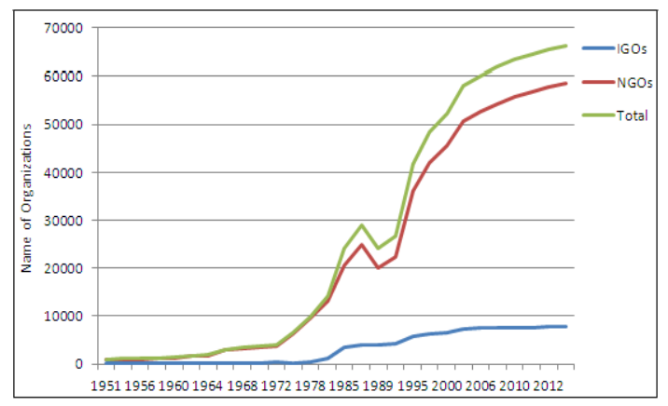

Figure 1: The Rapid Increase of Active NGOs for Launching Humanitarian Actions (Hassan, 2015)

NGOs are defined as a third sector or voluntary sector outside the government realm and is autonomously managed, that is self-governing. However, a precise, generally accepted, definition of NGO does not exist. Nevertheless, there exists several fundamental attributes that are generally agreed upon internationally as they match the UN agency’s conditions for the recognition of an NGO. Clearly, an NGO must be independent of any governmental direct control; it must also be nonprofit making and voluntary; it cannot be constituted as a political party; it cannot be a criminal group; and it has to be nonviolent. As a matter of fact, some of these conditions can blur. For example, NGOs can actually be part of a political organization explicitly or implicitly. Also, in the wake of increasing professionalization of the sector, voluntary features of NGOs are being questioned. (Raju, 2009; Willetts, 2011).

NGOs perceive themselves as entities that offer alternative visions to dominant discourses, support developmental paradigms, contribute to environmental issues, gender concerns, subaltern questions, and suchlike. By implication, according to Raju (2009) “NGOs are particularly concerned with the marginalized and the poorer sections of the community and their livelihoods, governance, and political rights”. Some urban-based NGOs may also provide to issues such as animal rights, environmental ethics, and conservation, that may at times clash with the interests of the poor. NGOs can be classified by composition, geographical location, size and organizational structure, strategy and evolutionary trajectory, and gender concern.

In Lebanon, many NGOs work to address issues the Lebanese people face since the civil war into the present day’s issues such as political and economic instability, border disputes, and human rights violations. NGOs have supported the Lebanese community through suppressing terror, advocating for human rights, encouraging gender equality, ending militarization, and recently, recovering from the Beirut explosion. These NGOs on the ground play an important role in improving Lebanon’s security and future (Strelow, 2020).

NGO employees, like other employees and employers, were forced to work remotely during the pandemic, yet, it might be more challenging to them due to the nature of their jobs as community serving workers, affecting their work and individual outcomes. Thus, this research studies the impact of telecommuting on job satisfaction among NGO employees in Lebanon. Employees participated from several NGOs, such as Norwegian Refugee Council (NRC), Relief International, Medair, Nabad for Development, Service Civil International (SCI), Danish Refugee Council (DRC), American Near East Refugee Aid (ANERA), War Child Holland, Save the Children, Medical Teams International (MTI), Solidarités International, and others.

## 1.4. Research Hypotheses

H10: There is no statistically significant correlation between telecommuting and job satisfaction during COVID-19 pandemic.

H11: Telecommuting during COVID-19 pandemic positively impacts job satisfaction.

## 1.5. Structure of the Graduate Project

This project is constituted of Five chapters.

Chapter 1 involves introducing the graduate project and providing a general insight about the topic of research which will address the impact of telecommuting, as a consequence of COVID-19 emergence, on levels of job satisfaction. It also covers the main and smaller research questions, as well as the aim and objectives of this research. An overview of the Norwegian Refugee Council as the organization of interest in which the investigation will be performed among its employees. Finally, given that this research is quantitative, the hypotheses are stated.

Chapter 2 encompasses the literature review in which a wide stream of existing research on telecommuting and job satisfaction is reviewed. After briefly reviewing the history and definition of telecommuting, its benefits and challenges are discussed. Then, the role of COVID-19 in shifting work practices from traditional to telecommuting was addressed. After giving an insight about telecommuting, job satisfaction was discussed in terms of definition, key factors impacting it, its outcomes, and measurement scales. Finally, the roles of telecommuting intensity, autonomy, work-family conflict, and social and professional isolation were discussed as factors of telecommuting that influence its outcomes, specifically job satisfaction.

Chapter 3 addresses the research methodology. It starts with defining the research philosophy and identifying the one adopted in this research. The same is applied to the research approach, research strategy, research methodological choice, time horizon, and techniques for data analysis.

Chapter 4 presents the finding and analysis in which findings are quantitively extracted from the SPSS software and presented in the form of numbers, graphs, statistics, and tables. Then these findings are analyzed using the software to support or refute the previously assumed hypotheses.

Chapter 5 consists of the conclusion and recommendations, and limitations of this research. Research questions are answered and objectives are met through which it is concluded whether the set hypotheses were validated or falsified. Limitations in the research while conducting it and testing the two hypotheses are also presented. Finally, recommendations to better enhance job satisfaction when telecommuting are suggested.

# CHAPTER 2: LITERATURE REVIEW

## 2. Literature Overview

The year 2020 brought an unprecedented outbreak, further characterized as a pandemic, of COVID-19, requiring governments worldwide to take measures such as social distancing and lockdown as ways to mitigate and reduce the spread of the virus among individuals. The health crisis eventually led to an economic crisis. As a result of such measures, and instead of completely shutting down their businesses, organizations, schools, restaurants, and many other industries had to adapt to the new situation by shifting their work to the virtual world through telecommuting. Telecommuting became the “new normal” in a very short period of time, being mandatory not optional as before, when almost the majority of businesses and employees were not prepared for implementing such a practice. As employees are considered an asset for an organization, it became important to study how they are experiencing this forced shift to telecommuting, specifically, studying their job satisfaction levels when telecommuting during the pandemic, since job satisfaction is considered a significant aspect of work yielding several beneficial outcomes such as increased performance.

In this literature review, the existing literature on telecommuting, the emergence of COVID-19, job satisfaction, and the impact of telecommuting during COVID-19 on job satisfaction were reviewed. First, telecommuting history and definition, as well as its benefits and challenges, were presented. Then, a review about the emergence of COVID-19 and the way it changed the business world and shifted work from in-office practices to telecommuting was covered. Afterwards, job satisfaction was defined, addressing its contributing factors, outcomes, and measures. Finally, research findings about the impact of telecommuting on job satisfaction, during the period of COVID-19 emergence, were presented under two titles. The first title covered the main factors influencing the relationship between telecommuting and job satisfaction, and the second one discussed the impact of telecommuting on job satisfaction, presenting literature and studies from pre- and during COVID-19.

## 2.1. Telecommuting

### **2.1.1. History and Definition**

Rather than moving workers to the work, Jack Nilles, an engineer who worked on projects for the National Aeronautics and Space Administration, had an idea to move the work to workers in order to reduce energy consumption and mitigate traffic problems. Through this idea, the term “telecommuting” was assumed to be first coined by Jack Nilles in 1973. (Allen, et al., 2015). Later on, companies realized the importance of telecommuting as decentralized work arrangements in addressing workforce issues. It was publicized as a strategy for companies to reduce real estate expenses (Bailey & Kurland, 2002) where IBM’s reports showed $75 million of savings in real estate costs related to office space as a result of telecommuting (Bakare & Gold, 2011). During the 1970’s and 1980’s, as the number of double-income households increased (Allen, et al., 2015), and as a way to fit labor needs for managing a healthy work-family balance (Gajendran & Harrison, 2007), telecommuting was touted as an option to respond to these needs. Additionally, telecommuting was adopted by companies as a way to comply with government regulations such as responding to The Clean Air Act, to reduce air pollution, and to the Americans with Disabilities Act in 1990, to raise the employment of disabled and mobility-impaired workers (Allen, et al., 2015; Bailey & Kurland, 2002). Figure 2 illustrates the historical conceptualization of telework including factors that serve to push employees out of the office and factors pulling them into the alternate workplace, usually the home.

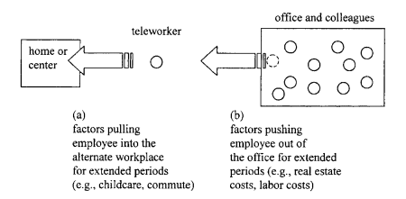

Figure 2: Historical conceptualization of telework (Bailey & Kurland, 2002)

The advances in Information and Communication Technologies (ICT) with their higher availability and accessibility, alongside the greater coverage of high-speed internet, and the companies’ need to adjust to ever changing environments and market demands (e.g., globalization, increased competition), all play crucial roles in the implementation of telework. (Wojack, et al., 2016). Telecommuting, also referred to as telework, virtual work, remote work, distance work, distributed work, and flexible work, is defined as a “work practice that involves members of an organization substituting a portion of their typical work hours (ranging from a few hours per week to nearly full-time) to work away from a central workplace—typically principally from home—using technology to interact with others as needed to conduct work tasks” by Allen et al. (2015). Table 1 provides different definitions of telecommuting alternative terms that were used in the existing literature. What all definitions had in common is that they involve working away from a central office at a remote location, and that most of them included the concept of using technology while working away from the central office to complete the work. (Allen, et al., 2015).

According to Gajendran & Harrison (2007), telecommuting is identified as an alternative work arrangement within which employees perform their tasks at a location away from their central office where they usually do these tasks, using electronic technology as a way of interaction with others inside and outside the firm. Telework can be classified by the number of working hours during a week away from the employers’ premises, including home. It is mainly classified into working from home once per week, working from home several times per week, and full-time teleworking. Telework can also be categorized by the locational flexibility indicating the place of performing work such as home office (performing tasks from home using ICT), Satellite Centre (e.g., client’s place), and street work (e.g., café) (Wojack, et al., 2016).

Allen et al. (2015), states that individuals who telecommute substitute the time usually spent in-office with time working away-rather than working additional hours away, ranging from working a few hours per week to full-time telecommuting. They are part of an organization, who mainly work from home, occasionally elsewhere, using information and communication technology.

Based on the fact that telecommuting, telework, virtual work, and remote work involve working away from a central office at a remote location using technology, they are to be used interchangeably in this paper and will be based on literature that uses them as their choice in terminology, consistent with the proposed definition of telecommuting by Allen et al. (2015) and Gajendran & Harrison (2007).

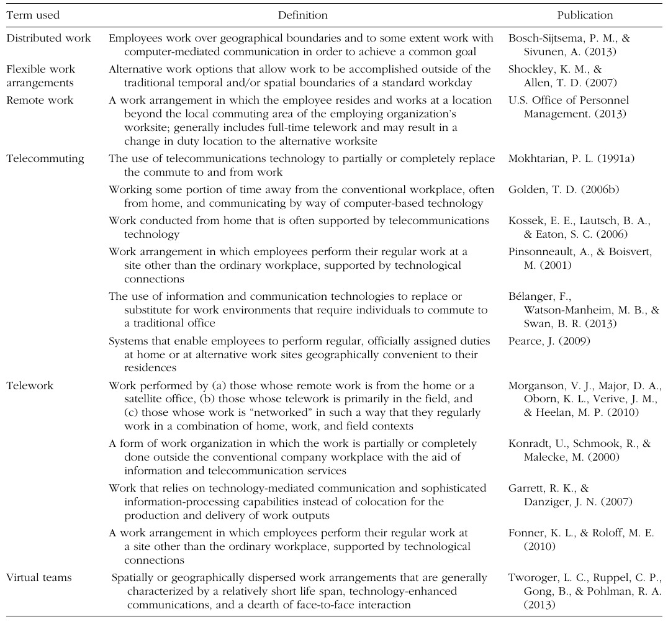

Table 1: Sample of Telecommuting Definitions Used in the Literature (Allen, et al., 2015)

Siha & Monroe (2006) developed a theoretical model for a successful telecommuting program as shown in figure 3; the model includes the main factors that the literature suggests are major precursors and outcomes of successful telecommuting initiatives. It proposes that the two important inputs encouraging organizations to consider a telecommuting strategy are government regulations and competition. It also proposes that the outcomes of a successful telecommuting program are: regulatory compliance, favorable environmental impact, productivity increases and cost reductions, and worker satisfaction as a result of flexibility and work-life balance.

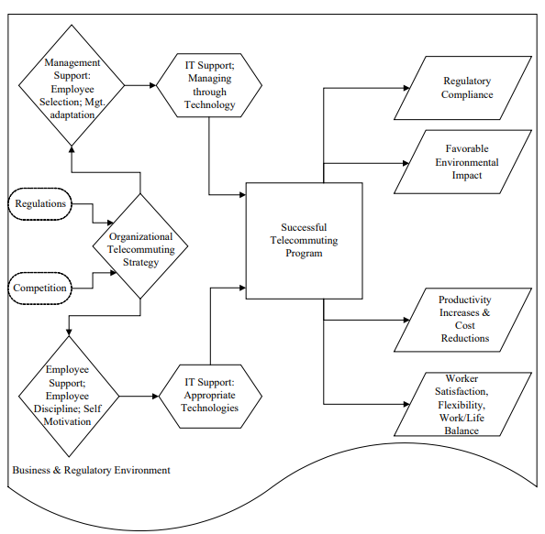

Figure 3: Telecommuting success model (Siha & Monroe, 2006)

### 

### **2.1.2. Benefits and Challenges**

1. Telecommuting Benefits

Practitioners’ and scholars have been showing significant interest in telecommuting as an increasingly popular work mode due to its flexibility and resulting benefits for both businesses and employees (Allen, et al., 2015; Raišienė, et al., 2020). Location flexibility aspect of telework, known as flexibility in the “where” of tasks, enables organizations to fit changing markets and meet labor needs (Gajendran & Harrison, 2007). For example, it allows organizations to attract and hire qualified expertise from all around the world whom will act as a competitive advantage in a fast-changing global work environment (Contreras, et al., 2020; Raišienė, et al., 2020). Moreover, it helps organizations to cut costs through saving space office and equipment, infrastructure, electricity, phone and internet bills, and cleaning and security staff costs, as well as saving employees time and costs spent on daily commuting (Diab-Bahman & Al-Enzi, 2020; Gajendran & Harrison, 2007).

In addition to the location flexibility, telework offers the advantage of schedule flexibility to suit the needs of workers, allowing them to balance work and private life and plan their work hours flexibly, where research showed that schedule flexibility is positively associated with job satisfaction, employee productivity, and low absenteeism (Allen, et al., 2015; Raišienė, et al., 2020).

According to Contreras et al. (2020), “Empirical studies have found favorable outcomes of teleworking such as job performance, job satisfaction, lesser work-family imbalance, reduced rates of stress, and lesser turnover intentions”. Similarly, Gajendran & Harrison (2007) stated that telecommuting has a clear advantage showing small yet favorable effects on autonomy, job satisfaction, performance, stress, turnover intent, and work– family conflict. However, in order for these benefits to be evident, employees need to have managerial, peer, and technological support to reduce issues arising from social isolation, alleviate work-family conflict, and minimize stress (Contreras, et al., 2020; Fana, et al., 2020).

Not only telecommuting has positive impacts on organizational and individual levels, but on a societal level too; such as having positive environmental effects, expanding work opportunities, and ensuring business continuity. On the environmental level, telecommuting has a promising role in alleviating traffic congestion and reducing air pollution. Through telecommuting, the number of individuals moving by automobile is expected to decrease, thus reducing both greenhouse emissions and pressure off transportation (Allen, et al., 2015; Giovanis, 2018). Moreover, on the level of expanding work opportunities, telecommuting increases the opportunities for disabled individuals and those having mobility impairments, environmental sensitivities, and chronic pain or fatigue to join the workforce through working from home (Allen, et al., 2015; Bakare & Gold, 2011). Finally, in the face of weather events, global pandemic outbreaks, terrorist attacks, and other emergencies that may adversely impact businesses and governments operations, telecommuting serves as one of the risk-mitigating strategies adopted by the business community to ensure business continuity during such events (Heng, et al., 2012).

1. Telecommuting Challenges

Despite the considerable benefits of telecommuting, its implementation arose new problems that teleworkers have to cope with. Most of the authors presented professional and social isolation as the most serious issue (Bailey & Kurland, 2002; Wojack, et al., 2016). Additionally, family conflict, career stagnation, and increased workload have been studied as telecommuting disadvantages (Blount, 2015; Gajendran & Harrison, 2007). Similarly, according to Raišienė et al. (2020), research showed that some of the challenges teleworkers face are the need for socialization, work-family conflicts due to lack of boundaries, and difficulties in effectively communicating and cooperating with managers and colleagues. Furthermore, some common problems arise from digital environments such as email and data overload, poor accountability and low trust and commitment in teams, and inadequate technological skills (Contreras, et al., 2020).

Working away from the workplace will definitely impose social isolation challenges on telecommuters where Allen et al. (2015) addressed that 62% of 11383 workers across 24 countries found that telecommuting is socially isolating, and 50% of them feared that telecommuting may adversely impact their chances of a promotion; and this may result in poorer performance and higher intent to leave their organizations. Telecommuters also stated that they missed the informal conversations in the organization that result in learning and sharing knowledge as well as conversations while being around friends and colleagues (Cooper & Kurland, 2002).

Although telecommuting and flexibility have been adopted as a way to help working families and improve work-family balance, it may also lead to work-family conflict. An inter-role conflict may arise where work interferes with family and family interferes with work, hindering individuals from meeting their role demands as a family member because of work demands, and on the other side from meeting their roles as employees because of home demands (Allen, et al., 2015; Contreras, et al., 2020).

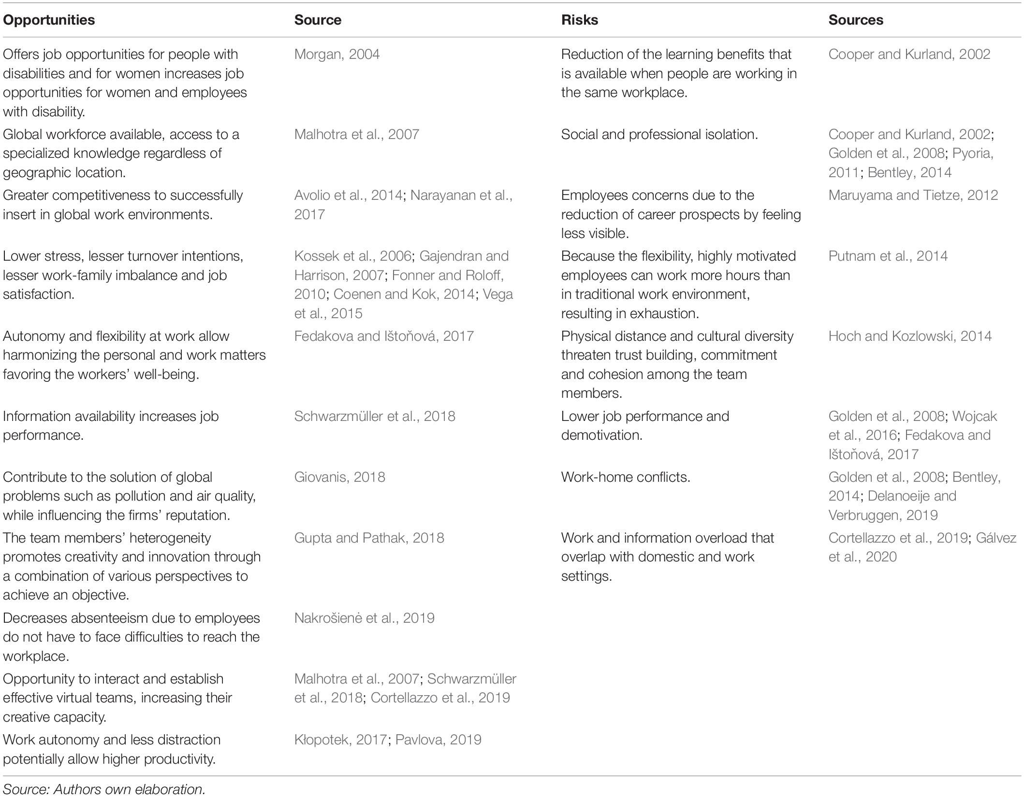These challenges may lead to adverse impacts on job satisfaction where the lack of satisfaction may cause lower performance among employees, and thus lower organizational performance (Susilo, 2020). Table 2 summarizes the main reported findings of teleworking opportunities and risks.

Table 2: Opportunities and Risks of Teleworking (Contreras, et al., 2020)

## 2.2. The Shift to Telecommuting During the Emergence of Covid-19

World Health Organization (WHO) was informed of idiopathic pneumonia cases in Wuhan City, China, on 31 December 2019. On 7 January 2020, the cause of this disease was identified by Chinese authorities as a novel coronavirus and was temporarily named “2019-nCoV”. A novel coronavirus (nCoV) is a new strain of a large family of viruses called Coronaviruses (CoV) that cause diseases ranging from the common cold to more severe ones. This new virus has not been identified in humans before, and was subsequently named the “COVID-19 virus”. The number of cases outside China increased rapidly leading the WHO Director-General to announce that the outbreak is characterized as a pandemic on 11 March 2020. By then, in 114 countries, more than 118 000 cases and 4291 deaths had been recorded (WHO, 2021). The virus has vastly spread worldwide with consistent increases in the number of confirmed cases and deaths.

In order to control and minimize the spread of COVID-19 virus, governments worldwide took certain measures to restrict the movement of populations (Richter, 2020). Governments have introduced social distancing, known as intentionally increasing the physical space between people, and lockdown as main security measures to avoid and reduce the spread of the virus and keep hospitals from the threat of being overwhelmed with COVID-19 cases. As a result, workplaces, schools, social venues like restaurants, public transportation, and tourist attractions had to close (Contreras, et al., 2020; Richter, 2020; Vyas & Butakhieo, 2021). Consequently, COVID-19 was not only considered a global health crisis, but also an international economic threat generating a wide range of challenges for employers and employees (Kniffin, et al., 2021).

Traditionally, the emergence of teleworking was different across countries, even within the same sector, and across occupations within the same country. Teleworking has been more common in higher-paid workers; for example, more than 75% of employees working from home had an earning above $65,000 per year. It was also more common in highly skilled and white-collar workers where over 40% of teleworkers were executives, managers, or professionals (Belzunegui-Eraso & Erro-Garcés, 2020; Fana, et al., 2020; Wang, et al., 2020). However, telework was also shown to be technically feasible for many low and mid-skilled clerical and administrative workers who recently started teleworking during the COVID-19 pandemic after previously having limited access to telework (Fana, et al., 2020).

The unprecedented pandemic of COVID-19 virus forced millions of people worldwide to shift from in-office work to remote and online work making remote work the new normal in a short period of time. Prior to the pandemic, most workers had little or no experience in remote working with only 2.9% of the U.S. workforce working remotely in 2017 (Wang, et al., 2020). However, during the pandemic, studies showed that the percentage of the workforce working from home in the U.S. increased from 8.2% in February 2020 to 35.2% in May (Vyas & Butakhieo, 2021).

The press extensively discussed the challenges of teleworking during the lockdown; business consultants were giving advices on ways to collaborate and organize work, human resources consultants were providing recommendations on maintaining the productivity of employees, and psychologists were debating on managing work-life balance and wellbeing while working from home (Raišienė, et al., 2020). Telework during the COVID-19 pandemic conveys both benefits and challenges. For instance, Baert et al. (2020) expected that the economic crisis following the health crisis imposed negative effects, such as declining economic growth, disintegrating supply chains and worsening employment prospects. However, opportunities may also arise, such as enabling the emergence of a greener economy and promoting a growth in online communication and its supporting technologies, suggesting that COVID-19 could lead to a breakthrough in telework.

In an extraordinary pandemic context, the scientific literature covering remote work may be interrogated. A key difference is that remote work was previously often responsive and optional, but COVID-19 forced many organizations and people to work remotely through ways they were unfamiliar with, during a period of psychological tension, while none is prepared for supporting such a practice, and sometimes it’s even unsuitable for the jobs performed (Kniffin, et al., 2021; Toscano & Zappalà, 2020; Wang, et al., 2020). Therefore, the benefits of telecommuting previously investigated might only, or especially, be valid for those who are frequently and optionally engaging in telecommuting, unlike those who are forced to do so during the pandemic (Wang, et al., 2020). For example, studies previously suggested that working from home can be beneficial for certain workers such as improving job satisfaction, work-life balance and wellbeing; however, this may not be fully applicable to the current conditions of telework. Since April 2020, many of the workers who started teleworking did so for the first time, and on a full-time basis, facing challenges in adapting to the newly practiced work mode, especially for workers in small and medium-sized firms that lack the knowledge and financial resources to fund greater investments in technologies supporting telecommuting (Fana, et al., 2020). Moreover, the shift to distance learning after the closure of schools created a burden on most working parents to support their children during their work hours and share the home office with their partners when lacking a private work room, and some lacked adequate digital devices or internet connection (Fana, et al., 2020; Richter, 2020).

## 2.3. Job Satisfaction

### **2.3.1. Definition**

A job represents an essential aspect of an individual’s life which provides him/her with the financial basis for life and achieves career-related personal goals; and satisfaction is defined as the fulfillment of one’s desires (Ali, 2016). Job satisfaction is defined differently among many authors and researchers. For example, one of the most initial and most cited definitions for job satisfaction is that of Hoppack in 1935: “any combination of psychological, physiological, and environmental circumstances that causes a person truthfully to say, I am satisfied with my job” (Agbozo, et al., 2017). Locke in 1976 defined job satisfaction as "a pleasurable or positive emotional state resulting from the appraisal of one’s job or job experiences" (Ali, 2016). According to Robbins & Judge (2017), job satisfaction is “a positive feeling about a job, resulting from assessing and evaluating its characteristics”; they state that an individual who holds positive feelings towards their work experiences high job satisfaction, and in contrast, an individual who holds negative feelings towards work experience low levels of satisfaction. Cranny ad colleagues, as cited by Rafferty & Griffin (2008), state that “there is general agreement that job satisfaction is an affective (that is, emotional) reaction to a job that results from the incumbent’s comparison of actual outcomes with those that are desired (expected, deserved, and so on)”. In general, most definition by authors agree on the affective feeling an employee holds towards his/her job. It could be the feelings and attitudes towards the job in general or towards specific features of the job such as the salary, working conditions, or colleagues (Agbozo, et al., 2017). Job satisfaction includes the evaluation of one’s own job, their beliefs about it, and their emotional experiences towards it (Rafferty & Griffin, 2008).

### **2.3.2. Key Factors**

Personal factors, along with group and organizational factors such as individuals’ needs and goals, their relationships with their coworkers and supervisors, and working conditions, policies, and compensation determine the job satisfaction attitude. However, although many external factors influence job satisfaction, it remains an internal affective feeling of an employee towards the job (Murad, et al., 2013). According to Robbins and Judge (2017), there are some characteristics that are likely to influence job satisfaction such as job conditions (intrinsic nature of the job itself, social interactions, and supervision), personality (positive versus negative core self-evaluation), pay (motivates people yet not necessarily make them happy), and corporate social responsibility (organization’s self-regulated actions that benefit society and the environment beyond law requirements). The Job Characteristics Model proposes that certain characteristics of a job such as task identity, task significance, skill variety, autonomy, and feedback were important factors of job satisfaction (Wallin, et al., 2013). Herzberg’s two-factor theory, also referred to as motivation-hygiene theory, suggests that there are intrinsic factors (motivators) related to job satisfaction and extrinsic factors (hygiene factors) related to job dissatisfaction. Herzberg proposed that the good feelings people had towards their jobs came from intrinsic factors related to the job itself such as achievement, responsibility, and advancement. However, when people were dissatisfied with their jobs, extrinsic factors arising from the job context were the reason, such as interpersonal relationships, company policy, salary, and personal life (Robbins, et al., 2011). Herzberg’s two-factor theory is represented in figure 4.

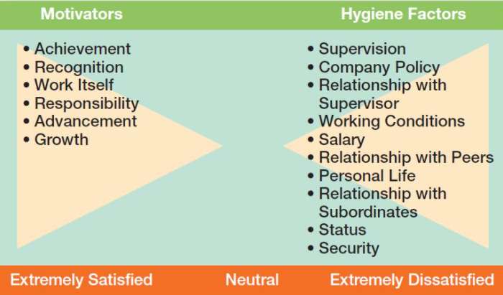

Figure 4: Herzberg’s Two-Factor Theory (Robbins, et al., 2011)

### **2.3.3. Outcomes**

Job satisfaction is one of the main factors that affect business organizations’ efficiency and effectiveness (Aziri, 2011). It is generally supposed to be directly linked to productivity and personal well-being (Murad, et al., 2013). Additionally, it has a great impact on an employee’s commitment to the firm, absenteeism, load of work performed, tardiness rate, and occupational accidents and complaints about the job (Paşaoğlu & Tonus, 2014). A satisfied employee is considered an asset for the organization as job satisfaction results in positive behaviors such as loyalty, commitment, hardworking and thus improved productivity and performance (Aziri, 2011; Murad, et al., 2013). Moreover, as evidenced by a review of 300 studies, the correlation between job satisfaction and improved job performance was found to be quite robust. Organizational citizenship behavior, customer satisfaction, and life satisfaction were also outcomes of job satisfaction (Robbins & Judge, 2017). On the other hand, a dissatisfied employee expresses dissatisfaction in negative behaviors such as absenteeism, tardiness, lack of loyalty, and increased increase number of accidents (Murad, et al., 2013; Paşaoğlu & Tonus, 2014). Robbins & Judge used the exit-voice-loyalty-neglect framework as a theoretical model to understand the impact of job dissatisfaction as shown in figure 5. They explain that dissatisfaction is expressed through exit (leaving the organization), voice (constructive attempts to improve conditions), loyalty (waiting for conditions to improve, and neglect (allowing conditions to worsen).

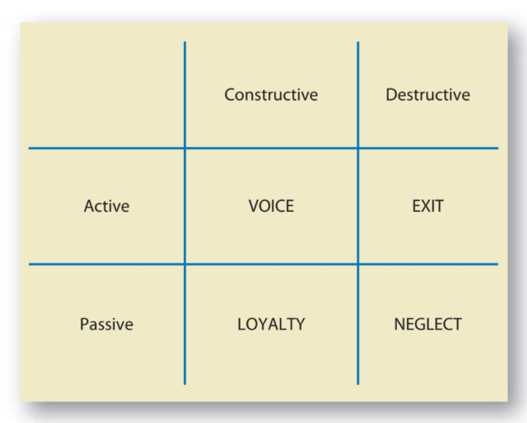

Figure 5: Responses to Dissatisfaction (Robbins & Judge, 2017)

### **2.3.4. Measurements**

There are two popular approaches to measure job satisfaction; the single global rating and the summation of job facets. The single global rating includes a response to one question which may be: “all things considered, how satisfied are you with your job?”. Respondents then answer by circling a number from 1 to 5 on a scale from “highly satisfied” to “highly dissatisfied”. However, the summation of job facets is more complex in which it identifies key element of the job such as supervision, relationship with coworkers, type of work, pay, and promotion opportunities. While the single global rating is a fast method, the summation of job facets helps managers identify and deal with problems faster and more accurately. (Robbins & Judge, 2017).

When assessing job satisfaction, different techniques have been adopted. The most common adopted approach involves the use of questionnaires in which a variety was developed over the last 70 years (Rafferty & Griffin, 2008). Likert scale is considered the most common data collection method when measuring job satisfaction. Other less commonly used methods include yes/no questions, true/false questions, checklists, and forced choice answers (Mishra, 2013).

Many scholars and authorities provided several types of job satisfaction measures (Ali, 2016). Two of the well-validated and most commonly used measures are the Job Descriptive Index (JDI) and the Minnesota Satisfaction Questionnaire (MSQ) (Rafferty & Griffin, 2008). Other commonly used measures include Michigan Organizational Assessment Questionnaire (MOA) and Brayfield and Rothe’s Overall Job Satisfaction Measure (Rafferty & Griffin, 2008). Additional used measures include Job in General Index, Kunin’s Faces Scale, and Job Satisfaction Survey (Ali, 2016; Rafferty & Griffin, 2008).

1. Job Descriptive Index (JDI)

JDI has probably been one of the most popular facet measure of job satisfaction. The original scale included 72 items that measured 5 major job satisfaction facets including work itself, pay, promotion opportunities, supervision, and coworkers (Ali, 2016; Rafferty & Griffin, 2008). It is a simple scale where participants answer by yes, no, or can’t decide (Mishra, 2013). As cited by Rafferty & Griffin (2008), Roznokwski made a number of modifications to the JDI measure after assessing it where the changes were done to manage issues such as changes in technology. Roznowski, along with other researchers, supported JDI’s reliability.

1. Minnesota Satisfaction Questionnaire (MSQ)

MSQ contains two forms, a long one and a short one. The long form consists of 100 items that measure 20 facets such as individuals’ satisfaction with achievement, advancement, and moral values. The short form consists of 20 items, 12 of which assess intrinsic satisfaction such as one’s opportunities to use abilities on job, and 8 of which assess extrinsic satisfaction such as promotion opportunities and pay. The short form has been found to be of good reliability. (Rafferty & Griffin, 2008).

1. Michigan Organizational Assessment Questionnaire (MOA)

MOA is a simple and short measure of overall job satisfaction demonstrating adequate reliability. It consists of three items, one of which is “all in all, I am satisfied with my job”. (Ali, 2016; Rafferty & Griffin, 2008).

1. Brayfield and Rothe’s Overall Job Satisfaction Measure

This is also an adequately reliable job satisfaction measure that consists of 18 items. However, several researchers have adopted a version consisting of 6 items of this measure. (Rafferty & Griffin, 2008).

1. Job in General Index

Job in General Index is a measurement of overall job satisfaction consisting of 18 items. It is considered as an improvement to JDI that focuses more on individual facets and less on job satisfaction in general (Ali, 2016; Mishra, 2013).

1. Kunin’s Faces Scale

Faces scale was developed by Kunin after he observed that attitude surveys translate individual feelings another’s words, resulting in distortion of meaning. It is a measurement of overall satisfaction consisting of one item to be answered by choosing the face expression that best describes one’s feelings towards the job. (Aziri, 2011; Mishra, 2013; Rafferty & Griffin, 2008).

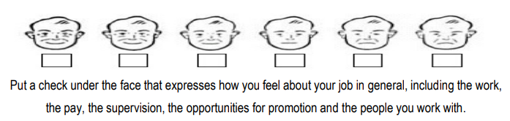

Figure 6: Kunin’s Faces Scale (Aziri, 2011)

1. Job Satisfaction Survey (JSS)

JSS assesses 9 facets of job satisfaction and overall job satisfaction with 36 items, 4 items for each facet (Mishra, 2013).

### 

## 2.4. Telecommuting and Job Satisfaction During COVID-19

### **2.4.1. Factors Affecting Telecommuting Job Satisfaction**

The way through which individuals perform their work activities may impact the effectiveness of telecommuting; where a number of work characteristics acting as moderators and mediators between telecommuting and employee outcomes shape the perceived nature of work, and thus affect telecommuting outcomes (Allen, et al., 2015; Wang, et al., 2020). In their meta-analytical research of 46 studies, Gajendran & Harrison (2007) developed a theoretical framework of the major mediating factors and individual outcomes of telecommuting as illustrated in figure 7.

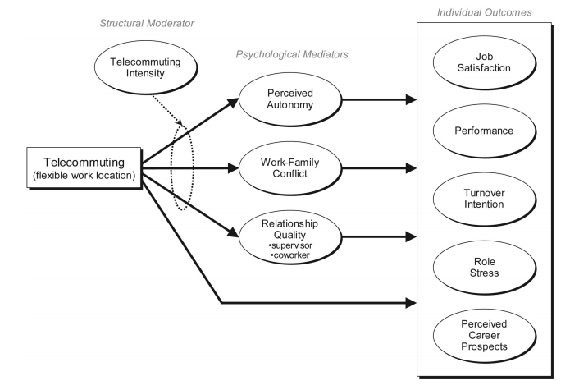

Figure 7: Theoretical framework for the consequences of telecommuting (Gajendran & Harrison, 2007)

1. Telecommuting Intensity

According to Gajendran & Harrison (2007), telecommuting intensity is defined as the “extent or amount of scheduled time that employees spend doing tasks away from a central work location”. It has been also referred to as virtual status, virtuality, home-centered versus office-centered telework (Gajendran & Harrison, 2007), frequency (Allen, et al., 2015), and as extent of telecommuting (Golden & Veiga, 2005). Until relatively recently, more research started to investigate the impact of individual telecommuting intensity on work outcomes. High-intensity telecommuters are those who spend almost all, or the majority, of their workdays away from a central workplace, while low-intensity telecommuters are those who telecommute for only 1 or 2 days per week spending the majority of their workdays in a central workplace (Gajendran & Harrison, 2007). The extent of individuals’ telecommuting frequency is likely to create major differences in individual outcomes of telecommuting, where employees who telecommute extensively are likely to have different experiences than those who do it infrequently, which likely affects the outcomes of this practice; for example, high-intensity telecommuting was positively associated with organizational commitment and negatively associated with intent to leave the organization (Allen, et al., 2015).

Golden & Veiga (2005) demonstrated a curvilinear relationship between the extent of telecommuting and job satisfaction as shown in figure 8 suggesting that this relationship is more complex than previously thought, and doubting the theory that claims this relationship is linear- as the extent of telecommuting increases satisfaction increases, regardless of the nature of their jobs. Their study stated that initially, as the extent of telecommuting rises, job satisfaction increases; yet, at higher levels of telecommuting, it begins to decrease slightly, and eventually plateaus. These results suggest that the benefits of additional increases in job satisfaction are not reported beyond a certain threshold in the extent of telecommuting. Similarly, Allen et al. (2015) concluded that “job satisfaction is highest among individuals who telecommute a moderate amount compared to those who telecommute either a small amount or more extensively”. Additionally, research suggests that the relationships between telecommuters and their supervisors, coworkers, and family are impacted as telecommuting intensity changes. For instance, higher intensity telecommuting has been shown to improve telecommuters’ relationship with supervisors, decrease their relationship quality with their coworkers, and gradually lower work-family conflict; eventually increasing job satisfaction.

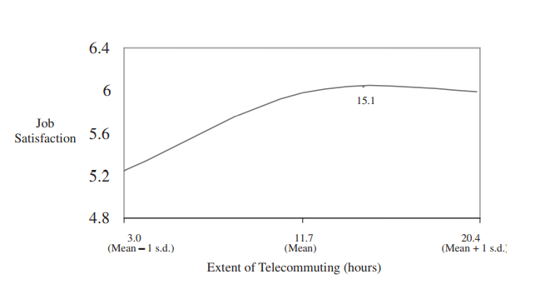

Figure 8: Extent of Telecommuting and Job Satisfaction (Golden & Veiga, 2005)

1. Autonomy

Teleworking offers the benefit of providing greater autonomy as for when and how workers will carry out their tasks (Golden, 2006; Susilo, 2020) compared to non-teleworkers, through allowing them to choose the location, scheduling, and way of completing their jobs to a certain extent (Gajendran & Harrison, 2007). In Allen et al. (2015) words, autonomy “reflects the extent to which a job allows the freedom, independence, and discretion to make decisions and to choose the method by which job-related tasks should be completed”, and specifically, perceived autonomy reflects employees’ own personal assessments of their level of autonomy (Gajendran & Harrison, 2007). Spatial and psychological distance from direct supervision along with the increased flexibility in choosing the time and way of performing the tasks, enhances employees’ perceived autonomy (Gajendran & Harrison, 2007). This is turn increases employee satisfaction and enhanced well-being, and thus increased productivity (Blount, 2015; Diab-Bahman & Al-Enzi, 2020).

Based on the theory that telecommuting increases perceived autonomy, and that increased perceived autonomy in turn drives positive telecommuting outcomes, autonomy has been researched as a mediating factor in the relationship between telecommuting and its outcomes, such as job satisfaction. Higher levels of autonomy enable telecommuters to report greater job satisfaction compared to those with lower levels of autonomy, indicating that the amount of autonomy in the job influences telecommuting outcomes and its degree of benefit (Allen, et al., 2015). Autonomy fully mediated the impact of telecommuting on job satisfaction, while partially mediating its impact on supervisor-rated performance, turnover intent, and role stress (Gajendran & Harrison, 2007). Additionally, Golden & Veiga (2005) explained that telecommuters will experience increased job satisfaction when having high discretion levels compared to those with low discretion, when both telecommuting less extensively. Similarly, at more extensive levels of telecommuting, job satisfaction will decrease at a higher rate for those with low discretion since they are more likely to experience increased frustration as they are continually seeking clarification and approval with less face-to-face interaction.

In the early months of COVID-19, family and work demands interfered greatly with work being more fragmented and intermittent throughout the day. However, the autonomy and flexibility offered by telecommuting to employees working from home made them highly appreciate it during disasters and pandemics (Oz & Crooks, 2020).

1. Work-Family Conflict

A highly debated consequence of telecommuting is the work-family conflict. Although telecommuting has been touted to as a means to balance work and family needs (Allen, et al., 2015; Bailey & Kurland, 2002; Ng, 2006), it removes the protective barrier between work and home creating blurred boundaries (e.g. physical, time, mental, emotional, behavioral, or relational boundaries) where demands from one domain can permeate to the other, leading to conflict (Baruch & Nicholson, 1997; Gajendran & Harrison, 2007; Olson-Buchanan & Boswell, 2006). Greenhaus & Beutell (1985) offer a definition of work-family conflict as “a form of inter-role conflict in which the role pressures from the work and family domains are mutually incompatible in some respect.” Specifically, inter-role conflict may arise when work interferes with family (WIF) and family interferes with work (FIW) such that compliance with one role would make it more difficult to comply with the other, (Allen, et al., 2015; Greenhaus & Beutell, 1985). The location flexibility offered by telecommuting erases the physical separation between work and home, allowing workers to more readily transition between work and family roles and to meet their own needs and demands of work and family (Golden & Veiga, 2005). The schedule flexibility associated with teleworking permits workers to schedule their work optimally and better conduct their work activities at times that suit them, thus reducing or preventing work’s interruption on the family and vice versa (Gajendran & Harrison, 2007; Golden & Veiga, 2005). In addition, Susilo (2020) reported the benefit of telework on work-family conflict through the workers’ ability to be with their families while working, which is mostly appreciated by busy workers who reside in the capital city. On the other hand, physical and temporal flexibility may lead to distractions and inter-role conflict; the availability and connectivity to information and communication technology tools enable individuals to be in constant connection with work, creating the demand to work above normal working hours and blurring the time-based boundaries between home and work (Allen, et al., 2015; Gajendran & Harrison, 2007). Moreover, Allen et al. (2015) states that working from home may increase the amount of family responsibilities, thus increase the chances for family interfering with work to occur.

In their research, Gajendran & Harrison (2007) found that among employees who had experience in telecommuting for over a year, it was associated with a more beneficial relationship with work-family conflict compared to those with an experience of less than a year, signifying that superior experience enables individuals to better take advantage of telecommuting. However, before the COVID-19 pandemic, most workers had little experience in telework (Wang, et al., 2020). The situation suddenly mandated workers worldwide to shift to a full-time telecommuting practice, rather than the voluntary and part-time practice prior the pandemic, creating additional significant challenges; one of the most significant challenges during the pandemic is the work-life conflict experienced by workers all over the world (ILO, 2020). The shift to distance learning after the closure of schools created a burden on most working parents to support their children during their work hours and share the home office with their partners when lacking a private work room, and some lacked adequate digital devices or internet connection (Fana, et al., 2020; Richter, 2020) increasing work-family conflict. As discussed earlier, maintaining boundaries between work and family has been a major challenge to telework, however, it is even more difficult to maintain during COVID-19 situation. Working from home offers employees a safe harbor from the virus, but the absence of separation between work and home creates a burden too (Kniffin, et al., 2021). According to ILO (2020), a recent survey showed that 22 per cent of individuals living with young children under 12 years had difficulties in concentrating on their jobs all, or most of the time, with only 5 per cent of households having no children and 7 per cent having older children aged 12–17 reported this issue. It was yet more stressful for single parents or parents whose children suffer from a disability or learning difficulty.

1. Social and Professional Isolation

Since interpersonal relationships and processes are vital aspects of organizational life, profound challenges are represented by telecommuting on social and professional isolation and relationships with supervisors and coworkers due to the disruption of social proximity (Allen, et al., 2015). And these challenges may affect job satisfaction when telecommuting.

Orhan et al. (2016) noted that “while increased face-to-face interactions promote individuals’ sense of social belongingness, lack of social support is associated with feelings of loneliness and perceptions of isolation”. Telecommuters experience isolation professionally and socially. Professional isolation manifests itself when employees fear that their promotion and organizational rewards opportunities are limited due to being away from workplace and out-of-sight; besides, social isolation manifests itself when employees lack access to social networks in the workplace such as friendship relationships, stating that they miss the informal interactions and learning they had with their colleagues and friends (Cooper & Kurland, 2002; Orhan, et al., 2016). Bailey & Kurland (2002) argue that social and professional isolation adversely impacts employees by becoming invisible at the workplace, missing out on office gossip, being forgotten in the distribution of more formally constructed information, and receiving poor evaluations. Over time, they become dissatisfied. Previous studies have shown that social isolation have deleterious effects on health and performance (Toscano & Zappalà, 2020) as well as on intent to leave one’s organization (Allen, et al., 2015) and on teleworkers organizational identification (Diab-Bahman & Al-Enzi, 2020). Technology cannot replace the experience of working onsite regardless of its availability, as it is supposed that media-rich technologies such as video have social and technological constraints (Golden & Veiga, 2005).

Moving from a conventional workplace to telecommuting is likely to change the frequency, quality, and mode of interaction with other members in the organization; it also makes immediate feedback and affective signals more challenging to send and receive due to the lack of face-to-face interactions. Thus, Gajendran & Harrison (2007) predicted a negative relationship between telecommuters and supervisors, however, their study proved the opposite, reporting a positive relationship between telecommuting and supervisor relationship quality regardless of telecommuting intensity condition. Allen et al. (2015) suggested that the reason behind this result is the possibility that “supervisors are more likely to grant telecommuting arrangements to employees with whom they have a high-quality relationship”. A negative influence on relationships with coworkers was detected at an extensive level of telecommuting when teleworkers spent the majority of time away from the principal workplace, however, under low intensity, telecommuting did not have an impact on relationship with coworkers (Allen, et al., 2015; Gajendran & Harrison, 2007).

It is evident that telecommuters experience social isolation, however, during COVID-19 lockdown, they experienced social isolation to the extreme point (Toscano & Zappalà, 2020). Several studies examined the relationship between social isolation and job satisfaction in telework. A study on 28 companies in New Zealand in a sample of 804 teleworkers confirmed the negative influence of social isolation on job satisfaction which was stronger on those who teleworked for eight or more hours a week than for those who teleworked for only up to seven hours a week (Toscano & Zappalà, 2020). Similarly, Golden and Veiga (2005) suggested that extensive telecommuting results in little opportunity for teleworkers to participate in informal and face-to-face interactions onsite for honest exchange of feelings, hindering employees from satisfying both individual and organizational needs; thus, at relatively extensive levels of telecommuting, a greater risk of frustration and isolation experienced by teleworkers exists, with a greater negative influence on job satisfaction. Another study by Orhan et al. (2016) on team virtuality found that social and physical isolation negatively influence job satisfaction. Moreover, in a sample of 265 Italian remote workers, Toscano & Zappalà (2020) found that social isolation is negatively associated with remote work satisfaction. Not only that, but since the study was done in April and May 2020, during COVID-19 pandemic, they also found that concern about COVID-19 moderated this relatioship suggesting that this negative association is stronger in employees more concerned about COVID-19 than in those less concerned.

### **2.4.2. Impact of Telecommuting on Job Satisfaction**

The most often cited benefit of telecommuting is increased job satisfaction (Golden & Veiga, 2005) as it has received the most empirical attention when studying the relationship between telecommuting and employee attitudes (Allen, et al., 2015). Researchers have argued that telecommuting provides employees with the choice to work away from a central location, reduces costs of working, decreases stress and provides more control over interactions with others due to the absence of managers and coworkers’ interruptions, and enables employees to better meet nonwork family-related responsibilities, such that the likelihood of work-family conflict is reduced, and as a result, increase job satisfaction (Gajendran & Harrison, 2007; Golden & Veiga, 2005). On the other hand, researchers have also argued that decreased social interactions with supervisors and coworkers along with increased feelings of isolation associated with telecommuting adversely impact job satisfaction (Golden & Veiga, 2005; Virick, et al., 2010). Moreover, lack of professional support, hindered career advancement, and inter-role conflicts negatively impact job satisfaction (Virick, et al., 2010). Therefore, the current literature on the impact of telecommuting on job satisfaction is still unclear with both positive and negative impact reported (Bailey & Kurland, 2002).

In their meta-analysis, Gajendran & Harrison (2007) found a positive correlation between telecommuting and job satisfaction. Their finding was consistent with the argument that telecommuting positively impacts job satisfaction, mainly because it enables individuals to better adjust work tasks to meet personal needs and family-related responsibilities (Virick, et al., 2010). However, research suggests that different frequencies of telecommuting relate differently to job satisfaction (Allen, et al., 2015). In addition to Golden & Veiga (2005), Virick et al. (2010) proved a curvilinear relationship between the extent of telecommuting and job satisfaction such that at lower levels of telecommuting, a positive relationship is reported, however, at higher levels of telecommuting, satisfaction plateaus. This may be explained by the ability of workers to earn the benefits of social interaction when spending more time in office and thus satisfying individual and organizational needs (Virick, et al., 2010) and the social and professional isolation at higher intensity of telecommuting that may offset the gains in job satisfaction (Allen, et al., 2015).

Previously, research on working from home focused primarily on people who chose to work from home, however, when it’s mandatory, it’s quite different (Kniffin, et al., 2021). During COVID-19 lockdown, workers all around the world experienced social isolation to the extreme point (Toscano & Zappalà, 2020) as governments implemented social distancing and lockdown measures to reduce the spread of the virus (Richter, 2020), and in a short period of time, telecommuting became the new normal (Wang, et al., 2020). Working from home during COVID-19 pandemic may decrease workers’ fear of being infected, enable them to spend time with family members which may decrease their perception of loneliness and depression, and protect them from continuous exposure to conversations with coworkers about the pandemic, therefore alleviate the effects of isolation on remote work satisfaction. However, from another point of view, the lack of social interaction and support from colleagues in individuals already suffering from the health situation concerned about COVID-19 may strengthen the adverse effects of social isolation on remote work satisfaction (Toscano & Zappalà, 2020).

Susilo (2020) found a significantly positive impact of working from home on job satisfaction after analyzing 316 responses from workers in Indonesia during COVID-19 pandemic. Similarly, a study by Baert et al. (2020) on 2,673 teleworkers during the pandemic showed that almost two thirds (65.7%) of participants experienced increased levels of job satisfaction with telework. Additionally, 64.6% of the participants reported that telework improves their work-life balance, with women reporting a smaller negative impact of telework on potential work-family conflicts than men, explained by the ability of women to better combine home and family responsibilities with job-related responsibilities when teleworking. However, it also showed that participants with children were less satisfied with the extended telework due to the COVID-19 crisis that forced schools to close and children to stay at home, while their parents are teleworking, making the situation more challenging as teleworkers now need to work and take care of their children at the same time.

A study by Fana et al. (2020) found that workers who suffered the most in the shift to telecommuting during COVID-19 were those whose social interactions are at the core of their occupation. They all stressed a sense of frustration due to the lack of face-to-face interactions with interviewed teachers feeling these negative emotions the most, and experiencing decreased levels of job satisfaction due to less interaction and poorer knowledge transfer. In the same study, other workers, mostly high-skilled professionals, also stated decreased levels of job satisfaction since they started teleworking. The deterioration of social interactions and professional recognition were the main reasons behind such a decrease in job satisfaction. They claimed that receiving meaningful feedback, and seeking information, opinions and guidance from their colleagues and supervisors were more difficult to attain when telecommuting. Some workers felt “invisible”, others missed informal and social interactions with their colleagues, which is a possibly intensified feeling due to living alone during the lockdown. Finally, workers who are most satisfied and prefer working from home more frequently were those who slightly rely on feedback and face-to-face interactions, and have little tasks interdependence (Fana, et al., 2020). Another study by Raišienė et al. (2020) reported that younger and middle-aged employees, who can combine telework with work in the office and have sufficient professional and pre-COVID-19 telework experience were more satisfied with telework, conversely, older generations working virtually three or more days a week, and especially those who shifted to full time telework during the lockdown, were less satisfied with telework.

## 2.5 Literature Review Summary

The impact of telecommuting on job satisfaction was extensively studied by researchers and authors. In general, before COVID-19 pandemic, studies found a positive correlation between telecommuting and job satisfaction. However, the stream of literature covering this topic is conflicting as there are several factors that were found to impact this relationship either positively or negatively; including telecommuting intensity, autonomy, work-family conflict, and social isolation, as well as relationships with coworkers and supervisors.

Some studies revealed a curvilinear relationship between telecommuting intensity and job satisfaction, where job satisfaction increases to a threshold and plateaus after a higher intensity of telecommuting.

Autonomy was shown to mediate the relationship between telecommuting and job satisfaction as the higher autonomy associated with telecommuting results in higher satisfaction.

Work-family conflict has been a highly debated consequence of telecommuting influencing job satisfaction. On one hand it meets employees needs of both work and family, and on the other hand it removes the protective barrier between the two worlds creating an inter-role conflict.

Finally, social isolation was reported to be the major challenge of telecommuting, as all reviewed studies agreed that social isolation due to telecommuting is negatively associated with job satisfaction. During the pandemic, studies mostly stressed about social isolation as a factor influencing the association between telecommuting and job satisfaction, as social isolation was forced, and practiced to the extreme point.

The most satisfied teleworkers were younger in age, could combine telework with work in the office, had experience in telework before the pandemic, and those who slightly rely on social interactions. Conversely, workers who relied most on social interactions in their work, and those who had little experience telecommuting before the pandemic yet practicing it more extensively now, were less satisfied. As a conclusion, job satisfaction with telecommuting depends on several factors to be studied to properly draw a comprehensive result.

# Chapter 3: Research Methodology

## 3.1. Research Philosophy

Choosing the appropriate research philosophy is considered the first step in constructing a research methodology to answer its questions, representing the external layer of the research ‘onion’ demonstrated in figure 9. The development of knowledge, in a particular field of interest, based on a system of beliefs and assumptions is known as the research philosophy (Saunders, et al., 2015). In business and management, five major philosophies exist: positivism, critical realism, interpretivism, postmodernism, and pragmatism.

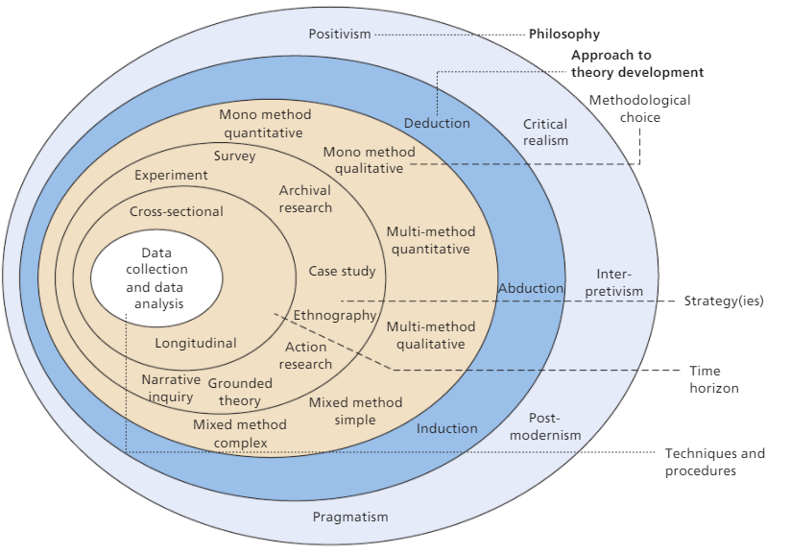

Figure 9: The Research ‘Onion’ (Saunders, et al., 2015)

Positivism relates to producing law-like generalizations based on working with an observable social reality. The positivist yields pure data and facts that are free from human interpretation or bias by focusing on a scientific method of research; thus, promising to give accurate and clear knowledge (Muhaise, et al., 2020).

In contrast to direct realism, which states that what humans’ experiences through their senses depicts the world accurately, critical realism philosophy explains humans’ observations and experienced sensations in terms of the underlying reality structures that shape these events. The critical realist views reality as external, independent, and the most important philosophical consideration, claiming that sensations and experiences alone are not enough to understand the world; yet, a mental processing, known as ‘retroduction’, is an essential second step. (Saunders, et al., 2015).

Interpretivism philosophy considers humans as different from physical phenomena assuming that human beings cannot be explored in the same way as physical phenomena. It emphasizes that different social realities develop among humans having different cultures and circumstances at different times, assuming that reality is subjective and can differ among different individuals, and thus aims to gain richer insights into humanity rather than building generalized, universal laws (Alharahsheh & Pius, 2020).

Postmodernism focuses on the function of language and power relations and intends to doubt dominantly accepted ways of thinking and give voice to the oppressed views and interpretations (Saunders, et al., 2015).

Pragmatism emphasizes that only concepts that support action are relevant. It attempts to reunite objectivism and subjectivism, facts and values, accurate knowledge and different experiences, by considering theories, ideas, concepts, hypotheses, and findings in terms of their roles as instruments of thoughts and actions; and in terms of their practical consequences (Muhaise, et al., 2020).

To obtain generalized and accurate knowledge about job satisfaction among employees, during COVID-19, as an effect of shifting to telecommuting, the positivism philosophy is chosen. In this philosophy, the researcher usually uses an existing theory in literature and develops a hypothesis, then tests it to confirm or refute it, while remaining objective and detached from the research; and this is what will be done in this research. We aim to collect measurable and quantifiable data through online questionnaires to test the hypothesis that telecommuting increases job satisfaction while being independent and external to the process of data collection and analysis.

**3.2. Research Approach**

Three main approaches to theory development are distinguished by Saunders et al. (2015); deductive approach, inductive approach, and abductive approach, representing the second layer of the research ‘onion’, that is, the second step of choice.

In a deductive approach, the researcher starts with an existing theory after reviewing the academic literature, then rises a question or hypothesis and aims to collect data in order to test the hypothesis, either confirming or rejecting it. In this approach, reasoning moves from a general theory to a specific law-like theory (Melnikovas, 2018).

Conversely, in an inductive approach, the researcher starts with an observation and collecting data to explore a phenomenon, then moves to description and analysis, in order to build or generate a theory. This means that an inductive approach starts with a specific observation through which a general rule is formulated (Melnikovas, 2018; Saunders, et al., 2015).

An abductive approach is a combination of both inductive and deductive approaches. The researcher starts by collecting data to explore a phenomenon, in order to build a new, or modify an existing, theory that is subsequently subjected to testing through further data collection, and is either verified or falsified (Saunders, et al., 2015).

As it is necessary to match the research philosophy and the research approach (Al-Ababneh, 2020), and since this research follows the positivism philosophy, the deductive approach was chosen as it relates more to this philosophy. This research started with reviewing the academic literature on an existing theory, that is the impact of telecommuting on job satisfaction, where we further created hypotheses to test the relationship between variables of telecommuting and job satisfaction to further validate or falsify the existing theories. Hence, this explains the use of a deductive approach.

**3.3. Research Strategy** **(Data Collection Method)**

A strategy is defined as a plan of action to reach a certain goal. Hence, a research strategy can be defined as a researcher’s plan that guides him/her to the way of answering the research questions. Several research strategies exist, including experiment and survey which are quantitative research strategies; ethnography, action research, grounded theory, and narrative inquiry which are qualitative research strategies; and finally, case study and archival and documentary research (Saunders, et al., 2015).

Experiment is characterized by being a laboratory-based form of research that requires a high level of precision to conduct it, and owes much to natural sciences. It studies the relationship between an independent variable and a dependent variable using hypotheses instead of research questions, in a standard experiment (Saunders, et al., 2015).

Survey strategy is a common and popular strategy that is usually associated with a deductive approach (Saunders, et al., 2015). A descriptive survey is used to identify the frequencies related to a specific issue among individuals, and an analytical survey is used to investigate the relationship between different variables. The researcher collects data and quantitatively analyzes it by means of descriptive and inferential statistics (Al-Ababneh, 2020). A survey is easy to explain and understand, with questionnaires being popular for their easy and economic collection of data from a sizeable population. However, it’s not the only technique of data collection, structured observations and structured interviews also fall under the survey strategy (Saunders, et al., 2015).

Ethnography was developed to study the culture and society of an ethnicity or a group of people. Action research was designed to inquire about real organizational problems and develop solutions through a participative and cooperative approach. Grounded theory refers to building a theory based on a set of data, specifically, it develops theoretical explanations of social interactions. A narrative inquiry refers to gathering data from participants narrating the complete stories of their experiences, rather than only asking them for certain questions and being answered. A case study refers to an intensive and in-depth research into a topic or phenomenon of a certain case (a person, group, organization, event… etc.) within its real-life setting. Finally, archival and documentary research provides considerable insights about a certain topic using a wide range of available documented, archived sources of data, that nowadays are easy to access and use due to digitalization of data. (Saunders, et al., 2015).

The selection of the appropriate research strategy depends on the research’s questions and objectives, the choice of research philosophy and approach, the extent of existing knowledge, and the extent of time and resources availability (Al-Ababneh, 2020; Saunders, et al., 2015). Since this research’s philosophy is positivism, and its approach is deductive, and due to time constraints and COVID-19 lockdown situation, the most suitable research strategy is the survey; as we aim to collect data from several NGOs’ employees using online questionnaires created by Google forms and distributed through social media platforms such as LinkedIn, Facebook, and WhatsApp, in a way that saves time and money, as well as complies with regulations of social distancing during the pandemic, and further quantitively analyze it.

In probability sampling, every case in the target population has an equal chance/probability of being selected through five main techniques: simple random, systematic random, stratified random, cluster, and multistage. Conversely, is non-probability sampling, cases of the target population have unknown probability of selection through quota sampling, purposive sampling, volunteer sampling (snowball and self-selection), and haphazard/convenience sampling (Saunders, et al., 2015). Usually, probability sampling is associated with survey research strategy, but due to the absence of a sampling frame, we had to consider using non-probability sampling through the self-selection sampling technique. The questionnaire will be sent to NGOs’ employees online via social media platforms to the candidate participants and they will be invited to answer it, where they have the choice to participate or not.

**3.4. Research Methodological Choice**

The methodological choice is related to the choice of using a quantitative, qualitative, or mixed methods research design as illustrated in figure 10. It is important to differentiate between quantitative research, which is based on numeric data and mathematical operations such as numbers and statistics, and qualitative research, which is based on non-numeric, descriptive data such as words and images (Melnikovas, 2018; Saunders, et al., 2015).

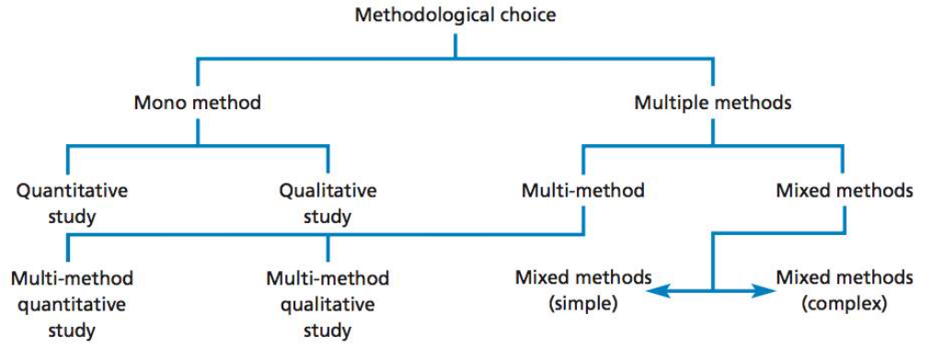

Figure 10: Methodological Choice (Saunders, et al., 2015)

In a quantitative research, variables are measured numerically and then analyzed through statistical and graphical techniques in order to examine the relationship between them. However, a qualitative research examines social meanings and relationships in order to generate a conceptual framework and theory (Saunders, et al., 2015).

Mono method refers to the use of only one data collection technique. It can be either mono method quantitative such as the use of only one questionnaire, or mono method qualitative such as the use of only in-depth interviews. Multi method refers to the use of more than one data collection technique, as either quantitative or qualitative, without mixing the two. For example, collecting data through in-depth interviews and diary accounts is considered a form of multi method qualitative study (Saunders, et al., 2015). Finally, mixed methods research refers to the use of both quantitative and qualitative methods within the same research as a way of reaching different purposes and counterbalancing the limitations of the use of single method (Melnikovas, 2018).

Since quantitative research is generally associated with positivism philosophy and deductive approach, and as we focus on examining the relationship between variables of telecommuting and job satisfaction through collecting data using a single form of survey that is through a questionnaire, our methodological choice is a mono method quantitative study.

**3.5. Time Horizon**

According to Saunders et al. (2015), there are two categories when choosing a time horizon, cross-sectional and longitudinal. A cross-sectional study involves studying a phenomenon through collecting data at a specific point of time and is referred to as a ‘snapshot’. Whereas a longitudinal study involves studying the change and development through repeatedly collecting data over a long period of time, and is referred to as a ‘diary’ (Melnikovas, 2018; Saunders, et al., 2015).

As this research is performed for a single academic course, it is necessarily time bound, thus it is a cross-sectional study. This is further explained by the fact that aims to be done only once to examine the relationship between telecommuting and job satisfaction at a specific point of time that is during COVID-19 pandemic.

**3.6. Techniques and/or Procedures for Data Analysis**

Data collection is not the end goal of a research, as this data must be further analyzed and interpreted to create information and answer the research questions. However, the type of data collected determines the way in which the data will be analyzed. For example, quantitative data can be analyzed using Microsoft Excel program or SPSS software, whereas qualitative data can be analyzed using several analytical techniques such as Thematic Analysis and Template Analysis. (Saunders, et al., 2015).

In this research, data was collected through a survey, specifically via online questionnaires, so it is quantitative data, and such data is analyzed quantitatively using descriptive and inferential statistics.

Various sophisticated computer software enable researchers to quantitively analyze collected data. The software to be used in order to analyze the quantitative data collected is the Statistical Package for the Social Sciences (SPSS). IBM SPSS is a flexible and feasible software that employs two types of software, SPSS Statistics supporting a hypothesis testing approach, and SPSS Modeler supporting a hypothesis generation approach (IBM, n.d.). Thus, SPSS Statistics is the software to be used as this research is testing the hypothesis that telecommuting increases job satisfaction in order to verify or refute this hypothesis.

Upon receiving participants’ answers to the survey’s questions, data will be encoded into the SPSS Statistics software in order to obtain statistics, graphs, and tables, and further interpret the data and test the correlation between the set of variables of telecommuting and job satisfaction, also via the software.

# CHAPTER 4: FINDDINGS AND ANALYSIS

## 4.1. Introduction:

After reaching the participants through social media platforms, data were collected via the questionnaire from 117 respondents, who are NGO employees, and coded into the IBM SPSS Statistics software. The data was then quantitatively analyzed into descriptive statistics in the form of charts and tables, representing the data collected as numbers and percentages to finally test the assumed hypothesis and either support or refute it. Thus, in addition to the descriptive statistics, a regression test was applied to study the correlation between telecommuting during COVID-19 and job satisfaction among NGO employees in Lebanon.

## 4.2. Findings (Descriptive Statistics)

The following figures represent the descriptive statistics obtained from the SPSS software after entering data about demographics, telecommuting factors, and job satisfaction.

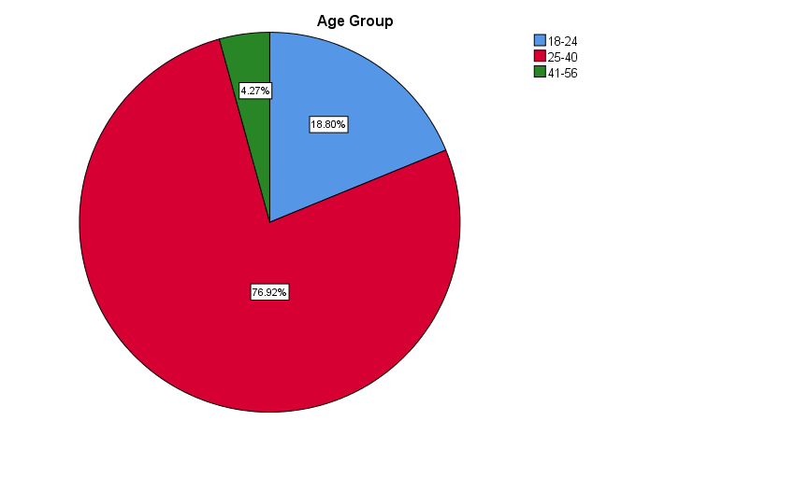

Figure 11: Pie Chart Count of Employees’ Age Groups

Figure 11 shows that the majority of the 117 respondents were Millennials as 76.92% of them (90 individuals) were aged between 25 and 40 years. Generation Z respondents represented 18.80% of the total sample (22 individuals), aged between 18 and 24 years. Only 4.27% of the respondents (5 individuals) belonged to generation X aged between 41 and 56 years. None of the employees belonging to Baby Boomers generation participated in the survey.

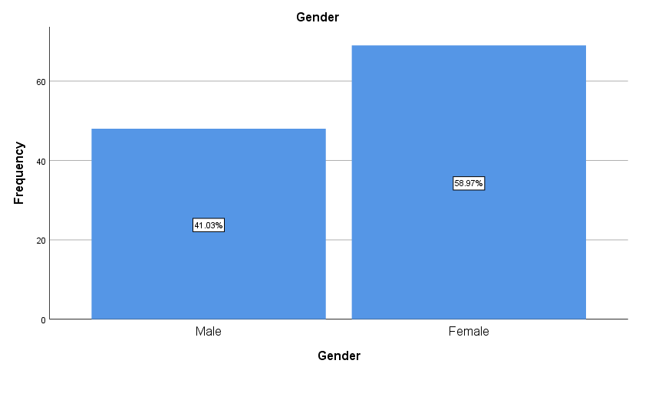

Figure 12: Bar Graph Categorizing Employees’ genders

66 of the respondents, which represent 58.97% of the total respondents, were females; whereas 44 respondents were males, representing 41.03% of the sample.

Figure 13 below shows that 24.79% of the respondents, a frequency of 29 individuals, were married while the majority of the respondents where single, representing 75.21% of the sample, that is a frequency of 88 individuals.

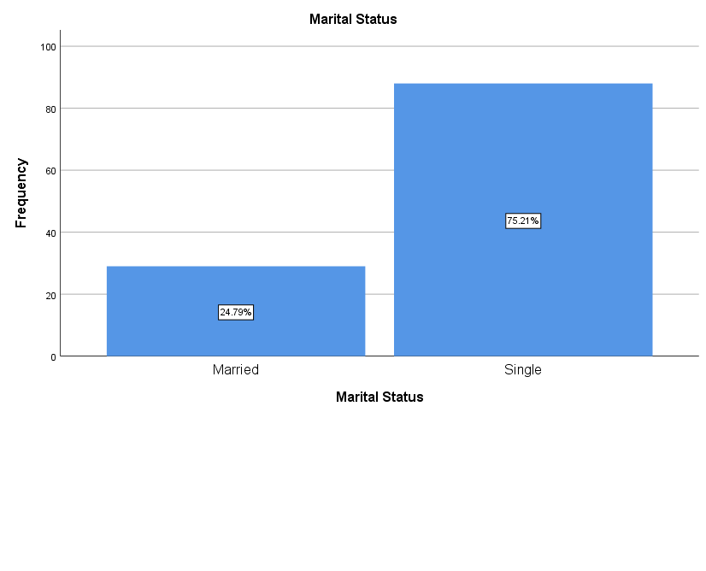

Figure 13: Bar Graph Categorizing Employees’ Marital Status

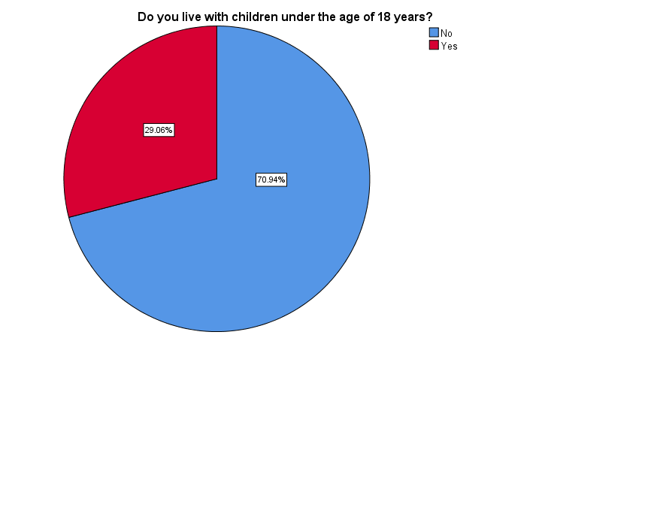

Figure 14: Pie Chart Categorizing Employees Living with Children Under 18

Figure 14 shows two categories of employees regarding living with children under the age of 18 or not. 70.94%, that is the majority of employees, answered that they do not live with children under 18 years old at home, however, 29.06% of the employees do live with children under 18 at home.

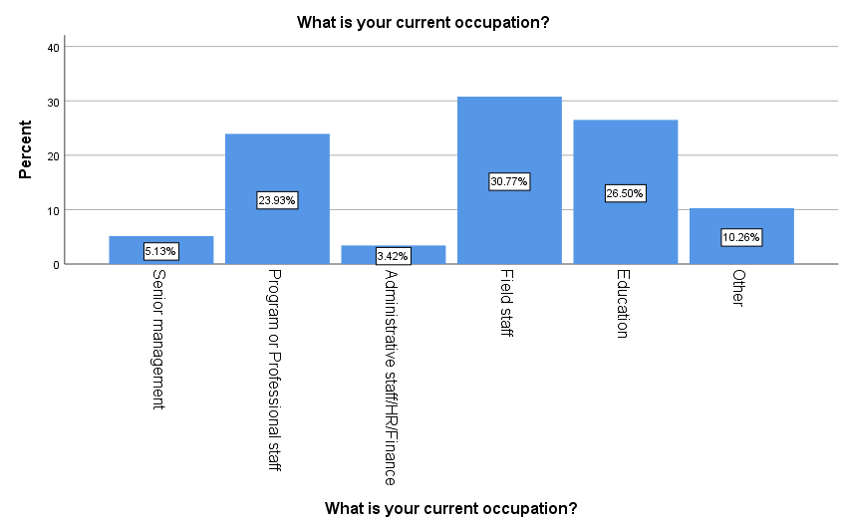

Figure 15: Bar Graph of Occupations

In figure 15, field staff is shown to be of highest percentage among other respondents, reporting 30.77%, equivalent to 36 respondents. Second comes the education staff with 26.50% of total respondents, a frequency of 31 respondents. 23.93% of the employees, that is 28 individuals, belonged to the program and professional staff. Senior management staff participated in the survey with a percentage of 5.13% of total participants, corresponding to 6 individuals. 4 respondents fit the administrative, human resources, and finance staff representing the lowest percentage of 3.42% of the total sample. Finally, 10.26% of the respondents, 12 individuals, answered as having other occupations, of which are information technology and software developers, logistics, and development and fundraising.

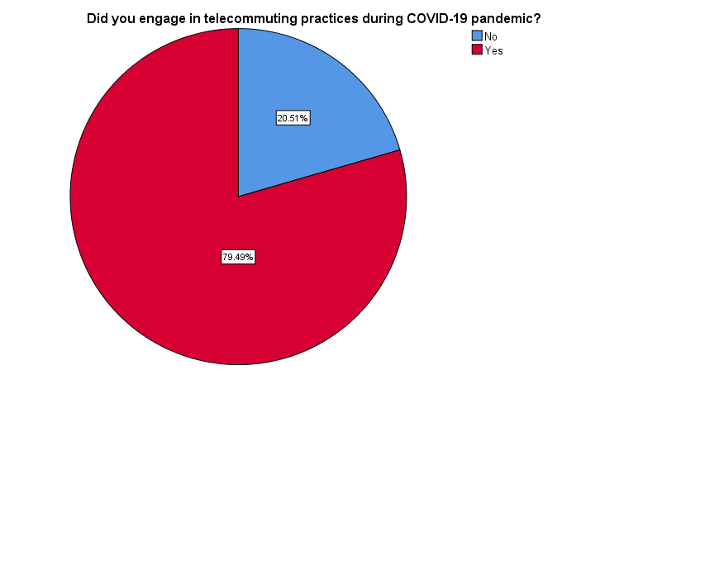

Figure 16: Pie Chart Count of Employees who Practiced Telecommuting during the Pandemic

Figure 16 shows that in this sample, 79.49% of employees (93 respondents) shifted to telecommuting practices during the COVID-19 pandemic, while 20.51% (24 respondents) didn’t shift and practiced working in-office as before the pandemic.

The results of figure 17 show that only 23.40% of the teleworkers had experience in telecommuting before the pandemic, yet, 76.60% of the employees, which is the majority, had no experience in telework.

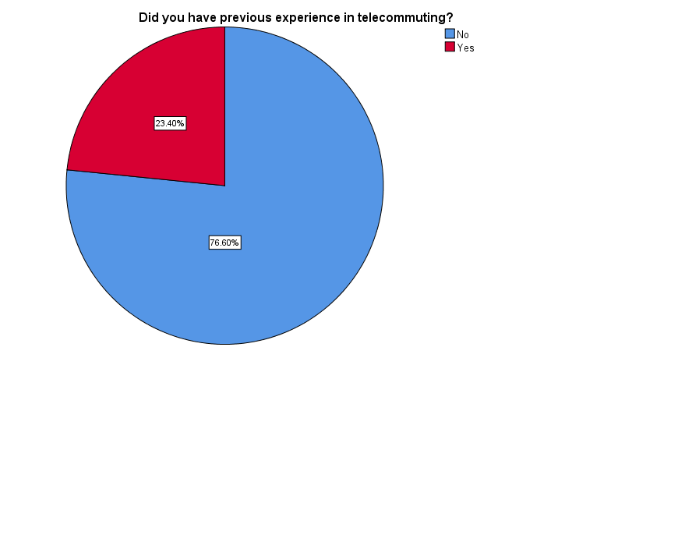

Figure 17: Pie Chart Count of Employees who Have Experience in Telecommuting

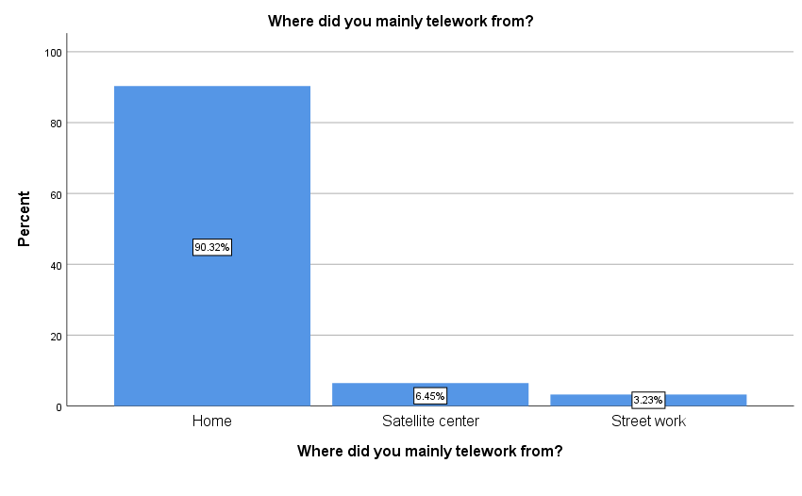Figure 18: Bar Graph of Locations that Employees Telework From

Figure 18 represents the locations in which the employees mainly teleworked from during the pandemic, showing a percentage of 90.32% of respondents working from home, 6.45% teleworking from satellite centers, and 3.23% teleworking from street locations.

|  |  |  |  |  |  |
| --- | --- | --- | --- | --- | --- |
| **How often did you telework per week?** | | | | | |
|  | | Frequency | Percent | Valid Percent | Cumulative Percent |
| Valid | Once or Twice/Week | 9 | 7.7 | 9.7 | 9.7 |
| Several times/Week | 41 | 35.0 | 44.1 | 53.8 |
| Full time/Week | 43 | 36.8 | 46.2 | 100.0 |
| Total | 93 | 79.5 | 100.0 |  |
| Missing | System | 24 | 20.5 |  |  |
| Total | | 117 | 100.0 |  |  |

Table 3: Intensity of Telecommuting

As shown in Table 3, most of the employees teleworked several times to full time during the week, with 44.1% of teleworkers working remotely several times per week and 46.2% teleworking full time, however, only 9.7% worked once or twice per week. The missing value in the table represents the 24 respondents who did not engage in teleworking during the pandemic, thus they weren’t asked about telecommuting related questions.

The below part of descriptive statistics represents data about telecommuting factors, that are autonomy, work-family conflict, and social and professional isolation, as well as job satisfaction measures using the Michigan Organizational Assessment Questionnaire; this data was only collected from those employees who shifted to telecommuting during the pandemic.

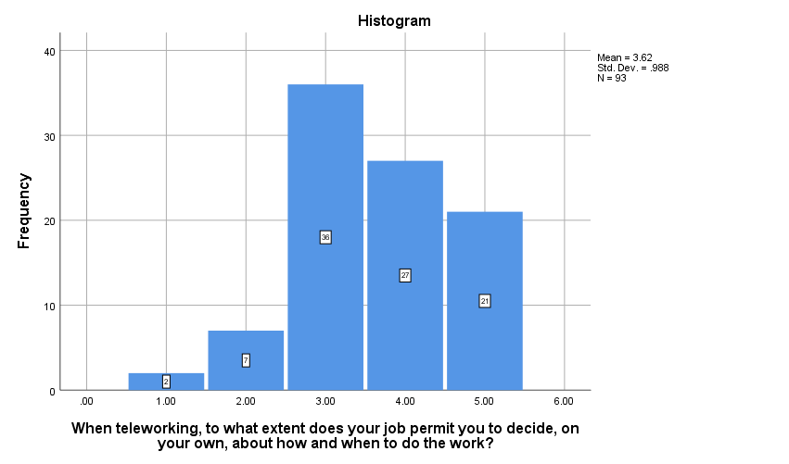

Figure 19: Histogram of Autonomy Level during Telecommuting

Out of the 93 respondents who worked remotely, 21 employees answered that when teleworking, their job gives them very much, almost complete, responsibility for deciding how and when the work is done, and 27 employees answered that their job gives them not complete, but much autonomy; A total of 36 employees were neutral as their job gives them neither much nor less autonomy when they telework. 7 employees had little autonomy, and 2 employees had very little autonomy when teleworking, recording that their jobs give them almost no “say” about how and when the work is done.

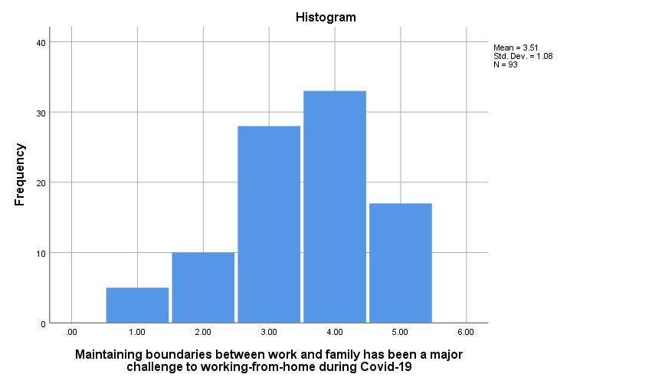

Figure 20: Challenge to Maintain Boundaries between Work and Family when Telecommuting

Respondents were asked to check statements on a 5-point Likert Scale ranging from strongly disagree to strongly agree. In the graphs, 1 represents strongly disagree, 2 represents disagree, 3 represents neutral, 4 represents agree, and 5 represents strongly agree.

Figure 20 displays 33 teleworkers who agree that maintaining boundaries between work and family has been a major challenge to working from home during the pandemic, followed by 28 teleworkers reporting neutral results, 17 strongly agreeing to this statement, 10 disagreeing, and 5 strongly disagreeing.

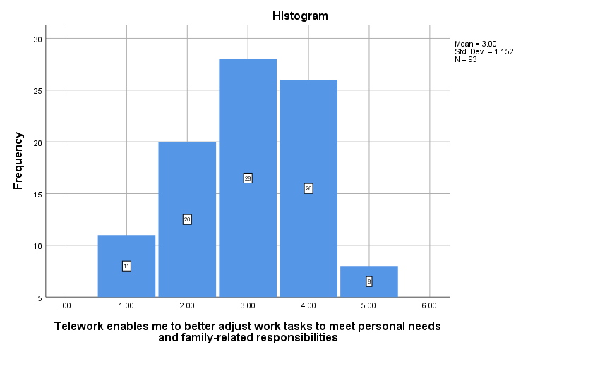Figure 21: Ability to Adjust Work and Family Needs when Teleworking

Teleworkers were asked to rate the statement “Telework enables me to better adjust work tasks to meet personal needs and family-related responsibilities” on a scale of agreeableness from 1 to 5, and the results are shown in figure 21; 28 respondents were neutral towards the statement, 26 agreed, 20 disagreed, 11 strongly disagreed, and 8 strongly agreed.

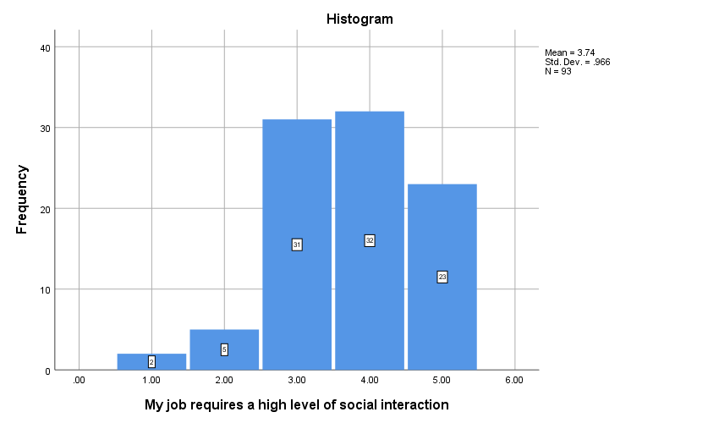Figure 22: Job Requirement for Social Interaction

Teleworkers were asked about the level of social interaction their job requires. Figure 22 confirms that 32 of them, agreed that their job requires high level of social interaction, 31 were neutral, 23 strongly agreed, 5 disagreed, and only 2 disagreed.

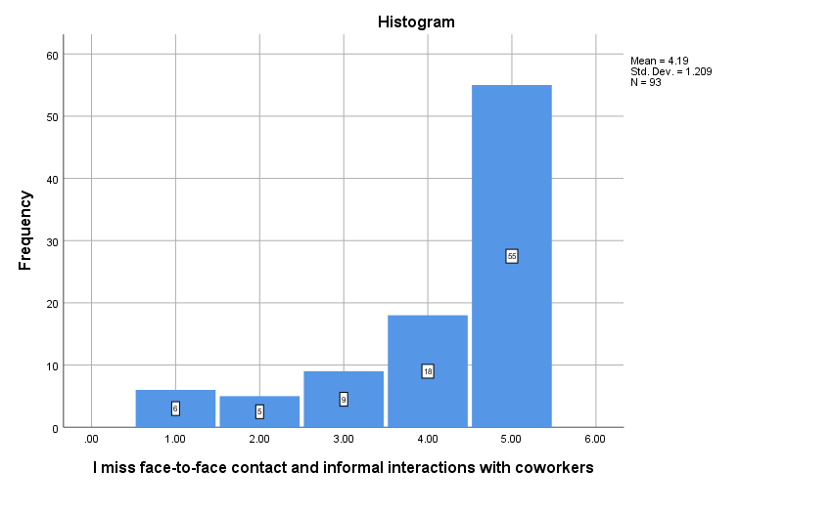Figure 23: Social Isolation

More than half of the teleworkers, 59.13%, strongly agreed with the statement that said “I miss face-to-face contact and informal interactions with coworkers”. Additionally, 19.35% of teleworkers agreed, 9.67% were neutral, 5.37% disagreed, and 6.45% strongly disagreed with this statement.

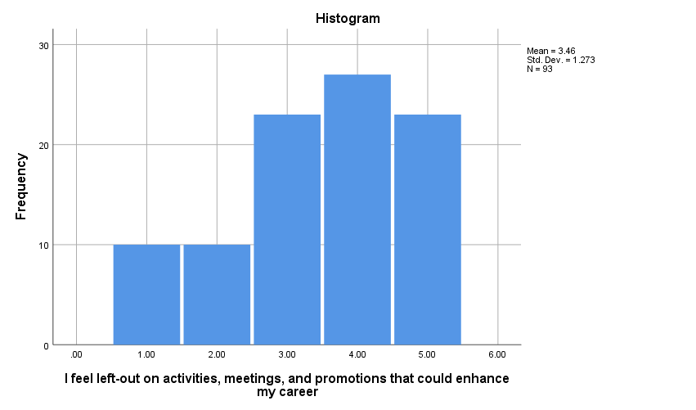

Figure 24: Professional Isolation

Figure 24 shows that 27 teleworkers (29.03%) agreed that they feel left-out on activities, meetings, and promotions that could enhance their careers, and 23 teleworkers (24.73%) strongly agreed with this statement; similarly, 23 respondents (24.73%) were neutral. Finally, 10.75% disagreed and also 10.75% strongly disagreed, a frequency of 10 teleworkers for each.

|  |  |  |  |  |  |
| --- | --- | --- | --- | --- | --- |
| **All in all, I am satisfied in my job** | | | | | |
|  | | Frequency | Percent | Valid Percent | Cumulative Percent |
| Valid | Strongly Disagree | 5 | 4.3 | 4.3 | 4.3 |
| Disagree | 6 | 5.1 | 5.1 | 9.4 |
| Neutral | 13 | 11.1 | 11.1 | 20.5 |
| Agree | 51 | 43.6 | 43.6 | 64.1 |
| Strongly Agree | 42 | 35.9 | 35.9 | 100.0 |
| Total | 117 | 100.0 | 100.0 |  |

Table 4: MOAQ Job Satisfaction Item 1

|  |  |  |  |  |  |
| --- | --- | --- | --- | --- | --- |
| **In general, I don’t like my job** | | | | | |
|  | | Frequency | Percent | Valid Percent | Cumulative Percent |
| Valid | Strongly Disagree | 63 | 53.8 | 53.8 | 53.8 |
| Disagree | 24 | 20.5 | 20.5 | 74.4 |
| Neutral | 18 | 15.4 | 15.4 | 89.7 |
| Agree | 9 | 7.7 | 7.7 | 97.4 |
| Strongly Agree | 3 | 2.6 | 2.6 | 100.0 |
| Total | 117 | 100.0 | 100.0 |  |

Table 5: MOAQ Job Satisfaction Item 2

|  |  |  |  |  |  |
| --- | --- | --- | --- | --- | --- |
| **In general, I like working here** | | | | | |
|  | | Frequency | Percent | Valid Percent | Cumulative Percent |
| Valid | Strongly Disagree | 8 | 6.8 | 6.8 | 6.8 |
| Disagree | 9 | 7.7 | 7.7 | 14.5 |
| Neutral | 20 | 17.1 | 17.1 | 31.6 |
| Agree | 40 | 34.2 | 34.2 | 65.8 |
| Strongly Agree | 40 | 34.2 | 34.2 | 100.0 |
| Total | 117 | 100.0 | 100.0 |  |

Table 6: MOAQ Job Satisfaction Item 3

To assess job satisfaction among respondents, the Michigan Organizational Assessment Questionnaire (MOAQ) was used. It consists of three items, “All in all, I am satisfied in my job”, “In general, I don’t like my job”, and “In general, I like working here”. The results of each item were represented in tables 4, 5, and 6 above. To assess the overall job satisfaction measure, the mean of the three items was computed on SPSS software and the result is represented in figure 26.

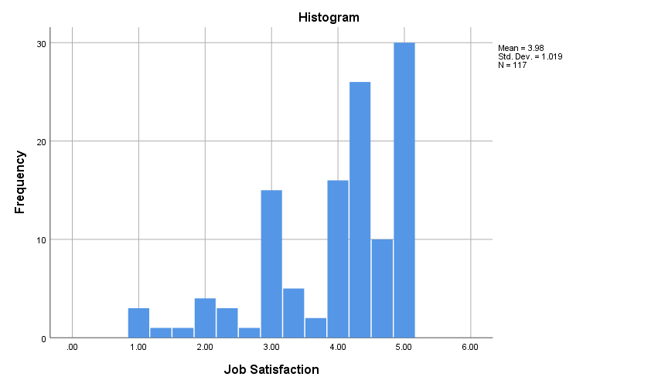

Figure 25: Measure of Job Satisfaction

## 4.3. Analysis

Demographic data describes the sample showing the level of diversity among respondents regarding their age, gender, marital status, and so on. The sample was mainly composed of NGO employees whose ages range between 25 and 40 years, a frequency of 90 individuals, and the others belonged to Baby Boomers and Generation Z age groups. As for the gender, the frequency of female participants was higher by 18% than that of men. The majority of the respondents were single, that is they don’t live with a partner, and were not living with children under the age of 18 years; these indicators have important implication when studying telecommuting and job satisfaction as they impact work-family conflict factor.

During COVID-19 pandemic, the majority of employees shifted to telecommuting practices as a way to comply with government regulations of social distancing and lockdown; Out of 117 NGO employees, a frequency of 93 employees recorded shifting to remote work during the pandemic, where 71 of them had no experience in telecommuting prior the pandemic. This is consistent with the literature of Vyas & Butakhieo (2021) and Wang et al. (2020) stating the fact that the emergence of COVID-19 virus forced employees to telework as a way to mitigate its spread, and that prior to the pandemic, most workers had little or no experience in remote working, however, during the pandemic, the percentage of the workforce working from home increased. Moreover, a percentage of 90.32% of employees worked mainly from home, which is consistent with the lockdown regulations as people stayed at home and avoided socialization. Respectively, 41 and 43 respondents, a sum of 84 out of 93, reported teleworking several times and full time per week. All these results indicate that the situation suddenly forced workers worldwide to start teleworking, where many of them did so for the first time, and on a full-time basis, rather than teleworking voluntarily and part-time as prior the pandemic, which is consistent with the literature of Fana et al. (2020) and ILO (2020).

In order to assess the level of autonomy that employees experience when teleworking, participants were asked to answer this question: When teleworking, to what extent does your job permit you to decide, on your own, about how and when to do the work? On a scale from 1 -very much, almost complete responsibility for deciding how and when the work is done- to 5 -very little autonomy, my job gives me almost no “say” about how and when the work is done. The mean was 3.62, indicating that there exists a small, yet favorable impact of telecommuting on autonomy, and proving that telework offers the benefit of providing greater autonomy as for when and how workers will carry out their tasks as mentioned in the literature.

The mean of “maintaining boundaries between work and family has been a major challenge to working-from-home during Covid-19” statement was 3.51 which means that employees agreed to this statement. However, the mean of “telework enables me to better adjust work tasks to meet personal needs and family-related responsibilities” was 3, indicating that the sample was neutral towards this statement, with answers being mainly distributed between neutral, agree, and disagree. These results can be explained by the lockdown regulations that mandated families to stay at home, and employees to suddenly shift to working from home, without prior experience or knowledge about this mode of work, which was challenging to most employees, in terms of balancing work and family needs and maintaining boundaries, as their homes became their offices, creating a challenge.

Most of the jobs required a high level of social isolation with a mean of 3.71 and a major distribution of answers between neutral, agree, and strongly agree. More importantly, by assessing social isolation, a mean of 4.19 was recorded, unsurprisingly indicating that the majority of teleworkers miss face-to-face and informal interactions with their colleagues which is explained by the prolonged, almost complete, lockdown that prevented them from socialization. Professional isolation assessment recorded a mean of 3.46 which means that in general, teleworkers agreed that they felt left-out on activities, meetings, and promotions that could enhance their careers.

To study the correlation between engaging in telecommuting practices during COVID-19 pandemic and job satisfaction, a linear regression test was computed on SPSS software. The results are listed in the boxes of table 7 below.

|  |  |  |  |
| --- | --- | --- | --- |
| **Variables Entered/Removeda** | | | |
| Model | Variables Entered | Variables Removed | Method |
| 1 | Engagement in telecommuting practices during COVID-19 pandemicb | . | Enter |
| a. Dependent Variable: Job Satisfaction | | | |
| b. All requested variables entered. | | | |

|  |  |  |  |  |
| --- | --- | --- | --- | --- |
| **Model Summaryb** | | | | |
| Model | R | R Square | Adjusted R Square | Std. Error of the Estimate |
| 1 | .325a | .106 | .098 | .96761 |
| a. Predictors: (Constant), Engagement in telecommuting practices during COVID-19 pandemic | | | | |
| b. Dependent Variable: Job Satisfaction | | | | |

|  |  |  |  |  |  |  |
| --- | --- | --- | --- | --- | --- | --- |
| **ANOVAa** | | | | | | |
| Model | | Sum of Squares | df | Mean Square | F | Sig. |
| 1 | Regression | 12.740 | 1 | 12.740 | 13.607 | .000b |
| Residual | 107.670 | 115 | .936 |  |  |
| Total | 120.410 | 116 |  |  |  |
| a. Dependent Variable: Job Satisfaction | | | | | | |
| b. Predictors: (Constant), Engagement in telecommuting practices during COVID-19 pandemic | | | | | | |

|  |  |  |  |  |  |  |  |  |
| --- | --- | --- | --- | --- | --- | --- | --- | --- |
| **Coefficientsa** | | | | | | | | |
| Model | | Unstandardized Coefficients | | Standardized Coefficients | t | Sig. | 95.0% Confidence Interval for B | |
| B | Std. Error | Beta | Lower Bound | Upper Bound |
| 1 | (Constant) | 3.333 | .198 |  | 16.877 | .000 | 2.942 | 3.725 |
| Did you engage in telecommuting practices during COVID-19 pandemic? | .817 | .222 | .325 | 3.689 | .000 | .378 | 1.256 |
| a. Dependent Variable: Job Satisfaction | | | | | | | | |

Table 7: Linear Regression Test

As the aim of this analysis is to predict the impact of telecommuting on job satisfaction during the pandemic, engagement in telecommuting practices is considered as the independent variable, and job satisfaction as the dependent variable; variables are represented in the first table. First, the statistical significance level of this model must be detected from the “ANOVA” table to assure that the predictor variable, that is the independent variable, is a good predictor of the outcome variable, that is the dependent variable. The significance value of this model is ρ=0.000 which is less than α=0.01, implying that the model is highly statistically significant. Next, the “Model Summary” table is analyzed to detect a correlation between the two variables. The R square values predict how well the independent variable predicts the dependent variable, in which the adjusted R square is considered more accurate than R square. This model’s adjusted R square=0.098 implies that 9.8% of the variance in job satisfaction was predicted from engaging in telecommuting practices, with R=0.325 indicating the presence of a slight correlation between job satisfaction and telecommuting. The “Coefficients” table shows a positive slope B=0.817 that signifies a positive correlation between the variables.

Thus, H1 is supported proving the presence of a statistically significant, slight, positive impact of engaging in telecommuting practices during COVID-19 pandemic on job satisfaction among NGO employees in Lebanon.

# CHAPTER 5: CONCLUSION AND RECOMMENDATIONS

## 5.1. Conclusion

The sudden emergence of COVID-19 pandemic and the related lockdown and social distancing regulations worldwide made teleworking not only just an option, but the new norm for many office employees; thus, it was important to study how this new mode of work impacts employees’ job satisfaction, which is considered an important predictor of performance. This study has made contribution to the research into the implications of telecommuting on job satisfaction during the pandemic, suggesting that engaging in telecommuting practices has a slight positive impact on job satisfaction, consistent with the stream of literature discussed before.

The majority of employees shifted to telecommuting in a sudden and forced manner, with little or no experience in this work arrangement. They became first and almost full-time teleworkers. So, in addition to job satisfaction levels, it was important to study how telecommuting impacted employees’ levels of perceived autonomy, work-family conflict, and social and professional isolation. Results suggest that teleworkers perceived a higher level of autonomy, as for deciding on their own how and when to do their tasks. Also, the results show that teleworkers found it slightly challenging to maintain boundaries between work and family. A major implication of the study was the evident social isolation teleworkers experienced, which was not surprising, especially due to extensive teleworking while complying to the lockdown regulations that made employees miss face-to-face and informal social interactions with their colleagues even more. Feelings of professional isolation were also detected among teleworkers.

Despite being researched much earlier, the pandemic has highlighted the need to investigate the implications of telecommuting as a significant work arrangement, as it is likely here to stay at a larger scale than before. Therefore, future research on telecommuting would permit an examination of the multitude of factors that play a role in shaping this arrangement’s outcomes, as well as an identification of the challenges inherent in this important and emerging form of work; such research will serve organizations to stay incisive to such implications in order to successfully adopt this work arrangement.

## 5.2. Limitations

Each research study has its potential limitations that should be noted. They represent restrictions, drawbacks, and weaknesses of the study, yet, they should be addressed in future research. In this study, several limitations are noted:

* The sample only contained observations from NGO employees in Lebanon, therefore, the results of the study cannot be generalized for other countries.
* The questionnaire was distributed on NGO employees via social media platforms due to social distancing and lockdown regulations, however, this way of distribution can’t be controlled as we can’t know for sure that answers were only collected from the intended sample, and that questionnaires were only filled once per person. Additionally, using these platforms directed the selection of participants mainly toward users of these platforms, for example, we couldn’t reach older employees through social media platforms so the sample was not diverse regarding the ages of respondents.
* Since this research was done for academic reasons, we were restricted by time and deadlines which limited our reach to more participants that could’ve added more diversity to the sample.
* This study was only limited to testing the impact of engagement in telecommuting during the pandemic on job satisfaction, without interpreting how the variables of telecommuting such as intensity, autonomy, work-life conflict, and isolation can alter the tested level of job satisfaction. Future research could focus on each variable separately, to gain an in-depth interpretation and understanding about the way these variables affect job satisfaction levels.
* Data was analyzed without using control variables such as age, gender, living with children and a partner, and occupation, which may potentially have important implications to the result of the analysis. Further investigation is needed to understand how differences in such variables may affect the levels of job satisfaction.
* A qualitative method to the investigation should’ve been incorporated as it is a better practice to involve both quantitative and qualitative approaches to any research in order to obtain a more clear and precise assessment and interpretation.

## 5.3. Recommendations

In the context of COVID-19 pandemic, telecommuting, especially working from home, became the only option. This new work arrangement imposes challenges on employers and organizations on how to successfully implement it and mitigate its challenges. The results of this study provide crucial insights that aid in setting several recommendations for companies and employees to fully take advantage of telecommuting while managing potential challenges.

* Companies must ensure the equipment of the proper information and technology devices used for telework and provide effective training and support to managers and employees. Training sessions should focus on the use of necessary equipment and technology to ease and increase engagement in telework and thus improve satisfaction. Training sessions should also focus on soft-skills, such as leadership skills (leading virtual teams and through crisis) and time-management skills, as well communication skills to maintain open communication and synergy between the teleworkers.
* In situations such as pandemics, it is essential to integrate emotional and social wellbeing of the employees which may impact their level of satisfaction. More specifically, social isolation was reported to be the major challenge of telecommuting that is negatively correlated to job satisfaction, however, during COVID-19 pandemic, workers experienced social isolation to the extreme point when complying to the regulations of social distancing and lockdown. Therefore, companies should find ways to decrease the feeling of social isolation through maintaining some form of social contact among employees, and between employees and supervisors; for example, they may use social channels such as frequent video conferences and remote coffee breaks.
* Work-life boundary management must be supported by companies by setting clear expectations about work outputs, while offering teleworkers the flexibility to adjust their own work schedules based on their own personal and family needs.
* Feedback from employees is a powerful tool that employers can benefit from so they can identify gaps and improve teleworking conditions. This feedback can be obtained through conducting regular surveys on the challenges that teleworkers face and on their needs; then these needs and challenges should be targeted and modified through providing online trainings, coaching sessions, and so on. Such information and improvements can lead to a positive impact on job satisfaction.
* In short, managerial, peer, and technological support need to be provided for employees to reduce issues arising from social isolation, alleviate work-family conflict, and minimize stress.

# REFERENCES

Agbozo, G. K., Owusu, I. S., Hoedoafia, M. A. & Atakorah, Y. B., 2017. The Effect of Work Environment on Job Satisfaction: Evidence from the Banking Sector in Ghana. *Journal of Human Resource Management,* 5(1), pp. 12-18.

Al-Ababneh, M. M., 2020. Linking Ontology, Epistemology and Research Methodology. *Research & Philosophy,* 8(1), pp. 75-91.

Alharahsheh, H. H. & Pius, A., 2020. A Review of key paradigms: positivism VS interpretivism. *Global Academic Journal of Humanities and Social Sciences,* 2(3), pp. 39-43.

Ali, W., 2016. Understanding the Concept of Job Satisfaction, Measurements, Theories and its Significance in the Recent Organizational Environment: A Theoretical Framework. *Archives of Business Research,* 4(1), pp. 100-111.

Allen, T. D., Golden, T. D. & Shockley, K. M., 2015. How Effective Is Telecommuting? Assessing the Status of Our Scientific Findings. *Psychological Science in the Public Interest,* 16(2), pp. 40-68.

Aziri, B., 2011. JOB SATISFACTION: A LITERATURE REVIEW. *Management Research and Practice,* 3(4), pp. 77-86.

Baert, S. et al., 2020. *The COVID-19 Crisis and Telework: A Research Survey on Experiences, Expectations and Hopes,* Bonn: IZA institute of Labor Economics.

Bailey, D. E. & Kurland, N. B., 2002. A review of telework research: findings, new directions, and lessons for the study of modern work. *Journal of Organizational Behavior,* 23(4), p. 383–400.

Bakare, A. S. & Gold, K. L., 2011. Estimating the impacts of global system for mobile telecommunication (gsm) on income, employment and transaction cost in Nigeria. *Journal of Economics and International Finance,* 3(1), pp. 37-45.

Baruch, Y. & Nicholson, N., 1997. Home, Sweet Work: Requirements For Effective Home Working. *Journal of General Management ,* 23(2), pp. 15-30.

Belzunegui-Eraso, A. & Erro-Garcés, A., 2020. Teleworking in the Context of the Covid-19 Crisis. *Sustainability,* 12(9), p. 3662.

Blount, Y., 2015. Pondering the Fault Lines of Anywhere Working (Telework, Telecommuting): A Literature Review. *Foundations and Trends in Information,* 1(3), p. 163–276.

Contreras, F., Baykal, E. & Abid, G., 2020. E-Leadership and Teleworking in Times of COVID-19 and Beyond: What We Know and Where Do We Go. *Frontiers in Psychology,* Volume 11, p. 590271.

Cooper, C. D. & Kurland, N. B., 2002. Telecommuting, professional isolation, and employee development in public, and private organizations. *Journal of Organizational Behavior,* 23(4), pp. 511-532.

Diab-Bahman, R. & Al-Enzi, A., 2020. The impact of COVID-19 pandemic on conventional work settings. *International Journal of Sociology and Social Policy,* 40(9), pp. 909-927.

Fana, M. et al., 2020. *Telework, work organisation and job quality during the COVID-19 crisis: a qualitative study,* Seville : European Commission .

Gajendran, R. S. & Harrison, D. A., 2007. The Good, the Bad, and the Unknown About Telecommuting: Meta Analysis of Psychological Mediators and Individual Consequences. *Journal of Applied Psychology,* 92(6), p. 1524 –1541.

Giovanis, E., 2018. The relationship between teleworking, traffic and air pollution. *Atmospheric Pollution Research,* 9(1), pp. 1-14.

Golden, T. D., 2006. Avoiding depletion in virtual work: Telework and the intervening impact of work exhaustion on commitment and turnover intentions. *Journal of Vocational Behavior,* Volume 69, p. 176–187.

Golden, T. D. & Veiga, J. F., 2005. The Impact of Extent of Telecommuting on Job Satisfaction: Resolving Inconsistent Findings. *Journal of Management,* 31(2), pp. 301-318.

Greenhaus, J. H. & Beutell, N. J., 1985. Sources of Conflict Between Work and Family Roles. *Academy of Management Review,* 10(1), pp. 76-88.

Hassan, E., 2015. NGOs and Their Implications in Promoting Social Development in Bangladesh: An Overview. *Sociology and Anthropology,* 3(1), pp. 24-36.

Heng, T. B. et al., 2012. Telecommuting for Business Continuity in a Non-profit Environment. *Asian Social Science,* 8(12), pp. 226-237.

IBM, n.d. *IBM.* [Online]   
Available at: https://www.ibm.com/analytics/spss-statistics-software  
[Accessed 22 April 2021].

ILO, 2020. *International Labour Organization.* [Online]   
Available at: https://www.ilo.org/travail/info/publications/WCMS_751232/lang--en/index.htm  
[Accessed 6 April 2020].

Kniffin, K. M. et al., 2021. COVID-19 and the Workplace:Implications, Issues, and Insights for Future Research and Action. *American Psychological Association,* 76(1), pp. 63-77.

Melnikovas, A., 2018. Towards an Explicit Research Methodology: Adapting Research Onion Model for Futures Studies. *Journal of Futures Studies,* 23(2), pp. 29-44.

Mishra, P. K., 2013. Job Satisfaction. *IOSR Journal Of Humanities And Social Science,* 14(5), pp. 45-54.

Muhaise, H., Ejiri, A. H., Muwanga-Zake, J. W. F. & Kareyo, M., 2020. The Research Philosophy Dilemma for Postgraduate Student Researchers. *International Journal of Research and Scientific Innovation (IJRSI),* VII(IV), pp. 201-204.

Murad, M. M. I., Zayed, N. M. & Mukul, A. Z. A., 2013. A Study on Job Satisfaction: Focus on Bankers of Bangladesh. *European Journal of Business and Management,* 5(17), pp. 14-20.

Ng, C. F., 2006. Academics Telecommuting in Open and Distance Education Universities: Issues, challenges, and opportunities. *International Review of Research in Open and Distance Learning,* 7(2).

Olson-Buchanan, J. B. & Boswell, W. R., 2006. Blurring boundaries: Correlates of integration and segmentation between work and nonwork. *Journal of Vocational Behavior,* Volume 68, p. 432–445.

Orhan, M. A., Rijsman, J. B. & Dijk, G. M. v., 2016. Invisible, therefore isolated: Comparative effects of team virtuality with task virtuality on workplace isolation and work outcomes. *Journal of Work and Organizational Psychology,* 32(2), pp. 109-122.

Oz, T. & Crooks, A., 2020. *ResearchGate.* [Online]   
Available at: https://www.researchgate.net/publication/344693089_Exploring_the_Impact_of_Mandatory_Remote_Work_during_the_COVID-19_Pandemic  
[Accessed 5 April 2021].

Paşaoğlu, D. & Tonus, H. Z., 2014. Strategic Importance of Human Resource Practices on Job Satisfaction in Private Hospitals. *Procedia - Social and Behavioral Sciences,* Volume 150, pp. 394-403.

Rafferty, A. E. & Griffin, M. A., 2008. Job Satisfaction in Organizational Research. In: D. Buchanan & A. Bryman, eds. *The SAGE Handbook of Organizational Research Methods.* s.l.:SAGE Publicatons Ltd, pp. 196-212.

Raghuram, S., Hill, N. S., Gibbs, J. L. & Maruping, L. M., 2019. VIRTUAL WORK: BRIDGING RESEARCH CLUSTERS. *Academy of Management Annals,* 13(1), pp. 1-34.

Raišienė, A. G., Rapuano, V., Varkulevičiūtė, K. & Stachová, K., 2020. Working from Home—Who Is Happy? A Survey of Lithuania’s Employees during the COVID-19 Quarantine Period. *Sustainability,* 12(3), p. 5332.

Raju, S., 2009. Nongovernmental Organizations. In: *International Encyclopedia of Human Geography.* New Delhi: Elsevier Ltd., pp. 450-455.

Richter, A., 2020. Locked-down digital work. *International Journal of Information Management,* Volume 55, p. 102157.

Robbins, S. P., Coulter, M., Sidani, Y. & Jamali, D., 2011. Motivating Employees. In: R. Roussan, S. Wightnab, K. Sherington & T. Lawrence, eds. *Management.* Harlow: Pearson Education, pp. 361-362.

Robbins, S. P. & Judge, T. A., 2017. Attitudes and Job Satisfaction. In: *Organizational Behavior.* Boston: Pearson, p. 116.

Saunders, M., Lewis, P. & Thornhill, A., 2015. Formulating the research design. In: *Research Methods for Business Students.* London: Pearson, pp. 165-171, 178-182, 200.

Saunders, M. N., Lewis, P., Thornhill, A. & Bristow, A., 2015. Understanding research philosophy and approaches to theory development. In: *Research Method for Business Students.* 7 ed. London: Pearson, pp. 124; 135-143; 145.

Siha, S. M. & Monroe, R. W., 2006. Telecommuting’s past and future:a literature review and research agenda. *Business Process Management Journal,* 12(4), pp. 455-482.

Strelow, C., 2020. *The Borgen Project.* [Online]   
Available at: https://borgenproject.org/ngos-in-lebanon/  
[Accessed 13 May 2021].

Susilo, D., 2020. Revealing the Effect of Work-From-Home on Job Performance during the Covid-19 Crisis: Empirical Evidence from Indonesia. *The Journal of Contemporary Issues in Business and Government,* 26(1), pp. 23-40.

Toscano, F. & Zappalà, S., 2020. Social Isolation and Stress as Predictors of Productivity Perception and Remote Work Satisfaction during the COVID-19 Pandemic: The Role of Concern about the Virus in a Moderated Double Mediation. *Sustainability,* 12(23), pp. 1-14.

Virick, M., DaSilva, N. & Arrington, K., 2010. Moderators of the curvilinear relation between extent of telecommuting and job and life satisfaction: The role of performance outcome orientation and worker type. *Human Relations,* 63(1), p. 137–154.

Vyas, L. & Butakhieo, N., 2021. The impact of working from home during COVID-19 on work and life domains: an exploratory study on Hong Kong. *Policy Design and Practice,* 4(1).

Wallin, A. O., Edberg, A.-K., Beck, I. & Jakobsson, U., 2013. Psychometric properties concerning four instruments measuring job satisfaction, strain, and stress of conscience in a residential. *Archives of Gerontology and Geriatrics,* 57(2), pp. 162-171.

Wang, B., Liu, Y., Qian, J. & Parker, S. K., 2020. Achieving Effective Remote Working During the COVID-19 Pandemic: A Work Design Perspective. *International Association of Applied Psychology,* 70(1), pp. 16-59.

WHO, 2021. *World Health Organization.* [Online]   
Available at: https://www.euro.who.int/en/health-topics/health-emergencies/coronavirus-covid-19/novel-coronavirus-2019-ncov  
[Accessed 23 March 2021].

Willetts, P., 2011. *The Global Development Research Center.* [Online]   
Available at: https://www.gdrc.org/ngo/peter-willets.html  
[Accessed 13 May 2021].

Wojack, E., Bajzikova, L., Sajgalikova, H. & Polakova, M., 2016. How to Achieve Sustainable Efficiency with Teleworkers: Leadership Model in Telework. *Procedia - Social and Behavioral Sciences,* Volume 229, pp. 33-41.

# APPENDIX: QUESTIONNAIRE

1. What is your age?

* 18-24
* 25-40
* 41-56
* 57-66
* >67

1. Specify your gender

* Male
* Female

1. Specify your marital status

* Married
* Single

1. Do you have children (under 18) at home?

* Yes
* No

1. Specify your occupation

* Senior management (executive director, associate director, COO)
* Program or professional staff (program manager, project coordinator...etc.)
* Administrative staff/ Human resources/ Finance
* Field staff
* Education
* Other

1. Did you shift to remote work during Covid-19 pandemic?

* Yes
* No

Note: those who answered No were transferred to question 16

1. Did you have remote work experience prior the pandemic?

* Yes
* No

1. Where did you mainly remote work from during the pandemic?

* Home
* Satellite center (e.g. Client’s home)
* Street work (e.g. café)

1. How often did you work remotely?

* Once or twice/week
* Several times/week
* Full time working away

1. When remote working, to what extent does your job permit you to decide, on your own, about how and when to do the work? Answer on a scale from 1 to 5

* 1 (Very little; the job gives me almost no “say” about how and when the work is done)
* 2
* 3
* 4
* 5 (Very much; the job gives me almost complete responsibility for deciding how and when the work is done)

1. Maintaining boundaries between work and family has been a major challenge to working-from-home during Covid-19.

* Strongly disagree
* Disagree
* Neutral
* Agree
* Strongly agree

1. Remote work enables me to better adjust work tasks to meet personal needs and family-related responsibilities.

* Strongly disagree
* Disagree
* Neutral
* Agree
* Strongly agree

1. My job requires a high level of social interaction.

* Strongly disagree
* Disagree
* Neutral
* Agree
* Strongly agree

1. I miss face-to-face contact and informal interactions with coworkers.

* Strongly disagree
* Disagree
* Neutral
* Agree
* Strongly agree

1. I feel left-out on activities, meetings, and promotions that could enhance my career.

* Strongly disagree
* Disagree
* Neutral
* Agree
* Strongly agree

MOAQ-Job Satisfaction Scale

1. In general, I don’t like my job.

* Strongly disagree
* Disagree
* Neutral
* Agree
* Strongly agree

1. All in all, I am satisfied in my job

* Strongly disagree
* Disagree
* Neutral
* Agree
* Strongly agree

1. In general, I like working here.

* Strongly disagree
* Disagree
* Neutral
* Agree
* Strongly agree