**GRADUATE PROJECT**

**THE IMPACT OF THE ECONOMIC CRISIS ON EMPLOYEES’ PERFORMANCE AND SATISFACTION IN LEBANESE PUBLIC SECTOR INSTITUTIONS**

**Submitted to the Lebanese International University**

**The School of Business**

in Fulfillment of the

Requirements for the Degree of

**Master of Business Administration in Human Resources Management**

By

**Mohamad Othman**

ID: 21030908

Campus: Beirut

Supervised by: Dr. Mohamad Mtairek

Spring 2020 – 2021

**DEDICATIONS**

*To my mother, my guardian angel, for her unconditional love throughout the years and for believing in me when no one else did.*

*To my dearest father, my role model, for earning an honest living for us and for encouraging me to believe in myself.*

*To my siblings, my backbone, for always loving and supporting me.*

*To my fiancé, my source of inspiration, for always believing in me, supporting me through thick and thin and pushing me to pursue higher education.*

**ACKNOWLEDGEMENTS**

*First and foremost, I would thank God for being able to complete this thesis with success.*

*Then, I would like to acknowledge everyone who played a role in this academic research.*

*The professors and staff at the Lebanese International University, I’m extremely grateful for your constant efforts and dedication.*

*I would especially like to thank Dr. Mohammad Mtairek, my supervisor, for providing me with his continuous support, guidance, and patience throughout this project.*

*My deepest appreciation goes to my family and my fiancé who believed in me and supported me endlessly throughout my years of study and through writing this thesis. Their value to me only grows with age and this accomplishment would not have been possible without them.*

**ABSTRACT**

For the past 18 months, Lebanon has been suffering from a wrenching economic crisis that has affected its social fabric. One of the most affected group by the inflation that has occurred are public sector employees, whose salaries have lost more than 90% of their value within less than 2 years.

This research will examine the crisis’s origin and describes the general situation of public sector employees. The research goes on to explain how the crisis affected these employees’ daily lives, their purchasing power, their work relationships (whether between each other as staff or with clients) as well as their overall productivity, satisfaction and loyalty. A questionnaire is distributed among employees to find out the extent of the economic crisis impact on them and know if there is any procedure taken by the institution to protect and maintain its workforce.

This study reveals that the economic crisis has highly impacted public sector employees’ lives, work performance and overall well-being. It was clearly proven that the absence of any institutional procedures to mitigate the risks of this economic recession has exacerbated their agony and they are constantly looking for other opportunities to make a living and they are no longer loyal to the institution that was once their life-saving body.

**Key words:** public sector employees – human resources management – economic crisis – loyalty – productivity – satisfaction – institution – procedures – turnover.

Table of Contents

LIST OF TABLES 7

LIST OF FIGURES 8

CHAPTER 1: INTRODUCING THE GRADUATE PROJECT 9

1. Introduction 9

1.1. Research Question 10

1.2. Research Aim and Objectives 10

1.3. Overview of the Organization 11

1.4. Research Hypotheses 12

1.5. Structure of the Graduate Project 13

CHAPTER 2: LITERATURE REVIEW 14

2. Overview 14

2.1. Human Resources Management 16

2.2. Lebanon’s Crippling Economic Crisis 20

2.3. The Lebanese Public Sector: A Threatening Reality 26

2.4. HRM Role During Economic Recessions 28

2.5. Summary of Literature Review 31

CHAPTER 3: RESEARCH METHODOLOGY 33

3.1 Research Philosophy 34

3.2 Research Approach 36

3.3 Research Strategy (Data Collection Method) 37

3.4 Research Methodological Choice 38

3.5 Time horizon 39

3.6 Techniques and/or Procedures for Data Analysis 40

CHAPTER 4: FINDINGS AND ANALYSIS 41

4.1. Introduction 41

4.2. Findings (Descriptive Statistics) 41

4.3. Analysis 60

4.4. Summary of Findings and Analysis 63

CHAPTER 5: CONCLUSION, LIMITATIONS, AND RECOMMENDATIONS 64

5.1. Conclusion 64

5.2. Limitations 65

5.3. Recommendations 66

REFERENCES 68

APPENDICES 70

APPENDIX 1: QUESTIONNAIRES 71

APPENDIX 2: INTERVIEW FORMS 74

APPENDIX 3: 75

# **LIST OF TABLES**

Table 1: Age Demographic Characteristics 42

Table 2: Gender Demographic Characteristics 42

Table 3: Educational level Demographic Characteristics 42

Table 4: Number of years of work 43

Table 5: type of contract 44

Table 6: Descriptive statistics 45

Table 7: Frequencies statistics 46

Table 8: Frequency results of income 47

Table 9: Frequency results of purchasing power 48

Table 10: Frequency results of performing tasks 49

Table 11: Frequency results of leaving job 50

Table 12: Frequency results of part time job 51

Table 13: Frequency results of teamwork spirit 52

Table 14: Frequency results of enthusiasm when dealing with clients 53

Table 15: Frequency results of the procedures taken by the institution 54

Table 16: Frequency results of creativity and innovation 55

Table 17: T-Test Results 56

Table 18: One Sample Test Result 57

Table 19: Correlation Between the procedures taken by the institution and creativity and innovation 58

Table 20: Correlation Between the procedures taken by the institution and creativity and innovation 58

Table 21: Correlation Between leaving jobs and looking for a part time job 59

Table 22: Correlation Between leaving jobs and looking for a part time job 59

# **LIST OF FIGURES**

Figure 1: The Municipality Logo 11

Figure 2: Human Resource Management Objectives 18

Figure 3: Breakdown of salaries, wages and benefits as % of total wage bill, January 2018. 27

Figure 4: The Research Onion (Saunders, M., Lewis, P., Thornhill, A., 2006) 33

Figure 5: Research Philosophies (Saunders, M., Lewis, P., Thornhill, A., 2006) 35

Figure 6: Research Approaches (Saunders, M., Lewis, P., Thornhill, A., 2006) 36

Figure 7: Research Choices and Methods (Saunders, M., Lewis, P., Thornhill, A., 2006) 39

Figure 8: Pie Chart results of income 47

Figure 9: Pie Chart results of the purchasing power 48

Figure 10: Pie Chart results of performing tasks 49

Figure 11: Pie Chart results of leaving job 50

Figure 12: Pie Chart results of part time job 51

Figure 13: Pie Chart results of teamwork spirit 52

Figure 14: Pie Chart results of enthusiasm when dealing with clients 53

Figure 15: Pie Chart results of the procedures taken by the institution 54

Figure 16: Pie Chart results of creativity and innovation 55

# **CHAPTER 1: INTRODUCING THE GRADUATE PROJECT**

# **Introduction**

Between a falling currency, rising inflation to momentous levels and a sharp scarcity of foreign exchange currencies, Lebanon is in the middle of an economic downfall that is considered the worst since the civil war, if not the worst at all. Since late 2019, signs of the economic crisis began to crystallize in Lebanon, which led some major depositors and politicians to withdraw their money from banks or transfer them outside Lebanon. This lack of responsibility only made things worse.

The scarcity of foreign currencies, specifically the US Dollars in banks, began to appear clearly in the markets, amid a set of wrongfully imposed decisions by the Central Bank such as limiting withdrawals in dollars and capital control. In addition, the Central Bank “Banque du Liban” issued a circular that only allows opening credits in dollars intended for the import of fuel, wheat and medicine. However, given that most of the goods are imported from abroad, the situation got only worse and the so-called "USD black market" appeared; this market recorded large gaps between its exchange rate (12,000 L.B.P as of May 2021) versus the official exchange rate imposed by the government since more than 30 years (1,500 L.B.P).

Amidst this crisis, the Lebanese business landscape had shifted from a free-market with endless opportunities to a drained economy with zero trust in it. The public sector also had its decent amount of deterioration throughout this downfall. The sector that has been long known for securing social and financial stability to its employees is no longer appealing to them.

Public sector employees’ salaries lost almost 90% of their value within less than 18 months. This overlapping crisis left them suffering to meet essential needs and basic goods including food and medical fees and treatments. From a human resources management perspective, there isn’t a single doubt that this huge shift has left these employees in despair. Their loyalty to their job, their level of satisfaction and their productivity during working hours must have been directly impacted by the ridiculous rate they are getting paid at compared to all the escalations in the country. The tangled hierarchy and bureaucracy within the public Lebanese institutions makes it even harder to find solutions for such situations.

During this research, we will try to zoom in to one of the Lebanese public institutions and further understand the impact of the crisis on public sector employees, as well as the present gaps in HR management within these institutions specifically during crisis. Our case study will be Baalback Municipality, and a representative sample of 100 employees will be interviewed to conduct our study.

# **Research Question**

In order to investigate the impact of the economic crisis on Lebanese public sector employees’ loyalty, productivity and satisfaction, the following problem formed of one question will be raised:

How does the economic crisis affect public sector employees’ performance, productivity and loyalty, and what institutional human resources measures could be taken to retain employees and avoid turnovers?

# **Research Aim and Objectives**

This research intends to study the impact of the economic crisis on public sector employees in terms of their performance, productivity and loyalty.

The objectives that are developed in accordance with the research question are:

* To reach 100 public sector employees from Baalback municipality who will help us understand the impact of the economic crisis on them through filling out a questionnaire.
* To determine the main roles of HRM during an economic recession.
* To specify the main steps undertaken, and others that should be taken, by Lebanese public institutions (specifically Baalback municipality) during the current economic crisis to retain employees and avoid turnovers.

# **Overview of the Organization**



Figure 1: The Municipality Logo

Baalbeck city is one of the most important historical cities in Lebanon. The structures in Baalbeck are among the most famous of the ancient structures. The archaeological site is the primary witness to the power, wealth, and greatness of the Roman Empire. These structures are dedicated to the deities Jupiter, Bacchus and Venus. Jupiter is among the largest Roman structures built in the world, while the Temple of Bacchus is the most preserved. The Temple of Venus in its geometric shape is unique in the Roman world.

The first municipal presence in Lebanon dates back to the nineteenth century under Ottoman rule, in Beirut after it became the capital of the ruler, where a consultative council was formed in 1522. The first municipality was formed in Deir al-Qamar in 1564, and after that, the municipality of Beirut was formed in 1562 under the Ottoman rule.

The municipality of Baalbek consists of about 200 employees, ranging from contractors, daily workers, and permanent employees, where all employees work from eight in the morning until three thirty in the afternoon, receiving citizens' transactions and completing them quickly, accurately and proficiently.

The following administrative departments make up the municipal hall:

* Accounting Department;
* Field Survey Department;
* Engineering department;
* Secretariat Department;
* Reception office;
* Documentation and Archiving Department;
* Reception Office;
* Media Office;
* Health Department;
* Labor Department;
* Police and Guard Department;
* Maintenance Department.

# **Research Hypothesis**

In quantitative research approaches, a hypothesis should be drawn to examine the link between dependent and independent variables. In order to study the relation between the economic crisis and the public sector employee’s performance, loyalty and satisfaction, a structured survey is conducted to verify two distinct null hypotheses as follows:

H11: The economic crisis greatly impacts public sector employees’ satisfaction, productivity and loyalty.

H01: The economic crisis has no impact on public sector employees’ satisfaction, productivity and loyalty.

# **Structure of the Graduate Project**

The project is made up of five distinct yet interlinked chapters, namely:

1) Introduction;

2) Literature Review;

3) Research Methodology;

4) Findings and Analysis;

5) Conclusion, Limitation, and Recommendations.

In the first chapter, we will present the research project, its objectives, the research question (problematic), then we will present a summary of the organization to be studied (case study) in addition to the hypothesis that will be validated or nullified.

Then, in the “Literature Review”, we will argue the current information about the consequences of the economic crisis on the public sector employees’ performance, satisfaction and loyalty.

In the third chapter, “Research Methodology” we will demonstrate philosophies, approaches, strategies, methods, time horizon, and techniques that will be applied to analyze data collected to achieve the desired results.

The fourth chapter, “Findings and Analysis” will focus on will focus on the findings of the field work where individual interviews with key informants from Baalback municipality were undertaken to answer the research question.

Finally, the last chapter “Conclusion, Limitations and Recommendations” will represent the conclusions and deductions drawn from the above collected data, as well as all the limitations faced throughout the study and hindered the work, in addition to any possible recommendations that can be proposed.

# **CHAPTER 2: LITERATURE REVIEW**

# **Overview**

Two years into the Lebanese economic crisis, the Lebanese Lira had lost 90% of its value on the black market (since October, 2019) due to a drastic decline in its exchange rate and banks have been limiting withdrawals. Prices are rising exponentially and goods are disappearing. The economic collapse left people with acute deficiencies of necessary goods and services, immense inflation and rising chaos, in a bankrupt country in the middle of a turmoil region. “As of December 2019, general government debt alone was 175.6 per cent of GDP, with a current account deficit of 23.9 per cent, which put Lebanon among the world’s most heavily indebted countries.” (ILO, 2020).

The spread of the Covid19 epidemic has exacerbated the sharp failure in the economy and further exacerbated the dire economic situation, where the government has issued several memorandums imposing curfews and lockdown measures. “A lockdown has been in place in Lebanon since 18 March, drastically reducing activities in the private and public sectors, with the exception of essential businesses and workers. The airport has been shut, as well as the country’s land borders and seaports. The government has been mobilizing efforts to support the most vulnerable families, workers and businesses grappling to survive the crisis.” (ILO, 2020).

Amidst this crisis, the landscape of the business environment in Lebanon has enormously changed. Companies, firms and institutions are facing major physical and logistics hardships. For the past 18 months, they have fought to endure their day-to-day tasks and subsequently, some thoughtful choices had to be adopted. Many workers couldn't arrive to work, others lost their occupations, and many had to share their jobs with others.

The public sector has also had its fair share of turmoil during this crisis. Although most employees have fixed term jobs, yet the income they earn has lost 90% of its value and therefore, its purchase power. Employees in the public sector are suffering to meet essential needs, with their salaries being pegged at the official exchange rate (1 U.S.D = 1,507 L.B.P) while prices in supermarkets and stores stand at the fluctuating black market rate (an average of 12,000 - 13,000 L.B.P. as of March, 2021), which points out the reality of the money’s real worth and the Purchasing Power Parity (PPP)[1].

The dramatic damage of purchasing power is extreme and commonly sensed by those who get paid in Lebanese Pound. “Lebanon’s average inflation rate in 2020 soared to 84.8 percent, the highest since 1992.The end-of-year inflation (December 2020 relative to December 2019) stands at 145.8 percent with the price of food and non-alcoholic beverages increasing by 5 times and the price of clothing and footwear increasing by 6.6 times.” (OCHA, 2021).

During any economic recession, the role of Human Resources Management is intensified to mitigate the risk of staff layoffs and demotivation, and to ensure staff retention, satisfaction and adequate performance. Nevertheless, the situation in the public sector is very delicate and unique where any HR related decision is centralized by the government and must be run through specific laws.

The “Rapid Diagnostic Assessment of Employment Impacts under COVID19 in Lebanon” conducted by the International Labor Organization states that in April 2020 the Lebanese government declared its fiscal rescue plan, which aims to shape a more viable economy and decipher economic imbalances. “The plan contains reforms such as piloting a comprehensive review of the salaries law, presenting universal health coverage to all citizens, reviewing the macroeconomic model and growth strategies, reducing the inefficient public sector wage bill, boosting job creation, including through a reduction of the National Social Security Fund (NSSF) contributions for newly employed persons under the age of 30, among other things”. (ILO, 2020). However, one year later, the government is still struggling in vain to conduct these reforms due to persisting political, financial and economic challenges.

# **Human Resources Management**

* + 1. **Definition**

Several HR practitioners and researchers explained Human Resources Management using distinct key terms, however, the core meaning of them all is to identify how to succeed in managing employees in a firm, a company, an organization or any institution.

In his article on “Definition of Human Resources Management”, Manish Narang discusses several definitions stated by some HR practitioners. He mentioned that Edwin Flippo describes Human Resource Management as “organizing planning, directing, development, controlling of procurement, integration, compensation, maintenance and separation of human resources to the end that individual, organizational and social objectives are achieved”. (Narang, no date).

Though, The National Institute of Personal Management (NIPM) of India has describe the human resources – personal management as “that section of management which is concerned with employees at work and with their connections within an organization. Its purpose is to bring together and develop into an effective firm of the men and women who make up organization and having regard for the well – being of the individuals and of working groups, to allow them to do their greatest involvement to its prosperity” (Narang, no date).

While, Robbins and Decenzo, “Human Resource Management is interested with the employee measurement in the management”. Later each firm is made up of workers, getting their services, rising their skills, encouraging them to a progressive phase of performance and guaranteeing that they continue to reserve their promise to the organization is essential to achieve organizational objectives. (Narang, no date).

* + 1. **HRM Purpose and Functions**

According to Picincu, A., the purpose of HRM is to take full advantage of a company’s performance by exploiting in the correct people, developing human talent, and supporting employees’ welfare. Although it may vary between each organization and the other, but the main purpose of Human Resources Management is as follows:

* Employee recognition and engagement;
* Internal and external recruitment;
* Labor and employee relations;
* Candidate selection;
* Career development;
* Employee onboarding and training;
* Employee compensation;
* Organization development;
* Employee performance assessment;
* Compliance with labor laws. (Picincu, 2019).

Similarly, Boundless Management argues that human resource management’s job is to manage people within a firm to accomplish the organizational goals. “The main functions of HRM are:

* Managing transformation and change;
* Aligning human resources and business goals;
* Understanding and integrating labor laws and ethics;
* Listening and responding to employees to maintain high job-satisfaction levels;
* Re-engineering organization processes;
* Staffing (i.e., hiring and firing) and training”. (Boundless Management, 2020).
  + 1. **HRM Objectives:**

According to Aline Sampras, the core objective of HRM is to guarantee the availability of knowledgeable and willing labor force for a firm. Separate of this, there are many other objectives. Specifically, HRM objectives are four-fold: Organization, personal, Functional and Societal. (Sampras, 2019).

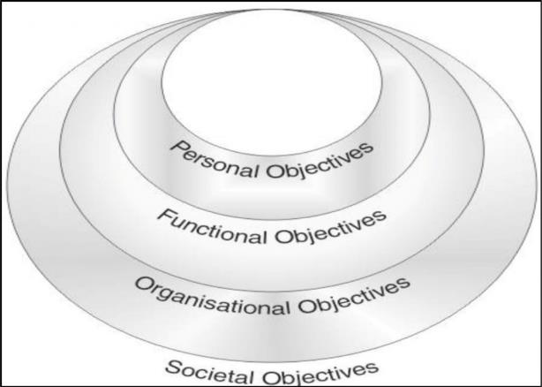

Figure 2: Human Resource Management Objectives

* **Functional Objectives:**

To preserve the contribution of department at a suitable level firm should fulfill the needs. Resources are not used when HRM is either more or less developed to suit the firm demands. (Sampras, 2019).

* **Personal Objectives:**

To provision Employees in achieving their personal objectives, as a minimum in so far as these objectives ameliorate the individual’s contribution to the firm. Personal objectives of employees must be preserved, booked and encouraged. (Sampras, 2019).

* **Societal Objectives:**

To be morally & socially accountable for the needs and challenges of society while reducing the negative impact of such demands upon the firm to use their resources for society’s benefits in ethical ways may lead to limit. (Sampras, 2019).

* **Organizational Objectives:**

To classify the role of HRM in fetching about organizational effectiveness, HRM is not a finish in itself but it is only a mean to contribute the organization with its main goals organization. (Sampras, 2019).

* **Other objectives:**
* To promote and preserve organizational structure and desirable working connections among all the participants of the organization.
* Develop harmonization among individual and groups within organization to protected the integration of organization.
* To spread an effective utilization of human resources in the accomplishment of organizational goals.
* Realize the basic organizational goals by making and utilizing an able and interested labor force.
* To generate services and chances for individual or group development so as to match it with the growing of the organization.
* To detect and satisfy individual and group requirements by providing satisfactory and reasonable wages, motivations, employee benefits and social security and measures for inspiring work, respect, gratitude, security, position.
* To preserve high employee’s morale and human relations by satisfying and improving the various conditions and facilities.
* To study and contribute to the minimization of socio-economic evils such as unemployment, under employment, inequalities in the distribution of income and wealth and to improve the welfare of the society by providing employment chances to women and disadvantaged sections of the society.
* To deliver an opportunity for expression and voice management.
* To offer services and conditions of work and creation of favorable atmosphere for maintaining stability of employment.
* Preserve high employee morale Training and development Opportunity for expression Provide fair, acceptable and efficient leadership Facilities and conditions.
* To create and utilize an able and motivated labor force Establish and maintain sound organizational structure Make facilities attain an actual utilization Identify and satisfy individual and group wants.
* To afford reasonable, adequate and effective leadership. (Sampras, 2019).

# **Lebanon’s Crippling Economic Crisis**

* + 1. **Historical Synopsis**

Following the Lebanese Civil War (1975-1990), Lebanon’s economy and markets became known for their private and liberal economic movement and openness to overseas with enormous capital, investments and labor mobility. In an article published by the Lebanese Embassy in Washington D.C, the major sectors of the economy were listed, where the “services” sector ranked first. “The Lebanese economy is based primarily on the service sector, which accounts for approximately 60% of GDP (down from approximately 70%. in the 1970’s). Major subsectors are commerce, tourism and financial services. Other components include health care and higher education.” (The Lebanese Embassy in USA, 2021).

In the beginning of the 1990s, Lebanon undertook an aspiring plan of social and economic renovation that complex widespread renewal of the country’s debilitated substructure, and it aimed at making Beirut, and Lebanon in general, a regional financial and commercial hub. However, abundant of the renovation strategy was reinforced through interior stealing, which controlled to the rise of both budget scarcities and a rising public debt. Nonetheless, in meanness of this debt, Lebanon was able to overcome the 2008 global economic recession with minimum setbacks. “Despite Lebanon’s uneasy economic recovery, its economy remained resilient in the face of the 2008 global economic recession. Increased domestic security contributed to investment and growth, while its small export base insulated the economy from the global downturn. From 2007 to 10, gross domestic product (GDP) growth averaged 8 percent.”. (Britannica, 2021).

Following the Syrian Crisis, the GDP development in Lebanon reduced to less than two percent from 2011 to 2017, as Lebanon had to contract with a enormous arrival of Syrian refugees as well as being reliant on a Syria’s economy that also faced a huge downfall ever since the crisis started.

For over three decades, since December 1997, the exchange rate of the Lebanese Lira has been secured at 1,507.5 Lebanese pounds per U.S. dollar. Nevertheless, since the 2019 economic catastrophe in Lebanon, a Black currency market has appeared with significantly higher exchange rates that reached 15,000 Lebanese Lira per U.S. D as of March, 2021. So, how did this dreadful economic recession happen?

* + 1. **The Lebanese Economic Meltdown - 2019**

Over the last few decades, many financial philosophies were drafted to explain the reasons behind sudden economic downfalls.

An economic recession is a turning point in the [economic](https://www.thebalance.com/what-is-the-business-cycle-3305912) sequence; it usually takes place when the economy decays and contracts following a full succession of growth. It is noteworthy to mention that consumer and business confidence are key elements that affect any economic recession. When confidence in the economy is lost, the demand consequently declines. Kimberly Amadeo states that there are twelve typical causes of an economic recession, namely:

1. High Interest Rates
2. Poor Management
3. Loss of Confidence in Investment and the Economy
4. Deregulation
5. Credit Crunches
6. A Stock Market Crash
7. Wage-Price Controls
8. When Asset Bubbles Burst
9. Falling Housing Prices and Sales
10. Post-War Slowdowns
11. Manufacturing Orders Slow Down
12. Deflation (Amadeo, 2021).

After the Lebanese civil war, the successive Lebanese cabinets started growing the public debt by providing capital bonds ruled by the Lebanese Pound, and then by dispensing Eurobonds[2]. Currently, the public debt has reached around 90 billion US dollars where around 33 billion comprise Eurobonds. (Chaker, 2020).

In the early 90s, Lebanon adjusted its financial accounts with tourism earnings, foreign care, incomes from its monetary business and the help of Gulf Arab states, which funded Lebanon by emphasizing central bank reserves. Though, one of its most reliable bases of dollars was remittances from the millions of Lebanese living abroad.

Following Syria’s crisis in 2011, remittances starting slowing down as well as the support provided by Gulf states due to political changes that occurred in the country. That was until 2016, when banks began offering important interest rates for novel creditors who wish to deposit fresh dollars, and even higher interest rates for Lebanese pound deposits.

Many economists defined Lebanon’s fiscal system as a “Ponzi scheme[3]”, where fresh money is hired out to pay existing creditors. It works until fresh money turns out. Ponzi scheme controllers promise great revenues with little to zero risk. But in reality, they use cash from new depositors to pay previous depositors and may take some of the cash for themselves.

In late September 2019, the Lebanese Pound started getting pegged in the black market at a relatively higher rate (1600 liras per U.S. dollar) than the official exchange one (1508 liras per U.S. dollar) due to the extreme shortage of dollars’ reserves.

In late 2019, the central bank issued several circulars enforcing limitations on cash withdrawals in foreign currencies, which directly suppresses people’s ability to withdraw US Dollar bank notes. The restrictions also targeted cash transfers within and outside Lebanon.

Four months into the crisis, these capital control measures escalated to the point where people were only allowed to withdraw around five hundred US dollars per month, or if they wish, they can withdraw them in Lebanese currency at the official exchange rate (1508 L.B.P per dollar) while the black market rate recorded 3000 L.B.P. per US dollar.

* + 1. **Deteriorating Living Conditions**

The Lebanese economic and political crisis which the state has been facing since late 2019 has led to widespread unemployment, skyrocketing prices, road blockages by angry protestors and non-defined governmental plans to mitigate the consequences of this severe downfall. By March 2021, the nation’s currency has reached a new low against the U.S. dollar, where it’s exchange rate sank to 15,000 to the Dollar on the black market, and then it rebounded to about 12,000.

In a country where most goods are imported, the currency’s downfall has left no sector unaffected. The sharp decline in the currency’s exchange rate devalued people’s salaries, where they lost around 85% of their initial value. Grocery store goods that were once considered affordable became out of reach. Many essential items and basic needs were no longer available such as milk on supermarket or pharmacies’ shelves, as well as fuel in gas stations. Other equally important basic items such as cooking oil and sanitary pads became extremely expensive as their prices peaked. “Food prices had risen 400 percent as of December compared with a year earlier, according to government statistics, while prices for clothing and shoes had gone up 560 percent and hotels and restaurants more than 600 percent” (Hubbard and Saad, 2021).

The rate of soldiers’ and police officers’ salaries has also collapsed, increasing fears of social unrest, theft and crimes across the country. In March 2021, Head of the Lebanese Army General Joseph Aoun, issued an exceptional public denunciation accusing the Lebanese political leaders with what the country has reached, and stating that soldiers are suffering and going hungry.

In addition, an end to subsidies (supported by the country’s central bank) is foreseen as the nation continues to use up its external reserves to support essential imports and basic things in the mid of the fast reduction of the local currency. Most of the Lebanese have be contingent on these grants since the middle of 2020 to afford day-to-day necessities like oil, bread and milk. In March 2021, Banque du Liban - the republic's central bank – “has seen its foreign exchange funds almost halved in just a year from a projected $30 billion to $16 billion. Of that, between $1 billion and $1.5 billion can still be earmarked for subsidies, enough to last two to three months”. (CGTN, 2021).

In an official announcement in March 2021, the Lebanese Minister of Finance Mr. Ghazi Wazni stated that many objects will be removed from the subsidized food basket, but he did not specify which items will be excluded. Upon his announcement, several UN agencies warned that the removal of subsidies will induce further harm to Lebanese people who are barely making a living. WFP stated in a report that this move will place an intolerable straining on household purchasing power and will consequently affect people’s food security. (Lebanon Crisis Response Plan, 2021). According to CGTN, “some 60 percent of Lebanese people are already struggling to put food on their table as steep inflation prices everyday essentials out of their reach and more than half the population has fallen victim to poverty”. (CGTN, 2021).

# **The Lebanese Public Sector: A Threatening Reality**

* + 1. **General Outlook**

When the second world war ended, Lebanon was colonized by Allied Forces and placed under French armed supervision. Around that time, and under the French management, most public utilities were either formed or improved.

In a study prepared by Dr. Georges Labaky, a professor at Notre Dame University, he explained the development of the nation and its public services as the reproduction of the statement “the infallibility of the State” which provides all possible services such as health facilities, education, safety and security, maintains the culture, resolves unemployment and ensures the overall development of the state. But during this process, the citizen is looked upon as a passive agent, while all the legal work is dictated by the state (Labaky, 2015).

According to a study published by ETF, there are around 110 000 workers who work in the public sector, where around 30,000 are formally employed through the Civil Service Board (CSB)[4] and advantage from its benefits such as health security. Conversely, the rest are hired as daily workers or contractuals. Furthermore, the CSB stated that the percentage of vacancies available in the public sector is approximately 69.50%. One of the dominant public sector groups are military and security services where around 86,000 people are hired. (Abou Jaoude, 2015).

Ever since it was created, the public sector was always confronted with a series of criticism due to its bureaucratic structure, the waste of resources in it and the poor relations with its citizens. The Lebanese administration is met with significant challenges of various nature (such as competition, new technologies, …) which induces huge complications. This reality opened the door to various improvements, consultancies, and reforms. However, all those considerations and modifications weren’t very successful in causing any significant change due to the lack of clarification of public service objectives.

* + 1. **Wages and Benefits Policies**

Within the Lebanese Public Sector, most of the expenses are spent on employees’ salaries and wages, which rounds up to around fifty-six percent.

The army forces and military personnel take up the biggest chunk of these wages and bills, in addition to the Parliament and Ministries Personnel and offices. However, in terms of civilian workers, the employees in both Foreign Affairs and Justice ministries make up the major shares, which are approximately 31% and 12% respectively. (Ministry of Finance Lebanon, 2018).

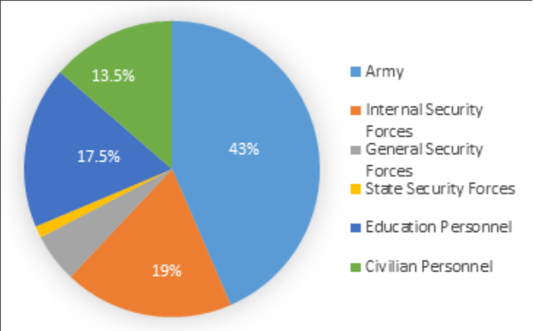

Figure 3: Breakdown of salaries, wages and benefits as % of total wage bill, January 2018.

Prior to the economic crisis that hit Lebanon in 2019, Le Borgne argued that retirement allowances and benefits were considered the most generous of all benefits. “For example, retired senior army and security officers can receive substantial compensation, reaching up to a US$300,000 lump sum in addition to monthly pensions and full medical coverage” as cited by (Saab, 2019). Nevertheless, these wages’ scales and benefits plans are designed based on the “Series of Ranks and Salaries” which is passed through Parliamentary voting and cabinet execution. In addition, all human resources related regulations are certainly centralized to the designated ministries and all governmental institutions have to abide.

# **HRM Role During Economic Recessions**

Since the beginning of the year 2020 (and early 2019), the real image of the struggling economy started to be felt when individuals and organizations began encountering financial limitations on cash withdrawals and transfers.

Employees in the private sector as well as the public sector were no longer able to get to work due to road blocks and protests, many of them got laid off and another portion started sharing jobs with their colleagues as part-timers. With the COVID-19 outbreak in March 2020, the situation became even worse and more aggravated, as people were no longer able to attend work physically due to continuous lockdown measures.

This newly imposed flexibility on previous HR limitations, such as working from home and flexible working hours, forced employers to search for new ways to manage human resources within their enterprises. Another aspect that they had to deal with was emotional distress, work anxiety, and burnout.

During economic crises, when revenues decrease, employers tend to cut down on human resources by laying off employees and merging certain terms of reference. Conversely, in more favorable scenarios, businesses tend to reduce HR costs and benefits such as holiday bonuses, loyalty bonuses, salary increases. According to the Families and Work Institute in its 2009 publication, "The Impact of the Recession on Employers" (Mayhew, no date), any reputable business that is wishing to survive any downfall must prioritize its employees’ benefits. It’s human resources personnel, and the incorporated standard operating procedures, must lead the process of retaining employees, and keeping them updated about their work conditions, benefits, and the overall strategy the company will be taking to overcome the recession.

According to (Mayhew, no date)[5], during any economic recession, human resource management is entitled to work on several aspects/areas to ensure risk mitigation and maximizing productivity, as well as maintaining, retaining and motivating employees. The main areas are:

* **Trust Leadership:**

Human Resources Management practitioners are entitled to address employees with frequent announcements, facts, and decisions which enhances trust in the company’s leadership. This effective communication implies transparency and can directly affect employees’ loyalty to the firm they work in. The loss of trust between the employees and the administration has proven to be one of the main reasons of why employees leave their job, according to Leigh Branham's book titled, "The Seven Hidden Reasons Employees Leave: How to Recognize the Subtle Signs and Act Before It's Too Late." While writing his book, Branham examined around 20,000 exit interviews created by the Saratoga Institute.

* **Company Status**

In the business world, most of the companies and businesses are prone to getting affected by economic recessions, even the most recession-proof ones such as essential products and services can endure massive downfalls. In all cases, the role of HR is to help the management in overcoming the recession with minimum damage, by explaining to the internal audience their business strategy, position and direction.

* **Staffing**

One of the main roles of HR during any crisis is to assure its employees that their contracts are binding and their jobs are safe. If the jobs are at risk, then the HR must clarify that to the employees in advance and take all the possible measures to reduce the magnitude of their layoffs, be it on the company or on them as individuals. Some examples are early notice periods, early retirement opportunities, compensations… etc. In case companies wish to retain their employees, then they usually tend to provide overtime hours instead of hiring new staff as a way to reduce costs.

* **Payroll and Benefits**

Undeniably, during any economic recession, pays and benefits shrink down and would not seem very appealing as during an economic recovery. In such cases, the HR’s role becomes very essential in sustaining employees’ pay by taking smart steps such as modifying healthcare plans, insurance plans, and cutting down on saving accounts. The HR must also counsel employees on possible ways to save money and reduce payroll deductions such as contributing in charities and giveaways.

# **Summary of Literature Review**

Human Resources Management is about managing and dealing with people at work, their work conditions, their relationship with the company/enterprise, as well as ensuring all business goals are achieved by employees whose human talents are supported and nurtured. One of the chief objectives of human resources management is to guarantee having competent and prepared employees within an organization; this objective comprises personal, functional, organizational and societal objectives that are embedded within it.

Since October 2019, Lebanon has been struggling to survive an economic recession that resulted from years of economic, political and financial mismanagement. The Lebanese Pound lost more than 90% of its value in less than 18 months, a situation that exacerbated the already crippling living situation of the Lebanese society.

During these dire circumstances, people became unable to pay for basic needs which were considered affordable just less than two years ago. In addition, many essential items are no longer available in supermarkets and shops such as milk and babies’ milk. The Covid-19 pandemic and the measures imposed by the government to contain its spread worsened the economic situation as many businesses closed and further jobs were lost.

One of the most affected groups by this crisis were public sector employees, whose salaries are paid in Lebanese Pound, hence losing 80% of their purchase power. Within the Lebanese Public Sector, employees are divided into different groups, such as fixed-term employees, day-to-day employees, contracted employees… etc. Nevertheless, only 30% of them are officially hired through the Civil Service Board (CSB) and benefit from social protection and health security. Prior to the aforementioned economic crisis, public sector salaries, allowances and benefits were considered quite substantial, especially when it comes to fixed-term employees. But the current situation switched the situation upside down and these salaries became devalued.

During economic downfalls, the role of human resources management is extensively grown to ensure risk mitigation, maximize productivity, as well as maintain, retain and motivate employees. According to HRM practitioners, the main aspects that need to be tackled during such tough times are: 1) Leadership; 2) Company Status; 3) Staffing; 4) Payroll and Benefits.

# **CHAPTER 3: RESEARCH METHODOLOGY**

This chapter[6] is mainly concerned with the six layers of the research onion: research philosophy, research approach, research strategy, choices, time horizons and data collection techniques and analysis procedures.

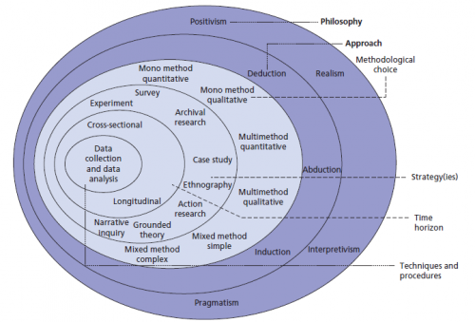

Figure 4: The Research Onion (Saunders, M., Lewis, P., Thornhill, A., 2006)

# **Research Philosophy**

Saunders, M., Lewis, P., Thornhill, A. (2006), define research philosophy as “a system of beliefs and assumptions about the development of knowledge”. In this part, we will tap on five distinct business management philosophies, namely: positivism, critical realism, interpretivism, postmodernism and pragmatism.

1. Positivism:

Positivism revolves around studying the scientific characteristics while incorporating an observable social reality to generate guiding deductions that act like laws. This philosophy entails accurate and truthful understandings as shown in Francis Bacon, and Auguste Comte writings.

1. Critical Realism:

Critical realism is an area of philosophy that examines what we see and experience with respect to their actual reality. Roy Bhaskar introduced this form of philosophy in the late twentieth century after analyzing “positivist direct realism” and “postmodernist nominalism” and proposing it as a strike balance between them.

1. Interpretivism:

Interpretivism indicates that humans create meanings to things, which is an added value that differentiates them from rigid physical phenomena. Interpretivism delves into the social worlds and contexts when studying human beings; it states that natural sciences and physical phenomena should be approached in a different manner than that of social sciences.

1. Postmodernism:

Linguistics and dialectology take up a huge part of the postmodernism philosophy. It focuses on the impact of language and power dynamics (reflected in the dialogue) in shaping the discussion and the accepted ways of thinking, as well as voicing out relegated points of view.

1. Pragmatism:

Pragmatism is generally associated with practicality and actionability. In pragmatism, a proposition is accepted only when its applicability is proved, while unworkable ideas are non-valid.

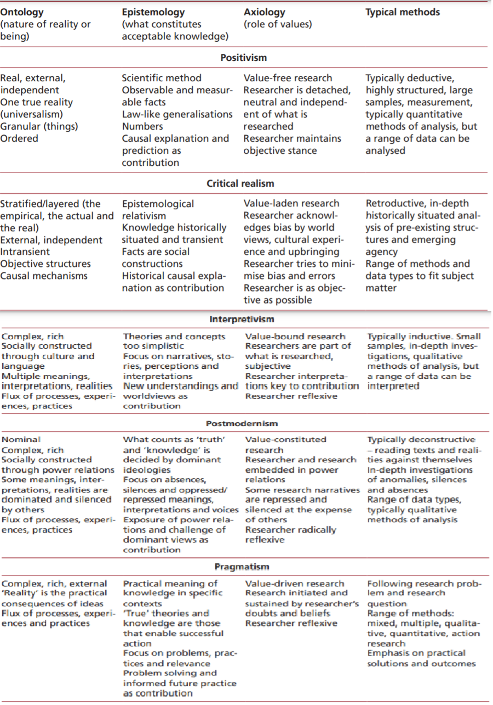

Figure 5: Research Philosophies (Saunders, M., Lewis, P., Thornhill, A., 2006)

Through this project, the positivism approach that depends on quantitative data collection will be applied.

# **Research Approach**

There are three major approaches that can be embarked in any research. They can be summarized by inductive, deductive, and abductive approaches.

1. Deductive approach:

A research approach is considered “abductive” when a theory is proposed, based on literature readings, and then gets validated throughout the research.

1. Inductive approach:

A research approach is considered “inductive” when data is collected to form findings and build a theory.

1. Abductive approach:

A research approach is considered “abductive” when data is collected to track specific trends in order to build a theory or amend an already existing one, then testing it again for validation.

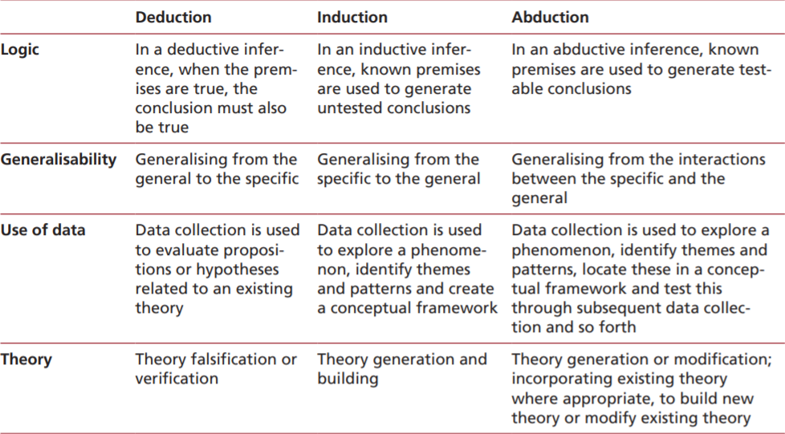

Figure 6: Research Approaches (Saunders, M., Lewis, P., Thornhill, A., 2006)

In this project, the deductive approach which builds on previously developed theories and intends to prove them will be applied.

# **Research Strategy (Data Collection Method)**

In this section we will focus on the research strategies or methods we may put into use while conducting a scientific research. According to (Yin, 2003), “each strategy can be used for exploratory, descriptive and explanatory research”. The methods that we will reflect in this section are:

1. Experiment:

An experiment is used to test and clarify the link between two variables: independent and dependent variables. One change in the independent variable will certainly cause a change or more in the dependent ones.

1. Survey:

A survey is a form of data collection that targets a pre-defined audience (respondents) aims to answer a set of questions. It is used for exploratory and descriptive research.

1. Case study:

A case study is a research strategy that targets one entity in order to come out with deductions and conclusions that can be later on generalized over several entities. It usually comprises empirical investigation of a phenomenon.

1. Action research:

Action research is a research strategy that is usually used in social sciences. It was first introduced by Lewin in 1946.

1. Grounded theory:

Initially introduced by Glaser & Strauss, the grounded theory comprises the collection and analysis of data, in order to “ground” or “build” a theory based on a series of observations and interpretations.

1. Ethnography:

This theory is derived from anthropology. It deals with studying the social world.

1. Archival research:

This strategy depends on documentation and administrative records as a main data source. It is usually used in historical researches.

In this research, a survey design will be applied, in which data are collected through a structured close-ended questionnaire to form deductions.

**Data Collection**

A structured closed-ended questionnaire was used to examine and verify the hypothesis on the relationship between the economic crisis and its impact on the Lebanese public sector employee’s performance and satisfaction.

A representative sample of 100 employees from Baalback municipality (our case study) were randomly chosen to answer the questionnaire. The total number of employees in the municipality is 207, so the chosen sample reflects 50% representation.

Respondents' responses were collected through Kobo-Collect program and coded under the SPSS program for statistical analysis to test variables and conclude deductions, trends and propose recommendations.

The first set of questions are demographic questions (gender, age, and educational level of the respondents), while the others are structural questions intended to understand and verify the effect of the economic crisis on Lebanese public sector employees’ performance, loyalty and satisfaction.

# **Research Methodological Choice**

There are two distinct terms that differentiate data collection and analysis techniques: One is called “quantitative” and the other is “qualitative”. In the below dissertation, we will explain each one separately and specify which one is used throughout this research.

A “quantitative” research is the type of research that depends on numerical data that can be generated from specific data collection techniques such as surveys, questionnaires…etc. in order to track trends, build deductions and generalize results.

Conversely, a “qualitative” research depends on non-numerical data that can be generated from interviews to delve into ideas and experiences, which are later on divided into themes to be analyzed.

A researcher can either use a (mono method) by applying a single data collection technique, or (multiple methods) by applying more than one data collection technique.

In this research, the quantitative method is being used to test the hypothesis, where responses will be embedded as numerical data into the data processing system to be used (SPSS).

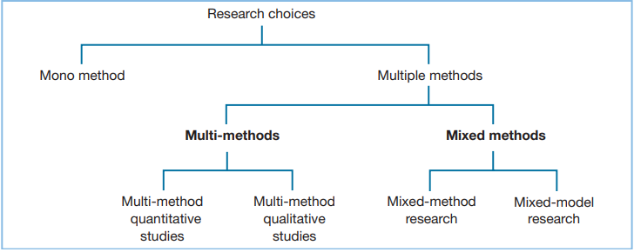

Figure 7: Research Choices and Methods (Saunders, M., Lewis, P., Thornhill, A., 2006)

# **Time horizon**

There are two types of time frames that can be planned for a research: cross-sectional and longitudinal.

A cross-sectional time horizon is used when the researcher intends to take a “snapshot” of the situation at a specific point in time.

Whereas, a longitudinal time horizon is used when the researcher intends to study the representation of events over a period of time, not a single snapshot. It mainly studies change and development over time.

An important question to be asked in planning a research is ‘Do I want my research to be a “snapshot” taken at a particular time or do I want it to be more akin to a “diary” and be a representation of events over a given period?’. The ‘snapshot’ time horizon is what we call as cross-sectional while the ‘diary’ perspective is called longitudinal.

The cross-sectional perspective will be adopted in this research paper as data will be collected only once as a “snapshot” of the situation.

# **Techniques and/or Procedures for Data Analysis**

Our intended population for this survey are the employees in Baalback Municipality – a sample from the Lebanese public sector employees. The data for this research will be collected through a survey (quantitative method) that is made up of closed-ended questions and a predefined list of answer options. The main objective of these questions is to understand the impact of the economic crisis on Lebanese public sector employees.

Data will be collected through 100 surveys. Employees’ responses will be coded under the SPSS program (Statistical Package for the Social Sciences) for statistical analysis. The data will be analyzed and some survey questions will be correlated to test variables and conclude deductions, trends and propose recommendations.

# **CHAPTER 4: FINDINGS AND ANALYSIS**

# **Introduction**

This part intends to provide data sets that will answer the research’s question, and verify or nullify the proposed hypothesis. The SPSS program was used to analyze the results of the questionnaire that was distributed to 100 employees at Baalbeck Municipality.

# **Findings (Descriptive Statistics)**

**Frequencies**

1. **Overview of demographic characteristics:**

|  |  |  |  |  |  |
| --- | --- | --- | --- | --- | --- |
| **Age** | | | | | |
|  | | Frequency | Percent | Valid Percent | Cumulative Percent |
| Valid | 19 | 1 | 1.0 | 1.0 | 1.0 |
| 23 | 1 | 1.0 | 1.0 | 2.0 |
| 24 | 1 | 1.0 | 1.0 | 3.0 |
| 25 | 1 | 1.0 | 1.0 | 4.0 |
| 27 | 2 | 2.0 | 2.0 | 6.0 |
| 28 | 2 | 2.0 | 2.0 | 8.0 |
| 29 | 3 | 3.0 | 3.0 | 11.0 |
| 30 | 5 | 5.0 | 5.0 | 16.0 |
| 31 | 3 | 3.0 | 3.0 | 19.0 |
| 33 | 11 | 11.0 | 11.0 | 30.0 |
| 35 | 3 | 3.0 | 3.0 | 33.0 |
| 36 | 6 | 6.0 | 6.0 | 39.0 |
| 37 | 1 | 1.0 | 1.0 | 40.0 |
| 38 | 3 | 3.0 | 3.0 | 43.0 |
| 39 | 1 | 1.0 | 1.0 | 44.0 |
| 40 | 2 | 2.0 | 2.0 | 46.0 |
| 41 | 2 | 2.0 | 2.0 | 48.0 |
| 42 | 4 | 4.0 | 4.0 | 52.0 |
| 43 | 4 | 4.0 | 4.0 | 56.0 |
| 44 | 5 | 5.0 | 5.0 | 61.0 |
| 45 | 4 | 4.0 | 4.0 | 65.0 |
| 46 | 2 | 2.0 | 2.0 | 67.0 |
| 47 | 3 | 3.0 | 3.0 | 70.0 |
| 48 | 3 | 3.0 | 3.0 | 73.0 |
| 49 | 2 | 2.0 | 2.0 | 75.0 |
| 50 | 3 | 3.0 | 3.0 | 78.0 |
| 51 | 2 | 2.0 | 2.0 | 80.0 |
| 52 | 4 | 4.0 | 4.0 | 84.0 |
| 53 | 2 | 2.0 | 2.0 | 86.0 |
| 54 | 1 | 1.0 | 1.0 | 87.0 |
| 55 | 2 | 2.0 | 2.0 | 89.0 |
| 57 | 2 | 2.0 | 2.0 | 91.0 |
| 58 | 3 | 3.0 | 3.0 | 94.0 |
| 60 | 1 | 1.0 | 1.0 | 95.0 |
| 61 | 1 | 1.0 | 1.0 | 96.0 |
| 62 | 2 | 2.0 | 2.0 | 98.0 |
| 63 | 1 | 1.0 | 1.0 | 99.0 |
| 64 | 1 | 1.0 | 1.0 | 100.0 |
| Total | 100 | 100.0 | 100.0 |  |

Table 1: Age Demographic Characteristics

|  |  |  |  |  |  |
| --- | --- | --- | --- | --- | --- |
| **Gender** | | | | | |
|  | | Frequency | Percent | Valid Percent | Cumulative Percent |
| Valid | Male | 92 | 92.0 | 92.0 | 92.0 |
| Female | 8 | 8.0 | 8.0 | 100.0 |
| Total | 100 | 100.0 | 100.0 |  |

Table 2: Gender Demographic Characteristics

The participants who respond to the questionnaire are 100 employees. 92 out of them are Males and 8 are females.

|  |  |  |  |  |  |
| --- | --- | --- | --- | --- | --- |
| **Educational Level** | | | | | |
|  | | Frequency | Percent | Valid Percent | Cumulative Percent |
| Valid | Bachelor and above | 21 | 21.0 | 21.0 | 21.0 |
| High school | 21 | 21.0 | 21.0 | 42.0 |
| intermediate | 40 | 40.0 | 40.0 | 82.0 |
| Primary | 18 | 18.0 | 18.0 | 100.0 |
| Total | 100 | 100.0 | 100.0 |  |

Table 3: Educational level Demographic Characteristics

This table indicates that the majority of the respondents (40 employees) are within the “intermediate education” level, while 18 employees have only pursued primary education, 21 employees are within the “high school education” level and 21 employees acquired a Bachelor’s degree and above.

|  |  |  |  |  |  |
| --- | --- | --- | --- | --- | --- |
| **For how many years have you been a public sector employee?** | | | | | |
|  | | Frequency | Percent | Valid Percent | Cumulative Percent |
| Valid | 1 | 1 | 1.0 | 1.0 | 1.0 |
| 2 | 6 | 6.0 | 6.0 | 7.0 |
| 3 | 2 | 2.0 | 2.0 | 9.0 |
| 4 | 2 | 2.0 | 2.0 | 11.0 |
| 5 | 3 | 3.0 | 3.0 | 14.0 |
| 6 | 2 | 2.0 | 2.0 | 16.0 |
| 7 | 4 | 4.0 | 4.0 | 20.0 |
| 8 | 5 | 5.0 | 5.0 | 25.0 |
| 9 | 6 | 6.0 | 6.0 | 31.0 |
| 10 | 6 | 6.0 | 6.0 | 37.0 |
| 11 | 10 | 10.0 | 10.0 | 47.0 |
| 12 | 9 | 9.0 | 9.0 | 56.0 |
| 13 | 2 | 2.0 | 2.0 | 58.0 |
| 14 | 1 | 1.0 | 1.0 | 59.0 |
| 15 | 2 | 2.0 | 2.0 | 61.0 |
| 16 | 3 | 3.0 | 3.0 | 64.0 |
| 17 | 4 | 4.0 | 4.0 | 68.0 |
| 18 | 4 | 4.0 | 4.0 | 72.0 |
| 19 | 3 | 3.0 | 3.0 | 75.0 |
| 20 | 6 | 6.0 | 6.0 | 81.0 |
| 21 | 2 | 2.0 | 2.0 | 83.0 |
| 22 | 6 | 6.0 | 6.0 | 89.0 |
| 23 | 2 | 2.0 | 2.0 | 91.0 |
| 27 | 1 | 1.0 | 1.0 | 92.0 |
| 28 | 1 | 1.0 | 1.0 | 93.0 |
| 30 | 1 | 1.0 | 1.0 | 94.0 |
| 33 | 2 | 2.0 | 2.0 | 96.0 |
| 39 | 1 | 1.0 | 1.0 | 97.0 |
| 40 | 1 | 1.0 | 1.0 | 98.0 |
| 41 | 1 | 1.0 | 1.0 | 99.0 |
| 42 | 1 | 1.0 | 1.0 | 100.0 |
| Total | 100 | 100.0 | 100.0 |  |

Table 4: Number of years of work

|  |  |  |  |  |  |
| --- | --- | --- | --- | --- | --- |
| **What is the type of your contract** | | | | | |
|  | | Frequency | Percent | Valid Percent | Cumulative Percent |
| Valid | Daily | 60 | 60.0 | 60.0 | 60.0 |
| Contracted | 3 | 3.0 | 3.0 | 63.0 |
| Permanent | 37 | 37.0 | 37.0 | 100.0 |
| Total | 100 | 100.0 | 100.0 |  |

Table 5: type of contract

This table shows that most of employees work as a daily worker (60), 37 of them are a permanent worker and the lowest percentage is the contractor worker (3).

**Descriptive Statistics**

|  |  |  |  |  |  |
| --- | --- | --- | --- | --- | --- |
| **Descriptive Statistics** | | | | | |
|  | N | Minimum | Maximum | Mean | Std. Deviation |
| was your income generated before the economic crisis sufficient/satisfactory? | 100 | 1 | 2 | 1.62 | .488 |
| to what extent has the economic crisis affected your purchase power? | 100 | 1.00 | 1.00 | 1.0000 | .00000 |
| are you still performing the same tasks with the same frequency as prior to the economic crisis? | 100 | 1.00 | 2.00 | 1.5200 | .50212 |
| have you considered leaving your job and finding an alternative job after the economic crisis occurred? | 100 | 1.00 | 2.00 | 1.4400 | .49889 |
| are you looking for a part time job? | 100 | 1.00 | 2.00 | 1.0500 | .21904 |
| do you still feel a teamwork spirit when working with your colleagues? | 100 | 1.00 | 2.00 | 1.4800 | .50212 |
| compared to the situation before the economic crisis do you still have the same enthusiasm when dealing with clients? | 100 | 1.00 | 2.00 | 1.7500 | .43519 |
| do you think that the procedures taken by the institution help in improving your performance? (same salary with the economic crisis) | 100 | 1.00 | 2.00 | 1.9400 | .23868 |
| within this situation do you feel that you could be creative and make innovative issues? | 100 | 1.00 | 2.00 | 1.7900 | .40936 |
| Valid N (listwise) | 100 |  |  |  |  |

Table 6: Descriptive statistics

**Frequencies**

|  |  |  |  |  |  |  |  |  |  |  |
| --- | --- | --- | --- | --- | --- | --- | --- | --- | --- | --- |
| **Statistics** | | | | | | | | | | |
|  | | was your income generated before the economic crisis sufficient/satisfactory? | to what extent has the economic crisis affected your purchase power? | are you still performing the same tasks with the same frequency as prior to the economic crisis? | have you considered leaving your job and finding an alternative job after the economic crisis occurred? | are you looking for a part time job? | do you still feel a teamwork spirit when working with your colleagues? | compared to the situation before the economic crisis do you still have the same enthusiasm when dealing with clients? | do you think that the procedures taken by the institution help in improving your performance? (same salary with the economic crisis) | within this situation do you feel that you could be creative and make innovative issues? |
| N | Valid | 100 | 100 | 100 | 100 | 100 | 100 | 100 | 100 | 100 |
| Missing | 0 | 0 | 0 | 0 | 0 | 0 | 0 | 0 | 0 |
| Mean | | 1.62 | 1.0000 | 1.5200 | 1.4400 | 1.0500 | 1.4800 | 1.7500 | 1.9400 | 1.7900 |
| Median | | 2.00 | 1.0000 | 2.0000 | 1.0000 | 1.0000 | 1.0000 | 2.0000 | 2.0000 | 2.0000 |
| Mode | | 2 | 1.00 | 2.00 | 1.00 | 1.00 | 1.00 | 2.00 | 2.00 | 2.00 |
| Std. Deviation | | .488 | .00000 | .50212 | .49889 | .21904 | .50212 | .43519 | .23868 | .40936 |
| Variance | | .238 | .000 | .252 | .249 | .048 | .252 | .189 | .057 | .168 |
| Range | | 1 | .00 | 1.00 | 1.00 | 1.00 | 1.00 | 1.00 | 1.00 | 1.00 |
| Sum | | 162 | 100.00 | 152.00 | 144.00 | 105.00 | 148.00 | 175.00 | 194.00 | 179.00 |

Table 7: Frequencies statistics

**Frequency Table**

|  |  |  |  |  |  |
| --- | --- | --- | --- | --- | --- |
| **Was your income generated before the economic crisis sufficient/satisfactory?** | | | | | |
|  | | Frequency | Percent | Valid Percent | Cumulative Percent |
| Valid | Yes | 38 | 38.0 | 38.0 | 38.0 |
| No | 62 | 62.0 | 62.0 | 100.0 |
| Total | 100 | 100.0 | 100.0 |  |

Table 8: Frequency results of income

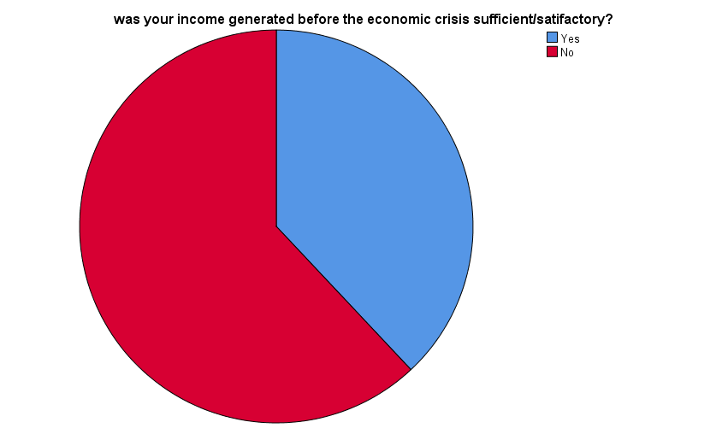

Figure 8: Pie Chart results of income

|  |  |  |  |  |  |
| --- | --- | --- | --- | --- | --- |
| **To what extent has the economic crisis affected your purchase power?** | | | | | |
|  | | Frequency | Percent | Valid Percent | Cumulative Percent |
| Valid | Strong | 100 | 100.0 | 100.0 | 100.0 |

Table 9: Frequency results of purchasing power

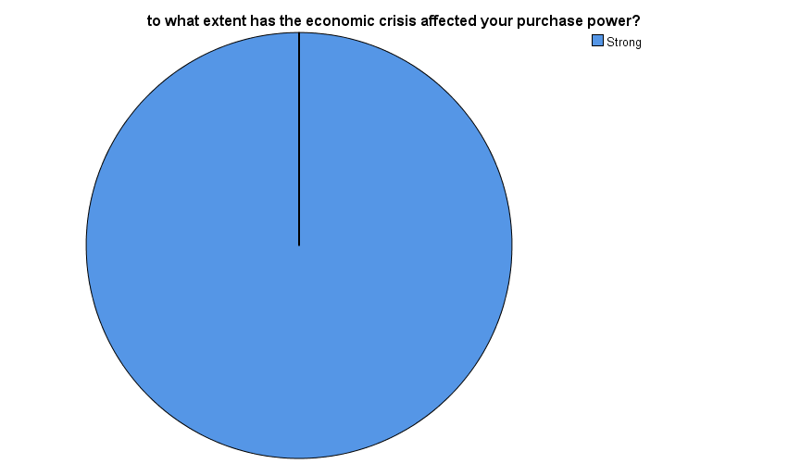

Figure 9: Pie Chart results of the purchasing power

|  |  |  |  |  |  |
| --- | --- | --- | --- | --- | --- |
| **Are you still performing the same tasks with the same frequency as prior to the economic crisis?** | | | | | |
|  | | Frequency | Percent | Valid Percent | Cumulative Percent |
| Valid | Yes | 48 | 48.0 | 48.0 | 48.0 |
| No | 52 | 52.0 | 52.0 | 100.0 |
| Total | 100 | 100.0 | 100.0 |  |

Table 10: Frequency results of performing tasks

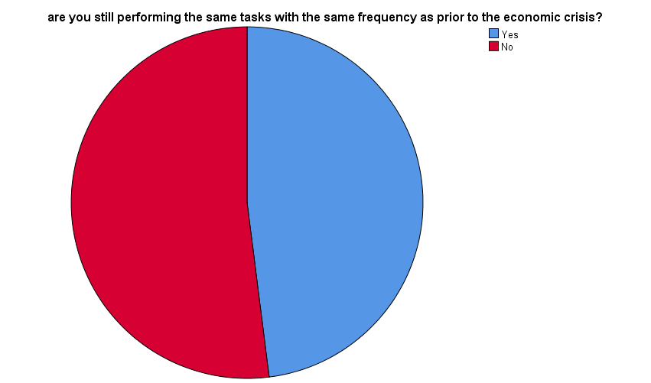

Figure 10: Pie Chart results of performing tasks

|  |  |  |  |  |  |
| --- | --- | --- | --- | --- | --- |
| **Have you considered leaving your job and finding an alternative job after the economic crisis occurred?** | | | | | |
|  | | Frequency | Percent | Valid Percent | Cumulative Percent |
| Valid | Yes | 56 | 56.0 | 56.0 | 56.0 |
| No | 44 | 44.0 | 44.0 | 100.0 |
| Total | 100 | 100.0 | 100.0 |  |

Table 11: Frequency results of leaving job

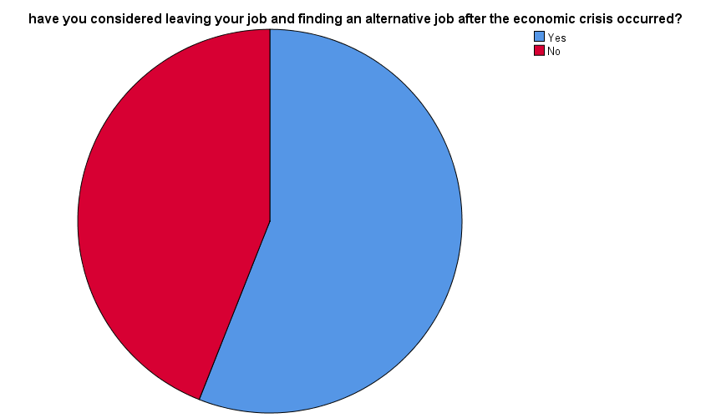

Figure 11: Pie Chart results of leaving job

|  |  |  |  |  |  |
| --- | --- | --- | --- | --- | --- |
| **Are you looking for a part time job?** | | | | | |
|  | | Frequency | Percent | Valid Percent | Cumulative Percent |
| Valid | Yes | 95 | 95.0 | 95.0 | 95.0 |
| No | 5 | 5.0 | 5.0 | 100.0 |
| Total | 100 | 100.0 | 100.0 |  |

Table 12: Frequency results of part time job

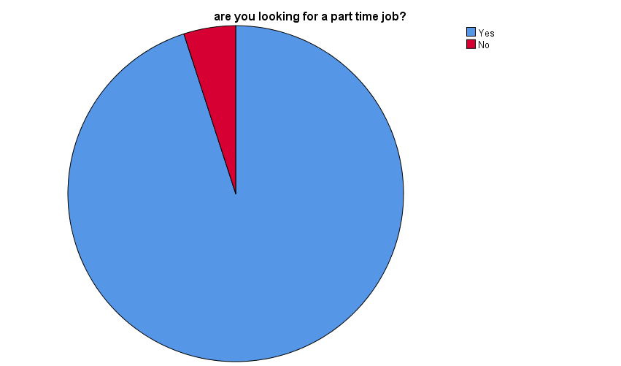

Figure 12: Pie Chart results of part time job

|  |  |  |  |  |  |
| --- | --- | --- | --- | --- | --- |
| **Do you still feel a teamwork spirit when working with your colleagues?** | | | | | |
|  | | Frequency | Percent | Valid Percent | Cumulative Percent |
| Valid | Yes | 52 | 52.0 | 52.0 | 52.0 |
| No | 48 | 48.0 | 48.0 | 100.0 |
| Total | 100 | 100.0 | 100.0 |  |

Table 13: Frequency results of teamwork spirit

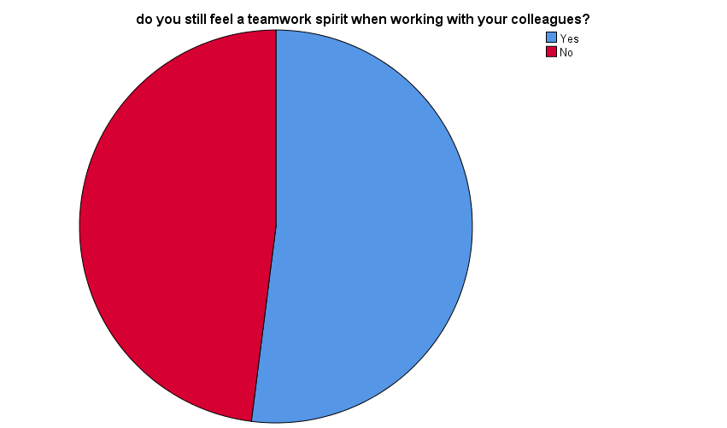

Figure 13: Pie Chart results of teamwork spirit

|  |  |  |  |  |  |
| --- | --- | --- | --- | --- | --- |
| **Compared to the situation before the economic crisis do you still have the same enthusiasm when dealing with clients?** | | | | | |
|  | | Frequency | Percent | Valid Percent | Cumulative Percent |
| Valid | Yes | 25 | 25.0 | 25.0 | 25.0 |
| No | 75 | 75.0 | 75.0 | 100.0 |
| Total | 100 | 100.0 | 100.0 |  |

Table 14: Frequency results of enthusiasm when dealing with clients

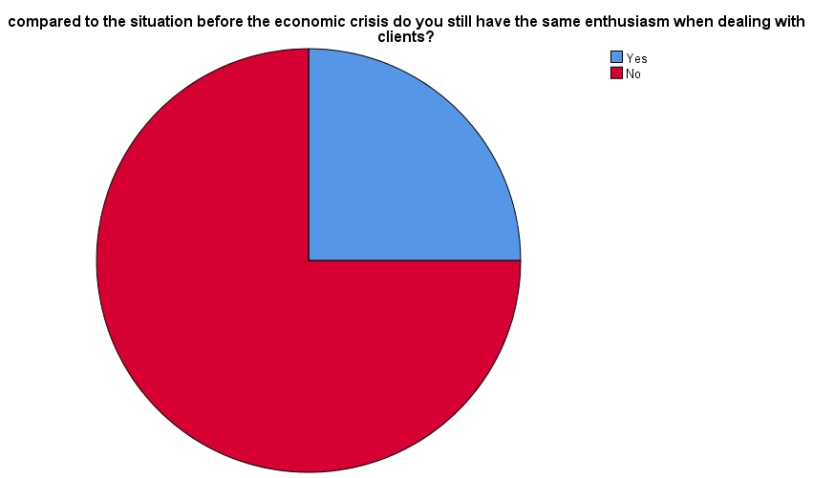

Figure 14: Pie Chart results of enthusiasm when dealing with clients

|  |  |  |  |  |  |
| --- | --- | --- | --- | --- | --- |
| **Do you think that the procedures taken by the institution help in improving your performance? (same salary with the economic crisis)** | | | | | |
|  | | Frequency | Percent | Valid Percent | Cumulative Percent |
| Valid | Yes | 6 | 6.0 | 6.0 | 6.0 |
| No | 94 | 94.0 | 94.0 | 100.0 |
| Total | 100 | 100.0 | 100.0 |  |

Table 15: Frequency results of the procedures taken by the institution

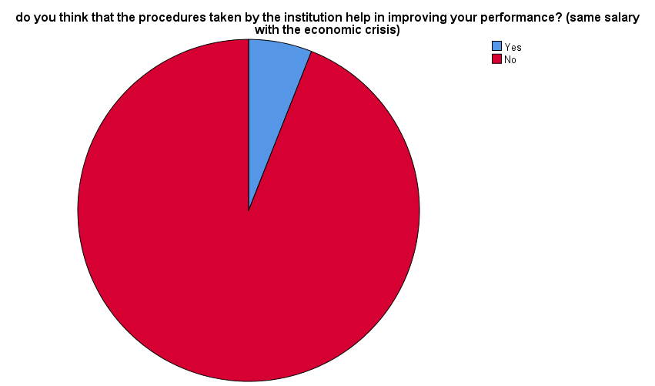

Figure 15: Pie Chart results of the procedures taken by the institution

|  |  |  |  |  |  |
| --- | --- | --- | --- | --- | --- |
| **Within this situation do you feel that you could be creative and make innovative issues?** | | | | | |
|  | | Frequency | Percent | Valid Percent | Cumulative Percent |
| Valid | Yes | 21 | 21.0 | 21.0 | 21.0 |
| No | 79 | 79.0 | 79.0 | 100.0 |
| Total | 100 | 100.0 | 100.0 |  |

Table 16: Frequency results of creativity and innovation

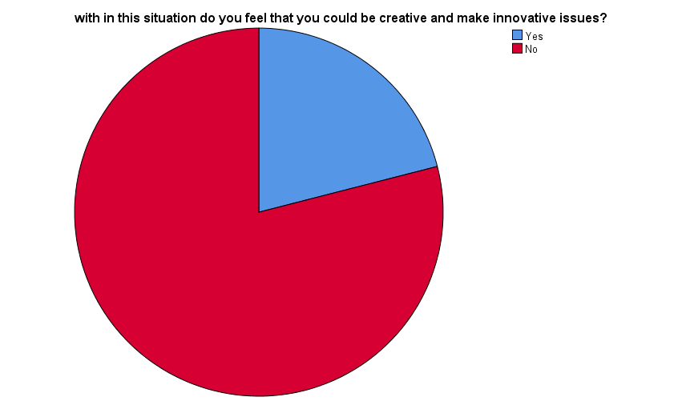

Figure 16: Pie Chart results of creativity and innovation

**T-Test**

Table 17: T-Test Results

|  |  |  |  |  |
| --- | --- | --- | --- | --- |
| **One-Sample Statistics** | | | | |
|  | N | Mean | Std. Deviation | Std. Error Mean |
| was your income generated before the economic crisis sufficient/satisfactory? | 100 | 1.62 | .488 | .049 |
| to what extent has the economic crisis affected your purchase power? | 100 | 1.0000 | .00000a | .00000 |
| are you still performing the same tasks with the same frequency as prior to the economic crisis? | 100 | 1.5200 | .50212 | .05021 |
| have you considered leaving your job and finding an alternative job after the economic crisis occurred? | 100 | 1.4400 | .49889 | .04989 |
| are you looking for a part time job? | 100 | 1.0500 | .21904 | .02190 |
| do you still feel a teamwork spirit when working with your colleagues? | 100 | 1.4800 | .50212 | .05021 |
| compared to the situation before the economic crisis do you still have the same enthusiasm when dealing with clients? | 100 | 1.7500 | .43519 | .04352 |
| do you think that the procedures taken by the institution help in improving your performance? (same salary with the economic crisis) | 100 | 1.9400 | .23868 | .02387 |
| within this situation do you feel that you could be creative and make innovative issues? | 100 | 1.7900 | .40936 | .04094 |
| |  |  |  |  |  |  |  | | --- | --- | --- | --- | --- | --- | --- | | **One-Sample Test** | | | | | | | |  | Test Value = 0 | | | | | | | t | df | Sig. (2-tailed) | Mean Difference | 95% Confidence Interval of the Difference | | | Lower | Upper | | was your income generated before the economic crisis sufficient/satisfactory? | 33.208 | 99 | .000 | 1.620 | 1.52 | 1.72 | | are you still performing the same tasks with the same frequency as prior to the economic crisis? | 30.272 | 99 | .000 | 1.52000 | 1.4204 | 1.6196 | | have you considered leaving your job and finding an alternative job after the economic crisis occurred? | 28.864 | 99 | .000 | 1.44000 | 1.3410 | 1.5390 | | are you looking for a part time job? | 47.936 | 99 | .000 | 1.05000 | 1.0065 | 1.0935 | | do you still feel a teamwork spirit when working with your colleagues? | 29.475 | 99 | .000 | 1.48000 | 1.3804 | 1.5796 | | compared to the situation before the economic crisis do you still have the same enthusiasm when dealing with clients? | 40.212 | 99 | .000 | 1.75000 | 1.6636 | 1.8364 | | do you think that the procedures taken by the institution help in improving your performance? (same salary with the economic crisis) | 81.279 | 99 | .000 | 1.94000 | 1.8926 | 1.9874 | | within this situation do you feel that you could be creative and make innovative issues? | 43.727 | 99 | .000 | 1.79000 | 1.7088 | 1.8712 | | | | | |

Table 18: One Sample Test Result

**Correlations:**

This table shows that there is a significant relationship between the procedures taken by the municipality and the employee creativity and innovation within the economic situation.

|  |  |  |  |
| --- | --- | --- | --- |
| **Descriptive Statistics** | | | |
|  | Mean | Std. Deviation | N |
| do you think that the procedures taken by the institution help in improving your performance? (same salary with the economic crisis) | 1.9400 | .23868 | 100 |
| within this situation do you feel that you could be creative and make innovative issues? | 1.7900 | .40936 | 100 |

Table 19: Correlation Between the procedures taken by the institution and creativity and innovation

|  |  |  |  |
| --- | --- | --- | --- |
| **Correlations** | | | |
|  | | do you think that the procedures taken by the institution help in improving your performance? (same salary with the economic crisis) | within this situation do you feel that you could be creative and make innovative issues? |
| do you think that the procedures taken by the institution help in improving your performance? (same salary with the economic crisis) | Pearson Correlation | 1 | .283** |
| Sig. (2-tailed) |  | .004 |
| N | 100 | 100 |
| within this situation do you feel that you could be creative and make innovative issues? | Pearson Correlation | .283** | 1 |
| Sig. (2-tailed) | .004 |  |
| N | 100 | 100 |
| **. Correlation is significant at the 0.01 level (2-tailed). | | | |

Table 20: Correlation Between the procedures taken by the institution and creativity and innovation

This table shows that there is a significant relationship between the employee leaving his job and finding alternative job after the economic crisis and finding (looking) for a part-time job.

|  |  |  |  |
| --- | --- | --- | --- |
| **Descriptive Statistics** | | | |
|  | Mean | Std. Deviation | N |
| have you considered leaving your job and finding an alternative job after the economic crisis occurred? | 1.4400 | .49889 | 100 |
| are you looking for a part time job? | 1.0500 | .21904 | 100 |

Table 21: Correlation Between leaving jobs and looking for a part time job

|  |  |  |  |
| --- | --- | --- | --- |
| **Correlations** | | | |
|  | | have you considered leaving your job and finding an alternative job after the economic crisis occurred? | are you looking for a part time job? |
| have you considered leaving your job and finding an alternative job after the economic crisis occurred? | Pearson Correlation | 1 | .259** |
| Sig. (2-tailed) |  | .009 |
| N | 100 | 100 |
| are you looking for a part time job? | Pearson Correlation | .259** | 1 |
| Sig. (2-tailed) | .009 |  |
| N | 100 | 100 |
| **. Correlation is significant at the 0.01 level (2-tailed). | | | |

Table 22: Correlation Between leaving jobs and looking for a part time job

# **Analysis**

As shown above, in terms of demographics, a hundred employees responded to the questionnaire, where 92 of them were men and only eight were women. The respondents’ ages ranged between twenty and sixty years old.

When it comes to educational level, 40% of the respondents have pursued intermediate education, while 18% have only reached primary education; the rest have pursued secondary education and above, all of which make up less than 50%. These employees’ employment years within the public sector varied between 1 year (fresh entrance) and 42 years (almost retirement).

As for the type of work contract, the largest percentage goes to daily workers who make up 60%, followed by the permanent employees who scored 37%, while contractors only make up 3% of the total number of respondents.

As for the question whether your salary was sufficient to meet your needs before the economic crisis, the survey results showed that 38% people answered “yes”, whereas 62%were not paid enough. This indicates that serious defeat in terms of employee’s satisfaction has already been there before the economic crisis. Emotional, financial and psychological damage may occur when employees are not getting fair wages. There is no doubt that the economic crisis has affected all employees’’ purchasing power, which was validated through the survey with a 100% score, but the magnitude is definitely more intensified when it comes to employees who have been already suffering with unfair wages before the crisis.

When it comes to performance and job duties, 48% of employees answered that they are still doing their job with the same duties and at the same pace as before the crisis, while the majority (52%) answered that they aren’t anymore and that their overall performance had decreased over time. According to John P. Campbell, individual differences on performance are a function of three main determinants: declarative knowledge, procedural knowledge and skill, and motivation. (Campbell, 1990).

By looking at the given situation, we can clearly deduce that neither “declarative knowledge” nor “procedural knowledge” were the factors affecting employees’ performance, because these same employees were already doing the very same tasks just a few months ago, but now they aren’t anymore – at least not with the same pace – which indicates that lack of “motivation” is the key element in this equation.

When we asked what the employee thought about leaving his job and looking for an alternative job after the economic crisis, the answers were quite alarming with 56% answering yes, and 44% not willing to leave. This indication puts the municipality, and the whole public sector, at a very critical point of sudden staff turnover; experienced staff whom the institution has invested immensely in them are planning to shift careers due to the lack of trust in the system they have been part of for a very long time.

The survey also showed that 95% of employees are looking for part-time jobs, which is a very high percentage but quite expected due to the economic crisis that the country is going through. This points out that job performance is expected to decrease once these employees start with another job, hence affecting the overall quality of the work.

When it comes to personal interaction and work relationships, almost similar percentages (52% versus 48%) were recorded when answering the question “do you still feel a teamwork spirit when working with your colleagues?”. However, 75% of employees no longer feel the same enthusiasm when dealing with customers compared to the economic crisis. Consequently, this will certainly affect the image of the institution among Lebanese citizens, which is already part of a sector usually criticized in this aspect.

As for any possible HRM measures taken by the municipality to mitigate turnover risks and decrease the exacerbated consequences of the crisis, 95% of employees stated the institution hasn’t taken any measures. In fact, the lack of proactive solutions is leaving all employees in despair, especially that they work in a public institution where such solutions must follow a bureaucratic process. This also explains the high negativity percentage recorded when employees were asked whether they think they can be creative and come up with innovative solutions during this crisis, where 79% answered “no”.

Through the SPSS program, some variables from the survey were correlated and tested to figure out the level of correlation (linkage) between them. Positive correlation is obtained when the significance level is below (0.1), while the correlation is considered negative when the significance rate is above (0.1).

Table 20 shows that there is a significant relationship between the procedures taken by the municipality and the employee creativity and innovation within the economic situation. This can be linked to the theory presented in (Chapter 2 - HRM Role During Economic Recessions) by Mayhew that during any economic recession, human resource management is entitled to work on several aspects/areas to ensure risk mitigation and maximizing productivity, as well as maintaining, retaining and motivating employees.

# **Summary of Findings and Analysis**

Results from this study show that the economic crisis has direct, tremendous and alarming impact on the public sector employees’ performance, loyalty and satisfaction. The majority of Baalback municipality employees are no longer interested in the jobs they occupy, as the unprecedented economic downfall turned their lives upside down with little to no hope of going back to where it was. Their purchasing power have lost 90% of its value which made them now considered among the “unprivileged” social class.

When it comes to their performance, these employees have lost their enthusiasm to perform their daily tasks and many of them do not feel any sense of belonging to the institution they are in anymore. Most of them are looking for part time jobs, if not full-time jobs and are considering leaving the job they are in.

The lack of institutional human resources recovery plans or crisis management plans escalates the intensity of the crisis and pushes the employees further away from looking for any solutions.

# **CHAPTER 5: CONCLUSION, LIMITATIONS, AND RECOMMENDATIONS**

# **Conclusion**

The features of the economic and social crisis in Lebanon began to loom on the horizon starting August 2019 with the rise in the exchange rate of the US Dollar against the Lebanese Pound, for the first time since 1993, from the official rate of 1507.5 to 1530 on the black market, and it continued to rise after the October 17 movement. The first (2019), so that before the end of 2020, it crossed the 8,000 LBP barrier.

The Central Bank of Lebanon adopted a policy of supporting basic materials to prevent the collapse of the country and provide for the needs of the people, but in return, its reserves decreased to reach the threshold of the compulsory reserve of $ 17.5 billion, which threatens all sectors, especially the basic ones, in the provision of basic materials to citizens, the most important of which are medicines, medical supplies, foodstuffs and fuel due to the possibility that the state will stop subsidizing it and the inability to import it from abroad.

The unemployment rate is expected to rise to 65% if the current situation continues. As the size of the closed institutions reached 15 thousand establishments and 80 thousand people lost their work as a result of the closure of these institutions, meaning an increase in poverty rates and an insane increase in the number of unemployed, and this situation was reflected in an increase in immigration rates, and in the situation of crimes, so that the country witnessed an increase in car theft crimes and killing.

The financial deterioration was reflected in the standard of living of the Lebanese public sector employees. As the prices of goods and services increased, the purchasing power of citizens shrank by 80% and their incomes lost much of their power, and they were prevented from their bank deposits in dollars, and access to their deposits in pounds became restricted to a limited ceiling.

Through any crisis, the role of Human Resource Management is mandatory to develop policies and procedures to protect employees and the institution. The HRM function has to focus on the honest communication in the recession. The HRM function has to inform the employees fairly about the salaries, reductions, bonuses and number of staff in advance as the employees can prepare themselves for any potential risks. Economic conditions not only affect the talent pool within an institution, but it also affects its ability to hire.

Employees in Baalback municipality are a clear example of how the economic crisis has shifted public sector employees’ lives upside down. Their loyalty to the institution they work in, their job satisfaction and their productivity have been directly impacted by the ongoing crisis and the current work conditions.

In addition, the hierarchical and bureaucratic composition of the Lebanese public sector institutions hinder any foreseen solutions and remedies. The Lebanese law prohibits any reforms in the HR policies unless enforced by law amendments issued by the Parliament. The Ministry of Interior and Municipalities, who is the direct responsible ministry, hasn’t taken any measures to retain municipal staff.

# **Limitations**

No major challenges were recorded when submitting and filling out the survey form. However, it was noted that employees were expressing their opinions and the extent of their suffering with extreme anger and heavy hearts. One of daily workers who get paid less than the minimum salary range said, “I have been an employee for more than thirty years, and I cannot buy a bag of milk for my two-year-old son who suffers from lactose intolerance and cannot be breastfed. My salary is not enough to buy basic food items (bread and vegetables). On the third day of each month I am left with zero money and I start borrowing from relatives and friends. Each month is worse than the previous one.”

# **Recommendations**

Based on what has been clarified in the dissertation above, we can deduce that any potential HRM measures must be directly linked to national measures that should be taken across all public sector institutions. In order to alleviate the harm of this crisis on public sector employees, more flexibility in terms of issuing decentralized circulars that deal with human resources management must be granted.

Once this flexibility is granted, potential HRM measures could be put into action to solve or at least mitigate the exacerbated consequences of the economic recession. The “Global Journal of Commerce and Management Perspective” presents some of the measures can be as follows:

* **“Strategizing for slowdown:** Companies need to evolve a strategy to slow down their growth in the same manner as they would have planned for robust growth.
* **Rightsizing for survival:** While downsizing may be an absolute cut-down of manpower, many a time without much a thought to the aftermath of it, but rightsizing is a much more thoughtful and strategize action with a retention plan for high performers which ensures that an organization has optimized its manpower to see it through the recession times.
* **Cost reduction:** The focus of organizations will be great on reducing costs, and training may be one of the functions where budgets may get impacted majorly.
* **Flexibility for upturn:** In all the various HR measures to the see the organization through the pressures of global recession, the organization with a strategy and action plan for slowdown can retain the flexibility and muscle to revive and take an upturn when market show a positive trend. Organizations must not become so lean and weak in terms of market image that they have lost the ability to take an upturn when trends seem to change.
* **Proactive alert to top management:** Trainer's role takes precedence when there's an action plan proactively presented to the management. Training managers must be able to foresee the impact on the organization in the coming times and identify areas where the function can significantly contribute to the sustainability of the organization”. (Gaikwad and Berad, 2015).

In addition, a parallel plan must be addressed to solve the national economic crisis which will consequently solve these employees’ problems. All these steps contribute to alleviating the severity of the economic crisis on all segments of society, including public sector employees, because the crisis affected all segments of society, so once we analyzed this problem and moved to a new stage that contributes to the revival of the public institutions sector and the return of its employees to a normal life free of economic and social problems, then we can reach an effective state that contains competent employees who in return will contribute to the promotion and development of the public establishment.

# **REFERENCES**

Amadeo, K. (2021) ‘Causes of an Economic Recession’, *The Balance*, 7 February. Available at: https://www.thebalance.com/causes-of-economic-recession-3306010 (Accessed on: 04.04.2021).

American University of Beirut. (2020) *Managing HRM in Times of Crises: Challenges of the Lebanese Economic Crisis and the COVID 19 Pandemic*. Available at: https://www.aub.edu.lb/osb/news/Pages/Managing-HRM-in-times-of-crises.aspx (Accessed on 23.03.2021).

Abou Jaoude, H. (no date). ‘Labour Market and Employment Policy in Lebanon’, *ETF*. Available at: file:///C:/Users/Lenovo/Downloads/etf_employment_policies_lebanon.pdf (Accessed on: 08.04.2021).

Boundless Management. (2020) *Purpose of Human Resource Management.* Available at:https://courses.lumenlearning.com/boundless-management/chapter/purpose-of-human-resource-management/#:~:text=The%20Mission%20of%20Human%20Resource,to%20achieve%20the%20organization's%20goals (Accessed on 31.03.2021).

Campbell, J. (1990). *Handbook of Industrial and Organizational Psychology,* pp. 687-732. Palo Alto, CA: Consulting Psychologists Press, Inc.

Chaker, J. (2020) ‘The Lebanese Economic Crisis 101 (Part 1)’, Jadaliyya, 23 March. Available at: https://www.jadaliyya.com/Details/40855 (Accessed on: 04.04.2021).

*CGTN*. (2021) Available at: https://news.cgtn.com/news/2021-03-17/With-cash-drying-up-Lebanon-to-trim-subsidies-on-some-goods-YHorOnZEGI/index.html (Accessed on: 05.04.2021).

Gaikwad, Y. and Berad, N. (2015) *‘Changing Role of HR in managing Global Recession’*. Global Journal of Commerce and Management Perspective. Available at: https://www.longdom.org/articles/changing-role-of-hr-in-managing-global-recession.pdf (Accessed on: 13.05.2021)

Hubbard, B. and Saad, H. (2021) ‘Lebanon’s Financial Collapse Hits Where It Hurts: The Grocery Store’, *The New York Times*. Available at: https://www.nytimes.com/2021/03/22/world/middleeast/lebanon-currency-groceries.html (Accessed on: 05.04.2021)

International Labor Organization. (2020) *Rapid Diagnostic Assessment of Employment Impacts under COVID19 in Lebanon*. Available at: https://www.ilo.org/wcmsp5/groups/public/---ed_emp/documents/publication/wcms_754666.pdf (Accessed on 23.03.2021).

Kebede, T., Stave, S., Katta, M. (2020) *Facing Multiple Crises: Rapid assessment of the impact of COVID-19 on vulnerable workers and small-scale enterprises in Lebanon*. International Labor Organization. Lebanon: Beirut.

Lebanon Crisis Response Plan. (2021). *Reliefweb*. Available at: https://reliefweb.int/sites/reliefweb.int/files/resources/LCRP_2021FINAL_v1.pdf (Accessed on: 05.04.2021).

Labaky, G. (2015). ‘The Reform of the Lebanese Public Administration in the Framework of the Changing Role of the State’, *Defense Magazine*. Available at: https://www.lebarmy.gov.lb/en/content/reform-lebanese-public-administration-framework-changing-role-state (Accessed on: 08.04.2021).

Mayhew, R. (no date). ‘HR Issues in the Recession’, *Chron*. Available at: https://smallbusiness.chron.com/role-hr-during-recession-period-59133.html (Accessed on: 08.04.2021).

Narang, M. (no date) *Definition of Human Resources Management*. Available at: https://www.economicsdiscussion.net/human-resource-management/definition-of-human-resource-management/31830 (Accessed on 31.03.2021).

Office for the Coordination of Humanitarian Affairs. (2021) *ACT Alliance Alert: Lebanon Crisis, 16 March 2021.* Available at:https://reliefweb.int/report/lebanon/act-alliance-alert-lebanon-crisis-16-march-2021 (Accessed on 24.03.2021).

Picincu, A. (2019) What Is the Purpose of HR Management? Available at: https://bizfluent.com/info-7750751-purpose-hr-management.html (Accessed on 31.03.2021).

Sampras, A. (2019) *Objectives of HRM*. Available at: https://www.hrmexam.com/2019/06/20/objectives-of-hrm/ (Accessed on 01.04.2021)

Seth, S. (2020) ‘How Does a Eurobond Work?’, *Investopedia*, 6 March. Available at: https://www.investopedia.com/articles/investing/081815/how-does-eurobond-work.asp (Accessed on: 04.04.2021).

Saab, M. (2019). ‘The politics of public sector and tax reform in Lebanon’, *International Growth Center*. Available at: https://www.theigc.org/blog/the-politics-of-public-sector-and-tax-reform-in-lebanon/ (Accessed on: 08.04.2021).

The Lebanese Embassy in U.S.A. (2021) *The Economy*. Available at: http://www.lebanonembassyus.org/the-country-of-lebanon/the-economy/ (Accessed on: 04.04.2021).

U.S. Securities and Exchange Commission. (no date) *Ponzi Schemes*. Available at: https://www.investor.gov/introduction-investing/investing-basics/glossary/ponzi-schemes (Accessed on: 05.04.2021).

# **APPENDICES**

# **APPENDIX 1: QUESTIONNAIRES**



1. Demographic Characteristics:

* Age:
* Gender:
* Male
* Female
* Educational level:
* Bachelor and above
* High school
* intermediate
* education

1. For how many years have you been a public sector employee?
2. What is the type of your contract?

* Daily
* Contracted
* Permanent

1. Was your income generated before the economic crisis sufficient/satisfactory?

* Yes
* No

1. To what extent has the economic crisis affected your purchase power?

* Strong
* Moderate
* Weak

1. Are you still performing the same tasks with the same frequency as prior to the economic crisis?

* Yes
* No

1. Have you considered leaving your job and finding an alternative job after the economic crisis occurred?

* Yes
* No

1. Are you looking for a part time job?

* Yes
* No

1. Do you still feel a teamwork spirit when working with your colleagues?

* Yes
* No

1. Compared to the situation before the economic crisis, do you still have the same enthusiasm when dealing with clients?

* Yes
* No

1. Do you think that the procedures taken by the institution help in improving your performance? (same salary with the economic situation...)

* Yes
* No

1. Within this situation, do you feel that you could be creative and make innovative solutions to mitigate the consequences of the crisis on your job?

* Yes
* No

**Thank you for your cooperation**

# **APPENDIX 2: INTERVIEW FORMS**

# **APPENDIX 3:**

1. PPP: Purchasing Power Parity (PPP) “is a popular metric used by macroeconomic analysts that compares different countries' currencies through a "basket of goods" approach”. “Purchasing power parity (PPP) allows for economists to compare economic productivity and standards of living between countries. Some countries adjust their gross domestic product (GDP) figures to reflect PPP.”.
2. “The Eurobond is a type of bond that is issued in a currency that is different from that of the country or market in which it is issued. Despite its name, it has no particular connection to Europe or the euro currency”. (Seth, 2020).
3. A Ponzi scheme is “an investment fraud that pays existing investors with funds collected from new investors”. (U.S. Securities and Exchange Commission, no date).
4. The Civil Service Board conducts the official recruitment processes in the Lebanese public sector.
5. All the below mentioned points in this part were tracked from the same source (Mayhew, no date). Available at: https://smallbusiness.chron.com/hr-issues-recession-59599.html
6. The information in this chapter is tracked from the same source: (Saunders, M., Lewis, P., Thornhill, A., 2006).