**GRADUATE PROJECT**

**BMGT695: Graduate Project in Management**

**THE IMPACT OF TEAMWORK ON THE PRODUCTIVITY OF AN ORGANIZATION IN LEBANON**

**Submitted to the Lebanese International University**



The School of Business

in Fulfillment of the

Requirements for the Degree of

**MASTERS DEGREE IN MANAGEMENT**

by

**Mostafa Hsayke**

ID: 41130241

Nabatieh, Lebanon

Supervised by Dr. Mohamad Mtairek

Spring 2017 / 2018

**DEDICATIONS**

I dedicate this Graduate Project to my family members who were so supportive where they encouraged me to finish this study from all of my heart till the end. Special dedication to my mother my endless love that without her prayers I didn’t reach what I reached today.

I also dedicate this Graduate Project to my Advisor Dr. Mohamad Mtairek who was more than a mentor and guide in leading me doing the project the right way with supporting me with all the information I needed to complete this project.

Finally, I dedicate this project to Al Majmoua my second family at Al Majmoua who were as always more than supporting responding to all my demand without any delay or disturbance.

**ACKNOWLEDGEMENTS**

I acknowledge this Graduate Project to the Lebanese International University mainly, Nabatieh Campus in particular for all the efforts providing us in order to achieve what we achieved.

Moreover, many acknowledgments go to Dr. Mohamad Mtairek for mentoring and guiding me throughout this semester enlightening my way to complete this successful Graduate Project.

Finally, many thanks go to Mr. Omar Abdallah and Mrs. Amal Hallal for providing all the needed data and information, also with helping me in filling the questionnaires in order to examine the suggested hypothesis.

**ABSTRACT**

The impact of teamwork on the productivity of an organization in Lebanon is a critical topic that needs investigation in order to get to know the feedback of good teamwork and its effect on the organization; especially with the presence of a wide look that teamwork is not a core condition for a better productivity. So that, this Graduate Project started with a highlight on the main objectives of the project, then setting the hypothesis that helped in testing the main link between the variables. After that, a look on history of teamwork and main types was displayed aligned with a look on productivity and how to achieve it in an organization. This literature review was a start point to all the chapters beyond, where the method of examination was selected due to the data retrieved from the theoretical part. The main methods for data collection was the questionnaire as a first method with the aid of interviews, and the methods of data analysis where mainly two the SPSS software and the Excel. The analysis of data revealed with results that showed significance on the suggested hypothesis about a definite relationship between the variables among the selected organization. As for the organization, Al Majmouaa’ organization was selected for this study for the easy access to the information and sources which made the study successful. After that, the conclusion was drawn upon the revealed results and then the recommendations were listed with respect to the experience of Al Majmouaa’ in teamwork and productivity and then about the impact of each variable on the other. After all this, the questionnaire was attached in the appendices aligned with the signed interview form to be reviewed at any time. Eventually, the list of references was attached at the end of the Graduate Project in order to show the resources of the project and the source of each one.

**TABLE OF CONTENTS**

THE THEORETICAL FRAMEWORK 13

CHAPTER 1: INTRODUCING THE GRADUATE PROJECT 14

1. INTRODUCTION 14

1.1. Research Problem 15

1.2. Objectives of the Graduate Project 15

1.3. Research Hypothesis 16

2. OVERVIEW OF THE ORGANIZATION 18

1. 2.1.Al Majmoua 18
2. 2.2.History 18
3. 2.3.Selected Branches 19
4. 2.4.Financial Services 19
5. 2.5.Non-financial Services 20
6. 2.6.Vision 21
7. 2.7.Mission 21
8. 2.8.Core Values 22

CHAPTER 2: LITERATURE REVIEW 23

1. INTRODUCTION 23

2. TEAMWORK DEFINITION 24

3. OBJECTIVES OF BUILDING A TEAM 24

1. 3.1.Collaboration 24
2. 3.2.Communication 25
3. 3.3.Change Management 25
4. 3.4.Problem Solving 25
5. 3.5.Flexible Thinking 26
6. 3.6.Trust 26
7. 3.7.Vision 26
8. 3.8.Delegation 27

4. NEED FOR TEAMS 27

5. BENEFITS OF BUILDING AND MANAGING TEAMS 28

6. CHARACTERISTICS OF EFFECTIVE TEAMWORK 30

1. 1.1.Organizational Structure 30
2. 1.2.Individual Contribution 30
3. 1.3.Team Processes 30
4. 6.1.Organizational Structure 31
5. 6.1.1.Clear purpose 31
6. 6.1.2.Appropriate culture 32
7. 6.1.3.Specified task 32
8. 6.1.4.Distinct roles 33
9. 6.1.5.Suitable leadership 33
10. 6.1.6.Relevant members 33
11. 6.1.7.Adequate resources 34
12. 6.2.Individual Contribution 34
13. 6.3.Team processes 37
14. 6.3.1.Coordination 37
15. 6.3.2.Communication 37
16. 6.3.3.Cohesion 38
17. 6.3.4.Decision making 39
18. 6.3.5.Conflict management 39
19. 6.3.6.Social relationships 40
20. 6.3.7.Performance Feedback 40

7. KEYS TO CREATE PRODUCTIVE ORGANIZATIONS 41

1. 7 1.People Performance: 41
2. 7 2.Designed Environment 41
3. 7 3.Workflow: 42
4. 7 4.Technology 42
5. 7 5.Human Resources: 42

CHAPTER 3: RESEARCH METHODOLOGY 43

1. 1.DATA COLLECTION METHOD 43
2. 2.STUDY LIMITATIONS 47

CHAPTER 4: FINDINGS AND RESULTS 49

1. 1.DATA ANALYSIS METHOD 49
2. 2.FACT FINDING RESULTS 49

CHAPTER 5: CONCLUSIONS & RECOMMENDATION 75

1. 1.CONCLUSIONS 75
2. 1.RECOMMENDATIONS 78

REFERENCE LIST 85

APPENDIX A 88

**LIST OF TABLES**

*Table 1 Difference between Quantitative and Qualitative Research Methods 41*

*Table 2 Descriptive Characteristics 48*

*Table 3 Frequencies 50*

*Table 4 Frequency Results 51*

*Table 5 Frequencies Level 51*

*Table 6 Frequencies Level 52*

*Table 7 Frequencies Level 52*

*Table 8 Frequencies Level 52*

*Table 9 Frequencies Level 53*

*Table 10 Frequencies Level 53*

*Table 11 Frequencies Level 53*

*Table 12 Frequencies Level 54*

*Table 13 Frequencies Level 54*

*Table 14 T-test Results 66*

*Table 15 One Sample Test Results 68*

**LIST OF FIGURES**

*Figure 1 AL Majmouaa' Financial Services 14*

*Figure 2 Al Majmouaa' Non-financial Services 15*

*Figure 3 Al Majmouaa' Core Values 16*

*Figure 4 Characteristics of Effective Teamwork 23*

*Figure 5 Gender Demographic Characteristics 45*

*Figure 6 Employment Status Demographic Characteristics 45*

*Figure 7 Age Demograhpic Characteristics 46*

*Figure 8 Educational Level Demographic Characteristics 46*

*Figure 9 Pie Chart Results 55*

*Figure 10 Pie Chart Results 56*

*Figure 11 Pie Chart Results 57*

*Figure 12 Pie Chart Results 58*

*Figure 13 Pie Chart Results 59*

*Figure 14 Pie Chart Results 60*

*Figure 15 Pie Chart Results 61*

*Figure 16 Pie Chart Results 62*

*Figure 17 Pie Chart Results 63*

*Figure 18 Pie Chart Results 64*

**PART I**

# THE THEORETICAL FRAMEWORK

# CHAPTER 1: INTRODUCING THE GRADUATE PROJECT

## INTRODUCTION

The projects that tackled impact of teamwork on the productivity of an organization are many, yet few in Lebanon. As we mention the topic it is already a known concept, yet the new perspective in this project is the selected organization and the type of study and linkage between the variables.

According to S. Woolf (2016), studies indicate that more than 75% of the employers in an organization do rate collaboration and teamwork as an essential and very important. So according to this study it was essential to tackle this topic and highlight on it in order to know Lebanon’s situation as for this topic, since the absence of teamwork is a gap and this may impact an organization negatively, the reason that make this research a guide for all the organization that are seeking to include teamwork system within their policy for what studies show and many organizations experienced.

The impact of teamwork exceeds productivity of an organization, it can also impact the satisfaction of employees, the engagement of employee, the sustainability of an organization and finally the profits of an organization. Linkage between the mentioned variables will be shown and highlighted on throughout the project in an aim to enhance the teamwork of an organization and to show to effective teamwork can do a difference in any organization or company and vice versa a negative teamwork will lead to organization destruction and collapse. So yes teamwork can be a sword of two side and according to the way that it is implemented through the impact will be resulted accordingly.

Though, it is essential for all the organization to have at least an idea about teamwork and how it can be implemented correctly, positively, and effectively.

## Research Problem

Teamwork effectiveness exceed the productivity, and almost all the Lebanese organization underestimate this fact. So the main problem of this research was resulted from the underestimation of Lebanese organization of teamwork impact, and how it can influence an organization positively. So this study aims mainly to display a wide knowledge about teamwork, a deep intervention to the definition, successful teamwork, and how to implement it, and then a highlight on the productivity and how productivity can be influenced by teamwork, how are the two variables working responsively what other variables can be influenced other than just the productivity.

## Objectives of the Graduate Project

It is so essential to address “The impact of teamwork and its impact on the productivity of an organization in Lebanon” and have a highlight on it to benefit the Lebanese market and organizations in general so that they can benefit from the case study to perform in a better way for their success and development. The main objectives of this graduate project are the following:

* 1. To emphasize on the importance of teamwork in any organization.
  2. To raise the awareness that teamwork can impact an organization, so it is essential to discuss how and where it can be impacted.
  3. To confirm that teamwork affects directly organization’s productivity, therefore, organization’s efficiency and effectiveness.
  4. To link the two variables and examine the relationship between them in order to specify the nature of this relation.
  5. To suggest the most inspiring practices for an innovative teamwork to foster productivity of an organization.

## Research Hypothesis

In order to examine the relationship between two variables, it is a must to set a frame of work that called the hypothesis where the variables are identified in a way to specify the type of each one and if they are linked to each other or no. In this graduate project the main topic of the project is: “The impact teamwork on the productivity of an organization in Lebanon”, so the hypothesis should be aligned with the main idea of the topic specifying the two main variables, both the independent and dependent variables with the progress of the graduate project the relationship between them will be also identified in a better way. In particular, the independent variable in this graduate project is the team work where the term teamwork is represented by its characteristics that help to effectiveness, on the other hand, the productivity, and it is the dependent variable where it is estimated that with any change in the independent variable a change in the dependent variable will take place. So for a better understanding for the variables they should be addressed in one hypothesis to be tested using a specific test and due to certain conditions. Thus, the suggested hypothesis is the following:

**Null Hypothesis (H10):** Teamwork effective characteristics cannot impact the productivity level of an organization in Lebanon.

**Hypothesis (H11):** Teamwork effective characteristics can impact the productivity level of an organization in Lebanon.

## OVERVIEW OF THE ORGANIZATION

1. Al Majmoua

The selected organization is Al Majmoua, which is basically a micro-finance non-profit institution with a main focus to support the small businesses and micro-entrepreneurs mainly women, helping them to develop concept of sustainable businesses across Lebanon (Abdallah, 2018 ).

1. History

As O. Abdallah (2018), Al Majmoua the non-profit institution is an independent MFI and it do follow the international practices in order to produce the best outcomes (Abdallah, 2018 ).

The naming of this association came out from an Arabic word, which is a reflection in English to “the Group” in order to summarize a certain message within its name. Though, the institution was initiated in 1994, and by the year of 1997 the institution was registered as an NGO by the Lebanese Ministry of Interior with a non-profit perspective (Abdallah, 2018 ).

Today, Al Majmoua institution have a selective number of services as offering both individual and group loans, and many other non-financial services to the borrowers and even to the non-borrowers through 22 branch covering almost all the Lebanese regions (Abdallah, 2018 ).

1. Selected Branches

As mentioned Al Majmoua branches cover the whole Lebanese regions, from south to north, west to east, as for this Graduate Project the selected two branches were both Marjaayoun and Sohmour for the easy access and network at the two selected branches.

1. Financial Services

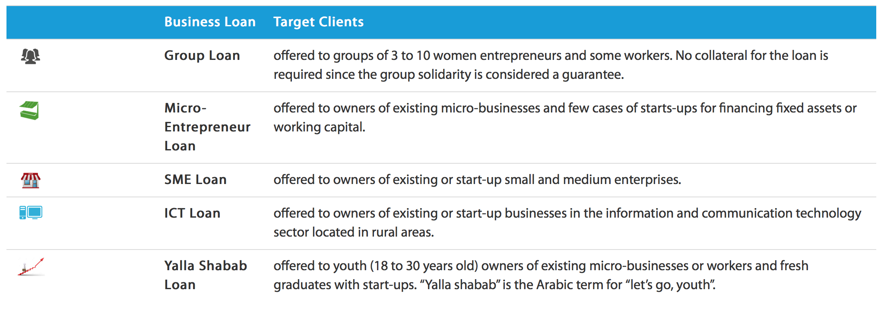

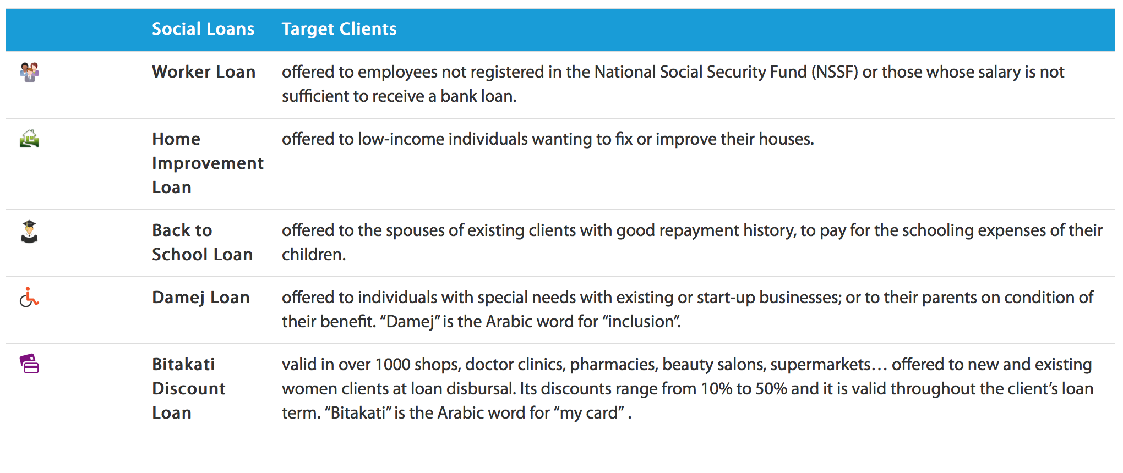

Figure 1 AL Majmouaa' Financial Services

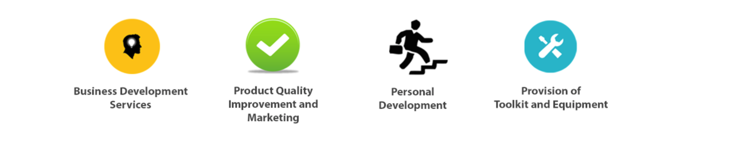

1. Non-financial Services

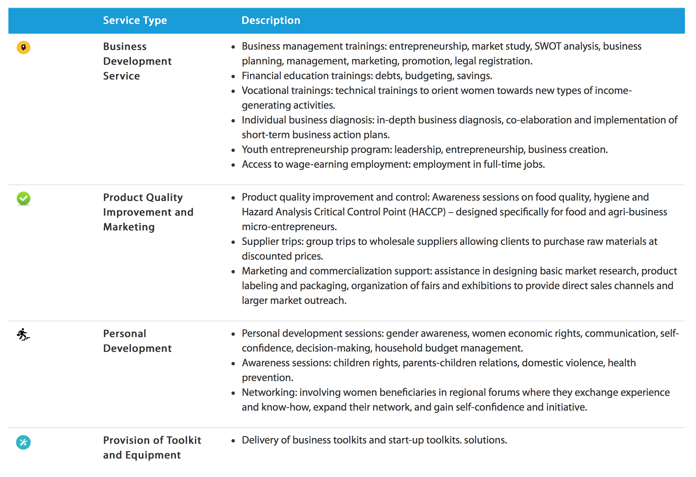

Figure 2 Al Majmouaa' Non-financial Services

1. Vision

Al Majmoua main vision statement is being a leader in the Lebanese market offering and creating most inclusive financial system equally to all the Lebanese with special access to the afforded services (Abdallah, 2018 ).

1. Mission

Al Majmoua mission is promoting sustainable development through enhancing both the social and economic conditions especially for the low-income individuals supporting mainly women and micro-entrepreneurs through provisioning with both financial and non-financial services across all the Lebanese regions (Abdallah, 2018 ).

1. 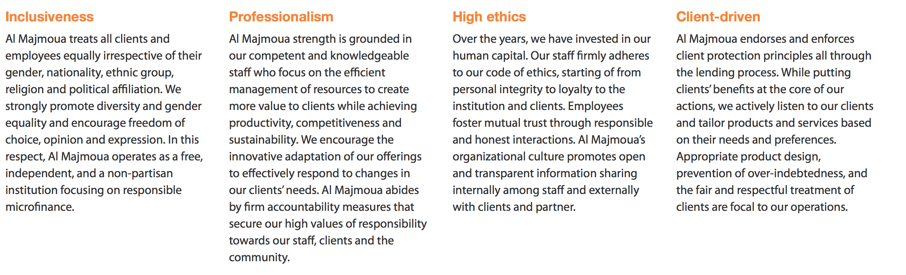Core Values

Figure 3 Al Majmouaa' Core Values

# CHAPTER 2: LITERATURE REVIEW

The purpose of this study is to review the impact of teamwork on the productivity of an organization in Lebanon, figure out the suitable practices, shedding the light on the areas that require some modifications, and finally to relate the two set variables and link them directly to the selected organization.

## INTRODUCTION

Messi L. (2015), emphasizing the importance of teamwork by referring that he was so lucky to be a part of a team, specifying that being among a team made him look good, and insisting that all the team members deserve the same credit as him since they all gave all the efforts to make any game successful (Messi, 2015). This declaration was objectively said by Messi, one of the most popular and innovative football player in the globe, mentioning this is so important in order to link the game with any project as the football game requires perseverance, planning, vision, teamwork a regular project do requires the same. As well, teamwork is a trait and it should exist in any job, hobby, or talent, and it shouldn’t be separated from a person’s personality.

As Kerpen D. (2017) emphasized on the importance of teamwork by saying: *“The difference between success and failure is a great team”* (Kerpen, 2017).

So Dave Kepren, the CEO of reputable organization Likeable referred that teamwork can influence the success or the failure of an organization and he insisted that he came to this conclusion through experience and real examples and stories.

Here’s simple examples showing the importance of teamwork and collaboration, in the literature review a highlight on the teamwork’s definition will be entitled, as well as the teamwork’s benefits, and the best applications to link this all then to the practical framework where all the theories will be linked to the real case of the selected organization to examine the topic on it and come out with the desired results.

## TEAMWORK DEFINITION

Teamwork was defined by Sun L. (2017) as the process toward working cooperatively with a gathering of individuals keeping in mind the end goal to accomplish an objective or a specified main purpose. Cooperation is regularly an urgent piece of a business, as it is frequently vital for partners to function admirably together, attempting their best in any condition. Collaboration implies that individuals will attempt to coordinate, utilizing their individual abilities and giving useful criticism, in spite of any individual clash between people (Sun, 2017).

## OBJECTIVES OF BUILDING A TEAM

According to Jarvis S. (2013), many are the objectives behind building a team, and it is important to mention them clearly in order to distinguish and understand them well. The objectives are as the following: Collaboration, Communication, Change Management, Problem Solving, Flexible Thinking, Morale Building, Trust, Vision, Delegation, Lean Thinking, Conflict Resolution. Below each one of the objectives will be addressed solely to maintain the understanding of each term.

* 1. Collaboration

Collaboration is absolutely important for a team, for a successful team must be aware of fruitful collaboration and how it reflects the goals and missions’ achievement. An organization should maintain collaboration as one of the related-cultural practices this will help employees to strive achieving a goal together. Training on collaboration can be achieved through different activities called the team building activities that will help to clarify the benefits and advantages of teamwork (Jarvis, 2013).

* 1. Communication

Communication is one of the success factors that not just help the organization but the team to achieve its goals. In particular, teams should be trained on all the aspects of communication as the verbal, non-verbal, and the body language where dealing with others should be considered well to avoid conflicts. Training on effective communication is important and can take place through workshops or internal and external trainings (Jarvis, 2013).

* 1. Change Management

Change is one of the most important factors that can be the reason of teamwork success, since the more the team is able to accept change and adapt it the more it can develop and achieve the desired objectives. The term discussed already can be called as well as the change management (Jarvis, 2013).

* 1. Problem Solving

It is something normal to face conflicts and problems, yet the thing lies in how the solution will be. Problem Solving is essential to successful and constructive to don’t leave an influence in the other side of the problem. The first thing to be done when applying the problem solving which is a thorough process is to face the problem facing the problem is half of the solution. Problem Solving can be taken as a course so that employees can be able to deal and know in which stage in problem they are and how they can implement the best solution with the minimum number of mistakes (Jarvis, 2013).

* 1. Flexible Thinking

Being flexible is a vital skill that should be present within any team, from the flexibility of thinking to the flexibility of dealing and listening, all the levels of dealing with the others need a flexible mind-set. Flexibility is totally demanded especially with the challenges that may arise at any time and all the team must hold up the responsibility together in a civilized way. This can help the organization as a whole since implementing such a culture will help in maintain the leadership skills and the decision making will enhanced among the employees (Jarvis, 2013).

* 1. Trust

A struggle will arise every time when the trust is weak among a team, and trust is one of the most basic and hard terms to be applied and used while dealing and collaborating as a team. Trusting the members of the team is essential and believing in their potential is also an important thing. Add to that employees can train on trust and can do trust based activities to enhance their trust in their colleagues (Jarvis, 2013).

* 1. Vision

Vision is divided into two parts, the big image of the organization and the simpler one of the employees and members and both should be aligned together in the same direction with the mission and the main objective and strategies of the organization, so that they cascade from the upper management to the lower management and lines to complete the capture. Add to that Understanding where you fit in to the bigger organizational goals can help an employee see their worth to the company and their feeling of being valued. (Jarvis, 2013).

* 1. Delegation

Delegation is more typical for group pioneers and supervisors as they all the more frequently want to assign undertakings or activities to their colleagues and subordinates. The capacity to assign adequately can likewise turn into an essential ability where a colleague may head up and singular venture with others answering to them (Jarvis, 2013).

## NEED FOR TEAMS

Attiyah M. (2003), affirmed that there will always be a reason or a problem that will oblige an organization to form and establish a teamwork or a task force to work together for achieving a certain purpose or aim, and some of the most signs that may require an organization to form a teamwork are as the following:

* The High level waste in FAO's resources and outputs of an organization.
* Increased complaints and discontent among the organization's members, focusing on partial and individual objectives.
* The manifestations of conflict and hostility among the members of the Organization.
* Not sharing information with others, and considering information as powerful.
* Blurred tasks and relationships.
* Lack of understanding and absorption of administrative decisions or failure to implement them appropriately.
* Weak loyalty and commitment, and signs of indifference among individuals.
* The lack of effective meetings and weak entrepreneurship and creativity.

Mentioned the most signs that can tell the need of forming a team or a workforce, yet an organization can witness other symptoms that may can be a sign to form and create a teamwork. The most essential thing is to know the best situation, time, and need for the formation of a teamwork, as well as mentioning it’s goals and purposes for all the team members for all to be clear their contribution and role (Al-Attiyah, 2003).

## BENEFITS OF BUILDING AND MANAGING TEAMS

According to Magloff L. (2017), through Team-building employees can perform better, in other words the company’s performance will all increase generally. In particular, team skills will witness an increase, communication, productivity and performance. Teamwork will able employees to share their experience, skills, and knowledge in a way they all benefit and develop their skills for a better level.

Improved Communication will be witnessed within the forming of a workforce or a teamwork, even though if employees already have a good communication skills team will teach them how to communicate better and in a modern way (Magloff, 2017).

Add to that, this will help in developing Team Roles in which each employee will be able to distinguish exactly what he/she is good at doing. Furthermore, team can be as an orientation and rotation for employees so that each one shares his/her experience in a specific field. For instance, if a team is working on an architectural project there has to be architects, engineers, consultants, accountants, project managers, and many more; that will be a perfect way to gain experience from other fields and share your experience (Magloff, 2017).

On the other hand, this can be clear in an example, supposedly a team of Human Resources Professionals are all together to come up with a certain project, this can be an ideal opportunity for any employee to take the time and develop his/ her own skills within the members of the same field as him/her. This can be great especially if each one of the professionals has a different educational background and each one of them have a diverse years of experience (Magloff, 2017).

Better Relationships will be formed with the formation of a team, each member of the team will know the others well, and they will attach and each one will start to search for the common points and common skills they can share (Magloff, 2017).

So that’s some of the benefits that can be achieved when building and managing teams.

## CHARACTERISTICS OF EFFECTIVE TEAMWORK

Figure 4 Characteristics of Effective Teamwork

The table previously specified three categories that without their presence and effectiveness the teamwork wouldn’t work as it should be. Some of these characteristics are common with the objectives mentioned before, yet these characteristics will be used as a measure for the questionnaire that will be later on distributed to the selected associations to examine the results.

A Study by Mickan S. and Rodger S. (2000), announced that the main three categories for an effective teamwork are the following:

* 1. Organizational Structure
  2. Individual Contribution
  3. Team Processes

Each one of the listed categories has some characteristics that without them a gap will take place in the formation of a teamwork.

* 1. Organizational Structure

Many theorists offer recommendations about the structural characteristics of teamwork, by referring to relatively stable procedures of coordination and control. Seven of the most commonly described structural characteristics include a clear purpose, appropriate culture, specified task, distinct roles, suitable leadership, relevant members, and adequate resources. They will be described in turn below.

* + 1. Clear purpose

West M. (1994), declared the essentiality and the need of an organization to have a stated obvious vision that underlie with the organization’s values and culture. That’s why usually an organization saturated generally through either the mission statements or particularly by the behaviour, code of conduct and the assumptions (West, 1994).

Beatty P. (1987) and Hedrick L. (1998), stated that when a mission statement is communicated and synchronised the values and assumptions across an organization this will lead to employees’ engagement and motivation (Beatty, 1987). So that a mission statement should say it all, it must reflect the main culture of an organization and its atmosphere from the simple things to the most complicated things (Leo, 1998).

Kirkman B. and Rosen B. (1999), identified that the flawless and measurable goals are as well derived from the mission statement, since the idea is that a mission statement is the upper management vision and planning of the things and the goals, objectives, aims all cascade from the main mission. So that it should be clear for all the team, thus each member can participate in setting the goals, by this way it will be easier for them to achieve the main goal and to better understand the task and the requirements and they will be working and striving to achieve them because of motivation (Kirkman & Rosen, 1999).

* + 1. Appropriate culture

Pearce J. & Ravlin E. (1987), they both declared the importance of teamwork with suggesting that teams should be integrated within the organization itself not solely, what can foster the work of an organization, and enhance employees’ motivation. On the other side, an organization should clearly state and define its expectation and its mechanisms of accountability for all teams so that they have a clear way to compare their behaviour with the code of conduct, rule, and regulations defined by an organization. Not doing so will lead to misguiding, and misleading in the authority where a team will start to prioritise its expectations regardless the vision of the organization (Pearce & Ravlin, 1987).

Furthermore, an organization must transform its values into practical standards to be used and applied by the formed teams.

Brill N. (1976), emphasized on the same idea that an organizational culture should transform the shared values into behavioural norms. An example on that, an organization that witnessed a huge success throughout its journey can easily reflect the success culture throughout its teams and employees this will foster the success of the team and individuals working in that association or organization (Brill, 1976).

* + 1. Specified task

Sundstrom E. (1990), clarified that the tasks must be clear and obvious so that a team can achieve them. In other words, Sundstrom insisted that teams require a task that end up with a tangible income or contribution to the association and at the same time aligned to the team purposes and aims, abilities and behaviours. In which, you can’t put purposes and tasks and you know that your team is weak at doing this task. Add to that, the tasks should be motivating for the members of a team, unless it is motivating for them they will not feel the responsibility to achieve it (Sundstrom, 1990).

* + 1. Distinct roles

Maple G. (1987), declared that essentiality of clarifying roles individually by all the team members, without the understanding there will be a gap in applying and executing the roles. On contemporary, constructing roles can be influenced by organizational factors, personal expectations, and interpersonal factors. In addition, the roles should be flexible and considerable to the differences of team members (Maple, 1987).

* + 1. Suitable leadership

Capko J. (1996), acknowledged the necessity of leadership with the increase of complexity and dynamicity of the team’s task. Here the role of leaders is to align the tasks with the vision of the organization, this will facilitate the goal setting process, and will follow with the ability to evaluate achievements. Another aspect for leadership, is the confident it gives especially when a leader delegates the responsibilities in an appropriate way. This can lead team members to become confident, independent, and proactive in doing their work (Capko, 1996).

* + 1. Relevant members

Hackman J. (1990), teams require a certain number of members exceeding or reducing the required number can impact negatively on the performance of the team, in addition to the number the quality of the members or the mix should be appropriate with a diversification in the tasks and the interpersonal skills to reflect some fruitful outcomes (Hackman, 1990).

Hckman J. (1990), added that in addition to the number and diversity a balance between heterogeneity and homogeneity of members’ skills, interests and backgrounds is likely preferred. The difference between a homogenous and heterogeneous team is that a homogenous team is made up of similar members who can complete tasks effectively with the minimum opportunity of conflicts. Whereas, heterogeneous teams are members that differ in the mind-set and have diversity and that is good to facilitate innovation, critical thinking, and problem solving skills (Hackman, 1990).

* + 1. Adequate resources

West A. (1994), in analysing the teamwork characteristics convinced that an organization should provide teams with fair financial resources, even with all the technical, administrative support and the professional education for them to reach the desired outcomes. A further thing that must be ready is the safety, without a safe physical environment team member will work with anxiety and fear, the better the physical the better the communication enhancement and cohesion. Where all the costs that may take place should be considered as resources for the team members (West, 1994).

* 1. Individual Contribution

Brill N. (1976), confirmed that the contributions done by an individual are not considered usually as antecedent condition, yet they can be considered as pre-requisite characteristics for the effective teamwork. Brill added that creating and monitoring the relations between employees especially those who have a variety of personalities and a bundle of experiences in both professional and unprofessional ways can be considered as a critical constituent for an applicable teamwork. For that, it is recommended for an individual to have minimum self-knowledge, commitment, trust, and flexibility (Brill, 1976).

* + 1. **Self-knowledge**

Blechert T. (1987), prolapsed that in a team each one of the members is a unique character and each member can bring a certain personality and position, where this can directly affect the function of the team (Blechert, 1987). In addition, employees or in other words members of the team need to be independent and aware before they feel the satisfaction, productivity, and respect of the other members of the team. That’s an important thing though employees or team members are able to produce and work but they still need to be self-aware and knowledgeable about their selves this can enhance their performance and productivity doing a project or a task (Blechert, 1987).

* + 1. **Trust**

Bassoff B. (1983), stated that competence and self-knowledge are both the origin of trust ability in an employee or individual. Trust isn’t a process of a day or two days it’s a process of a long time, that’s why trust is better when it takes slowly time to be built especially across team members where different competencies are found. As well, priorities, assumptions can differ especially through the development of confidence in others (Bassoff, 1983).

Trust can be an ideal skill to be achieved by the team members, thus individuals and employees will be willing to share their knowledge and skills without any fear such as the fear of diminishing or exploiting. Trust can often offer superior learning capacities with the incorporation of respect for other employees’ skills and expertise.

Developing respect needs an open discussion within the team members about the similarities and differences in each one of the employees with a highlight on the professional values and standards they like to share through dealing with each other.

Trust always develop better when the employees or the team members recognize an important thing which is the recognition and the appreciation of others unique skills and contributions to the project or task (Bassoff, 1983).

* + 1. **Commitment**

Ravlin E. (1987), indicated that the ability to trust aligned with the self-knowledge reveal as the building blocks of commitment. Thus, commitment is way in which the goals and values of a certain team can be united aligned with the right direction and the motive for the members of the team. In other words, the feeling of responsibility can increase the commitment rate. In addition to that, it is well known that committed employees especially team members will be more willing to make personal short term sacrifices, with the believe that this will help in generating a better mood for the team. Another thing that can be enhanced by the increase of commitment is the thrive among the employees and team members to challenges.

Normally, in an organization teams generate commitment through a common target for all the members and a one belief that the task can’t be solved and done otherwise else yet by team, where the delivery and coordination are always ready (Ravlin, 1987).

* + 1. **Flexibility**

The fourth thing should be found in team is the flexibility. The term flexibility means the ability to keep an accessible attitude, familiarise with different personal values, and to be open with the ideas of the team members.

Loxley A. (1997), added that flexibility usually requires reflection, regulation, self-knowledge, and honesty. The better an individual can understand the diversification in personal and professional values the better the outcomes and the lower the risk of judging others in accordance to their own value systems (Loxley, 1997).

* 1. Team processes

From its naming processes it is clear that its transforming input into output. While team processes are bundle aspects of both patterns and interactions for organizing that transform inputs into outputs. In teamwork case, team processes are described in terms of seven listed characteristics will be explained thoroughly below.

* + 1. Coordination

Pearce J. & Ravlin E. (1987), described coordination as the chronologically set of interpersonal actions needed for the performance of the complex tasks. In teams the need of connection is essential aligned with minimizing the differences of members to ensure that experts skills and knowledge are utilized in a well manner. Thus, development and evolution in a team without coordination will not be successful, that’s why a common target and shared understanding for both the team purpose and culture will definitely facilitate the coordination where the team members will be flexible to accept the costs and recognise the good outcomes of teamwork (Pearce & Ravlin, 1987).

* + 1. Communication

The importance of communication in all the aspects of the organization is exceptionally. Headrick L. (1998), declared that communication is essential and it does involve the observable substitution of information and a bundle interactions of power, values, and attitudes. For that, it is important for the effective teams to use a reliable communication process with a well-structured clearly specified responsibilities with suitable delegation.

Mutual knowledge cannot be attained without collaboration and frequent listening between employees and that’s so important in enhancing communication. Communication as well can be enhanced through the dual decision making and the formal-informal interchanges in an organization among employees. Communication enhancement would be enhanced better when all the meetings are agendas are clear and when all of meeting minutes mentioned carefully, as well the management is essential for an equal contribution from all the individuals’ sides (Headrick, 1998).

Communication has channels that should be taken into consideration to an effective communication between the team members. As well, any noise in these channels can amputate the message, where the messages can be formal and informal as well it can be verbal, non-verbal, written, and many more. So that, choosing the right communication tool and way is essential for a successful transmission of the messages, that all can help in enhancing a well and effective teamwork (Headrick, 1998).

* + 1. Cohesion

Huting P. (1996), declared that team cohesion grants employees and team members personal attraction to both the team and task. Where the members of the team can cooperate in an independent way around the team’s main task in order to achieve and meet the desired targets and goals.

In a social perspective, team members feel as if their future tasks belong to the team. Small team size, similar attitudes and physical proximity are achieved through cooperation. Also accurate performance feedback, good communication, success in adversity and conformity to norms will help in the success of this cooperation.

Coordination, communication and cohesion are highly dependent on the education about the teamwork through professionals in an organization that promote the interpersonal team processes. Due to the difference in the practice of professional models, offering education will minimise the different attitudes in the teamwork (Husting, 1996).

* + 1. Decision making

Kirkman L. (1999), affirmed that legitimate decisions and expanded information are usually a contribution of a broad range of employees or team members’ skills and knowledge.

The independency of an employee or a team member can be directly varying in accordance to the decrease or increase in the shared decisions and diffused responsibility. The used type of decision making usually not stable and changeable with respect to the situation, state, or condition of the team and as well with respect to the main purpose and aim of the structured team with the knowledge of its stage of development (Kirkman, 1999).

As it’s known that taking decisions by the employees or the team members can rise up some conflicts, yet the democratic voting tool can definitely reduce these interpersonal conflicts between employees saving the cost, time, and efforts of the members (Kirkman, 1999).

Further, the more the employee is active and participated in making the decisions, the more commitment and productivity can be increased (Kirkman, 1999).

* + 1. Conflict management

Payne M. (1982), announced that both creativity and destruction are formed from team conflict. It is the way the team perceive it, for the teams who value creativity and challenges can take it positively, whereas, the teams who perceive it in a negative way take it as negative effect. Positively, the teams the value creativity and innovative contributions, and promote an effective way to solve problems they need to have a careful management for the diversity.

Yet, the destructive team conflict is usually a reflection that has an interpersonal basis in either the work role or the organizational factors (Payne, 1982).

* + 1. Social relationships

Hackman J. (1990), added in the social relationships issue that the good social relationships can directly maintain effective teams. Where it is noticed that when the information is shared, the problems are solved collaboratively, and the practical assistance is offered then the team members are supportive to each other.

He added that teams’ effectiveness also revealed in the social networks that can enhance the access to the strategic information and to that where it can enhance better understanding for the tasks (Hackman, 1990).

* + 1. Performance Feedback

Firth-Cozens J. (1998), found that any performed work should be aligned with a feedback on time starting from an individual, to the team, as well to the whole organization. A given feedback regarding a done task can reveal a great note for the progress of a certain task.

Firth-Cozens J. (1998), recommended that the more balance in the traditional individual reward systems with team-based incentives the more congruent the team will become and this can directly impact the performance in a way or another, that can be a motivation for cooperation between team members rather than negative competition (Firth-Cozens, 1998).

## KEYS TO CREATE PRODUCTIVE ORGANIZATIONS

Boitnott J. (2015), insisted that specialists in productivity field, including job crafters, management consultants, and university researchers were surveyed to overwhelmingly cite five keys to create productive workplaces and organizations. The five keys are essential components to help improve performance and efficiency of individuals, teams, and organizations since this usually start on the personal level to spread to the organizational level as mentioned previously. The keys are as the following:

* 1. People Performance:

People performance can be achieved through several ways, starting be hiring and retaining effective personnel and management which can be a real investment for an organization. In addition, creating teamwork atmosphere will facilitate both communication and interaction between employees which means the ice breaking which can be a huge point to the motivation of employees to reach one objective and one goal which is the organizational strategic goal. Lastly, employees’ empowerment can give employees the spirit of authority and decision making which will impact the employees’ engagement in a certain organization.

* 1. Designed Environment

The general design and atmosphere can impress largely affect productivity. In addition, viewing the organization as a tool not just an expenditure is a must. Then, providing adequate access to resources including team members and equipment is essential. The design is so essential to enhance the productivity of employees, where the things can be done more easily and the operations can be facilitated to the maximum.

* 1. Workflow:

As well the workflow can be an enhancement to productivity, and this can be achieved through the redesigning work processes and the physical environment to improve workplace within workstations and throughout the office. And through implementing process efficiencies and reducing disruptions in workflow.

* 1. Technology

Technology had left impact in everything, even among productivity it has an impact through supporting the right tools – computers, software and the other appropriate equipment and making purchase and plan decisions with an eye to accommodating future needs.

* 1. Human Resources:

The last thing is the Human Resources, as all are important the Human Resources can be counted the one of the most important keys in productivity, through proposing guidance plus learning prospects. Then through upholding sufficient maintenance and support for staff levels. And through delivering competitive salaries, bonuses, rewards, and other incentives. Finally, through adopting flexible policies, such as flex-time and telecommuting.

**PART II**

**THE PRACTICAL FRAMEWORK**

# CHAPTER 3: RESEARCH METHODOLOGY

1. DATA COLLECTION METHOD

For this Graduate Project to be completed, an organization was selected in order to examine the suggested hypothesis upon the situation at this organization. In particular, to examine the hypothesis that was suggested at the very beginning a tool should be used for this examination, thus, the main data collection method that was selected is the Questionnaire, as the secondary tool the interview was used as an aid but not as the main source for information. So as M. Webster (2018), a questionnaire is a collection of questions and is used as a tool to obtain information from individuals the kind of such information are usually either personal or just useful information on a certain topic (Webster, 2018 ).

A questionnaire was set and designed of 10 questions covering the main topic of this Graduate Project which is “The impact of teamwork on the productivity of an organization in Lebanon”, each question in the questionnaire tackles a certain idea regarding the overall topic, and it was designed due to the effective characteristics of teamwork with linking it to the productivity, the questionnaire is attached within this Graduate Project in Appendix A.

As for the interview, it was done mainly to link the questionnaire results with the realistic situation that was reflected by Mr. Abdallah Sohmour Branch and Mrs. Hallal Marjaoun branch, the two branches were selected for the accessibility to get information from them, as well as they are two active branches with a suitable number of employees for them to respond to the questionnaire.

Returning back to the questionnaire design, the questions were all united with the same answer scale as open-ended questions, starting with “Extremely yes, Yes, Neutral, No, Extremely no” as an indication on emphasizing the term or refusing it, so the answer scale will be converted to values in the SPSS program in order to give each one of the variables a certain number and value that will help in determining the final result and the final situation. The type open-ended questions were mainly chosen to limit the respondents to the same scale and answers which will decrease biasness and will decrease wasting time and to make all the answers united under the same umbrella.

The questions of the questionnaire were all designed as a simple sentence with a simple clear words in order to be easy for the employees to understand them and to make it not that time consuming for employees to respond to them for the high number of respondents. In addition, at first some demographic characteristics were set in order to get to know well the characteristics of respondents such as the gender, educational status, age, and the employment status at al majmouaa in order to go further with the examination not just the regular examination. Then the questions took place to start with each one of the effective characteristics in order to give the respondent a situation he/she is experiencing at Al Majmouaa or not, upon the results the relationship between the suggested two variables will be revealed on and clearly identified.

So it is essential to highlight on the distribution of each variable in order to make the examination clear and make the results accurate. So the variables as the following:

Dependent Variable: Productivity Level of AL Majmouaa

Independent Variable: Level of Teamwork Efficiency (Effective Characteristics of teamwork).

So that as per the answers on the questionnaire the results will be shown, if the level of teamwork is clearly stated and the characteristics of teamwork are accurate at AL Majmouaa then the productivity of course is enhanced due to the successful implementation of teamwork.

The population of this Graduate Project are many, starting with the startups that want motivation to employees, and are trying hard to achieve sustainability. As well, any department that is witnessing any decrease in the performance of employees and less productivity on the level of the whole department should work hard on developing systems and activities to increase the productivity of employees and the productivity of the department as a whole. Moreover, organizations that are striving to develop their status regionally should work strongly on the teamwork concept since the trend all over the world is moving from individualism to collectivism, thus with joined efforts the success will be higher and higher.

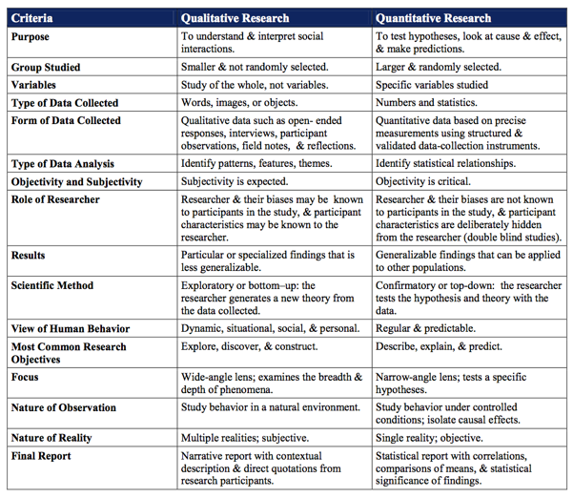As for the used method, quantitative method was used as the main method in collecting and analyzing the data, yet with the aid of qualitative data method in order to filter and get out with the maximum accurate results. The following is a brief differentiation between the qualitative and quantitative methods:

Table 1 Difference between Quantitative and Qualitative Research Methods

Highlighting on the interview, there were no structured questions to the interviews, the interview was mainly a regular conversation as a highlight on the situation at the two selected branches tackling the main chosen topic: “The impact of teamwork on the productivity of an organization in Lebanon”, so both Mr. Abdallah and Mrs. Hallal gave a highlight on their experience at AL Majmouaa especially regarding teamwork, and mainly Mr. Abdallah highlighted on the general information that were mentioned in the summary of the organization, where some of the information was retrieved from Mr. Abdallah and the other part from the official website of the organization. Even the interviews were not recorded or even written, the main data was given as hard copy and the other part of data were taken through internet from the official website.

So at the end, the data that will be examined is mainly the data retrieved from the questionnaire, yet the data that were retrieved from the interviews will be just an added data in order to make the link between variables more accurate and emphasized.

1. STUDY LIMITATIONS

Literature Review was a turning point in displaying the data from a theoretical perspective in order to highlight on all the keywords and terms that should be highlighted on, and although the literature review represented a great basic for starting with the topic of this Graduate Project, yet some limitations arose throughout the whole passage of the project that are worth to be noted.

At first, finding another organization for the examination next to Al Majmouaa was a little bit hard, so this was solved through examining both Sohumour and Marjyaoun branches in order to have a wider vision because of the hard procedures to enter the banking sector for some privacy issues. So among Al Majmoua two branches were selected for the examination especially for responding on the questionnaire that will be the main source for results and information.

Besides, the short time of the semester was an obstacle to do more interviews and to select more branches in order to make the examination more accurate. But, the data that revealed from the respondents at the two branches were sufficient to show and give a good result in addition if the time was more efficient it was great to conduct an interview at each department individually in order to examine the effectiveness and productivity of each department solely this will make the study more realistic and rich. Although that wasn’t done, yet the study that took place revealed a successful result and accurate data to rely on.

Finally, an obstacle that faced through the questionnaire distributing is that it was hard to distribute all the questionnaires to employees at the same time and with the same quality of information since some employees were busy with their customers, so this took a long time to be performed were the questionnaires were given lastly to department manager in order to distribute them to all the employees. In addition, some employees weren’t interested to respond to the questionnaire and left it empty, as well other part of employees weren’t able to fill it clearly, so this maybe under the title of bias or the title of misunderstanding.

With respect to the same issue, distributing questionnaires at the two different branches took also some time to be performed were this took more than one week to done which made the progress of the graduate project a little bit slower, yet at the end that was also solved.

Therefore, at the end of the Graduate Project all the mentioned limitations were reshaped and put under control. So in reality the mentioned limitations were just motivation to continue this project to the end with the most successful results. As well, all the data revealed were trustworthy and accurate to be relied on.

In the coming chapter, all the mentioned variables will be highlighted on and the questionnaires’ answers will be displayed in order to show the examination outcomes.

# CHAPTER 4: FINDINGS AND RESULTS

1. DATA ANALYSIS METHOD

The main data analysis method used throughout this research was the SPSS software that helped a lot in identifying and transforming the data from raw data with no indication to useful statistics that show the revealed results of the examination. So, the questionnaire was distributed by hand to both Sohmour and Marjaoun branches and by email to all Al Majmoua employees on an aim to get the whole opinions at all the branches, respondents to questionnaire were 65 within the branches with a concentration on Sohmour and Marjaoun branches for the interviews were conducted there.

In addition, Excel was used as a secondary analysis tool in order to analyze the demographic characteristics that were basically in the beginning of the questionnaire.

Through the coming part the fact findings and results, all the statistics will be displayed clearly to be reviewed and in order to validate the suggested hypothesis.

1. FACT FINDING RESULTS

This part will start basically with analyzing the demographic characteristics, where the four main variables are the gender, employment status, age, and finally the educational level. Starting with the gender male characterized by 47 while females just 18 and the total is 65 as the number of respondents of the questionnaire. Moving to the second variable which is the employment status distinguishing between part and full timers just 5 of the total number are part timers while the rest are from the Full Timers.

And then the age of the respondents, about 59 of the respondents are between the age of 25-45 whereas the rest are between the ages from 45 to 64. And the last variable is the educational level where the highest rate of the educational level is among the bachelor degree then masters and then doctoral what implies the range of respondents’ level.

Figure 5 Gender Demographic Characteristics

Figure 6 Employment Status Demographic Characteristics

Figure 7 Age Demograhpic Characteristics

Figure 8 Educational Level Demographic Characteristics

**Descriptives**

|  |  |  |  |  |  |
| --- | --- | --- | --- | --- | --- |
| **Descriptive Statistics** | | | | | |
|  | N | Minimum | Maximum | Mean | Std. Deviation |
| The purpose beyond creating the teamwork that I am a member in is clear and obvious which can mainly impact productivity of an organization. 1. The purpose beyond creating the teamwork that I am a member in is clear and obvious which can mainly impact pro | 65 | 1 | 5 | 3.68 | .986 |
| The organization provides an appropriate culture for the success of a teamwork when running a project with a specified bunch of tasks and assignments. | 65 | 1 | 5 | 3.43 | 1.172 |
| The tasks am responsible for are clear and obvious so that I can achieve them in order to achieve the overall productivity of an organization. | 65 | 1 | 5 | 3.32 | 1.239 |
| The individual roles are usually clarified and understood by all the team members. | 65 | 1 | 5 | 3.68 | .986 |
| Suitable leadership is used when the team’s tasks are more complex and dynamic. | 65 | 1 | 5 | 3.45 | 1.118 |
| Relevant number of teams are being set with the appropriate mix and diversity of task and interpersonal skills. | 65 | 1 | 5 | 3.77 | .996 |
| Self-knowledge, Trust, Commitment, and Flexibility are the main ingredients for an effective Individual Contribution. | 65 | 1 | 5 | 3.68 | .986 |
| Coordination, Communication, Performance Feedback can enhance the productivity of an organization by fostering the effectiveness of the team. | 65 | 1 | 5 | 3.43 | 1.172 |
| Decision Making and Conflict Management can enhance the role of a member among a team. | 65 | 1 | 5 | 3.85 | .939 |
| Team Processes cannot be done without some strong social relationships between the team members where productivity can be cordially enhanced. | 65 | 1 | 5 | 3.68 | .986 |
| Valid N (listwise) | 65 |  |  |  |  |

Table 2 Descriptive Characteristics

**Frequencies**

|  |  |  |  |  |  |  |  |  |  |  |  |
| --- | --- | --- | --- | --- | --- | --- | --- | --- | --- | --- | --- |
| **Statistics** | | | | | | | | | | | |
|  | | The purpose beyond creating the teamwork that I am a member in is clear and obvious which can mainly impact productivity of an organization. | The organization provides an appropriate culture for the success of a teamwork when running a project with a specified bunch of tasks and assignments. | The tasks am responsible for are clear and obvious so that I can achieve them in order to achieve the overall productivity of an organization. | The individual roles are usually clarified and understood by all the team members. |  |  |  |  |  |  |
| N | Valid | 65 | 65 | 65 | 65 |  |  |  |  |  |  |
| Missing | 0 | 0 | 0 | 0 |  |  |  |  |  |  |
| Mean | | 3.68 | 3.43 | 3.32 | 3.68 |  |  |  |  |  |  |
| Std. Deviation | | .986 | 1.172 | 1.239 | .986 |  |  |  |  |  |  |
| Variance | | .972 | 1.374 | 1.535 | .972 |  |  |  |  |  |  |
| Range | | 4 | 4 | 4 | 4 |  |  |  |  |  |  |
| Sum | | 239 | 223 | 216 | 239 |  |  |  |  |  |  |
| Percentiles | 25 | 3.00 | 3.00 | 2.50 | 3.00 |  |  |  |  |  |  |
| 50 | 4.00 | 4.00 | 4.00 | 4.00 |  |  |  |  |  |  |
| 75 | 4.00 | 4.00 | 4.00 | 4.00 |  |  |  |  |  |  |
|  |  |  |  |  |  |  |  |  |  |  |  |

Table 3 Frequencies

|  |  |  |  |  |  |  |  |
| --- | --- | --- | --- | --- | --- | --- | --- |
| **Statistics** | | | | | | | |
|  | | Suitable leadership is used when the team’s tasks are more complex and dynamic. | Relevant number of teams are being set with the appropriate mix and diversity of task and interpersonal skills. | Self-knowledge, Trust, Commitment, and Flexibility are the main ingredients for an effective Individual Contribution. | Coordination, Communication, Performance Feedback can enhance the productivity of an organization by fostering the effectiveness of the team. |  |  |
| N | Valid | 65 | 65 | 65 | 65 |  |  |
| Missing | 0 | 0 | 0 | 0 |  |  |
| Mean | | 3.45 | 3.77 | 3.68 | 3.43 |  |  |
| Std. Deviation | | 1.118 | .996 | .986 | 1.172 |  |  |
| Variance | | 1.251 | .993 | .972 | 1.374 |  |  |
| Range | | 4 | 4 | 4 | 4 |  |  |
| Sum | | 224 | 245 | 239 | 223 |  |  |
| Percentiles | 25 | 3.00 | 4.00 | 3.00 | 3.00 |  |  |
| 50 | 4.00 | 4.00 | 4.00 | 4.00 |  |  |
| 75 | 4.00 | 4.00 | 4.00 | 4.00 |  |  |

|  |  |  |  |
| --- | --- | --- | --- |
| **Statistics** | | | |
|  | | Decision Making and Conflict Management can enhance the role of a member among a team. | Team Processes cannot be done without some strong social relationships between the team members where productivity can be cordially enhanced. |
| N | Valid | 65 | 65 |
| Missing | 0 | 0 |
| Mean | | 3.85 | 3.68 |
| Std. Deviation | | .939 | .986 |
| Variance | | .882 | .972 |
| Range | | 4 | 4 |
| Sum | | 250 | 239 |
| Percentiles | 25 | 4.00 | 3.00 |
| 50 | 4.00 | 4.00 |
| 75 | 4.00 | 4.00 |

**Frequency Table**

|  |  |  |  |  |  |
| --- | --- | --- | --- | --- | --- |
| **The purpose beyond creating the teamwork that I am a member in is clear and obvious which can mainly impact productivity of an organization.** | | | | | |
|  | | Frequency | Percent | Valid Percent | Cumulative Percent |
| Valid | Extremely No | 4 | 6.2 | 6.2 | 6.2 |
| No | 4 | 6.2 | 6.2 | 12.3 |
| Neutral | 9 | 13.8 | 13.8 | 26.2 |
| Yes | 40 | 61.5 | 61.5 | 87.7 |
| Extremely Yes | 8 | 12.3 | 12.3 | 100.0 |
| Total | 65 | 100.0 | 100.0 |  |

Table 4 Frequency Results

|  |  |  |  |  |  |
| --- | --- | --- | --- | --- | --- |
| **The organization provides an appropriate culture for the success of a teamwork when running a project with a specified bunch of tasks and assignments.** | | | | | |
|  | | Frequency | Percent | Valid Percent | Cumulative Percent |
| Valid | Extremely No | 8 | 12.3 | 12.3 | 12.3 |
| No | 5 | 7.7 | 7.7 | 20.0 |
| Neutral | 10 | 15.4 | 15.4 | 35.4 |
| Yes | 35 | 53.8 | 53.8 | 89.2 |
| Extremely Yes | 7 | 10.8 | 10.8 | 100.0 |
| Total | 65 | 100.0 | 100.0 |  |

Table 5 Frequencies Level

|  |  |  |  |  |  |
| --- | --- | --- | --- | --- | --- |
| **The tasks am responsible for are clear and obvious so that I can achieve them in order to achieve the overall productivity of an organization.** | | | | | |
|  | | Frequency | Percent | Valid Percent | Cumulative Percent |
| Valid | Extremely No | 10 | 15.4 | 15.4 | 15.4 |
| No | 6 | 9.2 | 9.2 | 24.6 |
| Neutral | 8 | 12.3 | 12.3 | 36.9 |
| Yes | 35 | 53.8 | 53.8 | 90.8 |
| Extremely Yes | 6 | 9.2 | 9.2 | 100.0 |
| Total | 65 | 100.0 | 100.0 |  |

Table 6 Frequencies Level

|  |  |  |  |  |  |
| --- | --- | --- | --- | --- | --- |
| **The individual roles are usually clarified and understood by all the team members.** | | | | | |
|  | | Frequency | Percent | Valid Percent | Cumulative Percent |
| Valid | Extremely No | 4 | 6.2 | 6.2 | 6.2 |
| No | 4 | 6.2 | 6.2 | 12.3 |
| Neutral | 9 | 13.8 | 13.8 | 26.2 |
| Yes | 40 | 61.5 | 61.5 | 87.7 |
| Extremely Yes | 8 | 12.3 | 12.3 | 100.0 |
| Total | 65 | 100.0 | 100.0 |  |

Table 7 Frequencies Level

|  |  |  |  |  |  |
| --- | --- | --- | --- | --- | --- |
| **Suitable leadership is used when the team’s tasks are more complex and dynamic.** | | | | | |
|  | | Frequency | Percent | Valid Percent | Cumulative Percent |
| Valid | Extremely No | 6 | 9.2 | 9.2 | 9.2 |
| No | 7 | 10.8 | 10.8 | 20.0 |
| Neutral | 11 | 16.9 | 16.9 | 36.9 |
| Yes | 34 | 52.3 | 52.3 | 89.2 |
| Extremely Yes | 7 | 10.8 | 10.8 | 100.0 |
| Total | 65 | 100.0 | 100.0 |  |

Table 8 Frequencies Level

|  |  |  |  |  |  |
| --- | --- | --- | --- | --- | --- |
| **Relevant number of teams are being set with the appropriate mix and diversity of task and interpersonal skills.** | | | | | |
|  | | Frequency | Percent | Valid Percent | Cumulative Percent |
| Valid | Extremely No | 4 | 6.2 | 6.2 | 6.2 |
| No | 4 | 6.2 | 6.2 | 12.3 |
| Neutral | 5 | 7.7 | 7.7 | 20.0 |
| Yes | 42 | 64.6 | 64.6 | 84.6 |
| Extremely Yes | 10 | 15.4 | 15.4 | 100.0 |
| Total | 65 | 100.0 | 100.0 |  |

Table 9 Frequencies Level

|  |  |  |  |  |  |
| --- | --- | --- | --- | --- | --- |
| **Self-knowledge, Trust, Commitment, and Flexibility are the main ingredients for an effective Individual Contribution.** | | | | | |
|  | | Frequency | Percent | Valid Percent | Cumulative Percent |
| Valid | Extremely No | 4 | 6.2 | 6.2 | 6.2 |
| No | 4 | 6.2 | 6.2 | 12.3 |
| Neutral | 9 | 13.8 | 13.8 | 26.2 |
| Yes | 40 | 61.5 | 61.5 | 87.7 |
| Extremely Yes | 8 | 12.3 | 12.3 | 100.0 |
| Total | 65 | 100.0 | 100.0 |  |

Table 10 Frequencies Level

|  |  |  |  |  |  |
| --- | --- | --- | --- | --- | --- |
| **Coordination, Communication, Performance Feedback can enhance the productivity of an organization by fostering the effectiveness of the team.** | | | | | |
|  | | Frequency | Percent | Valid Percent | Cumulative Percent |
| Valid | Extremely No | 8 | 12.3 | 12.3 | 12.3 |
| No | 5 | 7.7 | 7.7 | 20.0 |
| Neutral | 10 | 15.4 | 15.4 | 35.4 |
| Yes | 35 | 53.8 | 53.8 | 89.2 |
| Extremely Yes | 7 | 10.8 | 10.8 | 100.0 |
| Total | 65 | 100.0 | 100.0 |  |

Table 11 Frequencies Level

|  |  |  |  |  |  |
| --- | --- | --- | --- | --- | --- |
| **Decision Making and Conflict Management can enhance the role of a member among a team.** | | | | | |
|  | | Frequency | Percent | Valid Percent | Cumulative Percent |
| Valid | Extremely No | 2 | 3.1 | 3.1 | 3.1 |
| No | 6 | 9.2 | 9.2 | 12.3 |
| Neutral | 4 | 6.2 | 6.2 | 18.5 |
| Yes | 41 | 63.1 | 63.1 | 81.5 |
| Extremely Yes | 12 | 18.5 | 18.5 | 100.0 |
| Total | 65 | 100.0 | 100.0 |  |

Table 12 Frequencies Level

|  |  |  |  |  |  |
| --- | --- | --- | --- | --- | --- |
| **Team Processes cannot be done without some strong social relationships between the team members where productivity can be cordially enhanced.** | | | | | |
|  | | Frequency | Percent | Valid Percent | Cumulative Percent |
| Valid | Extremely No | 4 | 6.2 | 6.2 | 6.2 |
| No | 4 | 6.2 | 6.2 | 12.3 |
| Neutral | 9 | 13.8 | 13.8 | 26.2 |
| Yes | 40 | 61.5 | 61.5 | 87.7 |
| Extremely Yes | 8 | 12.3 | 12.3 | 100.0 |
| Total | 65 | 100.0 | 100.0 |  |

Table 13 Frequencies Level

**Pie Chart**

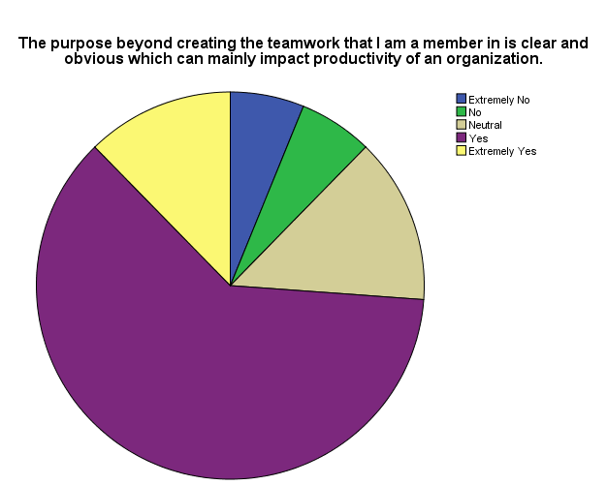

Figure 9 Pie Chart Results

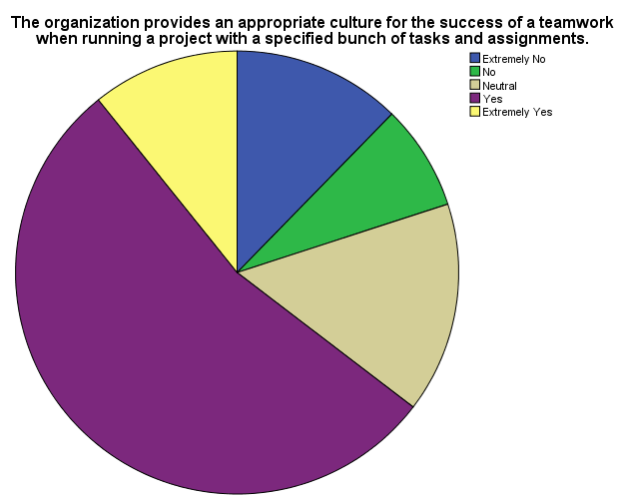

Figure 10 Pie Chart Results

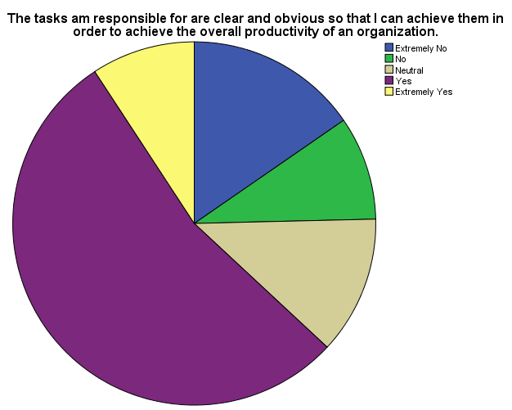

Figure 11 Pie Chart Results

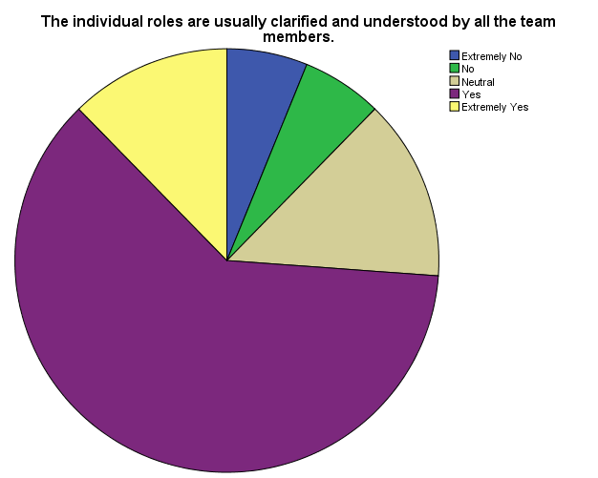

Figure 12 Pie Chart Results

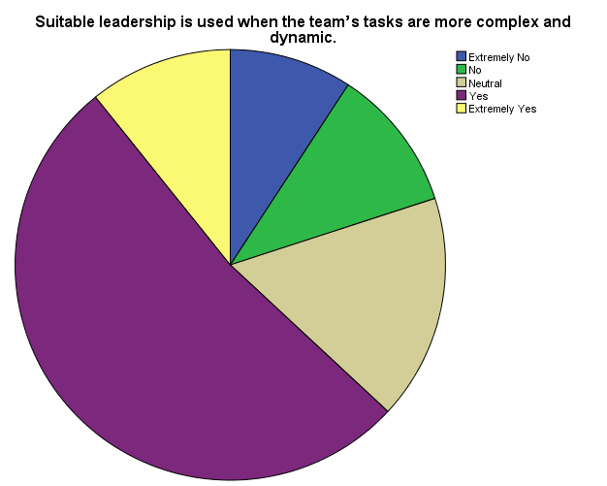

Figure 13 Pie Chart Results

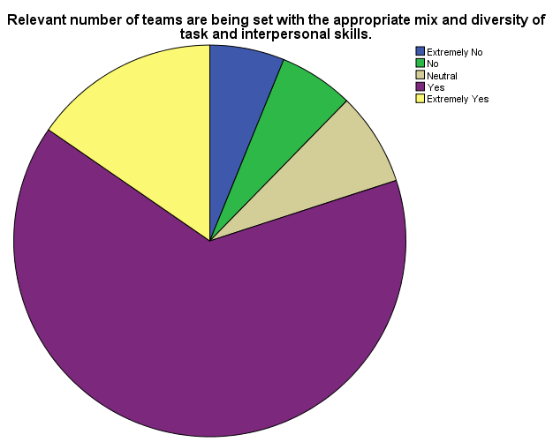

Figure 14 Pie Chart Results

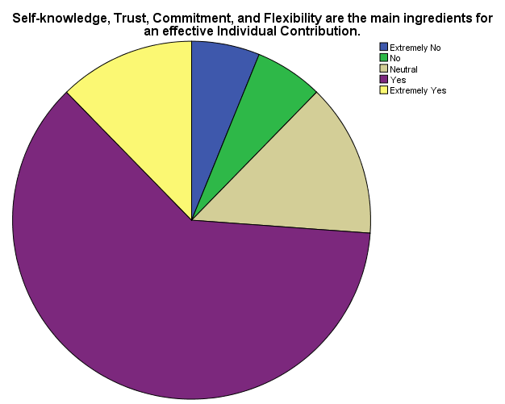

Figure 15 Pie Chart Results

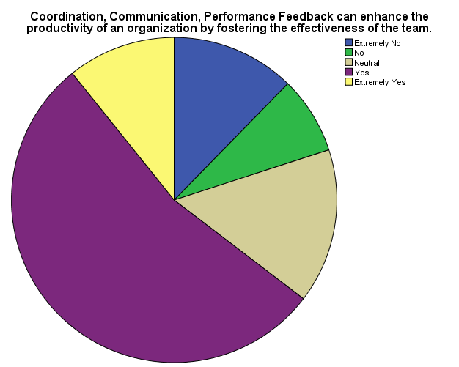

Figure 16 Pie Chart Results

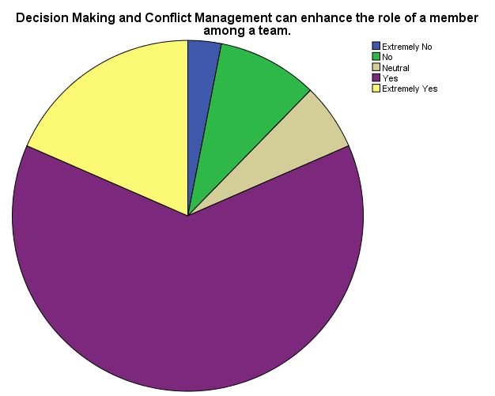

Figure 17 Pie Chart Results

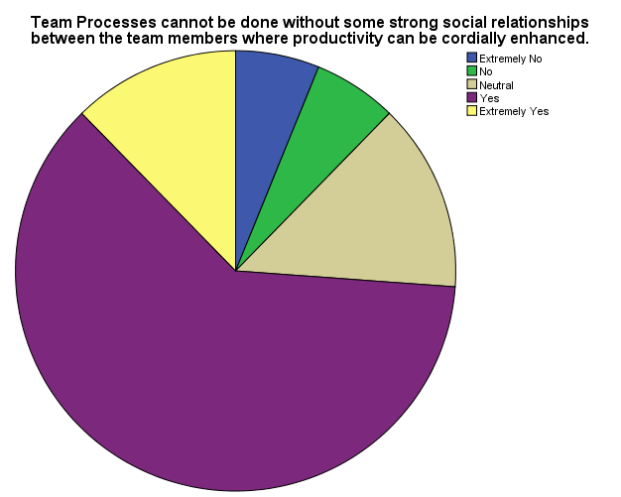

Figure 18 Pie Chart Results

**T-Test**

|  |  |  |  |  |
| --- | --- | --- | --- | --- |
| **One-Sample Statistics** | | | | |
|  | N | Mean | Std. Deviation | Std. Error Mean |
| The purpose beyond creating the teamwork that I am a member in is clear and obvious which can mainly impact productivity of an organization. | 65 | 3.68 | .986 | .122 |
| The organization provides an appropriate culture for the success of a teamwork when running a project with a specified bunch of tasks and assignments. | 65 | 3.43 | 1.172 | .145 |
| The tasks am responsible for are clear and obvious so that I can achieve them in order to achieve the overall productivity of an organization. | 65 | 3.32 | 1.239 | .154 |
| The individual roles are usually clarified and understood by all the team members. | 65 | 3.68 | .986 | .122 |
| Suitable leadership is used when the team’s tasks are more complex and dynamic. | 65 | 3.45 | 1.118 | .139 |
| Relevant number of teams are being set with the appropriate mix and diversity of task and interpersonal skills. | 65 | 3.77 | .996 | .124 |
| Self-knowledge, Trust, Commitment, and Flexibility are the main ingredients for an effective Individual Contribution. | 65 | 3.68 | .986 | .122 |
| Coordination, Communication, Performance Feedback can enhance the productivity of an organization by fostering the effectiveness of the team. | 65 | 3.43 | 1.172 | .145 |
| Decision Making and Conflict Management can enhance the role of a member among a team. | 65 | 3.85 | .939 | .117 |
| Team Processes cannot be done without some strong social relationships between the team members where productivity can be cordially enhanced. | 65 | 3.68 | .986 | .122 |

Table 14 T-test Results

|  |  |  |  |  |  |  |
| --- | --- | --- | --- | --- | --- | --- |
| **One-Sample Test** | | | | | | |
|  | Test Value = 0 | | | | | |
| t | df | Sig. (2-tailed) | Mean Difference | 95% Confidence Interval of the Difference | |
| Lower | Upper |
| The purpose beyond creating the teamwork that I am a member in is clear and obvious which can mainly impact productivity of an organization. | 30.066 | 64 | .000 | 3.677 | 3.43 | 3.92 |
| The organization provides an appropriate culture for the success of a teamwork when running a project with a specified bunch of tasks and assignments. | 23.597 | 64 | .000 | 3.431 | 3.14 | 3.72 |
| The tasks am responsible for are clear and obvious so that I can achieve them in order to achieve the overall productivity of an organization. | 21.627 | 64 | .000 | 3.323 | 3.02 | 3.63 |
| The individual roles are usually clarified and understood by all the team members. | 30.066 | 64 | .000 | 3.677 | 3.43 | 3.92 |
| Suitable leadership is used when the team’s tasks are more complex and dynamic. | 24.841 | 64 | .000 | 3.446 | 3.17 | 3.72 |
| Relevant number of teams are being set with the appropriate mix and diversity of task and interpersonal skills. | 30.499 | 64 | .000 | 3.769 | 3.52 | 4.02 |
| Self-knowledge, Trust, Commitment, and Flexibility are the main ingredients for an effective Individual Contribution. | 30.066 | 64 | .000 | 3.677 | 3.43 | 3.92 |
| Coordination, Communication, Performance Feedback can enhance the productivity of an organization by fostering the effectiveness of the team. | 23.597 | 64 | .000 | 3.431 | 3.14 | 3.72 |
| Decision Making and Conflict Management can enhance the role of a member among a team. | 33.014 | 64 | .000 | 3.846 | 3.61 | 4.08 |
| Team Processes cannot be done without some strong social relationships between the team members where productivity can be cordially enhanced. | 30.066 | 64 | .000 | 3.677 | 3.43 | 3.92 |

Table 15 One Sample Test Results

**PART III**

**GRADUATE PROJECT CONCLUSIONS AND RECOMMENDATIONS**

# CHAPTER 5: CONCLUSIONS & RECOMMENDATION

1. CONCLUSIONS

As can be noted from this Graduate Project that teamwork does really have an impact over productivity, tackling both the productivity of employees and the productivity of an organization as a whole. So this link is essential for an organization to determine teamwork’s effectiveness to the sustainability and success of an organization thus it should be implemented and should be used a one of the strategic plans to the organization from the very beginning an organization should set those plans in order to achieve the respected goals.

A better teamwork doesn’t stop with higher productivity but it can impact higher profits, higher employees’ engagement, higher employees’ satisfaction, thus moving an organization from local standards to regional and global standards.

On the other hand, organizations must invest in its employees investing in employees is a win-win situation for an organization since employees will be developed for the benefit and for the service of an organization which will make it easier for an organization to achieve its departmental objectives and overall goals.

As a conclusion from the whole project, the topic of the research is familiar so the resources were many and the topic were examined at different destinations like European and American organization which can show the importance of this link and can also emphasize on the link between the mentioned variables.

As for the objectives, it wasn’t easy to set up the objectives and achieve them so this critical thing was successfully done through achieving all the objectives that were set at the beginning of the Graduate Project. Thus, following are the main set objectives and how they were achieved through over the Graduate Project:

To emphasize on the importance of teamwork in any organization. This emphasis was mainly shown in the literature review where it was displayed clearly the effectiveness of teamwork and the main characteristics that help in increasing this effectiveness. After that, the results in the examination done all showed a positive link between the two variables about a relationship between productivity and effective teamwork.

To raise the awareness that teamwork can impact an organization, so it is essential to discuss how and where it can be impacted. So after the Literature review, it was mentioned that teamwork has a great impact on many variables especially on productivity especially when the characteristics are applied responsively. After that, throughout the examination and questionnaire the results revealed were as an awareness to the importance of teamwork in an organization and how can a teamwork make goals achieving easier. Therefore, an organization should apply the effective characteristics to teamwork because it is aware of the positive impact it has on the organizational atmosphere.

To confirm that teamwork affects directly organization’s productivity, therefore, organization’s efficiency and effectiveness. As it is known efficiency and effectiveness are the outcome of productivity, so as the link between productivity and teamwork is present then the link between the three variables will be present as well, and this was shown at the examination part especially when the results were shown within the SPSS test that took place. In addition, This increase in productivity that will lead to an increase in the efficiency and effectiveness will finally lead to an increase in the overall profits of the organization, that was shown also within the SPSS results where at Al Majmouaa institution with the increase of teamwork especially when serving clients the more clients are satisfied the more they come the more profits that will return to benefit other people since Al Majmouaa is a non-profit institution that aim to help people especially women and people who have innovations and new ideas.

To link the two variables and examine the relationship between them in order to specify the nature of this relation. At the very beginning of the Graduate Project the main topic was selected and the main hypothesis was set in order to be examined in a way to be either accepted or rejected, for this hypothesis and in respect with the main topic the hypothesis was linked with the main topic by selecting the main variables where they are organized as variables, dependent and independent variables. So that was obviously done throughout the Graduate Project moving on to the next part of the project where the link between the variables was specified and the type of relationship between them was identified among the last chapter which is the fact findings and results.

To suggest the most inspiring practices for an innovative teamwork to foster productivity of an organization. The last set objective was to highlight on many practices to be applied in order to increase the effectiveness of teamwork, so this will be tackled in the coming part the recommendations where the most inspiring practices will be mentioned in order to be used for a fostered team in an aim to foster also productivity of an organization.

Following are the suggested recommendations, they were written due to the selected organization experience and according to the revealed results from the questionnaires, as well as the conducted interviews.

1. RECOMMENDATIONS

The absence of teamwork is the main motivation to foster the characteristics of teamwork, since experiencing a group of people working on the same project or on solely project yet under the same ceiling with no team spirit is really a curse. This will make it harder for them to develop, by development it is meant the communicational development, the skills development, the practical development since teamwork can enhance these all and can help employees to get to know themselves better which will enhance each individual to work on his career in order to achieve what can be achieved.

So, as mentioned through the objectives of this Graduate Project after the examination of the hypothesis and the success of the link between the selected variables, some recommendations are suggested with respect to what were throughout the whole project, starting with the literature moving to the questionnaire and interview ending with the fact findings and results.

The following are some recommendations that will help teamwork to be fostered in order to foster the productivity of an organization:

1. Emphasize the point of collaboration: It is imperative in any organization to feature and underscore the significance and centrality of cooperation. So as a begin before anything is set and a gathering is framed the group pioneer should make the point of being in a group and the viability of gatherings as opposed to people.
2. Lead by illustration: Being a case in a group is so imperative, a colleague who looks for incredible correspondence among the group should work harder, create more grounded, and keep the business moving and that is called showing others how its done with the goal that the colleagues will be influenced by the conduct. Too sharing extraordinary musings, treating duties, parts, and associations with the colleagues a similar way you need others to will improve that to an awesome level.
3. Build up trust and regard: Things will never complete when there isn't common trust and regard among representatives by and large in an organization and among colleagues especially. Trust is so critical in a group since the individuals should believe each other's in doing their part, also they should be completely trustful in the group pioneer that he/she is managing them the correct way and the best compelling way.
4. Encourage associating: In a group it is vital for the individuals to set time for the ice breaking and getting know each other's well this can build the trust between them also the regard and comprehension. Such thing typically should be set by the group pioneer and the individuals genially in a little gathering or assembling for the objective of mingling.
5. Cultivate open correspondence: Communication in every one of its channels is a compelling device in the achievement of a collaboration. So promising the individuals in a specific group to talk straightforwardly, share contemplations and thoughts, make proposals, and voice their suppositions are so fundamental for the accomplishment of a cooperation.
6. Clearly framework parts and duties: The blueprint parts and obligations ought to be expressed obviously from the earliest starting point like and they should be comprehended by every part in the gathering in a way that every part is completely devoted to complete his/her errand without perplexity. The freedom can help in decreasing time squandering and can spare expenses particularly on the HR level where individuals can assign on the off chance that they require an assistance from each other.
7. Organize gathering frames: Along with setting up clear parts, there should be set gathering shapes set up for tackling a wander, diminishing troubles, talking with each other and giving feedback. Afresh, these tenets will empower agents to put less vitality in coordination and more on their veritable work.
8. Set portrayed destinations: Each gathering should know accurately what they're advancing toward including what goals they ought to hit and when. Set quantifiable targets inside a specific era that social occasion people can measure themselves against both only and as a gathering. Knowing where they stay in association with the portrayed benchmarks will give accumulated motivation and propelling power to work into a solitary unit.
9. Recognize extraordinary work: Praising and seeing an occupation well done will help assurance and soul, encouraging gatherings and individuals to continue doing magnificently.
10. Mediate conflict quickly and viable: It's commonplace for the battle to develop in a gathering setting – there may be a correspondence breakdown at some point or another or people may have singular issues. How a battle is managed should be clear under the gathering frames. If an associate has an issue by what technique would it be a smart thought for them to manage it? Who might it be prudent for them to address first? Impact these practices and wants to clear from the most punctual beginning stage by then handle conditions quickly to empower a gathering to continue forward and keep up a not too bad working environment.
11. Allow partners to viably take an interest in the essential initiative: Having a sentiment singular relationship in the fundamental authority process will set individuals' affiliation and enthusiasm for the gathering, impacting them to feel like they are an irreplaceable bit of a choice that is instead of just a touch of the confound.
12. Maintain the change of work: clearly unprecedented partners will wear down different assignments, yet attempt to ensure that everyone still has practically identical workloads. There shouldn't be any single individual bearing the most noticeably awful piece of the work. The motivation behind being in a gathering is to coordinate to share the pile and make something one couldn't do alone.
13. Meet reliably… and mix it up: Meetings shouldn't block proficiency or be a pointless activity, however, gatherings ought to regardless meet as often as possible to associate, screen progress and goals, hurl contemplations around and fabricate care about what each part is wearing down. Plan ordinary social events to reconnect, yet put aside a couple of minutes is used capably and effectively and consider trading things up by endeavoring a versatile gathering or meeting in a superior place, like a café. Taking things outside of the workplace has been seemed to construct gainfulness and let correspondence stream more typically.
14. Don't micromanage: While bunches should meet routinely together and with their supervisors, it's up 'til now indispensable not to micromanage. Give your gathering the time, space and self-rule to convey tackle their own particular without feeling like they're for the most part been watched or judged.
15. Create space: Give your gathering the physical and mental space to make and work in peace. This may mean setting specific conditions where total people simply work alone or are not allowed to send or browse email. Things can achieve more quickly as a gathering, however, individuals still need their own particular chance to focus on their bit of the endeavor.
16. Start gathering traditions: This goes for gatherings and the association general – influence traditions to join people and develop a sentiment bound together culture and solidarity. They can be silly and direct, for instance, a running inside joke, or authentic and nitty-gritty, for example, offering a significant inspiration for when a gathering has accomplished their destinations, however, find a way for the gathering to relate on another level that isn't just business related.
17. Use size further reinforcing your favorable luck: Both of every kind gatherings have their own particular inclinations. Greater gatherings have more work, yet humbler social occasions routinely have a tendency to show more individual theories and expect particular risk for finishing things. Whatever the traverse of your gathering is, consider what it needs to work best and use its size further reinforcing your favorable luck.
18. Make utilizing a gathering commitment: When adding someone else to the association or gathering, have the present gathering say something with respect to an official conclusion, especially in case they're a touch of the social occasion. One person's aptitudes, perspective and dedicated state of mind can without a lot of an extent impact general social occasion stream. By having the opportunity to state something with respect to newcomers, the present gathering will have the ability to help pick the best fit.
19. Give progressive feedback: Teams should get visit contribution from their pioneers and each other. This can mean feedback on completed work yet what's more fuse sharing any request, comprehension, recognition or issues the gathering may have.
20. Take time to watch: Acknowledge and regard assemble wins. Is celebrating only fun, and in addition strengthens a gathering's preparation to participate and lock in for the association when their effort is unmistakably esteemed and celebrated.
21. Involve cooperation with HR designs: Human Resources office shouldn't work aside from the organization it should stressing collaboration from the choosing procedure to the selecting keeping in mind the end goal to underscore it and too to design it with the key arrangement.

**REFERENCES**

# REFERENCE LIST

Abdallah, O., 2018 . *The impact of teamwork on productivity of an organization in Lebanon* [Interview] (14 March 2018 ).

Bassoff, B., 1983. *Interdisciplinary Education as a Facet of Health Care Policy: The Impact of Attitudinal Research.* s.l.:Journal of Allied Health.

Blechert, T., 1987. *Intraprofessional Team Building.* USA: American Journal of Occupational Therapy.

Firth-Cozens, J., 1998. *Celebrating teamwork.* s.l.:Quality in Health Care.

Hackman, J., 1990. *Groups that Work (and Those That Don’t).* 1 ed. San Francisco: Jossey-Bass.

Headrick, L., 1998. *Interprofessional working and continuing medical education.* s.l.:British Medical Journal.

Husting, P., 1996. *Leading work teams and improving performance.* 9 ed. s.l.:Nursing Management.

Kirkman, L., 1999. *Beyond Self-management: Antecedents and Consequences of Team Empowerment.* 1 ed. s.l.:Academy of Management Journal.

Loxley, A., 1997. *Collaboration in Health and Welfare.* 1 ed. London: Jessica Kingsley Publishers.

Majmoua, A., 2018. *Al Majmoua The Lebanese Association For Development.* [Online]   
Available at: https://www.almajmoua.org/homepage.aspx

Payne, M., 1982. *Working in Teams.* England : The Macmillan Press.

Pearce, J. & Ravlin, E., 1987. *The Design and Activation of Self-Regulating Work Groups.* 11 ed. s.l.:Human Relations.

Ravlin, E., 1987. *The Design and Activation of Self-Regulating Work Groups.* 11 ed. s.l.:Human Relations.

Webster, M., 2018 . *merriam-webster.* [Online]   
Available at: https://www.merriam-webster.com/dictionary/questionnaire

**APPENDIXES**

# APPENDIX A

**QUESTIONNAIRE**

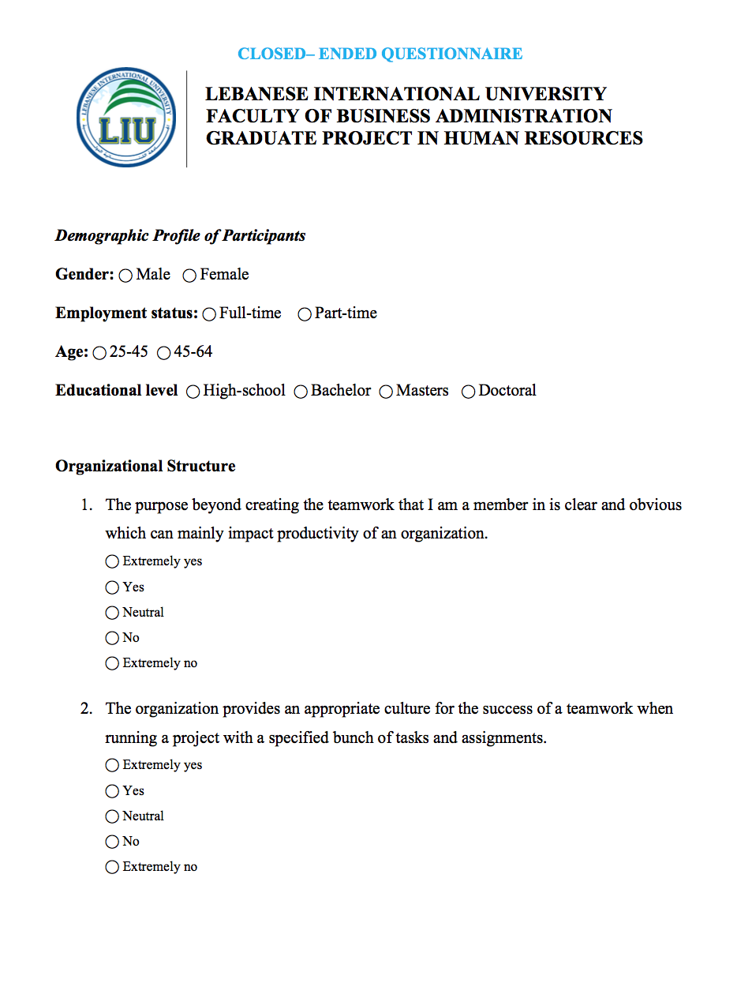

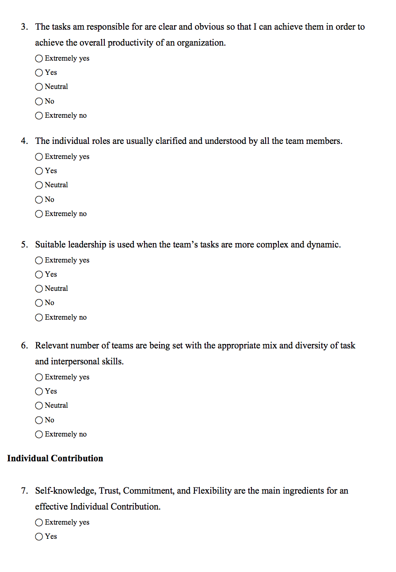

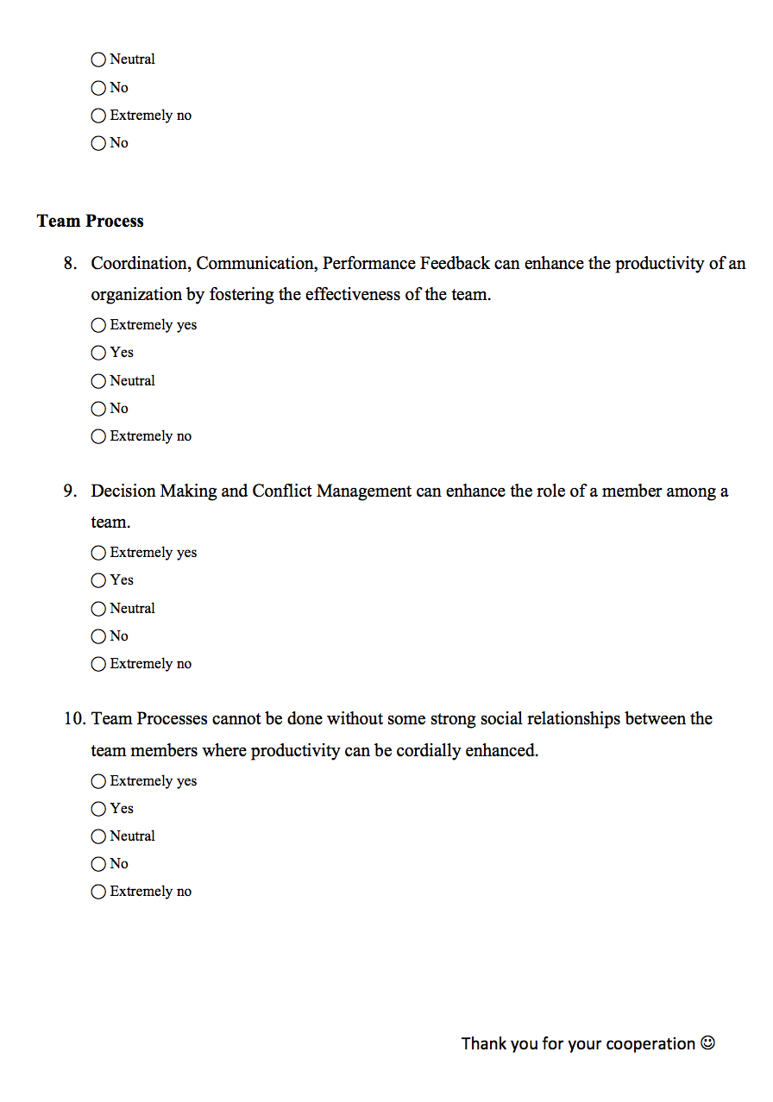

# APPENDIX B

**GRADUATE PROJECT INTERVIEW FORM**

