**GRADUATE PROJECT**

**The impact of E-Leadership on employee’s productivity in Lebanese Healthcare organizations.**

**Submitted to the Lebanese International University**

**The School of Business**

in Fulfillment of the

Requirements for the Degree of

**Master of Business Administration in Management**

By

**Zeinab Abbas Fayad**

ID: 31730959

Campus: Saida, Lebanon

Supervised by: Dr. Mohamad Mtairek

Fall 2020-2021

**DEDICATIONS**

This project is dedicated to my family and my husband. My lovely parents who taught me the best knowledge and support me in every step to attain my goals. They are my guide and my inspiration to accomplish the largest task. I would also like to dedicate this research to my sister who is my biggest motivator and my support system.

Second, I dedicate my dissertation work to my husband, Abdullah, the one who stand by my side and has been a source of support. I am truly thankful for having him in my life.

**ACKNOWLEDGEMENTS**

I cannot express enough thanks to my advisor Dr. Mohammad Mtairek for his continued support and encouragement. His guidance helped me in all the time of this research. I could not have imagined having a better mentor for my MBA thesis.

Also, my sincere thanks also goes to my colleagues who work in pharmaceutical companies and all the employees in Lebanese healthcare organization, because without them this research would be incomplete.

**ABSTRACT**

Globalization, technology, pandemics, and another factors have to mutate leadership into leadership complexity and increased virtual collaboration. One of this transformation that affects leadership style is the current trend: The virtual or electronic leadership (E-leadership) that can influence employee’s productivity.

The purpose of this research is to find the correlation between E-leadership and employees productivity. And the objectives is to find out the effect of E-leadership on productivity, the importance of virtual leadership in Lebanese Healthcare Organizations, and the role of virtual team.

The data were collected from employees working in Lebanese Healthcare Organizations as hospitals, pharmacies, dispensaries, and pharmaceutical companies. The size of the sample was 102 respondents. The survey was distributed through several applications like whatsapp, Facebook, linkedIn, and Instagram.

The data were analyzed by SPSS software. After finding’s analysis, the results show a high positive correlation between the two variables and statistically significant. As a conclusion, E-leadership have an impact on employee productivity.

Table of Contents

LIST OF TABLES 6

LIST OF FIGURES 7

CHAPTER 1: INTRODUCING THE GRADUATE PROJECT 8

1. Introduction 8

1.1. Research Question 9

1.2. Research Aim and Objectives 9

1.3. Overview of the Lebanese healthcare organizations 9

1.4. Research Hypotheses 10

1.5. Structure of the Graduate Project 11

CHAPTER 2: LITERATURE REVIEW 12

2. Overview 12

2.1. Leadership 13

2.2. E-Leadership 14

2.3. Organizational Culture 20

2.4. Employee’s Productivity 23

2.5. Summary of Litterature Review 28

CHAPTER 3: RESEARCH METHODOLOGY 30

3.1 Research Philosophy 30

3.2 Research Approach 31

3.3 Research Strategy (Data Collection Method) 31

3.4 Research Methodological Choice 33

3.5 Time horizon 34

3.6 Techniques and/or Procedures for Data Analysis 35

CHAPTER 4: FINDINGS AND ANALYSIS 36

4.1. Introduction 36

4.2. Findings (Descriptive Statistics) 36

4.3. Analysis 42

4.4. Summary of Findings and Analysis 45

CHAPTER 5: CONCLUSION, LIMITATIONS, AND RECOMMENDATIONS 47

5.1. Conclusion 47

5.2. Limitations 48

5.3. Recommendations 48

REFERENCES 50

Bibliography 50

Appendix 1: Questionnaire 53

# **LIST OF TABLES**

Table 1 frequency results of the employee's generation 37

Table 2 frequency results of education's level 38

Table 3 frequency results of organization's type 39

Table 4 frequency results of years' experience 39

Table 5 frequency results of the different specialization 41

Table 6 frequency results of the best way of interaction within healthcare organization 42

Table 7 descriptive statistics, 1: strongly agree, 5: strongly disagree 45

Table 8 correlation test between independent and dependent variables. Independent variable: e-leadership, dependent variable: productivity 46

# **LIST OF FIGURES**

Figure 1example that shows the calculation of employee's productivity. (Inc., 2020) 24

Figure 2 bar chart results of employee's gender 38

Figure 3 pie chart results of education's level 38

Figure 4 pie chart results of organization's type 39

Figure 5 pie chart results of years' experience 40

Figure 6 pie chart results of the different specialization 42

Figure 7 pie chart results of the best way of interaction within healthcare organization 43

# **CHAPTER 1: INTRODUCING THE GRADUATE PROJECT**

# **Introduction**

All business sectors in Lebanon faced several crises such as Covid-19, Port of Beirut blast and the variable rate of Lebanese pound per U.S dollar. Due to all these disasters, the Healthcare organizations such as hospitals, pharmacies, dispensaries and pharmaceutical companies are affected directly in all the departments. During crises, an urgent action plan is very necessary to continue the work on the same rhythm. One of these plans that has been taken is to remote work to keep social distancing and help Lebanese employees to stay safe. Here is the role of Leaders to get the right infrastructure to manage their employees in order to transform any threat into opportunity and influence employees’ performance, productivity and satisfaction. Else, the technology is allowing employees to work from home or anywhere by changing the mode of collaboration and agreement. Many firms are using mobile phones, emails, and video-conferencing to do the work remotely and the ways of communication between leaders and employees are changed.

Whatever the reason or the policy for every company, Remote work represent an important thing now. Productivity, performance, motivation and many other factors are affected when the work transform from face to face to remote team. How the medical and administration staff can work remotely in healthcare company? Is the virtual organizational structure fit for healthcare organization? Does E-leader training program exist in every healthcare organization?

# **Research Question**

The main research question in this project is: “How electronic leadership (E-Leadership) affects employee’s productivity in Lebanese Healthcare organizations?” So we will test the relationship between E-Leadership and employee’s productivity.

Many sub-questions that will clear that relationship such as:

1. Does E-leadership affect the performance of the employee?
2. How effective is the virtual team in healthcare sectors?
3. How many problematic issues are related to E-Leadership in the healthcare organizations?
4. Has the outcome been affected by E-leadership and employee relationship?
5. Is remote team can be more productive than real team?

# **Research Aim and Objectives**

The aim of this project is to find the influence of e-leadership on employee’s productivity in Lebanese healthcare organizations. In addition, the objectives of this research are to find out the impact of remote work on employee from different departments in the healthcare organizations and to find out how the electronic leadership can fit into healthcare organizations.

# **Overview of the Lebanese healthcare organizations**

The healthcare organization or the healthcare system are the places that offer a clinical services and authorities like nurses, doctors, medical representative and doctors. Also, an administration staff consider as a part of the healthcare organization. This organization is for people and resources where healthcare services meet the health needs.

When the employees of healthcare organization will be mentioned, this is mean the employees of hospitals, pharmacies, laboratories, and pharmaceutical companies. Every healthcare system has special properties.

In Lebanese hospitals, the administration staff (HR/IT/Accountant/Finance) can work from home with flexibility, and this way of work is not for a short-term response for a circumstances but it will be a long-term strategy. In addition, the medical staff (nurses and doctors) can work remotely using the new technology as robotic equipment, long-distance diagnosis and monitoring.

Since the work of the most pharmaceutical companies in Lebanon as distributors, medical representative can reach their customers through the collaborative tools, which is mean they can work remotely.

# **Research Hypotheses**

A Hypothesis expresses your expectations about what our research is looking for. It’s not only a guess, it ought to be founded on existing knowledge. It, likewise, must be measurable, which means it can be supported or refused based on scientific research methods.

In order to study the relation between E-leadership and employee’s productivity in Lebanese healthcare organizations, we will test two hypotheses:

H0: There is a possible relationship between E-leadership and employee’s productivity in Lebanese healthcare organizations.

H1: There isn’t a possible relationship between E-leadership and employee’s productivity in Lebanese healthcare organizations.

# **Structure of the Graduate Project**

This project comprises 5 chapters that are organized in a typical way. These 5 chapters are: Introduction, Literature Review, Methodology, Findings and analysis, and finally Conclusion, Limitation, and Recommendations.

Chapter 1 is the introduction, where the subject of the research will be presented then the research questions that will be discussed. After that, the research aims and objectives, overview about healthcare organizations in Lebanon, as well as the research hypotheses that will test the relationship between the variables (E-Leadership and employee productivity).

Chapter 2 is about literature review, where is mentioned several sub-topics from previous studies and projects about E-leadership and employee’s productivity. While Chapter 3 is about research methodology, where we will highlight research philosophy, research approach, research strategy, research methodological choice, time horizon and finally the techniques for data analysis. In the third part of this chapter, we will go quickly through the parts of the survey that was filled by the employees of healthcare organizations that worked from home.

Chapter 4 illustrates findings and analysis. We will state the results of the examination in the form of graphs and tables, by using the SPSS programing and then will be discussed.

At last is chapter 5, which is the conclusion. This chapter consist of three parts. The first one is the conclusion where the question of the research and the objectives will be answered and demonstrate. In the second part, the limitations of the study, where is the unavailable resources, small sample size, or flawed methodology etc. It will be short section about basic discussion of any unanswered questions that our study does not address. The last part is recommendation are based on the results of our research and indicate the measures that can be taken.

# **CHAPTER 2: LITERATURE REVIEW**

# **Overview**

The workplaces of numerous organizations have changed definitely. Nowadays, organizations have moved away from working with workers who are in their visual vicinity to working with individuals around the world. The business activities have got more worldwide and competitive when contrasted with the past. This occurs because of quicker movement in information and communication technologies, which delivered the jobs to be more powerful and multidimensional. To react to such changes rapidly, companies are enhancing their organizational structures, systems, strategies, and cycles to become more adaptive and flexible (Okechuku and Nebo, 2020).

We live in a dynamic environment, for this reason, many organizations introduce virtual teams (VT). As definition, virtual team is a group of people, separated from each other geographically or organizationally, but connected through information technology to reach mutual goals. Especially now, due to Covid-19 pandemic, virtual teams are growing in popularity (Okechuku and Nebo, 2020).

Several studies indicate that electronic leadership (E-leadership) is created and used to enhance communication and coordination, and to promote common sharing of inter-organizational resources and competencies (Okechuku and Nebo, 2020).

It is a big challenge for the bosses to lead a virtual team, since they need to develop new leadership style to assort resources more efficiently, to improve team productivity, and to sustain the organizational culture (Okechuku and Nebo, 2020).

# **Leadership**

In a business setting, leadership is when a leader can direct colleagues and employees with a strategy to achieve the firm’s goals (Ward, 2020). In other words, leadership influences the performance and the productivity of employees within the organization and it can be founded in anybody who can be present anywhere. However, there are specific rules and duties that make a real leader, with high quality of leadership (Surji, 2014). Some practices and commitments are identified to help leaders accomplish a perfect performance and striking productivity. These practices and their suitable commitments are the follow:

First, every leader should model the way and the commitments is when they discover your vote by explaining your own ethics and set the models by adjusting activities to shared qualities and values. Second, inspire a mutual vision, in order to imagine the future by envisioning, energizing and honoring prospects and enroll others in a typical vision by engaging shared yearnings. Third, Pioneers have an enthusiasm to challenge the process, seeking for opportunities by looking for novel approaches to adjust, develop and improve and take risks and face challenges by continually producing small successes and learning from mistakes. Fourth, empower others to act, encourage coordinated effort by advancing agreeable objectives and building trust and reinforce others by sharing power. The last one is energize the heart by perceiving commitments and create spirit of community to celebrate victories and values.

Leaders have a huge impact in affecting workers’ performance and productivity. In fact, leaders represent the most important element in the company and many studies show that when employees stay for long time in the company and determine how productive they are, it means that the relationship between leaders and workers is typical. However, if the relationship between manger and employee is broken, nothing like benefits or bonuses will urge laborers to remain: Employees don’t leave companies; they leave managers (Surji, 2014).

# **E-Leadership**

Definition of E-Leadership:

These days, organizational leader struggles with two forces: First is the increase of worldwide scattering in divisions, subunits, customers, suppliers and partners. Second, the booming of communication technology that has prompted colleagues, coworkers and bosses to interact easily wherever they are (DasGupta, 2011). So leaders confront these forces by electronic leadership. After several interviews with many leaders and due to the worldwide changes that are related to new technologies, the digital evolution, new values and predictions and the experts reported that the old leadership strategies doesn’t give the same results with future challenges of leadership. In other words, to increase and create competitive advantages, every organization should follow the digital information and technological revolutions. At present, the new work environment re-shapes the present leadership style to another unique style that called Electronic or digital leadership. E-Leadership is the new mediator between pioneers and followers. The structure of organization becomes virtual organization and the real team is known as virtual team (Mohamed, 2019). However, E-leadership has been defined as a social influence interceded by ICTs (Information and Communication Technologies) that can make a change in attitudes, thoughts, feelings, and performance (Wart, et al., 2017).

The information and communication technologies (ICTs) or the advanced information technologies (AITs) like e-mail, virtual team, video-conferencing., have different roles including interaction, planning and informing and data analysis. The new leadership paradigm requires the bosses to achieve leadership goals through computer-mediated way with virtual teams that are present in different locations and different times (Wart, et al., 2017).

E-leadership vs. traditional leadership:

Between the traditional leadership and the electronic leadership, several points have completely changed and another has continued as the old leadership style.

The essential differentiations of e-leadership maybe in what is suggested by using “feeling the managers’ and leader’s quality”, and accomplish speed, lastingness, and perspective of a leader’s communication techniques. Nevertheless, the inspiration driving e-leadership also is to take the relationship among various people levels characterized by methods for an affiliation structure.

The contrast between Leadership and E-leadership is measured by different parameters. Some are the following: Environment (Real word vs. Virtual word), role of ICTs (Not required vs. Mediated through ICTs), organization (Real organization vs. Virtual organization), team (Real team vs. Virtual team (VT)), superior-Subordinate relationship (Control-and-Command vs. Collaboration) and Command (Authority-based vs. Expertise based) (Al-Ghalili and Al-Harethi, 2019).

Virtual team:

The virtual environment isn’t a smooth environment; it is defined by high degree of risks, complexity of tasks, unknown things, and many members that join from different locations. In this environment, the efficiency and productivity are more difficult than the real environment to achieve specific demands. The maximum amount of care is needed to make a successful virtual team with high performance. There are keys of competencies that are required beyond the technical and communication skills. First, since managers and team members located in different places or in different time zones, self-motivation is very important because every member monitor himself. Every virtual employee should make a daily plan and daily goals and work on it. Second, when the trust between colleagues is high, a strong interaction will appear. In addition to that, every member should be aware of how to deal with other cultural attributes. Third, being a worker that can face any work complexity and uncertainty. Fourth, using Information and communication technologies, employee must be able to use different ICTs tools in order to communicate and collaborate effectively with the virtual team members (Mohamed, 2019).

Virtual teams were classified depending on two variables: the number of locations and the number of managers. When there is one manager for a team at one location, the VT is called teleworker. But when the one manager is for a team at different locations, the VT is called remote team. Many managers for a team at one location is a matrix teleworker but multiple managers for a team across multiple locations is called a matrix remote team (Cascio and Shurygailo , 2008).

The impact of E-leadership on different types of generations:

A generation represents a group of people that are born in the same time span, share historical and social life experiences. These experiences bring mutual ideas, same personality and values of each generation (Duquesnoy, 2011). Generational differences have an important impact on the organization to create an environment full of harmony, respect, and mutual effort that lead to success. Every generation is characterized by mix of skills, behaviors, perceptions and desires. Therefore, employees from every generation may have variety of expectations and preferences about leadership and performance (Al-Ghalili and Al-Harethi, 2019).

Baby boomers are age group for people who were born from 1945 to 1964. This generation is identified by hard-workers, loyal employees, self-absorbed, and people who prefer a stable work environment. They accept the chain of command, they respect the hierarchy levels within the organization and they prefer their managers to lead and give orders to them. Baby boomers are neither into technology nor do they like change, so they prefer the traditional leadership more than E-leadership (Duquesnoy, 2011).

Generation X- people born between “1965-1980”. Generation X are very loyal to the workplace and contribute to the entrepreneurial spirit more than baby boomers. This generation works to live, the work/life balance is very important for them. They are very independent, self-motivated and self-sufficient. People of generation X are familiar with the technology revolution, they aim to go fast to express and create new ideas (Duquesnoy, 2011).

Generation Y- were born after 1980 and some studies indicate that they were born between 1980 and 1995. This generation is very different from the previous generations. If they are dissatisfied, they leave the organization easily. They are very optimistic and can learn rapidly. Technology is considered as an essential thing in their work. E-leadership enhances their work and makes it easier (Duquesnoy, 2011).

Generation Z- This generation is called the digital generation. They attracted the consulting organizations. Since they are an essential part of the internet generation, they become desirable customers for several markets (Al-Ghalili and Al-Harethi, 2019). The famous quote during leadership that is used by digital natives-“Don’t manage me, understand me” .So when managers and leaders understand an employee from this generation, the last will give an unexpected work (Klein, 2018).

Baby boomers, Generation X, Millennial, and generation Z have different values, experiences, point of view, and the differences between them can make a gap. So a good leadership is called here to lead a team involving people from different generations. Managing multigenerational groups effectively means more than understanding the contrasts between workers from different generations. In other words, it means to create culture to embrace all of them, support them to respect, help, appreciate each other, and push colleagues toward progress (Power, 2019).

Most of the employees from baby boomers and generation X prefer the traditional leadership and the tradition work from 9 till 5 rather than telecommuting. While Millennial and generation Z are very flexible to work from home (Power, 2019).

E-leadership challenges:

Leadership and E-leadership are facing the same challenges, but concerning challenges that are faced by E-leadership, they happen in different places, because there are indirect interactions and supervision. In addition, E-leaders need to develop new skills to adopt the E-environment. The best leadership style that should be applied by E-leaders is transactional and transformational leadership. The major sources of challenges can be categorized as follow:

1. Trust

Trust has been broadly concentrated in the virtual group's research. Mutual trust assumes a fundamental part in effective global unions, and it is strongly significant in virtual groups that face vulnerability and need knowledge of all the individuals of the group. The key point in virtual distances is trust, it plays a main role to explore the leadership related characteristics, abilities, and behavioral patterns that may improve and create trust in a virtual environment. Consequently, E-leaders who can reduce the degree of uncertainty with their conduct and activities advance trust through setting mutual desires, upgrading intelligence, and inspiring and motivating team members, which may improve team achievement and organizational value creation.

1. Communication

For many reasons, face-to-face communication is better than computer-mediated contact. First, it is more considerable in nonverbal. Second, due of the multiple communication channels, the information minimizes. Third, when the communication is face to face, the social presence and the conversational involvement will maximize feelings. Fourth, the social context helps the informational transition. And finally, the physical communication does not take place anymore and the level of expertise will be minimized.

Subsequently, communication across culture presents E-pioneers with specific challenges like dealing with the team, who don’t have a common setting or who should verifiably talk since they don’t get an opportunity to state all of what they need to state. Sensitivity, trust-building limit, and the capacity to make solid connections to connect the communication gap. Thus, E-leader is strongly needed to motivate and inspire the worldwide team to upgrade group attachment and improve the collaboration.

1. Distance and time

According to E-leaders, distance is a critical challenge. Distance may be physical like zone or firm size, operational as team size or cultural distance as different values. To create a successful team and to skip these gaps, E-leader can enhance a feeling of intimacy between members, and by enforcing the right information technologies.

In this manner, E-pioneers are needed to proactively relieve time-related pressure, the tight time tables, and deadline inherent to virtual tasks, he likewise expected to address emerging issues quickly, and successfully arrange colleagues’ tasks throughout various time regions, along these lines the colleagues’ skills, abilities, and capabilities will be completely harnessed, and the team success might be augmented.

1. Diversity

Diversity is the variety of human structure, accepting framework and strategies for adjusting to situations that exist inside various groups and individuals. It is normally applied to like the distinctions in race, identity, language, and religion. Numerous components may cause the diversity such as culture, geographic area, communication style, etc. The contrast between high and low context can clarify numerous communication issues that pioneers face when they cooperate with those of different cultures (Lubna Alfehaid and Elham Elshafei, 2019).

# **Organizational Culture**

Definition:

The way to a successful organization is to have a culture dependent on an emphatically held and broadly shared allowance of beliefs that are supported by strategy and structure. When an association has a solid culture, three things occur: how top management wants employees to react to any situation, workers accept that the normal reaction is the best possible one, and employees knowing that they will be rewarded for showing organization’s values.

Organization culture is how employees behave within the company. This culture contains a mutual values and beliefs founded by leaders and their methods, shaping worker’s perceptions, behaviors and understandings. Every enterprise has his own organizational culture.

To be a successful leader, you should live companies’ culture every day and communicate with employees on it. A good organizational culture bring the organization and its leadership to a high level. Some companies’ cultures are similar to each other, such as manufacturing and health care organization share common cultural values.

Therefore, the cultural characteristics that differentiate each organization include the following: values, degree of hierarchy and degree of urgency, task orientation, functional orientation, and organizational subcultures (SHRM, n.d.).

How to sustain the organizational culture without office especially for the healthcare staff:

Several large companies switch to online working when there is a reason like natural disasters and pandemics or for no reason like U.S. employees-8% of U.S. workers worked from home at least once a week.

To sustain the organizational culture for remotely team, in any business, many points are discussed on how managers can ensure that valued aspects of the culture. Share your company’s values: According to the organizational culture, the most important part is values. For remote workers, the organization values are a solid comprehension of how the company works and how you establish a positive workplace. Check out these creative ways to share and maintain the values with the employees who work from home: Add values from first day, create a weekly round-up, and establish digital one-to-one recognition (Jackson, n.d.). Improve and establish communication norms to enhance clarity and reduce interruptions, Build camaraderie and avoid isolation because remote employees work from home, there’s no water-cooler conversation to approach people from each other, so some ideas are needed to build a good relationship between colleagues as fun chat channels, make video-chat happy hours, and make some funny classes and meditation sessions together. A priority of the face-to-face meetings since Screen isn’t enough to make a 100% successful communication, so seeing colleagues face-to-face is very important. The Cooperate company-wide initiative through trainings, seminars, and conferences to keep the spirits of the values and to promote the culture (Jackson, n.d.). So, all of those steps develop a strong remote culture, empower employees, and enhance trust between them. Some of the healthcare staff, pharmacists, physicians, nurses, medical representative, HR, and so on, can work remotely, but for other employees, working from home doesn’t apply. So, how healthcare staff can work from home? The answer of this question is in the following points: Nurses, physicians, and medical representatives can perform several works from home through live video diagnosis. There are many cases that don’t need the physical presence of the healthcare staff to treat patients directly (Mehaffey, 2020). Remote staff should have an access to the collaboration tools and to the health record system, especially for medical representatives, accountant, and human resource. Those can connect with customers and patients through collaboration tools easily (Mehaffey, 2020). At the end, put a work-from-home policy because most of the healthcare staff might not be familiar with remotely work. So the great way to facilitate it, is to establish and communicate remote and mobile work policies (Mehaffey, 2020).

* 1. **Employee’s productivity**

Overview:

Nowadays, the key issue that most companies face is the need to enhance employee’s productivity. In other words, employee’s productivity or workplace’s productivity is an evaluation of an employee or group of them. Productivity affects directly the organization’s profits. In a specific period of time, productivity might be assessing in terms of output (Hanaysha, 2016).

In most cases, the productivity of a given worker will be evaluated comparative to an average of workers doing the same work (rouse, 2014). When the employee is productive, it will be considered as an investment that provides an important return to the company. The importance of productivity within the organization lies in the difference between an employee who makes a profit and the employee who makes a cost on the company (Harness, 2018).

How to Measure Productivity:

The recession, national economy, inflation, competition, etc. are factors that affect any organization’s productivity. As a company, you can’t control all external factors, but you can control and measure employee’s productivity. The labor productivity equation is used to measure that productivity: Labor productivity= Total output/Total input. An example is shown in the figure below to explain how the labor productivity is measured (Inc., 2020).

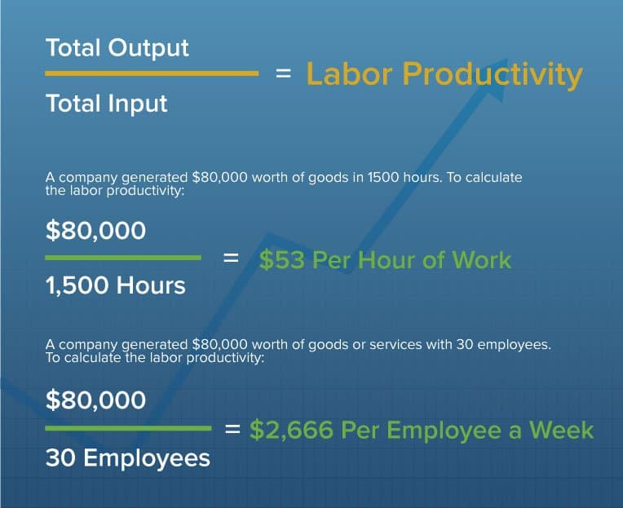

Figure 1example that shows the calculation of employee's productivity. (Inc., 2020)

This is how we calculate workers’ productivity, but to measure employee’s productivity at the workplace or of remote employees, many ways can be applied. Set a baseline, it is important to build up a beginning spot to measure worker’s productivity. Actually, this involves utilizing operation output numbers for a business ordinary day to put an average. The total will be divided by the number of workers, either for the whole organization or different departments. The leader should Identify benchmarks and targets, based on how benchmarks are set, the target of productivity will change. Targets and benchmarks change from industry to another, some jobs have built-in benchmarks. When the tasks are identified and the position of employees is precise, the productivity will be measured. For example, the manual worker’s productivity is easier to measure than the tangible and intangible worker. It is very necessary to know everything about the job and the worker should involve in every task. Indicate suitable comparisons is also a way to measure employees’ productivity. The entirety of employee’s tasks should be measured and not the single activity. To complete many tasks, an employee must be high productive element. In addition, to identify the best producer, an employer should compare employee’s daily activity against a rival group. This information turns as efficiency standards to make comparison appropriately. In addition, define the redundant routines, once the employer eliminates the redundancies in routines, the output will increase. For example, the several trips to the office of an employer are not only redundant but also a waste of time. Moreover, a set up benchmark and zones of redundancy help to make a way for tracking individual progress. Considering this, it typically figures out who is productive and who isn’t. Managers will soon recognize underperforms and successful people. Employees participate in every essential process, when he makes a daily update about his work. Asking a worker about his day can be considered as a motivation. They appreciate that they can do their work without a supervision, but it does not always leads to a high productivity. As well, the human element is consistently a factor and remains the center of problem or solution to productivity. Productivity measurement is unsettled if the worker doesn’t have any desire to work. Those who do will reliably make a great work with few or no motivation. The expertise and information that workers bring to the workplace are the definition of productivity. Besides, when employees feel that they are important elements in the organization, when they fully understand their role, and many trainings and rewards take place to accomplish goals, the productivity will increase. To keep a worker engaged with the measurement process, bosses should appreciate every single work and value from employees. In other words, when employees feel that the company believes their thoughts and they value their ideas, this can remove the feeling that they are just numbers. High turnover rates is experienced by several organizations because employees feel voiceless. And finally, take note of unusual circumstances, extenuating circumstances might affect how employers measure the productivity of their workers. A new system and a new job can perverse productivity numbers. To sum up, the level of employee’s productivity changes from company to another. For certain organizations, work and material have taken a secondary lounge to the utilization of innovation to finish all tasks. It is more about understanding the key drivers that support productivity. Postponements, unreasonable desires and the absence of worker’s commitment, all are factors into processes that can upset a productive workforce (Anon., 2016).

On the other hand, a system is needed to measure the productivity of remote employees. Several studies show that employees working from home are more productive that those working in an office.

Nathan Olsen, CEO of Best Notes, keep their employees accountable and engaged in the work through an effective discussing way and getting deep work achieved on time. Another example is the co-founder of a real estate investment company that called iwillbuyhouse.com, Alexander Romanov, indicates that the full-time remotely workers make different functions within the business like web marketing, business analysis, invoice processing, etc. They measure the productivity of their remote employees through monitoring software. The CEO of Day Translations measures productivity of their international remote workers through a timer, report, and separates software for every department.

All these examples show the importance of the productivity measurement of employees who work from home (Anon., n.d.).

How to Improve Productivity:

“If employees are happy, their productivity will increase, and that’s exactly what you need to help your business grow”

To obtain more quality and efficient work, eight tips and habits improve the level of productivity in the workplace. First of all, it is very important to make short and long term lists to prioritize jobs on time. Every employee should make a precise plan to achieve their daily goals. This can make the work more efficient. In addition, to increase the moral and job satisfaction of employees, delegation and responsibility are very important when the worker gain the leadership task. It will be reflected in a positive way within the organization; which means, the benefits of company and employee’s productivity will rise. However, regular breaks are very important during work because this time is when the employees feel free to check their phones and social media platform. This enhances that this time spent at their offices will be more productive. Another tip is how providing the right tools and equipment, to perform duties efficiently and on the spot, every company should offer employees with the right tools and equipment. When workers use high quality and modern program tools, these can save time and effort, and improve productivity. Additionally, comfortable workplace is needed to help employees make an effective work. Setting realistic goals and precise a clear focus and clear directions can facilitate the relation between leader and employee, and improve productivity.

Constructive criticism enhances also employees to do a good job. From time to time, motivating and rewarding workers improve the success of the staff. The last tip that can help the productivity to increase is when the organization can make employees happy, when the workplace is very stressful, employees become less productive and have absenteeism. Workers need to be happy. Showing employees how much the organization value and respect, they will help the productivity to increase (Jackson, n.d.).

On the other hand, there are five tips to increase productivity while working remotely, that are:

One, Set priorities, it is necessary to focus on the main point and remove what to do list that is not an important form. When prioritizing things, these will save employees from any rapidly change and make everything clear about what’s expected. Employees should be realistic about what they can and can’t achieve based on their working from home situation. They must be very honest with managers and colleagues and not overcommit. The flexibility of time helps employees to do their work whenever they want during or not the work hour.

Two, define boundaries, to raise the concentration level and to minimize disruptions, virtual team must find a comfortable area and stress-free zone from their home. The psychological boundaries need to be established to compromise productivity. Three, managers can reach workers anytime (Quick meetings) to make a micro-meeting, for example to pass quick information and make decision. This way can reduce time and be more productive (Maurer, 2020). Four, over-communication, transparency and clear information facilitate the relation between managers and employees to avoid unclear discussion. In addition, over-communication makes all people have all the information to give more and to be more productive. Five, practice self-care, which means build self-care in the life of every employee is very necessary to reduce their stress level and to clean mind like contact with friends or go outside (Maurer, 2020)

* 1. **Summary Of Literature Review**

To sum up what we found based on the literature review, many researchers discuss the importance of leadership within the organization. So, leadership is the influence of a leader on the follower in order to achieve mutual goals and objectives. Some practices and their suitable commitments are identified to help leaders to achieve high performance and perfect productivity.

A leader is one of the most important elements in any industry, because he is the one who leads, provides a vision, have an effective role model, inspires, motivates, delegates and empowers. Additionally, when the relationship between leader and the employee is typical, the output of the organization will rise.

With the development and innovation in the information and communication technology, a new style is applied that is called electronic leadership or E-leadership. Now, many firms are doing business through electronic medium. E-leadership is defined as a way when the leader directs his followers through information and communication technology (ICT). The responsibility and the role of the leader is still the same, but the way of communication is changed (Renu, 2014).

The real team becomes a virtual team (VT). A virtual team is a collection of people that interact through independent tasks from different geographical locations. Four categories of virtual team are: Teleworker, remote team, matrix teleworker, and matrix remote team (Okechuku and Nebo, 2020)

Generational differences have an important impact on the organization to create an environment full of harmony, respect, and mutual effort that lead to success. Every generation is characterized by mix of skills, behaviors, perceptions and desires. Therefore, employees from every generation may have variety of expectations and preferences about leadership and performance. Four generations were discussed: Baby boomers, generation X, Millennial and generation Z. The last three generations is familiar with technology and E-leadership style (Al-Ghalili and Al-Harethi, 2019).

Many challenges are faced E-leadership such as the way of trust, communication, distance and time, and diversity. E-leaders need to develop new skills to be adopted to the E-environment (Lubna Alfehaid and Elham Elshafei, 2019).

Every organization has its own organizational culture. It is how employees behave within the organization, and how this culture contains a mutual values and beliefs. To sustain this organizational culture remotely, every industry must share its values, improves communication, build camaraderie and avoid isolation, and cooperate company-wide initiative (SHRM, n.d.).

Employee productivity is the evaluation of the work for each employee or for a group of them.

Productivity affects the output of the company. When the productivity level increases, profits of the company will also increase. Employee’s productivity at the workplace will be measured through: set of baseline, benchmark and targets, tasks, suitable comparison, redundant routines, individual progress, daily updates, account for the human factor, motivation, employee’s feedback, and the note of unusual circumstances. On the other hand, to measure the productivity of remote worker, a leader should use the same criteria but through a technological way. It is very necessary to improve employee’s productivity in the workplace or for the virtual team. To obtain more quality and efficient work, eight tips and habits improve the level of productivity in the workplace: Efficiency, delegation, reduce confusion, provide the right tools and equipment, enhance the conditions of workplace, set realistic goals, rewarding, and make employees happy. In other way, there are five tips to increase productivity for remote team that are: Set priorities, define boundaries, quick meetings, over-communication, and practice self-care (Anon., n.d.).

# **CHAPTER 3: RESEARCH METHODOLOGY**

# **Research Philosophy**

# Research philosophy is a very vast topic. This term represents a system of the research’s ideas, following new and credible knowledge about the research object that is acquired. That is to say, research philosophy is the basis of the research methodology, which includes the option of the research strategy, figuring the problem, data collection, processing, and analysis (Žukauskas, et al., 2017). A researcher must have an analytical mind, keep an open-mind and embrace a critical thinking mindset (Roberts, 2007) .The research philosophy will reflect the author’s hypotheses, and these hypotheses are the base of the research strategy. There are four major philosophies: Pragmatism, positivism, realism, interpretivism. The best choice of a specific research philosophy depends on the research question of the project, and the purpose and objectives of it. In this research project, to collect the required data, a questionnaire will be used. In other words, this project would be pure quantitative. In addition to that, when the research is quantitative, the research philosophy must be “positivism”, where the data collection method is highly structured (Dudovskiy, n.d.).

# Positivism adjusts itself to the strategies for the natural science. It will start with initial hypothesis and work to more specific details. There aren’t gray in positivism, it tends to be white or black. Positivism utilizes just research data that are demonstrable and are collected in value-free manner, empower target results to be produced and general logical laws to be made. There isn’t any subjectivity in positivism research and a number is a number (Stainton, 2020).

Research positivists

Here, to test the impact of E-leadership on employee’s productivity in Lebanese healthcare organizations, we are using a questionnaire where we asked questions linked to virtual team productivity and the impact of E-leadership, regarding the motivation, commitment, and satisfaction. This survey will be distributed to several employees working in Lebanese Healthcare Organizations at the workplace and from home (hospitals, pharmacies, and pharmaceutical companies) through social media platform. Via this comparison, we will find how the productivity affects when the face-to-face team transform into remote team.

# **Research Approach**

For every research paper, we should choose the best research approach. This last is a plan and a procedure to detailed methods of data collection and analysis. There are three research approaches: The first one is “Inductive approach”, which occurs when it is working from observations towards a conclusion. This approach has an obvious limitations but it has very valuable insights. The second approach is “Deductive approach”, where there is a conclusion which is logical from several premises. Which means, if there are two propositions, A and B, and they are both true, then C is also true. This approach is used effectively in combination with new theory and to make conclusions from the research literature. The last approach is called “Abductive approach”, involves a surprising fact, which is the inference rather than premise. The abductive process is very creative, intuitive, and revolutionary. As the work of Einstein’s, it was a mix of deductive, inductive and abductive. (Researcher, 2009).

Our research philosophy that is applied here is positivism, so the deductive approach will be applied. The deductive approach is very clear and logic. In other words, when the hypotheses are true, the conclusion is absolutely true, and the research would go from general idea to a specific one. So in our research, we start with a general idea (hypothesis) that is if there is a possible relationship between E-leadership and employee’s productivity in Lebanese healthcare organizations.

# **Research Strategy (Data Collection Method)**

There are many strategies to do data collection. Qualitative and quantitative data collection methods help the researcher to answer the research question. Some are the following:

First is *Experiment,* where you can temper variables and measure their effects on others in order to test a causative relationship. Second, you can use a *survey* to understand the general points of view of a group of people through a list of questions distributed in person or over mobile phone. Third, *Interview or focus group,* through an open discussion with participants to gain an in-depth understanding about the topic. Fourth, *Observation* which is a way to measure something without any affection to understand things in its natural setting. Fifth, *Ethnography* that is used to study the culture of a community by recording your observations. Sixth, *Archival research,* it is to know current or archival practices, meanwhile records from libraries or internet. Seventh, *grounded theory*, when the study is inductive because it is based on the data collection. Eighths, *case study*, one case is studied in details to get more insight on the topic. Ninth, *the action research*, in order to diagnose a problem and purpose a solution. Finally, the *secondary data collection*, is where the researcher have to analyze data from populations that is not first-hand to access on it by using of existing database that have already been collected (Bhandari, 2020).

So the quantitative methods deal with variables that can be measured. On the other hand, the qualitative methods deal with factors that cannot be measured. But in some cases, we can see a mixed method. In our research, we will use the survey research strategy.

In these days, research is very important and a survey is a research method that is used to gain information through collecting data methods. Each survey has a study’s goal and multiple purposes. Usually, the data is obtained through the use of specific procedures to make sure that every participant can answer the questions and to avoid biased views that could influence the outcome of the study. The process is asking a group of people for information through a questionnaire, this last can be offline or online (E-mail, social network, URLS) (Anon., n.d.).

To create forms for data collection, web-based applications are needed such as Google forms. The questionnaire of this project is made by Google forms, where we can create surveys to meet curriculum objectives, ask different questions, apply validation options to control data entry, create professional looking forms and multiple ways to administer forms (Love, 2014). Our questionnaire consists of three parts: Demographics, Virtual leadership (Independent variable), and employee’s productivity (dependent variable). These parts are covered by fourteen questions that should be answered all. First part is the demographic part: Generation, Gender, Education, Organization type, Experience, and specialization. In the second part, the data required is about the way of interaction of medical and administration staff within the Lebanese healthcare organization. And in the final part, the employee’s productivity, the required questions is about how E-leader can improve productivity, how the virtual organizational structure can fit for healthcare organization, how the existence of E-leader plays a main role within the healthcare company, and how the E-leader training program offers for all employees.

From our population, we choose the respondents randomly. The characteristics of this questionnaire is that a respondent is any worker at Lebanese healthcare organizations. The size of this questionnaire is 100. The sample will be sent through the social media via Whats App, Instagram, Facebook, and LinkedIn applications by distributing the questionnaire link.

# **Research Methodological Choice**

As a definition, the research methods are the processes, strategies or techniques that can be used in data collection or analysis evidence to uncover new information or create better understanding of an identified topic (Guides, 2019). There are three research methods: First, the qualitative research, which occurs when the author wants to explore and understand the meaning of individual and groups, assign to a social or human problem. The second one is the quantitative research, where there is an examination for objective theories by testing the relationship between variables. In other words, this approach is to gather information that focused on phenomena description, where there is a large number of participants. And the researcher use survey to collect data. The third approach is the mixed methods research, which is the mix between quantitative and qualitative, integrating the two data collection methods. In our research, the research philosophy is positivism, so the research approach must be quantitative. Here we used quantitative approach where there are variables that can be measured and the data can be analyzed using statistical program (SPSS). The methodological choices of quantitative research design can be divided into four main choices: Descriptive research is when the author describes current situations of a specific variables. The second one is correlational research, seeks to determine the relationship between two or more variables using statistical data. Another type is causal-comparative or quasi-experimental research, which establishes cause-effect relationship through the variables. The last type is for the true experimentation called experimental research, attempts to establish the cause-effect relationship through a scientific method (Anon., n.d.).

In this project, the methodological choice is technically the correlational method because we study the relationship between two variables: E-leadership and employees productivity. And we are using one method to collect data is the questionnaire form.

# **Time horizon**

Time horizon is very important for the research design, where it is independent of the research methodology. There are two types of time horizon: Cross-sectional and longitudinal. The first type, cross-sectional, where data are collected just once, likely over a period of days, weeks or months, to answer a research question. The second type, longitudinal, it occurs when the researcher wants to study a specific phenomenon at more than one point in time (for example: before and after a change) (Chat, 2016). Here, the time horizon of our research will be cross-sectional because this project is not prepared to be repeated over time. Testing the relationship between E-leadership and employee’s productivity will not be affected by time. Cross-sectional studies are designed to give information on variables in different cases, but at the same time. It will appear when there are bonds of resources or time. In our questionnaire, all variables should be similar, but the variable that we are studying must stay constant during time. This is the difference with the longitudinal studies, where variables will change during the research. In this project, the constant variable is the E-leadership and the variable under study would be the productivity of employees working within healthcare organizations. Productivity will be measured with specific indicators that are mentioned in the questionnaire: Virtual organization, remote team, real team, generations and specializations.

# **Techniques and/or Procedures for Data Analysis**

Since the data collected are measurable, the method used to collect information is quantitative (questionnaires). A compatibility between the techniques and procedures for data analysis with the type of data collected is very important to do a great work. In this project, we use a specific software that is compatible with our data.

Statistical Package for the Social Sciences (SPSS) is used here to make data analysis. The SPSS® software platform shows advanced statistical analysis, a library to learn algorithm, text analysis, open source extensibility, integration with large data, and deployment into applications (IBM, n.d.). SPSS is a powerful statistical analysis software platform because it is easy to use, has an efficient data conditioning, quick and reliable, comprehensive, a platform to open source integration, and a place where the data is very secure (IBM, n.d.).

We use here SPSS statistics type where we can start from general idea (hypothesis) to more specific perception (indicators measured in the survey).

First, we set our variables as numbers to quantify them. Second, we will analyze all variables by calculating their frequencies. And then, by using the correlation tests in the SPSS, we will analyze the correlation between variables. In the questionnaire, there are fourteen questions, so the SPSS will include fourteen variables. At the end, we can deduce the correlation between E-leadership and employees’ productivity.

# 

# **CHAPTER 4: FINDINGS AND ANALYSIS**

# **Introduction**

After contacting many people through social media, 102 respondents are filled out the survey.

The data were analyzed through SPSS software. Two parts will present in this chapter, “Findings” is the first part, where we will show the figures and tables that present the end results of our study. Then, we analyzed the data in “Analysis” part. In the end, a summary about findings and analysis that we have done.

# **Findings (Descriptive Statistics)**

| **Generation** | | | | | |
| --- | --- | --- | --- | --- | --- |
|  | | Frequency | Percent | Valid Percent | Cumulative Percent |
| Valid | Generation X (Born 1965-1980) | 2 | 2.0 | 2.0 | 2.0 |
| Generation Y (Born 1981-1999) | 96 | 94.1 | 94.1 | 96.1 |
| Generation Z (after 2000) | 4 | 3.9 | 3.9 | 100.0 |
| Total | 102 | 100.0 | 100.0 |  |

Table 1 frequency results of the employee's generation

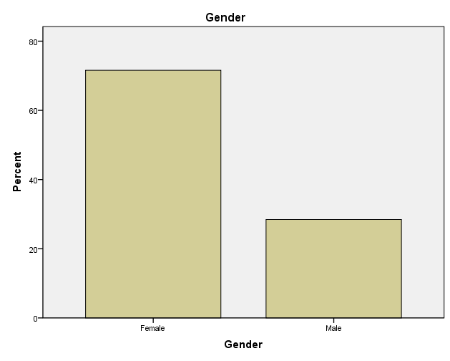

Figure 2 bar chart results of employee's gender

| **Education** | | | | | |
| --- | --- | --- | --- | --- | --- |
|  | | Frequency | Percent | Valid Percent | Cumulative Percent |
| Valid | Bachelor | 35 | 34.3 | 34.3 | 34.3 |
| Diplome | 1 | 1.0 | 1.0 | 35.3 |
| Master | 55 | 53.9 | 53.9 | 89.2 |
| MD | 2 | 2.0 | 2.0 | 91.2 |
| Ph.D | 9 | 8.8 | 8.8 | 100.0 |
| Total | 102 | 100.0 | 100.0 |  |

Table 2 frequency results of education's level

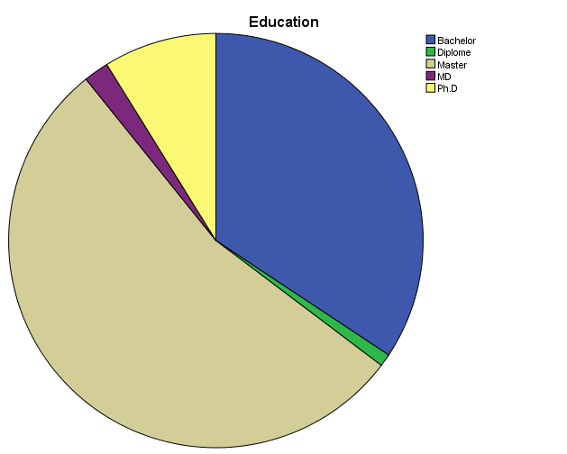

Figure 3 pie chart results of education's level

| **Organization type** | | | | | |
| --- | --- | --- | --- | --- | --- |
|  | | Frequency | Percent | Valid Percent | Cumulative Percent |
| Valid | Government | 8 | 7.8 | 7.8 | 7.8 |
| Multinational (MNC) | 12 | 11.8 | 11.8 | 19.6 |
| Private | 82 | 80.4 | 80.4 | 100.0 |
| Total | 102 | 100.0 | 100.0 |  |

Table 3 frequency results of organization's type

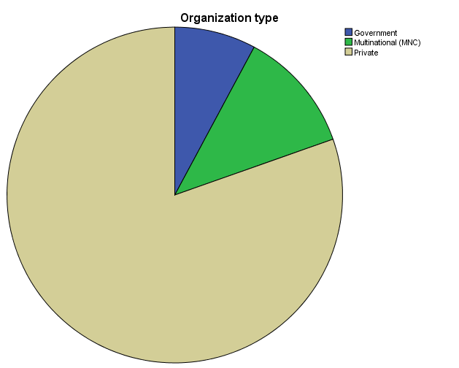

Figure 4 pie chart results of organization's type

| **Experience** | | | | | |
| --- | --- | --- | --- | --- | --- |
|  | | Frequency | Percent | Valid Percent | Cumulative Percent |
| Valid | 1 | 25 | 24.5 | 24.5 | 24.5 |
| 2 | 24 | 23.5 | 23.5 | 48.0 |
| 3 | 22 | 21.6 | 21.6 | 69.6 |
| 4 | 17 | 16.7 | 16.7 | 86.3 |
| 5 | 14 | 13.7 | 13.7 | 100.0 |
| Total | 102 | 100.0 | 100.0 |  |

Table 4 frequency results of years' experience

1: 0-3 years, 2: 3-5 years, 3: 5-7 years, 4: 7-10 years, 5: More than 10 years.

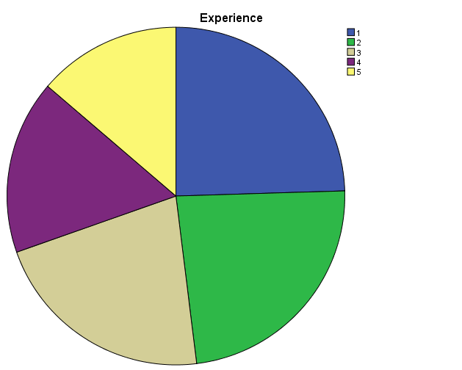

Figure 5 pie chart results of years' experience

| **Specialization** | | | | | |
| --- | --- | --- | --- | --- | --- |
|  | | Frequency | Percent | Valid Percent | Cumulative Percent |
|  | |  |  |  |  |
| Valid | Country manager | 1 | 1.0 | 1.0 | 1.0 |
| Dietitian | 1 | 1.0 | 1.0 | 2.0 |
| Education | 1 | 1.0 | 1.0 | 2.9 |
| Food safety | 3 | 2.9 | 2.9 | 5.9 |
| Insurance Consultant | 1 | 1.0 | 1.0 | 6.9 |
| IT/HR/Finance/Accountant | 8 | 7.8 | 7.8 | 14.7 |
| Lab tech | 1 | 1.0 | 1.0 | 15.7 |
| lab technician | 1 | 1.0 | 1.0 | 16.7 |
| Lab technician | 2 | 2.0 | 2.0 | 18.6 |
| LAB TECHNICIAN | 1 | 1.0 | 1.0 | 19.6 |
| Medical representative | 46 | 45.1 | 45.1 | 64.7 |
| Nurse | 3 | 2.9 | 2.9 | 67.6 |
| Pharmacist | 18 | 17.6 | 17.6 | 85.3 |
| Physician | 9 | 8.8 | 8.8 | 94.1 |
| Physiotherapist | 1 | 1.0 | 1.0 | 95.1 |
| Quality control analyst | 1 | 1.0 | 1.0 | 96.1 |
| Sales manger | 1 | 1.0 | 1.0 | 97.1 |
| social science | 1 | 1.0 | 1.0 | 98.0 |
| Teacher | 1 | 1.0 | 1.0 | 99.0 |
| Translation/psycho social support | 1 | 1.0 | 1.0 | 100.0 |
| Total | 102 | 100.0 | 100.0 |  |

Table 5 frequency results of the different specialization

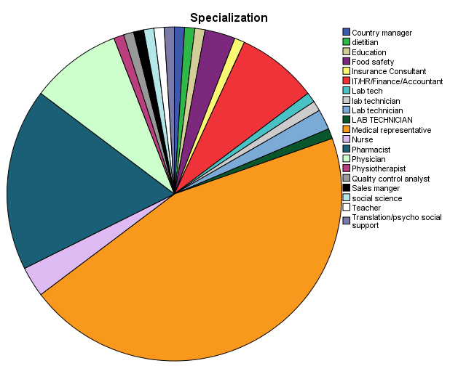

Figure 6 pie chart results of the different specialization

| **Best way of interaction within healthcare organization** | | | | | |
| --- | --- | --- | --- | --- | --- |
|  | | Frequency | Percent | Valid Percent | Cumulative Percent |
| Valid | E-mail | 1 | 1.0 | 1.0 | 1.0 |
| Face-to-Face | 94 | 92.2 | 92.2 | 93.1 |
| Telephone/Mobilephone | 2 | 2.0 | 2.0 | 95.1 |
| Video conferences | 5 | 4.9 | 4.9 | 100.0 |
| Total | 102 | 100.0 | 100.0 |  |

Table 6 frequency results of the best way of interaction within healthcare organization

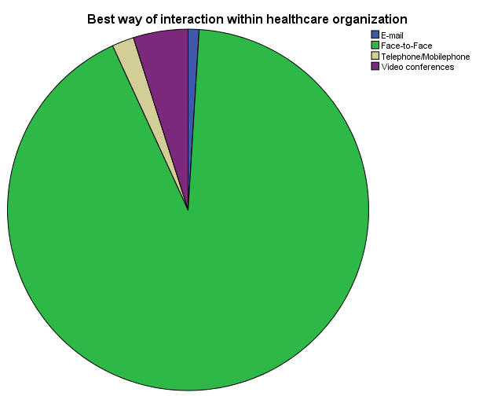

Figure 7 pie chart results of the best way of interaction within healthcare organization

# **Analysis**

A brief summary about our sample done above through a descriptive statistics. 102 respondents.

First, analyze of demographics part of this sample.

* Table 1 shows us the generation distribution of our sample. “Generation” of the employees that participate in this sample is distributed over 3 ranges: Generation X (2%), generation Y (94.1%), and generation Z (3.9%). We don’t have any employee from Pre-Boomers and baby boomers generations. We can conclude that the majority of employees is at generation Y (from 1981 till 1999).
* Figure 2 represents the gender of our sample. It presents 29 males out of 102 respondent (28.4%) and 73 females out of 102 respondent (71.6%). There is a diversity in the gender and we remark that the percentage of female gender is greater than male gender.
* Table 2 and figure 3 present the level of education of the sample, where 34.4% of employees had bachelor degree, 1% had diploma degree, 53.9% had master’s degree, 2% are physicians, and 8.8% had Ph.D. degree. So the majority of the sample had master’s degree.
* Table 3 and figure 4 show the different type of organizations that the employees working in. 7.8% are working in a government organization, 11.8% are working in a multinational companies, and 80.4% are working in a private companies. The majority of the sample are working in a private companies.
* Table 4 and figure 5 present the years of experience among the respondents. 24.5% are working for 0-3 years(1), 23.5% are working for 3-5 years(2), 21.6% are working for 5-7 years(3), 16.7% are working for 7-10 years(4), and 13.7% are working for more than 10 years(5). So we can conclude that the years of experience in our sample is close to each other but the average of employees are working between 3 and 7 years.
* Table 5 and figure 6 show the variation of the specialization among the respondents who are working within the healthcare organization. 7.8% are working in the administration department as HR/IT/Finance/Accountant, 45.1 are medical representative, 2.9% are nurses, 17.6% are pharmacists, 8.8% are physicians, 5% are laboratory technicians, and 17.8% are working as managers, dietitians, food safety, physiotherapist, quality controller and another specialties are mentioned in the table 5. The majority of the sample are working as medical representative.
* And in table 6 and figure 7, we observe the best way of interaction between employees within the healthcare organization from the different departments. 1% prefer to interact through e-mail, 92.2 prefer to interact in a direct way (face-to-face), 2% prefer to contact through the mobile phone and telephone, and 4.9 choose the video conferences as a best way of interaction within the healthcare organization.

| **Descriptive Statistics** | | | | | |
| --- | --- | --- | --- | --- | --- |
|  | N | Minimum | Maximum | Mean | Std. Deviation |
| Medical staff can work remotely | 102 | 1 | 5 | 3.24 | 1.073 |
| Administration staff can work remotely | 102 | 1 | 5 | 2.21 | .825 |
| Remote team can be more productive than real team | 102 | 1 | 5 | 3.46 | 1.105 |
| The existence of E-leader in healthcare organization is one of the requirements for organization to survive | 102 | 1 | 5 | 2.24 | .869 |
| E-leader plays a significant role in improving productivity in healthcare organization | 102 | 1 | 5 | 2.23 | .807 |
| Your healthcare organization offers E-leader training program for all employees | 102 | 1 | 5 | 2.66 | .990 |
| The virtual organizational structure is fit for healthcare organization | 102 | 1 | 5 | 2.79 | .926 |
| Valid N (listwise) | 102 |  |  |  |  |

Table 7 descriptive statistics, 1: strongly agree, 5: strongly disagree

* The average of the data is 35.2% that agree with the statement where medical staff can work remotely.
* The average of the data is 55.8% that agree with the statement where administration staff can work remotely.
* The average of the data is 30.8% agree that remote team can be more productive than real team.
* 55.2% is the average of the data that agree with the existence of e-leader in healthcare organization is one of the requirements for organization to survive.
* 55.4% is the average of the sample that agree with the statement where e-leader can plays a significant role in improving productivity in healthcare organization.
* 46.8% agree with the statement where the healthcare organization offers e-leader training program for all employees.
* 44.2% agree that the structure of virtual organization is fit for healthcare organization.

| **Correlations** | | | |
| --- | --- | --- | --- |
|  | | Productivity | Eleadership |
| Productivity | Pearson Correlation | 1 | .462** |
| Sig. (2-tailed) |  | .000 |
| N | 102 | 102 |
| Eleadership | Pearson Correlation | .462** | 1 |
| Sig. (2-tailed) | .000 |  |
| N | 102 | 102 |
| **. Correlation is significant at the 0.01 level (2-tailed).  Table 8 correlation test between independent and dependent variables. Independent variable: e-leadership, dependent variable: productivity  There is a positive correlation between productivity and e- leadership (46.2%), and the relationship between these two variables is very strong for sig. equal .000 less than 0.01.  So the hypothesis H0 is accepted and H1 is rejected. | | | |

# **Summary of Findings and Analysis**

To sum up, we can conclude the following findings:

* The majority of employees (94.1%) is from the generation Y (from1981 till 1999).
* The distribution of the gender is the following: 28.4% males and 71.6% females.
* The plurality of the sample (53.9%) had master’s degree.
* The most of employees who participate in this study are working in a private organizations.
* 24.5% of the sample worked for 0-3 years, 23.5% of the employees worked for 3-5 years, 21.6% worked for 5-7 years, 16.7% worked for 7-10 years, and the smallest percentage (13.7%) is for the employees who worked more than 10 years.
* Most of the respondents are medical representative (45.1%).
* The majority of employees prefer to make a direct interaction (Face-to-Face) with 92%.
* The most of respondents are agree that the administration staff can work remotely more than the medical staff and remote team are less productive than real team.
* More than 50% of the sample agree that the presence of e-leader within the organization is very important and he plays a significant role.
* Less than 50% of the sample agree that the structure of virtual organization is fit for the healthcare companies.
* The correlation between E-leadership and productivity is highly positively correlated (0.462**).
* The correlation test indicates that H0 is accepted and H1 is rejected.

# **CHAPTER 5: CONCLUSION, LIMITATIONS, AND RECOMMENDATIONS**

# **Conclusion**

Now the most of the businesses are doing business through electronic medium. The responsibilities and the objectives of leader is the same but the only change is the way of communication. The new style e-leadership is new especially in healthcare organization.

In this study, we observed that employee productivity is highly dependent on the virtual leadership. Any change in leadership type can affect directly the productivity of employees within the healthcare organization. The results of the study show how this relationship between those two variables are positively correlated.

Our results indicate the significant statistics because the Pearson correlation is 0.462 and the significant (2-tailed) is 0.000 less than 0.01. So H0:” There is a possible relationship between E-leadership and employee’s productivity in Lebanese healthcare organizations” is accepted and H1:” There is not a possible relationship between E-leadership and employee’s productivity in Lebanese healthcare organizations” is rejected. In addition, the answer of the research question: The E-leadership affect positively the employees productivity within the Lebanese healthcare organization.

Moreover, the comparison of the findings and the literature review is very similar.

Based on what mention in the literature review, followers are influenced by the style of e-leadership in order to achieve goals and objectives. In addition, the last three generations is familiar with technology and e-leadership more than pre and baby boomers (Al-Ghalili and Al-Harethi, 2019). E-leader needs to develop new skills to be adopted to every E-business (Lubna Alfehaid and Elham Elshafei, 2019). Every organization has its own culture, so for this reason, the variety of opinion in the sample is clear.

This project can be a key for other studies. In the future researches, the effect of e-leadership will influence not only the productivity of employee, but also the motivation, satisfaction, and many factors. In addition, the virtual leadership fit in all types of organizations as school, universities, and banks and so on.

# **Limitations**

Our study had several limitations and obstacles. First, the majority of the respondents is from the generation Y (mid age), because the questionnaire was distributed through social media. No person from pre-boomers or baby boomers generations were answered our survey, so what about nurse/physician/ manager above 55 years old? Do they prefer e-leadership than leadership? Second, the questionnaire was distributed via social media. This medium have some disadvantages in our research: one, the majority of the sample is young. Two, due to the corona virus, the medical staff is very busy to participate in our research and the most respondents are from the administration and sales departments. Third, since e-leadership is relatively a new concept in Lebanon and the training on it is still not very required on Lebanese healthcare organization, the majority of employees requested a brief explanation about remotely work before they were filled the survey.

# **Recommendations**

We have remarked that electronic leadership is a modern and new style of leadership where the medium of connection between leaders and followers (employees) is electronic as zoom, Google meet, Skype etc. So the traditional leadership is no longer be effective as before, the new leadership style is very required. This means that virtual leadership is much needed for a greater future.

* Universities should involve E-leadership course in all majors.
* Healthcare organizations should create new formats to develop e-leadership skills. Proper training should be given to the leaders as well as to the followers to stay up to date about the latest communication technologies and to save time and remove distance barriers.
* E-leadership will be a competitive advantage for many organizations.
* Leaders should use videoconferencing and video calling more than the other tools as mobile phone or email, because this can facilitate for the e-leader to see the expressions and reactions of the employees.

,

# **REFERENCES**

# Bibliography

Al-Ghalili and Al-Harethi, 2019. Managers’ Readiness To Adopt E-Leadership.

Andriukaitienė, P. Ž. a. J. V. a. R., 2017. *Philosophy and Paradigm of Scientific Research.* [Online]   
Available at: https://www.intechopen.com/books/management-culture-and-corporate-social-responsibility/philosophy-and-paradigm-of-scientific-research

Anon., 2016. *11 WAYS TO MEASURE EMPLOYEE PRODUCTIVITY – BEST PRACTICES TO CONSIDER.* [Online]   
Available at: https://mitrefinch.com/blog/how-to-measure-employee-productivity/

Anon., n.d. *How to Calculate Productivity at All Levels: Employee, Organization, and Software.* [Online]   
Available at: https://www.smartsheet.com/blog/how-calculate-productivity-all-levels-organization-employee-and-software

Anon., n.d. *How to measure productivity of remote employees and those working from home – 12 business leaders share their secrets.* [Online]   
Available at: https://www.hivedesk.com/blog/work-from-home-remote-employee-productivity/

Anon., n.d. *Key Elements of a Research Proposal.* [Online]   
Available at: https://www.wssu.edu/about/offices-and-departments/office-of-sponsored-programs/pre-award/_Files/documents/develop-quantitative.pdf

Anon., n.d. *What is a Survey – Definition, templates, methods, characteristics, and examples.* [Online]   
Available at: https://www.questionpro.com/blog/surveys/

Bhandari, P., 2020. *A step-by-step guide to data collection.* [Online]   
Available at: https://www.scribbr.com/methodology/data-collection/

Cascio and Shurygailo , 2008. E-leadership and virtual team.

Chat, l., 2016. *Time horizon: cross-sectional versus longitudinal studies.* [Online]   
Available at: https://kalyaneynath.wordpress.com/2016/06/02/time-horizon-cross-sectional-versus-longitudinal-studies/  
[Accessed 2 june 2016].

DasGupta, P., 2011. e-Leadership. *Emerging Leadership Journeys.*

Dudovskiy, J., n.d. *Research Philosophy.* [Online]   
Available at: https://research-methodology.net/research-philosophy/#:~:text=Within%20the%20scope%20of%20business,Realism

Duquesnoy, P., 2011. Generations, leadership style and employee performance.

Guides, R., 2019. *University of Newcastle Library guides.* [Online]   
Available at: https://libguides.newcastle.edu.au/researchmethods  
[Accessed 8 December 2020].

Hanaysha, 2016. Improving employee productivity through work engagement: Evidence from higher education secto.

Harness, J., 2018. *The Importance of Employee Productivity.* [Online]   
Available at: https://bizfluent.com/info-8292773-importance-employee-productivity.html

IBM, n.d. *IBM.* [Online]   
Available at: https://www.ibm.com/analytics/spss-statistics-software  
[Accessed 14 March 2020].

IBM, n.d. *IBM SPSS Statistics.* [Online]   
Available at: https://www.ibm.com/uk-en/products/spss-statistics

Inc., S., 2020. How to Calculate Productivity at All Levels: Employee, Organization, and Software.

Jackson, J., n.d. *How HR can help maintain company culture with remote workers.* [Online]   
Available at: https://www.lucidchart.com/blog/how-to-maintain-company-culture-with-remote-workers

Jackson, K., n.d. *8 Ways to Increase Productivity in the Workplace.* [Online]   
Available at: https://businesstown.com/8-ways-increase-productivity-workplace/

Klein, P., 2018. Leadership Perspective on the New Generations (Generation Y and Generation Z).

Love, C., 2014. *5 Reasons to Use Google Forms with Your Students.* [Online]   
Available at: https://www.technokids.com/blog/apps/reasons-to-use-google-forms-with-your-students/

Lubna Alfehaid and Elham Elshafei, 2019. Understanding the influence of E-leadership on Virtual Team Performance. *International Journal of Business and Applied Social Science.*

Maurer, R., 2020. *5 Tips to Increase Productivity While Working Remotely.* [Online]   
Available at: https://www.shrm.org/hr-today/news/hr-news/pages/5-tips-increase-productivity-while-working-remotely-covid-coronavirus.aspx

Mehaffey, L., 2020. *Can healthcare staff work from home?.* [Online]   
Available at: https://www.ringcentral.com/us/en/blog/can-healthcare-staff-work-from-home/

Mohamed, A. a., 2019. Understanding the influence of E-leadership on Virtual Team Performance Empirical Study. 5(10).

Okechuku and Nebo, 2020. Assessment of Relationship between E- Leadership and Virtual. 4(8).

Power, 2019. *This Is How You Lead a Team That Spans 4 Generations.* [Online]   
Available at: https://www.inc.com/rhett-power/d.html

Pranas Žukauskas, J. V. a. R. A., 2017. *Philosophy and Paradigm of Scientific Research.* [Online]   
Available at: https://www.intechopen.com/books/management-culture-and-corporate-social-responsibility/philosophy-and-paradigm-of-scientific-research

Renu, 2014. E-Leadership- A New and modern Style of Leadership. *International Journal of Advances in Management and Economics.*

Researcher, 2009. *Deductive, inductive and abductive approaches.* [Online]   
Available at: http://elearning.net.marjon.ac.uk/research-skills/researchmethods/researchsocsci_mo_251110/html/course_files/deductive_4_2.html

Roberts, R. C. a. W. J. W., 2007. Intellectual virtues: An essay in regulative epistemology..

rouse, M., 2014. *Employee productivity.* [Online]   
Available at: https://whatis.techtarget.com/definition/employee-productivity

SHRM, n.d. *Understanding and Developing Organizational Culture.* [Online]   
Available at: https://www.shrm.org/resourcesandtools/tools-and-samples/toolkits/pages/understandinganddevelopingorganizationalculture.aspx

Stainton, H., 2020. *Positivism and Interpretivism: A Simple Explanation.* [Online]   
Available at: https://tourismteacher.com/positivism-and-interpretivism-simple-explanation/

Surgi, K., 2014. [Online].

Surji, K., 2014. The Positive Affect of Leadership on Employee Performance and Its Impact on Improving Workplace Environment in Addition to Organizational Culture. January.

Ward, S., 2020. What is Leadership?.

Wart, Wang, R. & Liu, 2017. Operationalizing the definition of e-leadership: identifying the elements of e-leadership. p. 7.

Žukauskas, P., Vveinhardt, J. & Andriukaitienė, R., 2017. *Philosophy and Paradigm of Scientific Research.* s.l.:Management Culture and Corporate Social Responsibility.

**APPENDIX 1: QUESTIONNAIRE**

**The impact of E-leadership on Employees Productivity in Lebanese Healthcare Organizations**

Dear helpers, I'm Zeinab Fayad MBA student at LIU spilling down my thesis. Kindly participate in this survey and fill out the questions to help me complete my study concerning the effect of pay cuts on employee performance. Thanks for your time and support.

Generation:

* Pre-boomers (Born before 1945)
* Boomers (Born 1946-1964)
* Generation X(Born 1965-1980)
* Generation Y(Born 1981-1999)
* Generation Z(after 2000)

Gender:

* Female
* Male
* Prefer not to say
* Other:

Education:

* Bachelor
* Master
* Ph.D
* Other:

Organization type:

* Private
* Government
* Multinational (MNC)
* Other:

Experience:

* 0-3 years
* 3-5 years
* 5-7 years
* 7-10 years
* More than 10 years

Specialization:

* Physician
* Nurse
* Pharmacist
* Medical representative
* IT/HR/Finance/Accountant
* Other:

Best way of interaction within healthcare organization:

* Face-to-Face
* E-mail
* Telephone/Mobilephone
* Video conferences
* Instant messaging
* Social media
* Other:

Medical staff can work remotely:

* Strongly agree
* Agree
* Neutral
* Disagree
* Strongly disagree

Administration staff can work remotely:

* Strongly agree
* Agree
* Neutral
* Disagree
* Strongly disagree

Remote team can be more productive than real team:

* Strongly agree
* Agree
* Neutral
* Disagree
* Strongly disagree

The existence of E-leader in healthcare organization is one of the requirements for organization to survive:

* Strongly agree
* Agree
* Neutral
* Disagree
* Strongly disagree

E-leader plays a significant role in improving productivity in healthcare organization:

* Strongly agree
* Agree
* Neutral
* Disagree
* Strongly disagree

Your healthcare organization offers E-leader training program for all employees:

* Strongly agree
* Agree
* Neutral
* Disagree
* Strongly disagree

The virtual organizational structure is fit for healthcare organization:

* Strongly agree
* Agree
* Neutral
* Disagree
* Strongly disagree