**GRADUATE PROJECT**

**The Effect of Leadership Style on Employee Satisfaction**

**Submitted to the Lebanese International University**

**The School of Business**

in Fulfillment of the

Requirements for the Degree of

**Master of Business Administration in Management**

By

**Ahmad Al Akkad**

ID: 31530027

Campus: Saida

Supervised by: Dr. Mtairek

Spring 2019 – 2020

**DEDICATIONS**

I would like to dedicate my work to my family: Mother, Father, sisters, brother, my fiancée and to each person who has given me a helping hand and made this long journey brighter. Also, I want also to appreciate my friends and all the instructors for their advice, motivation, care and support. Thank you all for always being there for me.

**ACKNOWLEDGEMENTS**

With deep appreciation, I would really like to acknowledge Dr. Mohammad Mtairek for his support, help and assistance across my MBA graduate project. I would like to appreciate and thank all the staff and Managers in the Banks and everyone who helped in achieving our goal in our project.

**ABSTRACT**

One of the most important outcomes related to human resources is employee job satisfaction. The behavior of highly satisfied workers is linked to higher satisfied employee. Additionally, leadership is viewed as one of the primary determinants of employee job satisfaction. The aim of this research was to classify the various leadership styles implemented by existing bank supervisors in Lebanon (South) and their results on job satisfaction for employees. To achieve the current goal, a study of 100 employees from 6 different banks in South Lebanon was conducted. SPSS was used to analyze the data. The results showed a significant positive relationship between both the democratic leadership style and the employee job satisfaction and an inverse relationship between laissez-faire leadership style and employee job satisfaction. Nonetheless, there was no association regarding the autocratic style and the employee job satisfaction. Because of the lack of time given to finish this report, there have been some limitations on the extent of employee involvement, number of banks that were targeted, and techniques of analysis applied. Future studies are therefore encouraged to extend the study in the Lebanese context to different levels.

Table of Contents

LIST OF TABLES 8

LIST OF FIGURES 9

CHAPTER 1: INTRODUCING THE GRADUATE PROJECT 10

1. Introduction 10

1.1. Research Question 11

1.2. Research Aim and Objectives 12

1.3. Overview of the Sector/Domain/Organizations 13

1.4. Research Hypotheses 13

1.5. Structure of the Graduate Project 14

CHAPTER 2: LITERATURE REVIEW 15

2.3. Leadership Styles 17

CHAPTER 3: RESEARCH METHODOLOGY 31

3.1 Research Philosophy 31

**3.1.1 Positivism** 32

**3.1.2 Interpretivism** 32

**3.1.3 Critical Realism (CR)** 32

**3.1.4 Pragmatism** 32

**3.1.5 Postmodernism** 32

3.2 Research Approach 33

**3.2.1 Deductive Approach:** 33

**3.2.2 Inductive approach:** 33

**3.2.3 Abductive approach:** 33

3.3 Research Strategy (Data Collection Method) 34

3.4 Research Methodological Choice 35

3.5 Time horizon 36

3.6 Techniques and/or Procedures for Data Analysis 37

CHAPTER 4: FINDINGS AND ANALYSIS 38

4.1. Introduction 38

4.2. Findings (Descriptive Statistics) 38

**4.2.1- The overview of Characteristics of the Demographic part:** 38

**4.2.2 Testing the theoretical framework** 41

**4.2.3. Statements of satisfaction** 41

**4.2.4. Correlations** 42

4.3. Analysis 43

4.4. Summary of Findings and Analysis 47

CHAPTER 5: CONCLUSION, LIMITATIONS, AND RECOMMENDATIONS 48

5.1. Conclusion 48

5.2. Limitations 49

5.3. Recommendations 49

REFERENCES 51

APPENDICES 53

APPENDIX 1: QUESTIONNAIRES 53

# **LIST OF TABLES**

Table 1-The rate of response among sampled banks 39

Table 2- Workforce distribution by province 39

Table 3-Gender distribution for employees 39

Table 4-Distribution of family status for employees 40

Table 5- Age distribution for employees 40

Table 6-Education level distribution for employees 40

Table 7-Job title distribution on employees 40

Table 8-seniority of employees 41

Table 9-Job responsibility of employees 41

Table 10-length of operation with same manager 41

Table 11-the values of the mean and frequency of leadership styles 42

Table 12- The values of the Mean and Frequency of Employee satisfaction Variables 43

Table 13-Pearson Correlation test between leadership style and employee satisfaction 43

Table 14-Pearson Correlation Between 44

# **LIST OF FIGURES**

Figure 1-Leadership styles and Job satisfaction 20

Figure 2-Employee Participation 26

Figure 3-Employee and Customer Satisfaction 27

Figure 4-Research Onion 31

# **CHAPTER 1: INTRODUCING THE GRADUATE PROJECT**

# **Introduction**

Organizations are organizational networks in which human capital constitutes the most important commodity for productivity and effectiveness. Human capital is the most important element in achieving the corporate objectives and goals (Mosadragh, 2003). Due to globalization in this new period with dramatic shifts in the business world, businesses are seeking to gain competitive advantages based on the quality with their human capital. Managing workers from various cultures and backgrounds is a challenging job and relies on the efficiency of the managers (leaders) in charge (Albion and Gagliardi, 2007).

Effective organizations are based on the efforts, participation and dedication of their employees in achieving their goals. The leadership style of managers is one of the key factors for effectiveness of organizations. Today, organizations are more concerned with identifying, creating, and strengthening their leadership style. Leadership is a management role that is often aimed at individuals; it is a method of manipulating people to achieve the organization's objectives (Skansi, 2000). Fiedler (1996), one of the most regarded leadership scholars, underlined the value of leadership by arguing that a leader's effectiveness is a significant determinant of a group's success or failure. Transformational leadership is a new leadership strategy that has caught the attention of many scholars over the past three decades in the field of organizational behavior.

Burns (1978) developed this theory and later improved it with Bass (1985).The principal principle of the theory of transformational leadership is the capacity of the leader to inspire followers to succeed beyond their standards (Krishnan,2005). Good leadership and employment satisfaction among workers are two factors that have been considered central to organizational performance (Kennerly 1989). A competent leader sets guidance for the company to achieve desired objectives and lead followers.

Similarly, workers with a high degree of work satisfaction are likely to seek more commitment and organizational objectives. Leadership plays an important role in assessing work satisfaction for the workers. It greatly affects the morale and commitment of the employees. According to Mosadegh Rad and Yarmohammadian (2006), employee satisfaction refers to the attitude of employees towards their jobs and the organization which employs them.

Organizational success is highly contingent upon its workers. Happier and fulfilled workers would be more efficient and successful for the organization (Saari & Judge, 2004). Job satisfaction helps create healthy attitudes in workers, strengthens their values, increases their performance and establishes a friendly relationship with their colleagues. Despite the fact that there is comprehensive research about the relationship between leadership style and job satisfaction in a wide range of fields and in a wide range of environments, there is still a lack of research to examine this relationship in the Arab countries.

Therefore, the researchers were inspired to close this gap by initiating a paper that aimed at exploring and explaining the effect of leadership style on the employee satisfaction in Lebanon.

# **Research Question**

The following research questions reflect these objectives:

1. From employee perspective, what are the most adopted leadership styles by the bank managers?
2. What level of satisfaction does the employee have in the banks understudy?
3. Is there any relation between the leadership style followed by the managers in the banks and the employee satisfaction?
4. What are the biggest important features of work satisfaction of the workers in the selected banks?

# **Research Aim and Objectives**

More than before, companies need to know their workers better and have a personal relationship with them in order to maximize the individual and team capacities of the workers within the company and the marketplace (Chen & Huang, 2009). Managers today understand the value of introducing these new approaches and activities to promote, inspire and engage the workers (Williams and Anderson, 1991). Our leadership habits are translated from our activities that get the best out of the workers, by inspiring them to reach their maximum level of effort. It would help increase the employee job satisfaction of the workers and their commitment to the company and work positions (Carroll, Levy and Richmond, 2008). The hard work and sacrifices expended by the human workers much of the time determine the company's loss or success. The banking sector has shown a lot of positive proof for its high performance in the last years in Lebanese context “ABL, 2018; Achi & Sleilati, 2016”. There is still a lack of longitudinal research illustrating the key determinants of such a success. And because the leadership style for managers is among the factors that affect the behavior and employee job satisfaction, this research is conducted for a better understanding of the leadership styles of managers in banks in Lebanon and their relation to work employee satisfaction. Such a study is important for managers to define the best models of leadership to follow and also to detect their direct impact on banking efficiency and the Lebanese market.

The objective of such a study is to define the leadership styles of the managers in the banks in the South and their impact on Lebanon and to assess the employee job satisfaction. The most relevant leadership styles are highlighted to managers to be adopted by surveying bank workers, thereby achieving the highest degree of employee satisfaction.

# **Overview of the Sector/Domain/Organizations**

Banks in Lebanon:

The banking sector in Lebanon is known in the Middle East for its complexities and services. The Banking sector in Lebanon generates 40% of the Gross Domestic Product making the sector one of the leading drivers of economic growth in Lebanon (Achi and Sleilati, 2016). For the past years, Arabs and European entrepreneurs and the one how deposit are being attracted to the banking sector in Lebanon. Such a competitive climate, therefore, pressured the Lebanese banks to invest at one of the major assets: its human capital. Scientifically, there is a shortage of research on topics relating to human resource management in the banking sector in Lebanon. This research will thus add considerable value by highlighting the existing banking population features in Lebanon and analysing the most successful leadership styles implemented to improve job satisfaction for employees. Throughout the last 50 years, Lebanon's number of banks ranged from 60 to 92 banks of varying sizes, existence and ownership structure (ABL, 2018). These include private commercial banks operated by small, medium and large sized businesses, short- and long-term credit or investment banks, international and Islamic banks and mixed banks.

# **Research Hypotheses**

The following hypotheses represent the research framework.

H10: There is a significant relationship between autocratic leadership and employee job satisfaction

H11: There is no significant relationship between autocratic leadership and employee job satisfaction

H20: There is no significant relationship between democratic leadership and employee job satisfaction

H21: There is a significant relationship between democratic leadership and employee job satisfaction

H30: There is a significant relationship between Laissez-Faire leadership and employee job satisfaction

H31: There is no significant relationship between Laissez-Faire leadership and employee job satisfaction

H40: There is a significant relationship between the employee’s demographics and their job satisfaction

H41: There is no significant relationship between the employee’s demographics and their job satisfaction

# **Structure of the Graduate Project**

Our project is divided into 5 chapters; each chapter has its own data. Chapter 1 covers the introduction of our project title and the project questions with listing the aim and objectives of the project then having an overview on the sector we are going to cover then listing the hypotheses. Chapter 2 covers the literature review of our project. This part tells us everything needed to be known about the problem that we are facing. Chapter 3 is about the methodology of our project: the philosophy, the approach, the strategy and other factors about the project. Chapter 4 presents the results of the questionnaire that was analyzed using SPSS (in our case), the results (graphs and tables) and the analysis of the findings, and chapter 5 is divided into 3 parts: conclusion, limitations and recommendations.

# **CHAPTER 2: LITERATURE REVIEW**

**2.1. Management:**

Management in modern times is the most skewed but the most significant problem.

It is mostly linked with businesses, but it ranges from personal relationships to partnerships, from house to workplace to productive and nonprofitable organizations (Alyasa Gan, 2018).

It all depends on what you manage and how you manage because there is no one method in management that suits all. It all depends on when you handle vast volumes of data, logical thinking, complicated jobs and easy ones. This means we are going to handle people with different capacity to think, process data and interpret situations.

Since managers are likely to have people working around them, it is crucial to have the resources they use to help people boost productivity and self-actualization, which will become the criterion for their performance. Managers cannot be solely liable for their organizational failure because they operate in a larger position than themselves. A 1 to 2-line management concept is definitely not enough, and it would be arrogant to ignore the classical management theory laid down by Fayol (no date). Management is the most detailed piece of research that interprets what management should be but unfortunately one of the world’s most criticized by misunderstood theory (Fayol, no date).

Most people would agree that a manager and a leader vary but go a step further and ask them what the variation is, and they would generally start hem and haw. They may have a visual picture, but they cannot put it into words. They don't really seem to have a good concept (Turk, 2007). There is a management phrase saying, "Managers do it right, while leaders do the right thing." This is one of those pithy sayings that sound sweet, but it just doesn't tell us anything.

One simple response is that leadership is intangible, but charisma includes. Many suggest there is something you are born with that is indefinable. Another response is that managers do things through the book and obey rules, going up within the company based on their performance and achievements. On the other hand, leaders follow their own instincts and may not be in a position allowed in the hierarchy.

**2.2. Difference between a Manager and a Leader?**

A manager may, according to others, have earned his or her place of power through time and dedication to the company or upper management, not because of his or her leadership qualities. Although this has the feeling of consistency, there are many exceptions everyone can think of. "Experts" often suggest administrators are insensitive to something that appears to pop up when problems arise. It is on familiar terrain or by time-tested tactics, when they act. The leader is more effective than the manager. A leader not only reacts and responds but takes the initiative and performs results. A leader does not just say, "Something will be done"; he or she actively ensures it is done. Leaders can infuse feeling, pride and the desire to succeed with reasoning, data and analysis.

The best approach is that a good manager and leader can and should be one and the same. Of course, leaders are born, but more leaders are made (Wayne, 2007). In general, a leader is a "people person". As Gandi (2014) said, "I suppose leadership meant muscles at one time; but today it means getting along with men”. A leader offers individuals the opportunity to develop, both professionally and personally. A leader looks at the employees' skills and abilities. He uses those skills for all the project, but at the same time looks for ways to improve them, whether by interactions, workshops or even knowledge sharing (Wayne, 2007).

A leader makes others feel respected and important. He or she excels in providing ways to offer bonuses, appreciation and thanks to the employees. A leader generates a work atmosphere where people feel valuable and respected. The real leader credits public contributions to the workers. Mary Kay Ash, president of Mary Kay Products, briefly explains it as: “There are two things people want more than sex and money: recognition and praise”. Efficient, meaningful recognition feels vital to people. It helps them to make a bigger difference in the future. Good leaders / managers place the commendation in writing. A thank you note or an acknowledgment letter sent to the recipient, with a copy of the receiver's file, magnifies the appreciation effect. Successful leaders / managers use vision and imagination to create a continuous improvement atmosphere, making things better for their staff, the project and the organization. The ability to inspire "followership" is a crucial leadership attribute. ‘‘A true leader makes people follow her’’ (Ariane, 2014). The successful relationship between leader and follower encourages people to be more than they could have been without the relationship. People are accomplishing and achieving more than they would ever have thought possible without a successful leader. Any manager who aspires to become a leader / boss must believe that he or she is important to people. When you behave as you think it is important to people, then people will feel important. A leader / manager fosters loyalty through his or her sense of responsibility taking the blame when things go wrong, praising community victories, including small ones, giving credit where credit is due, exchanging recognition , making promises.

People need to feel involved, feel in the information, and be a part of the project's activities and processes. The inclusion is provided by the good leader / manager, which goes beyond listening and feedback. The manager / leader shall share details and plans with the team.

# **2.3. Leadership Styles**

The researchers around the world found that the leader ability to influence the followers is called leadership style. The ability to make a team that can concentrate on a target and getting results in the end through others is called leadership (Richard, Hughes and ginnett, 2002). There are different elements to describe the leadership concept. First, it is for must to have a group of people that works in one organization. Second, presence of a leader that can motivate the followers is crucial. Third, there must be a target to reach (Clawson, 2002).

There are various leadership theories discussed throughout the literature, including the approach to characteristics, behavioral approach, contingency approach, transactional and transition theories, the theory of grid leadership (Bass, 1990; Robbins, Judge, 2003),

but the autocratic, democratic, and laissez-faire leadership styles are the more appropriate leadership styles to be discussed in this study. A leader may follow the required style based on the group's circumstance, traits and values, as well as the nature of the tasks to be accomplished.

**Autocratic Leadership style:**

Such leadership style is distinguished by the intense supervision of community members by the leader for a reason that people within decision-making processes reduce business efficiency (Bernhard and Walsh, 1995). Moving beyond making decisions, autocratic leadership means attempting to impose or control beliefs and values over followers. The key application of economic values would be autocratic leadership, as they rely on a clear logic of productivity in their actions and feel that subordinates do not need to take part in decision taking (Bass and Stogdill, 1990). This style of leadership is viewed as prevalent by subordinates, as they force their views and beliefs on others and ask others what to do by making overwhelming decisions (Washburn, De Luque and Waldman, 2007).

**Democratic Leadership Style:**

This style of leadership fosters burden sharing, team promotion, and ongoing consultation. A democratic leader also values his or her team's views and advice and works as part of this group by taking some criticism into account when deciding (Pierce & Newstrom, 2000). A democratic leader is a skillful, strong, powerful, collaborative, respectful and good person (Choi, 2007). Moreover, Gastil (1994) described a democratic leader as one who allocates responsibilities between followers or teams and empowers them to help in the decision making process. Gastil (1994) identified other democratic leadership alternatives, such as servant leadership, educational leadership, super leadership, transformation leader and values leader. Improved employee satisfaction, increased efficiency and reduced workforce turnover are among the advantages of a democratic leadership style. It also has a beneficial influence on the reliability of the transmitted information (Foels et al., 2000). In summary, it helps the followers to engage in any decision the team takes and to offer their voices. Sadly, this style is time consuming because decisions are taken almost simultaneously with workers and can contribute to the claim of policies (Janet & Robert, 2007; Mohammad Mosadegh Rad & Hossein Yarmohammadian, 2006).

**Laissez-fair Leadership Style:**

The laissez-faire style of leadership is often known as 'hands-off' model in where the boss provides little to no guidance and allows staff as much independence as possible (Chowhan and Shekhwat, 2015). This gives the employees the power to decide the priorities, to take decisions and to overcome any problems that might arise by relying on their own power and skills (Berson and Linton, 2005). Leader Laissez-fair is seen as a liberator. Important criteria such as policies, priorities, budgets and deadlines are defined by the leader and the team leaders, then the groups operate separately until participation is requested (Cherry, 2012).

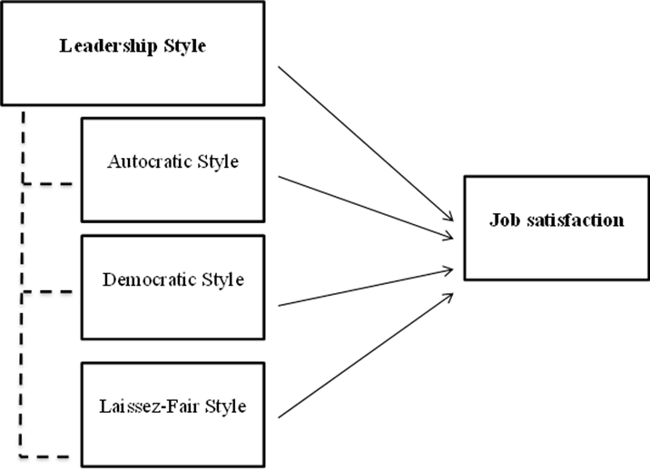

Figure 1-Leadership styles and Job satisfaction

**2.4. Employee satisfaction:**

Employee utilization is critical for company performance. This leads to a competitive advantage, and in the companies, Human Resource Management (HRM) is often concerned with this topic. HRM can be described as the management of the organization's employee related to decisions and behavior to implement competitive advantage strategies. Another meaning of HRM (Armstrong, 2000) is that it is the strategic management of an organization's members that leads to the achievement of the goals of that organization. When workers are satisfied, they are more loyal and efficient (Hunter and Tietyen, 1997), and these happy employees influence customer loyalty and organizational efficiency (Potterfield, 1999). Employee satisfaction is described as the mixture of affective responses to the varying expectations of what he / she wants to receive as compared to what he / she receives (Cranny, Smith and Stone, 1992).

The companies will also seek to include the employee standards to achieve employee satisfaction. Also, employees' emotional state can also influence their satisfaction. This forces the managers to build and maintain the organization’s ideal working environments. There is no limit to achieving full satisfaction for the workers, and it can differ from employee to employee. Often, they need to adjust their attitudes to more efficiently perform their duties to achieve greater work satisfaction (Miller, 2006). Having better relationships with the co-workers, high wages, decent working conditions, incentives for training and employment, job improvements or any other advantages can be related to increasing employee satisfaction.

It should be understood that when examining employee satisfaction, an employee might be more satisfied with a satisfactory item, while the other employee may be less satisfied with the same item. Because of this, it would be easier to evaluate employee satisfaction from a specific perspective (Baloush, 2014). In other words, the total of all satisfying factors makes up the degree of satisfaction of that employee. In general terms, employee satisfaction can be defined as how happy an employee is with his or her job role (Moyes, Shao and Newsome, 2008).

Investigating what the workers are pleased with and evaluating the organizational employee satisfaction is crucial to the performance and improves the organization's productivity for getting a competitive advantage (Kelley, 2005). Researching employee satisfaction in terms of multiple variables and in specific fields (such as manufacturing, service sector, etc.) would also enrich the literature and relate to organizations.

Employee satisfaction at work has been related to how people think, feel and experience their jobs (Spector, 1997). It is commonly used in the human resources sector, which believes that the internal and external features are job satisfaction reporting elements (Chang, 1999). In other words, job satisfaction, the emotional state is rewarding as a result of career harm evaluation or work experience (Locke, 1976). The survey of organizational job satisfaction is widely studied. all which variable has to do with how people feel about their jobs and various aspects of their work (Rainey, 1997). It is really the degree to which people like or dislike their job (Spector, 1997). Experts described employee satisfaction as "a directory of temporary knowledge accessible at the time for inclination to the practiced profession against outside chance”. Employee satisfaction is the metric that says the general emotion of the employee about their job and workplace. This tests his or her commitment to the job, and to what degree the job meets the needs of the employee. Several studies have concluded that the degree of employee satisfaction is used to assess an employee's intentions towards their workplace (Sweeney et al, 2002). Researchers have addressed multiple factors such as enthusiastic behavior, hygiene factors, administrative accountability and organizational climate based on different theories (Darrow, 1971; Kuo et al, 2007). A variety of activities was carried out to please the workers. The most significant of which is the concept of importance in the Maslow. Through this theory, he proposes that an individual needs to begin from the basic needs (food, cloth and shelter) and end at self-actualization level. Some specialists applied the theory of need to identify the factors affecting employee satisfaction.

**2.5. Job Loyalty:**

Loyalty is a state of mind and represents the relation between employees and the organization they work for, influencing their decision to remain with the organization (Allen and Grisaffe, 2001). It also defines creating the organization, which can be called an exciting response, particularly when the employee believes in the organization's principles and goals, and has a strong desire to keep a relationship with an organization (Mathieu and Zajac, 1990). There is a deep desire to remain a part of the organization's ability to maintain a high standard of organizational commitment and a firm conviction and appreciation of the organization's principles and objectives (Beckeret, 1995).

It is considered as a belief that plays a constructive role in sustaining the organisation's member. Strong retention of membership of employees in their organization can be defined as "the relative intensity of individual recognition and dissemination" (Wu and Norman, 2006).

If satisfaction is a basic feature of legitimate responses and attitudes in the workplace, employee engagement is an appropriate response to the entire company (Chen, 2006).

As demonstrated by empirical research, work satisfaction is a prerequisite to organization’s loyalty. This shows how loyalty, employee satisfaction of the organization of work and the actual fidelity mediator satisfaction variables turnover (Chen, 2006). There is a good relationship between employee satisfaction, organizational working employees and loyalty (Williams, 1996). Employee satisfaction has been positively associated with employee loyalty to their employer (Martensen and Gronholdt, 2001). In addition, some still maintain a clear association between employee organizational loyalty and employee satisfaction (Wu and Norman, 2006). Low work satisfaction results in low morale, low commitment to the company and a rise in sales jobs (Soler, 1998). It can also lead to a low job satisfaction withdrawal from job, search for a new job or a shift. Their current job and career happy employees are more organizational loyalty than disillusioned workers with their jobs (Kim et al., 2005).

**2.6. Workplace Environment:**

The position of the job is included in the working area where the employee performs his or her tasks and everyday activities, such as the office or construction site. Certain considerations such as noise level, fresh air, refreshment and benefits, such as childcare, are usually also part of the workplace environment. Depending on the essence of the work environment, workplace climate may have either positive or negative effects on employee satisfaction rates. Employees can work better if good atmosphere is provided for them. The results of the job are directly related to the work environment; the more friendly it (environment) is the better the result will be. Employee satisfaction takes a significant part of the organizational success. The workers will work better if a healthy climate is provided for them. There are different aspects of satisfaction with the physical environment which contribute to the satisfaction of the employee.

Researchers asked the employees questions which may involve how happy they are with their work environment. If an employee achieves a higher degree of satisfaction, then it decreases turnover and, in effect, increases an employee's productivity (Dole and Schroeder, 2001). Carlopio (1996) found that employee satisfaction is optimistically related to job efficiency and is implicitly related to potential turnover. The current working climate in different organizations has a positive effect on employee satisfaction.

**2.7. Employee Productivity:**

Productivity is a measure of performance which includes both efficiency and effectiveness. So, it is important to know who the successful workers are. High efficiency, and profitable companies have a community that fosters employee involvement. Workforce is also more likely to participate in decision making, setting targets or problem-solving tasks, resulting in higher output of the workforce (Hellriegel, Slocum and Woodman, 1998). Encourage a more inclusive style in participatory management and improve efficiency and satisfaction for employees and even lower pay costs for staff (Wisconsin, Madison, 2000). According to Miller and Monge (1986), job satisfaction improves efficiency by providing high quality encouragement at the time of implementation and by increasing work capabilities. Human resource policies which promote workplace engagement seek to provide opportunities for workers to contribute to decisions, opportunities to expend discretionary effort, and means to develop relevant skills (Berg 1999).

Participation programs, in these policies, specifically impact the first two things-rewards and benefits and as a result, benefits to learn skills as well as job structure and knowledge flows are thought to strengthen. It is expected that these cumulative effects will improve X performance and profitability (Baloush, 2014).

**2.8. Employment Commitment:**

Employee involvement was described differently (Mowday, Porter and Steers, 1982). Steer, 1997) refers to employee engagement to match the individual’s interests with the organization whereby the individual defines and extends initiative on behalf of the organization’s general objectives.

Employment commitment has been defined as composed of two affective and continuing constructs (Allen and Meyer, 1990). In some cases, variations are seen as an attitude between dedication and work satisfaction (Mowday, et al., 1982). Commitment is a more general response to an organization, and work satisfaction is more a response to a particular job or to various aspects of the task. Wiener (1982) notes that job satisfaction is an attitude to the working circumstances, facets and aspects of the job. Commitment thus implies more commitment to the working company as compared to individual tasks, environmental conditions, and where the tasks are conducted (Mowday, et al., 1982). Compromise would be more consistent than work satisfaction over time when defined on these terms. Daily workplace events can affect the level of job satisfaction of an employee, these transitory events must not cause a worker to seriously reassess his or her commitment for the whole organization" (Mowday et al., 1982). In a research by Andrew Hale Feinstein Associate professor of University of Nevada, Las Vegas (1998) “Relations Between Job Satisfaction & Organizational Commitment Among Restaurant Employees”, he proved that the many of the element scores for job satisfaction, store position had a major impact on the level of satisfaction with policies.

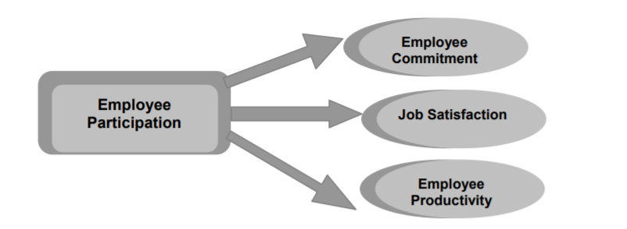

Figure 2-Employee Participation

**2.9. What is the relationship between employee satisfaction and customer satisfaction?**

There is a clear positive relationship between employee satisfaction and consumer satisfaction in various empirical studies (e.g. Band, 1988; Reynierse & Harker, 1992). Positive improvements in employee behavior, as shown by this abundance of studies contribute to positive changes in customer satisfaction. Some inquiries provided explicit measure of this relationship. A research by Sears Roebuck & Co., for example, found that a five-point change in employee perceptions led to a 1.3 increase in customer satisfaction which in turn produced sales increases of 0.5. Brooks (2000) analyzed the relationship between financial performance and variables of customer and employee. Brooks found that the relationship between employee attitudes and consumer-related variables accounted for between 40 and 80 percent of customer satisfaction and customer loyalty depending on the business segment and sector. Some have found that perceived employee happiness, perceived employee engagement and perceived employee dedication had a substantial effect on perceived quality of product and perceived level of service (Vilares and Cohelo, 2000).

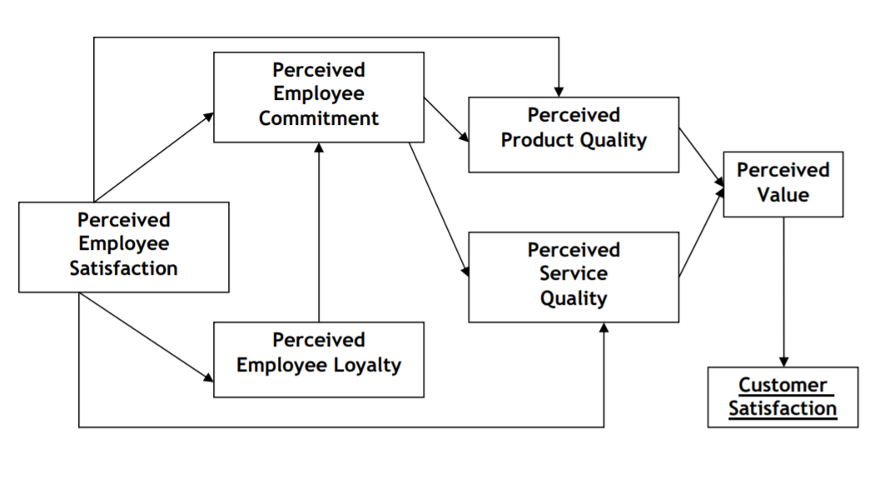

Figure 3-Employee and Customer Satisfaction

**2.10. Leadership and employee engagement:**

Transformative leaders have four distinct factors: charisma (idealized influence), inspirational motivation, intellectual stimulation and individualized consideration. These are the 4 I’s of the Transformational Leader (Bass, 1985). What does employee engagement mean?

Kahn (1990) described employee engagement as an effort to make use of the involvement of members of the company in the work. Employee involvement is passion and interest in the work. People are personally really attached to their job and inspired by the job itself. Past experiments were used to follow two methods for recognizing the employee engagement roots. Kahn (1990) set a method that is a psychological state attachment method, and other approaches are a standard solution to labor demand (Bakker & Demerouti, 2008; Xu & Thomas, 2011; May, Gilson & Harter, 2004).

The second method was a tool that could involve organizational factors such as job security and social aspects such as support from managers, contradictory responsibilities and autonomy. Employee engagement has shown similar characteristics to organizational citizenship conduct and employee engagement if not the same. Employee engagement has similar characteristics to the conduct of organizational citizenship and staff engagement (Mansoor and Aslam, 2012). The conduct of organizational citizenship varies from employee involvement in that the conduct of organizational citizenship requires activities that are not part of one's work requirements, whereas employee involvement is a structured role in the execution of the duties of the employee (Saks, 2006). Employee engagement will enhance the conduct of organizational citizenship by focusing on employee engagement and increasing employee engagement that may be outside the criteria defined in-organization (Mansoor and Aslam, 2012). Some have indicated a strong relationship between employee engagement & citizenship activity in organizations (Bakker and Demerouti, 2008). Employee involvement is the degree to which people appreciate and believe in what they are doing feel rewarded for doing it. Employee commitment is a positive attitude maintained by the worker towards the organization and the ideals advocated by the organization. Employees feel connected when their job seeks personal meaning and inspiration, provides positive interpersonal help and works in a good work environment.

**2.11. Supportive Leadership:**

A supervisor or a leader may play a significant role in improving the work environment's motivational characteristics like job autonomy. Leaders are most influential in the sense of individual work because the leader is the person most likely to reflect the organizational culture or environment and directly influence subordinate actions (Zaigham, 2007). A leader is the one who leads others towards a common goal and creates an atmosphere in which leaders of the other group feel actively engaged in the organization's operation.

Leadership is variables that can influence innovation in circumstances. Leadership can be attributed to individual folks ' imagination. The findings of empirical studies suggest that the leadership effect correlates with enhanced public trust in the followers of the higher job targets and improved expectations of people at work, which will, in effect, yield positive outcomes such as unity, work satisfaction, commitment or spirit, psychological excellently being and success (Jiao, Richards and Zhang, 2011). When leaders encourage strategic thinking within the company, workers will be more interested in the company and involved. As workers participate in their work, they increase the activities supporting the organization's good (Strickland, 2010).

The leader is an essential element of the job environment and can influence how people perceive their jobs. Note that the leader can have a positive impact on employee engagement by giving birth to a sense of commitment to the job when leaders have reasonable goals or fairness, and appreciate good results (Macey and Shnieder, 2008). Leadership will improve employee motivation, collaboration, commitment, competency, and efficiency (Shamir et al., 1993; Shieh and Li, 2012).

Previous studies indicate a correlation between the leader's actions and the attachment related positive attitude of the followers. A positive leadership style is used in this report. Results from previous research have shown that transformational leadership can carry the excitement and feeling of identifying with one's job (Macey and Schneider, 2008). Supportive Leader is a transformational leadership sub-dimension (Shin and Zhou, 2003), which is named individualized consideration. Individualized consideration includes personalizing contact with followers through the provision of effective mentoring, instruction and understanding (Grant, 2012). Employees will be involved in their work when they think that the leader knows about their well evidenced by the ability to communicate effectively the text that is hard, happy to listen to employees, willing to follow up with the problems with the positive actions and able to fulfil the values of the organization in their own behavior. If workers trust their representatives, they will be more likely to devote themselves to their jobs, as they feel mentally safe (Kahn, 1990). Engagement of employees includes the active support and engagement of top executives with strong mission statement, vision and values. Kahn (1990) established theoretical and empirical proof of the start of the leadership employee engagement relationship. Trust in the leader, the help of a leader and the development of an environment free of psychological safety are components which enhances employee engagement. Leadership can create an atmosphere in which workers can easily participate in actions about organizational citizenship. A leader actions have a big impact on employee output or performance. Saks (2006) found a positive connection between the encouragement of managers and the engagement of employees.

Theorists proposed that the theory of social exchange might provide an insight into how leaders affect the organization's achievements. The theory of social exchange indicates that workers would reciprocate the leader's actions towards them with their own actions and the existence of an acceptable mutual relationship as part of the formation of social exchange relationships (Soeib, Othman and D ' Silva, 2013). Leader conduct with people is a source of inspiration and satisfaction. The attitude and success of followers are also affected by leadership (Bycio, Hackett & Allen, 1995). Leadership is an integral aspect of building employee engagement. Leadership research has shown a clear relationship between leadership styles or behaviors and constructs that some people claim are part of the attachment, like motivation, job satisfaction, organizational engagement, and participation in organizational citizenship.

# **CHAPTER 3: RESEARCH METHODOLOGY**

This chapter gives a summary about the Research METHODOLOGY applied. It includes information about the research philosophy, research approach, research strategy, research methodological choice, time horizon, techniques and/or procedures for data analysis.

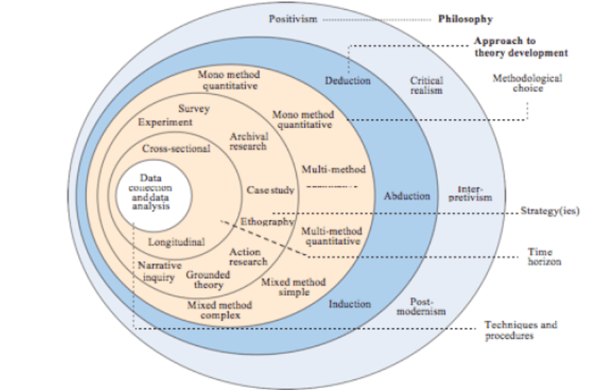

Figure 4-Research Onion

# **Research Philosophy**

The research philosophies are a belief in how to gather, interpret and use data about a phenomenon. There are five main philosophies that endorse any research, and they are defined based on your research issue, aim and objective. Such philosophies include:

Positivism, Interpretivism, Critical Realism, Pragmatism and Post Modernism.

**3.1.1 Positivism**, as a theory, adheres to the belief that only "factual" knowledge gained by perception (the senses), including calculation, is true. According to positivism studies, the researcher's function is limited in an analytical way to data collection and analysis. Study results in these types of studies are typically measurable and quantifiable. Positivism relies on assumptions which are quantifiable and contribute to statistical analysis. It was reported that “as a philosophy, positivism is in accordance with the empiricist view that knowledge stems from human experience. It has an atomistic, ontological view of the world as comprising discrete, observable elements and events that interact in an observable, determined and regular manner”. In this research, we are going to use the Positivism philosophy because our research is based on quantitative research.

**3.1.2 Interpretivism**, often known as interpretivist, requires researchers to interpret aspects of the analysis, thereby incorporating interpretivism into a study of human interest.

**3.1.3 Critical Realism (CR)** is a philosophical concept distinguishing the 'real' world from the 'observable' world. It is difficult to perceive the 'true' because it remains regardless of human expectations. From our viewpoints and observations, the world as we know and understand it is built by what is observable.

**3.1.4 Pragmatism** is a deconstructive philosophy promoting the use of mixed methods (quantitative and qualitative method).

**3.1.5 Postmodernism** is primarily applied in the arts and social sciences. It consists of a loose coalition of intellectual viewpoints that collectively present a daunting critique of the basic assumptions on which modernism, specifically the method of scientific research, is cantered.

# **Research Approach**

The research approach consists of three approaches that cover the 5 philosophies that we mentioned before; these three approaches are: Deductive approach, Inductive approach, and Abductive approach.

## **3.2.1 Deductive Approach:**

A deductive method is concerned with "developing an established theory-based hypothesis then designing a study method to test the hypothesis" and usually deductive approaches have been adopted by the positivism philosophy that is usually used when doing a quantitative study. In our case, we will be using the Deductive approach to reach our results. You must always start with previous outcomes when doing deductive research (the result of an inductive study). Deductively thinking means checking certain theories. You cannot do deductive analysis when there is no research done yet. The deductive reasoning assumptions can be true when all the assumptions set out in the inductive analysis are valid, as well as the terms are simple.

## **3.2.2 Inductive approach:**

In many forms of qualitative data analysis, especially grounded theory, the inductive approach is evident (Strauss & Corbin, 1990). It is quite similar to the general trend defined by others for the qualitative data analysis (Miles & Huberman, 1994). The primary aim of an inductive approach is to allow research results to emerge without the constraints imposed by formal methodologies from the regular, dominant or important themes inherent in raw data. This approach is mainly used when interpretivism philosophy is applied.

## **3.2.3 Abductive approach:**

It is a type for logical inference that starts with an observation or a collection of observations and then finds the simplest and most probable explanation for the observations. Unlike deductive approach, this method provides a logical inference but does not validate it positively. Consequently, abductive approaches are viewed as having some remnant of confusion or doubt, expressed in terms of retreat such as "best possible" or "most probable."

# **Research Strategy (Data Collection Method)**

This section summarizes the method of data collection and the process of using SPSS software to analyze the obtained data. There are 8 strategies we can use in a research: " Experiment, survey, case study, archival research, ethnography, action research, grounded theory and action research". Some of these strategies can be used for a quantitative research "when working with factors that can be measured" and some can be used for a qualitative research "when working with factors that can’t be measured" and some of these strategies can be used for mixed researches "quantitative and qualitative research " where some of the data can be measured and some of it can’t be.

In our case, we will be going through a survey strategy because our case is a quantitative research, and the best strategy that can be taken is survey where we can examine by questioner the answers of the respondents and analyze them on the SPSS system.

**3.3.1 Data Collection**

The primary data source collected was a questionnaire attached in Appendix A. The aim of the questionnaire was just to collect quantitative data on only the link between leadership styles and the impact on job satisfaction. The questions on the questionnaire were simple, transparent and appropriate and were expected to take the respondent no more than ten minutes to answer. The collection of data included fulfilling the questionnaire online via the shared link, when participants were absent during the analysis in the bank, the researcher sent the questionnaire to their email addresses. The questionnaire consisted of 3 sections; Section "A" asked participants to score their agreement with specific claims about the three different types of leadership. This section used five levels of like, varying from 1'strongly disagree' to 5'strongly agree'. It also sought to evaluate the types of leadership: Autocratic, Democratic and Laissez-Faire.

Section "B" requested the participant to score their acceptance level for specific statements and topics inside the workplace. This section had 5 levels in scoring, ranging from 1 "strongly disagree" to 5 "strongly agree". This segment aims towards evaluating employee satisfaction by measuring job quality, interpersonal relationship, training, empowerment and policies). Although section "C" centered on having general participant information, including demographic details. For example, the questions included: gender, marriage status, age, level of education, seniority, job role, seniority with the same director, responsibility for jobs, period of time working in the bank, region of work.

# **Research Methodological Choice**

Our research must have a specific methodology that we use to support our work and methods of data collection. If we want quantitative data to be obtained, we are possibly evaluating variables and checking or testing current theories or hypotheses. Sometimes, however, statistical collections and numeral crunching are not the key to understanding values, opinions and knowledge that are best understood by qualitative data. Questionnaires also seem a simple and easy choice as a way to collect people's information. In addition, they are very difficult to design because of their frequency of use in many contexts in the world today. The answer rate will almost always be an issue (low) unless you have ways to get people to complete and turn them in on - the-spot (and that, of course, restricts your survey, how long a questionnaire might be, and the types of questions you ask). Quantitative research has several characteristics starting with focusing on testing hypotheses and theories; it is also analyzed through statistical and math analysis; quantitative research is mainly expressed in graphs, numbers, and tables. It also requires a lot of respondents where we distribute closed questions. While a Qualitative research focuses on exploring ideas and formulating a theory or hypotheses and is analyzed through categorizing, interpreting, and summarizing, qualitative research is mainly expressed by words but requires few respondents through open ended questions.

In addition to the quantitative and the qualitative research methods, there is a mixed method. This method mixes up the two types of research where it can make a survey and conduct an interview. Let's say you're conducting interviews to find out how happy the participants are with their research and offer new perspectives to their responses. Later, you use the survey as a large-scale method to test the observations. Another strategy may be to launch a survey to figure out patterns or thoughts or values, accompanied by interviews in order to better understand their factors behind the patterns.

In our research, we are conducting the quantitative method through a survey. The survey is done through a questioner distributed for the banks. The number of banks in Lebanon is 15, and they have 115 branches all around Lebanon. Only 6 of these banks were covered in our survey and that was because of flexibility and availability of the managers and employees.

# **Time horizon**

Time horizons are required, regardless of the research methods used, for research design. There are two different types of time horizons: longitudinal and cross-sectional.

Cross-sectional: In order to address a research query, a study may be conducted in which data are collected only once, maybe over a period of weeks or months or either days. These studies are called cross-sectional or one-shot studies. Our study will also go through the cross-sectional research because our data only need to be collected once.

Longitudinal experiments repeat themselves over a prolonged period of time. A particular time frame is limited to cross sectional studies. This work is often restricted to a fixed time period, and thus the horizon of cross-sectional time is used in our study.

However, in some instances the researcher may wish to study individuals or events in more than 1 point to address the research question. For example, the researcher may want to analyze the actions of workers during a change in top management so as to know what results the change has achieved. Here, since data are collected at two different times, the analysis is not a cross-sectional nor one-shot sort but is carried over a period of time longitudinally. Such experiments are called longitudinal experiments, and this refers to when information on a dependent variable is obtained at two or even more times to solve the study questions.

# **Techniques and/or Procedures for Data Analysis**

In our case, the research is a quantitative research based on secondary data. The quantitative research has an outcome that is usually measurable thus data will be collected by questioner that will be distributed on respondents. The outcome of the questioner is analyzed by a software called SPSS “statistical package of the social sciences’’, and it is used for complicated statistical data analysis by different types of researchers. The SPSS software was developed for the social scientific data processing and statistical analysis. It was initially introduced in 1968 and was purchased later by IBM in 2009. SPSS is used for the collection and review of survey data by market analysts, health analysts, survey agencies, government departments, educational researchers, advertising organizations, data miner and many more.

In addition to SPSS, NVivo is a program which facilitates research into qualitative and mixed approaches. It is meant to help people organize, evaluate, and gain insights into unstructured or qualitative data like interviews, social media, web material, posts and open-ended survey.

# **CHAPTER 4: FINDINGS AND ANALYSIS**

# **Introduction**

The preceding section implemented the research methods and the methodologies used for data collection. The following section shows the effects of further interpretation analysis of the data. The study used different statistical methods to help explain the relationship between the variables examined. SPSS is a program was used to analyze the data that came from the questioner that was distributed on respondents to test the hypotheses that were mentioned before and decide whether to reject or accept them.

# **Findings (Descriptive Statistics)**

## **4.2.1- The overview of Characteristics of the Demographic part:**

A- Survey:

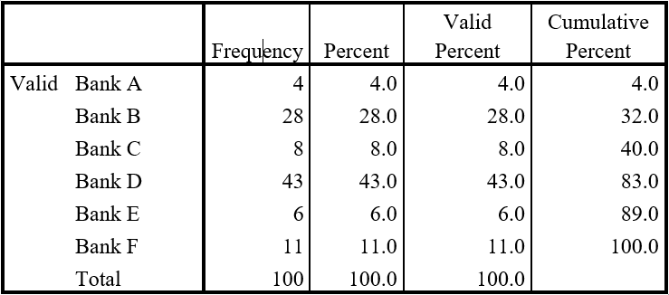

Table 1-The rate of response among sampled banks

B- Province:

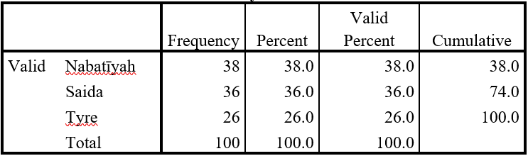

Table 2- Workforce distribution by province

**C- Gender:**

Table 3-Gender distribution for employees

D- Status of employees:

Table 4-Distribution of family status for employees

E- Age

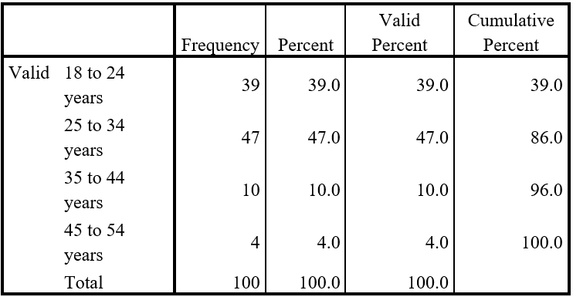

Table 5- Age distribution for employees

F-Education level:

Table 6-Education level distribution for employees

G- Job title

Table 7-Job title distribution on employees

**H-**Seniority:

Table 8-seniority of employees

**Responsibility:**

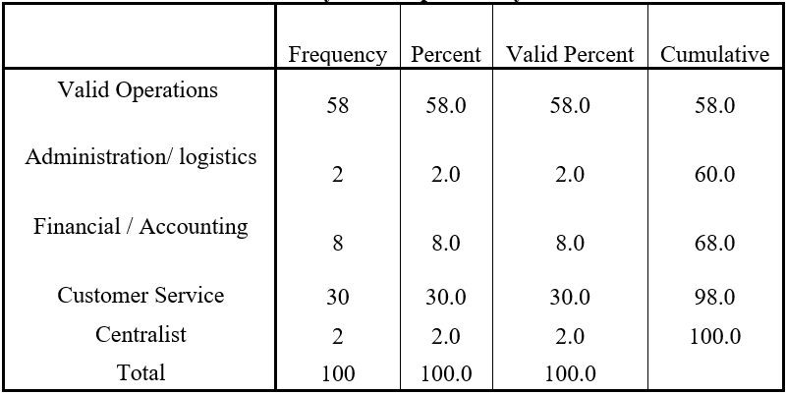

Table 9-Job responsibility of employees

**J-** The lengths of service with same supervisor:

Table 10-length of operation with same manager

## **4.2.2 Testing the theoretical framework**

Leadership style statements:

Table 11-the values of the mean and frequency of leadership styles

## **4.2.3. Statements of satisfaction**

|  |  |  |
| --- | --- | --- |
| **Nature of work** | **Mean** | **Percent** |
| I am able to improve skill and knowledge from my job | 4.38 | 87.6 |
| Managers give Importance to my ideas to do things better | 4.06 | 81.2 |
| My job is sustainable, and I have interest in it | 4.22 | 84.4 |
| **Average** | **4.22** | **84.4** |
| **interpersonal relation** | **Mean** | **Percent** |
| The supervisor of listens to the suggestions | 4.09 | 81.8 |
| In this bank free discussion occurs between the superiors and employees | 4.19 | 83.8 |
| Managers communicate the weaknesses of the employees in Non-threatening way | 4.24 | 84.8 |
| **Average** | **4.17** | **83.46** |
| **Training** | **Mean** | **Percent** |
| The training programs are Useful and help to acquire knowledge and skill | 4.51 | 90.2 |
| Managers encourage us to participate in the training courses | 4.34 | 86.8 |
| We are provided with opportunity to implement new methods and apply creative ideas | 4.05 | 81 |
| **Average** | **4.30** | **86** |
| **Policies** | **Mean** | **Percent** |
| The policies of management create conducive work environment | 3.98 | 79.6 |
| Career opportunities and their growth is immensely considered by the management | 3.98 | 79.6 |
| There is a trust and openness strategies adopted by management | 4.26 | 85.2 |
| **Average** | **4.07** | **81.46** |
| **Empowerment** | **Mean** | **Percent** |
| Managers Delegate of authority to allocate resources for various work | 3.64 | 72.8 |
| Authority given to employees to complete the assigned task | 3.70 | 74 |
| There is an easy accessibility of required information | 4.15 | 83 |
| **Average** | **3.83** | **76.6** |

Table 12- The values of the Mean and Frequency of Employee satisfaction Variables

## **4.2.4. Correlations**

To test the hypothesis that was stated before, the Pearson correlation test was done and

represented in table 13.

Table 13-Pearson Correlation test between leadership style and employee satisfaction

|  |  |  |
| --- | --- | --- |
| Correlations | | Employee Satisfaction |
| Job Title | Pearson Correlation | .231* |
| Sig. (2-tailed) | .021 |
| N | 100 |
| Age | Pearson Correlation | -.011 |
| Sig. (2-tailed) | .917 |
| N | 100 |
| Province | Pearson Correlation | .171 |
| Sig. (2-tailed) | .089 |
| N | 100 |
| Seniority | Pearson Correlation | -.121 |
| Sig. (2-tailed) | .232 |
| N | 100 |
| Same Manager | Pearson Correlation | -.150 |
| Sig. (2-tailed) | .137 |
| N | 100 |

Table 14-Pearson Correlation Between

Job Satisfaction and Demographics

# **Analysis**

**Table 1:** Over 100 respondents from six separate banks all around the South, 43% of respondents operate in Bank D, 28% workers completed the survey in Bank B, only 11% in Bank F, whereas Bank C offers 8% and Bank E 6%. Eventually, as can be seen in Table 1, 4 per cent job in Bank A.

**Table 2:** The 100 participants were collected from three various regions throughout the South, mostly 38% of participants operate in Nabatieh banks, 36% operate in Saida banks, while 26% operate in Banks in Tyre.

**Table 3:** The corresponding data shown in Table 3 reflects Question QD1 of the survey, 63 participants were females among the 100 survey takers while 37 were men. The information provided indicates that the majority of the participants were females.

**Table 4:** The current data is an overview of the survey QD2 query, which asked about the family status of the participant. Table 4 reveals that 71% of workers are single, 24% were married, 2% were widowed and 3% were divorced.

**Table 5:** Question QD3 gave participants four separate categories to state their age.

Of the 100 participants, 39 were aged around 18 and 24. 47 workers belong to the age group between the ages of 25 and 34, with 10 workers in the group between the ages of 45 and 54, and only four participants were between the ages of 45 and 54. Meaning they were mostly young. In the table below we can see the distribution for the 5 categories.

**Table 6:** In question 4 in the Demographic segment respondents were asked to state their highest educational standard. As predicted, most of the participants had a bachelor's degree, which accounted for slightly more than 70 % of the survey, nearly 23 % of the survey had a Master's degree, while the findings are seen in only 7 percent of those who finished high school, results shown in table 6.

**Table 7:** Question 9 asked respondents to mention the job title inside the bank. Table 7 provides a description of job status, seniority among samples. Most of the respondents were non-management members, almost 86 per cent. Supervisors also accounted 12% of respondents. In total, only 2 percent of respondents served as middle managers. The table notes that a total of 86 of the 100 participants hold non-management roles inside the company and 14 hold a management role.

**Table 8:** Question 7 carried out six separate category choices in order to gather data on the participant's period of employment inside the bank. The lengths of such years varied from a single year to more than 20 years of bank jobs. Table 8 below mentions the classes, the number of participants to pick the class and the rate overall. The table reveals that 83 % of the respondents has been with the organization from 1 to 9 years, whereas 14 % has been with the organization for more than 10 years.

**Table 9:** It indicates the frequency % of participants cantered on their roles at work. The largest (58 percent) of the sample worked an operations processing job, 30 percent were a customer support employee, while 8 percent held financial accounting roles and the remaining 2 percent were centralists.

**Table 10:** The following table indicates that the majority (59 percent) of respondents served 1 to 2 years with the same boss, and 25 percent served 3 to 5 years with the same boss. Nevertheless, 9 per cent worked for the same boss between 6-9 years, while 5 per cent operated with 14 to 20 years with the same boss. The participants minority operated with the same boss for 10 to 14 years.

**Table 11:** In order to identify the most followed leadership style among banking sector in South Lebanon, the frequency and mean of each statement included in questionnaire were measured and the average mean of the comments representing a particular variable was calculated, for example, Autocratic leadership was measured and translated to frequency to determine its prevalence, those described in table 21. The autocratic style of leadership tends to be 3.01 (60.15%), while the average Democratic leadership style is 3.79 (75.8%), and the average Laissez-Faire leadership style is 2.76 (55.13%).

**Table 12:** Workers are mainly satisfied with training courses 86 percent, followed by the nature of work 84.4 percent, and interpersonal relations 83.46 percent, followed by policies with 81.46 percent and last empowerment with 76.6 percent, the mean value of employment satisfaction is 4.11, that data can help us know that employees are satisfied by 82.2 percent in banks that are located in south of Lebanon.

**Table 13:** The correlation coefficient (r) is usually a measure of linear correlation between any two variables. It extends from -1 to + 1. A correlation coefficient with + 1 means that in a strong linear relationship two variables are ideally related, whereas a correlation coefficient with -1 means that in a negative linear the two variables are ideally related. If the was zero then that means that there is no relationship between the 2 variables, any correlation that is above 0.3 is considered accepted.

Based on the findings reported in table 13, the correlation among Autocratic style of leadership and employment satisfaction is statistically not significant (p = 0.251 > 0.05) and the coefficient of correlation r = 0.125 < 0.3. There is therefore no relationship between these variables, and acceptance of H1. Whereas the second H2 hypothesis indicated a significant relationship among bank managers 'Democratic leadership style and their employees' job satisfaction, the test showed a strong statistically meaningful strong correlation between the two variables for p = 0.004 < 0.05 and r = 0.536, so H2 is accepted. The positive association occurs by 53 percent, which also improves employee satisfaction in another way as democratic leadership activities improve.

With regard to the third hypothesis H3, the researchers suggested that there is no substantial association between the bank managers' Laissez-Faire leadership style and their employees' job satisfaction, according to the correlation table, p = 0.041 <0.05 and r = - 0.24, while there is a substantial negative low correlation between the two variables, Employee satisfaction should decrease as Laissez-Faire leadership practices increase, for this H3 is rejected. The final H4 hypothesis indicated there was no important association between the ethnicity of the workers and job satisfaction, the correlation of this study is represented in table 14.

**Table 14:** We can conclude from the test that there is a positive correlation between job satisfaction and job title (p=0.02 < 0.05). while no relation between the other demographics and job satisfaction

# **Summary of Findings and Analysis**

We can conclude from the analysis we got that:

* “The majority of respondents are from bank D.”
* “The majority of respondents operate in Nabatiyih Banks.”
* “Most of the respondents were women.”
* “Most of the respondents were single.”
* “The highest percent of employees ages was between 18 and 24.”
* “70 of participants had bachelor’s degree.”
* “Most of the respondents were nonmanagerial employees.”
* “83% of employees been from 1 to 9 years in the same organization.”
* “58% of the sample worked an operations processing job.”
* “Most of respondents served 1 to 2 years with the same Manager.”
* “Most of the Managers were using the Democratic leadership style with there subordinates.”
* “Workers are mainly satisfied with training courses with 86 %.”
* “The correlation test indicates that H1 and H2 are accepted H3 and H4 are rejected.”

# **CHAPTER 5: CONCLUSION, LIMITATIONS, AND RECOMMENDATIONS**

# **Conclusion**

We can conclude that in South Lebanon banks, the most used style of leadership is Democratic leadership style followed with Autocratic style then Laissez-Faire. However, there was a positive relationship between Democratic model and the Laissez-Faire model, this finding was consistent with the experiments in Finland, Sweden, Kenya and Ghana.

The key remarkable trait of Democratic leadership would be to help workers recognize accountability for completing their job, in addition to communicating effectively job procedures, therefore increasing this type of communication and leading to improve behaviors of Democratic leadership style, thus raising employee job satisfaction.

As for the Autocratic leadership, the employees liked to be a part of the decision-making group of people, in addition to providing input without coercion, though employees felt that superiors would not allow them to operate on their own in difficult circumstances; this is perceived to be a form of control for workers.

Satisfaction might increase when more training programs were introduced. Workers believed that these programs enable them to learn knowledge and skills. Moreover, if managers motivate employees to engage in programs, satisfaction might increase; the nature of work is also a reason for employee satisfaction, particularly if employees are able to develop their skills, and if work is sustainable. Another explanation for satisfaction is personal relationships. If managers honestly share ideas with workers and point out shortcomings in a non-threatening way, workers will be more satisfied. Policies are also a cause for satisfaction particularly when management adopts confidence and openness strategies. In general, the rate for employee satisfaction was considered to also be high (82 percent), and it can be improved if employees are motivated and encouraged to complete the entire task they are provided.

With relation to demographics, it has been noticed that job title would improve employee satisfaction; it has also been noted that women spend longer time working in the very same bank than males as a result of being promoted to senior positions, whereas males typically shift from bank to many other jobs for better chances. Females occupied most of the supervisor roles whereas middle manager roles were filled by males. It is also been noted that most bank workers fall to the age range around 25 and 34, whereas most survey participants were females.

# **Limitations**

Due to the current situation, corona virus spread all over the world which led to closing all vital centers, prevented us from distributing our questioner over the respondents. In other words, we couldn’t get primary data for our research; we got secondary data from previous projects to complete our research and proof our hypotheses for the reader.

# **Recommendations**

To managers in the banking sector, recognizing their leadership style is strongly recommended as it has a direct effect on employee job satisfaction. It will improve employee's productivity and help achieve bank objectives. Since Democratic leadership style contributes to higher results, managers should therefore be trained to follow this model. Managers should also avoid models like Autocratic and Laissez-Faire style due to their negative effects on employee performance.

# **REFERENCES**

Ariani, D. W., 2014. Relationship Leadership, Employee Engagement and Organizational Citizenship Behavior.

Aydin, B., 2009. A Research Analysis on Employee Satisfaction in terms.

Balouch, R., 2014. Determinants of Job Satisfaction and its Impact on.

Budhwar, P. S. and Debrah, Y. (2001) ‘Rethinking comparative and cross-national human resource management research’, International Journal of Human Resource Management. Taylor & Francis, 12(3), pp. 497–515.

Bishbishy, A. H. M. a. N. E.-., 2014. The Empact of transformational leadership style on employee satisfaction. Alexandria, Egypt, s.n.

Bulgarella, C. C., 2005. Employee Satisfaction and customer satisfaction.

Gan, A., 2018. What is MAnagment. p. 3 .

Qureshi, K. K. B. a. T. M., 2007. Impact Of Employee Participation On Job Satisfaction,.

Šehić, D., 2014. TRANSFORMATIONAL LEADERSHIP&employee satisfaction.

Bass, B. M. and Stogdill, R. M. (1990) Bass & Stogdill’s handbook of leadership: Theory, research, and managerial applications. Simon and Schuster.

Thomas, D. R., 2003. A general inductive approach for qualitative analysis. p. 11.

Turk, W., 2007. *Manager or Leader?.* s.l.:s.n.

Hackman, M. Z. and Johnson, C. E. (1995) ‘Leadership communication skills’, The leader’s companion: Insights on leadership through the ages, pp. 428–431.

Mohammad Mosadegh Rad, A. and Hossein Yarmohammadian, M. (2006) ‘A study of relationship between managers’ leadership style and employees’ job satisfaction’, Leadership in Health Services. Emerald Group Publishing Limited, 19(2), pp. 11–28.

Mullins, R. and Syam, N. (2014) ‘Manager–salesperson congruence in customer orientation and job outcomes: The bright and dark sides of leadership in aligning values’, Journal of Personal Selling & Sales Management. Taylor & Francis, 34(3), pp. 188–205.

Obuobisa-Darko, E. and Obuobisa-Darko, T. (2015) ‘Leadership and employee satisfaction in the Ghanaian banking sector’, Leadership. Citeseer, 7(8).

Richard L Hughes and Ginnett, R. C. (2002) Leadership Enhancing the lessons of Experience, Sixth Edition.

Savery, L. K. (1994) ‘The Influence of the Perceived Styles of Leadership on a Group of Workers on their Attitudes to Work’, Leadership & Organization Development Journal. MCB UP Ltd, 15(4), pp. 12–18.

Spector, P. E. (1985) ‘Measurement of human service staff satisfaction: Development of the Job Satisfaction Survey’, American journal of community psychology. Springer, 13(6), pp. 693–713.

# **APPENDICES**

# **APPENDIX 1: QUESTIONNAIRES**

